Name: Carrie Reaver
Bi- Weekly Report Dates: April 23-29
Week 11 Total: 88,922 steps- high day was 15,958 steps, low day was 5,925 steps

Week 11 Reflection and Graphs
Reflection: During the week of April 23-29, I exceeded my step goal by obtaining 88,922 steps. I typically play soccer and do personal workouts 6-7 days a week and walking to classes/club meetings occurs 5 days a week. On my high day, which was Tuesday, I woke up early and ran for 30 minutes, then I have afternoon soccer practice which involved scrimmaging for one hour. My engagement with soccer helped me obtain lots of steps that day. I also went to the gym that night to run and practice on my own for 30 minutes. My work load was low this week, so I had a lot of extra time to work out. My activity occurs throughout the entire day, as I am usually on the move throughout the whole day, running errands, going to practice, walking to meetings, or going to class. On my low day, Saturday, I decided to sleep in, rest in bed, and take it easy to let my body rest and to get a mental break from the week as well. Even though it’s important to get 10,000 steps in every day, I felt it was more important to rejuvenate my body so I could have another busy week without feeling ran down. I only got about half the required steps in on that day. Overall, being on a sports team and being engaged in lots of academics/extracurriculars is a tremendous boost to my activity level.

HIGH DAY

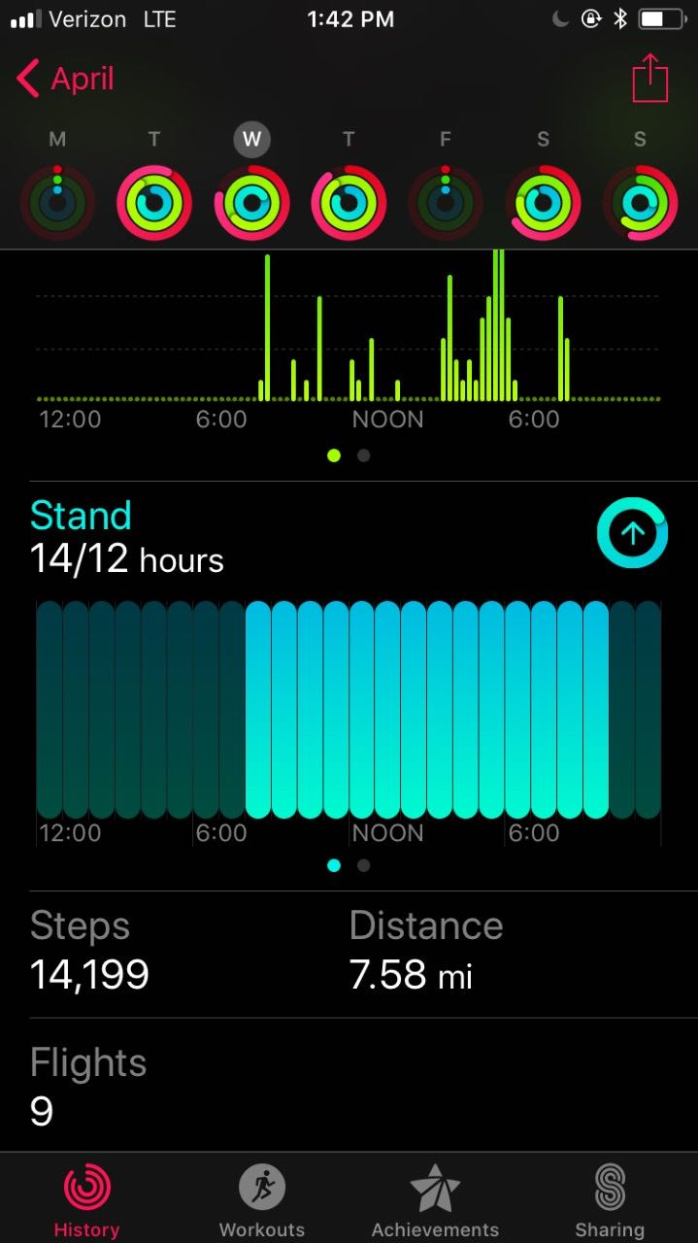
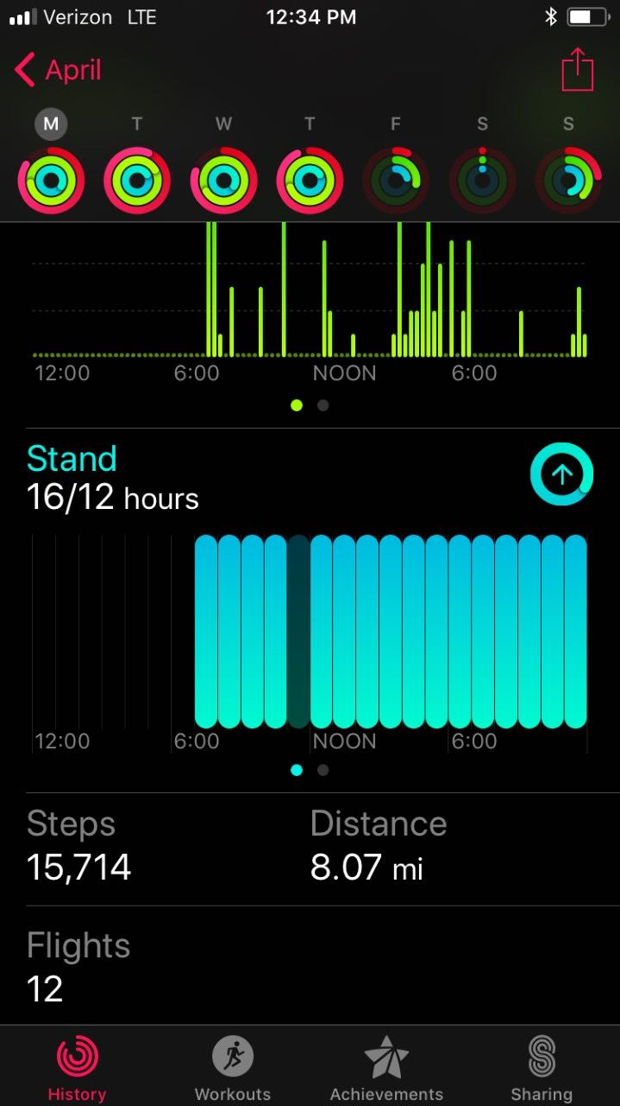
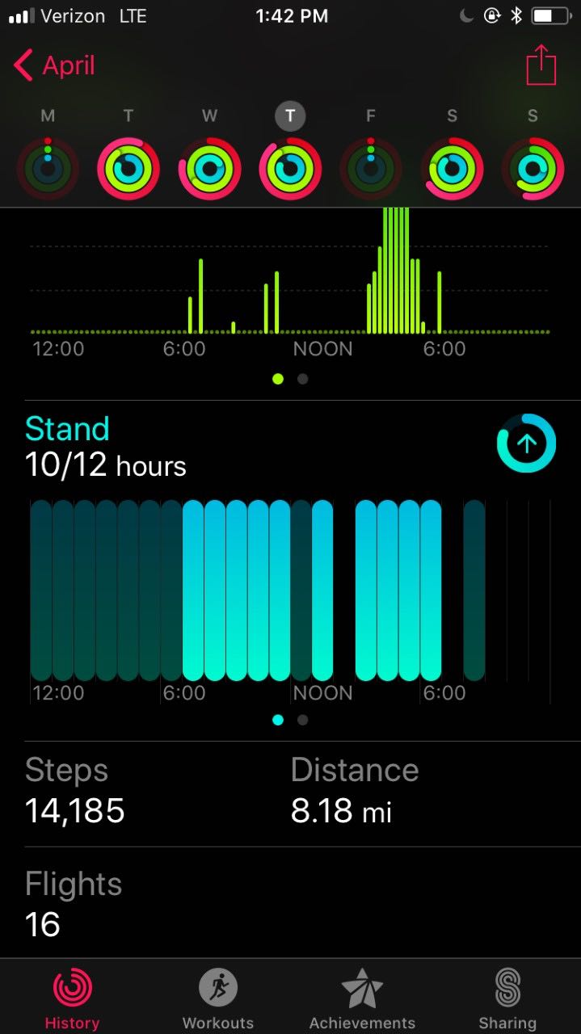
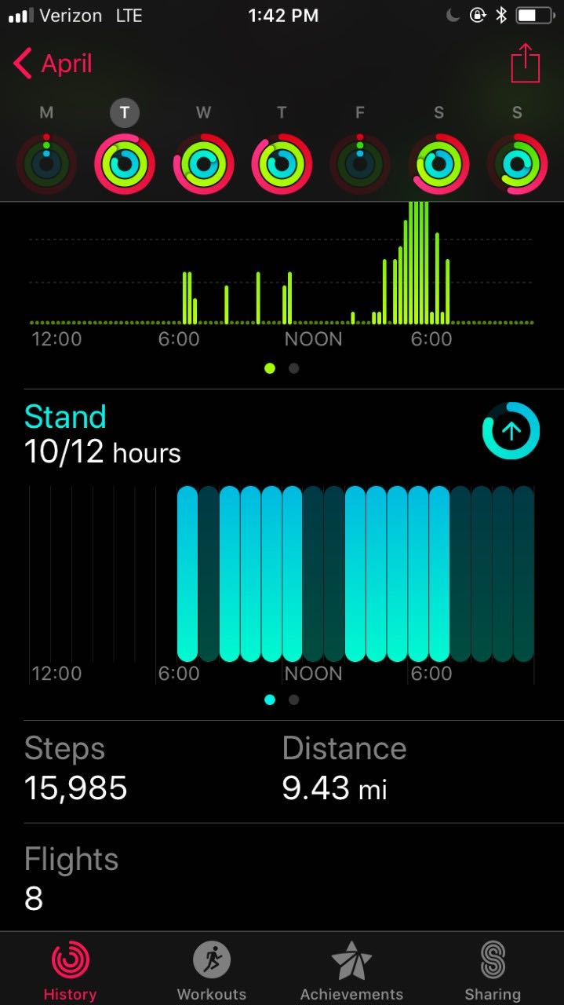

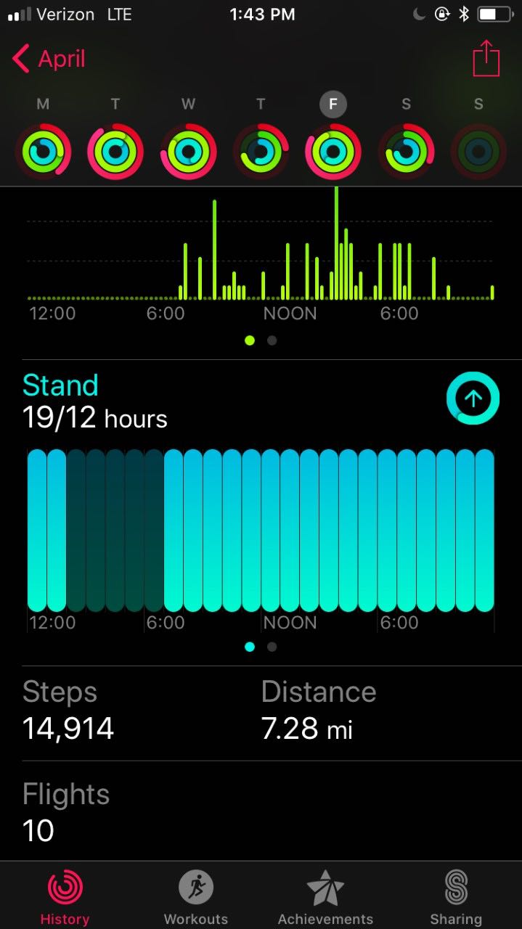
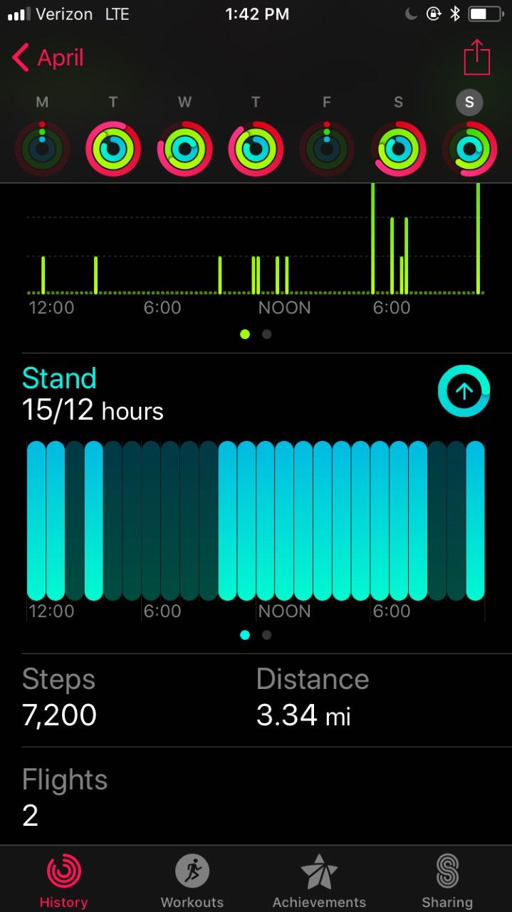
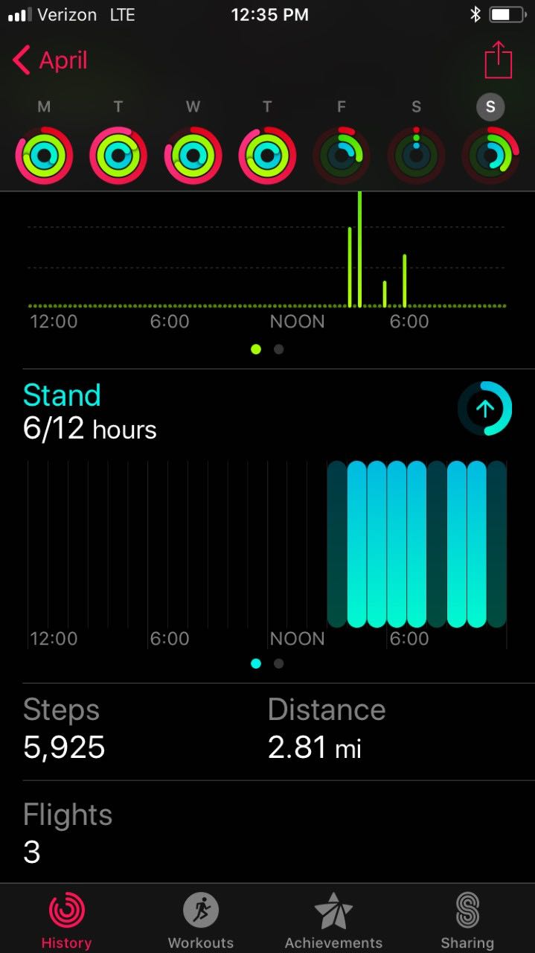

LOW DAY

