r

A Comparison of the Fields of Nursing, Astronomy, and Sociology: How They Differ in Terms of Structure, Language, and Reference
Ashlee Ratliff
ENGL 165-50
Professor Green
April 22nd, 2020

A Comparison of the Fields of Nursing, Astronomy, and Sociology: How They Differ in Terms of Structure, Language, and Reference
This study considers the differences between three academic disciplines: the applied fields, natural sciences, and social sciences. These disciplines have many similarities and differences. All three disciplines often use jargon, and all have a high emphasis on collaboration with other authors. However, the social sciences usually use abstracts, whereas the natural sciences and applied fields often do not. Additionally, the applied fields often vary in their use of structure, language, and reference from field to field – neither the natural sciences or the social sciences differ as much. I also attempt to compare three academic fields – nursing, astronomy, and sociology. In this article, I will aim to answer the question: What are the similarities and differences in language, structure, and reference in writing in three academic fields?
Structure, language, and reference play significant roles in the comparison of these disciplines and fields. Structure is the organization of an article, such as the use of the IMRaD format. Language is the precise use of words that an author uses to make their point, such as the use of passive or active voice. Finally, reference is how an author relies on others and their work to present their information, an example being the use of citations and footnotes.
Writing across the curriculum, henceforth referred to as WAC, plays a significant role in each of these three components. WAC and structure are inextricably linked, as WAC encourages the use of standard headers, such as IMRaD, to increase understanding of an article across disciplines. Language and WAC also often interact in the way that language must be understandable so that others can comprehend the meaning of the written text. It is also present in the use of jargon in some articles, as it helps convey information to those within the field. Finally, WAC and reference often conflate as references serve to give credit to other authors. These other authors can come from vastly different fields or disciplines, and others from other fields may read the article for understanding. Thus, WAC must be present to ensure understanding.
Literature Review
Writing across the curriculum (WAC) is a hugely influential pedagogy that has become prevalent in many forms of college writing and courses. To explore this topic in an initial assignment, I conducted research to form an annotated bibliography regarding the concept of WAC through its use in several studies. Through my research, I found common themes emerge from each source. Every one of the sources discussed in this literature review includes a common idea of WAC being of incredible importance in any student's education. However, they also differ in distinct ways. Mostly, this is dependent upon the writer's beliefs about how WAC impacts their field of research. WAC has had a positive impact through its use across college courses, affecting writing-intensive majors, and continuing to evolve in writing curricula.
Students who participate in a WAC model in the classroom will experience learning benefits in later coursework. McCarthy (1987) utilizes a study where she analyzes the impact of WAC across three courses in a student's college career. Although the subject, Dave Garrison, was unable to view the similarities between classes, they exist and could have significantly decreased Garrison's workload. In her article, McCarthy states that Garrison did not see how the skills he learned in one class could apply to others without conscious thought and evaluation. (McCarthy, 1987). While McCarthy admits that skills do not necessarily apply themselves without thought from one course to another, however, if a student recognizes them, they can quickly become influential on a student's success. While Garrison did not ultimately receive the benefits of WAC in his courses, McCarthy believes that a student could, if the classes were appropriate and a student was aware of the connection. If that is the case, a student's writing ability could improve, and grades would increase. These impacts can have a dramatic positive effect on a student's university career. These impacts are directly related to the use of WAC in coursework.
In comparison to this, Stout (2010) utilizes WAC through a creative writing assignment. For one student, this assignment became very helpful when she attempted to use it in another course. The professor stated that Stout's example was better than their own, and the student was permitted to use her essay. (Stout, 2010, p. 1165). Although Stout's general education Chemistry class and the student's English class varied greatly, WAC played a role in this student's success. Without its impact, she would not be able to use the skills and techniques she learned to create her autobiography in her later coursework, and she would likely not have done as well. Additionally, her grade was presumably improved by the autobiography, as she was permitted to use it in her course due to its relevance in multiple classes. All of these are benefits that can be found solely from the use of WAC in a college writing assignment. McCarthy (1987) and Stout (2010) agree that WAC can have a positive impact on college writing. However, they conduct their research differently. McCarthy uses a study, whereas Stout uses a specific autobiography assignment.
Secondarily, WAC's impact in writing-heavy majors was promoted primarily by the articles written by Stout (2010) and Luthy et al. (2009). Each of these sources supported the use of WAC in courses that are often writing-intensive. However, they analyze it in separate ways. To begin, Stout's article, while also promoting the benefit WAC had on later courses, also explained the advantage to his own through an assignment. He explains that through his autobiography assignment, a student learned the benefit of good writing skills and communication in chemistry, and also developed a connection with chemistry in a unique way. Also, this assignment served as a basic introductory essay for writing in chemistry. (Stout, 2010, pgs. 1163 and 1165). While creative writing is not a common assignment in chemistry, WAC became impactful to promote communication and writing skills in the major, as well as a deeper understanding of the field of chemistry. These offer many benefits for students, such as better grades in the course and more advanced knowledge of the field.
In comparison to Stout (2010), Luthy et al. expand upon the benefits of WAC, but in nursing as opposed to chemistry. They state the numerous benefits, among them, encouraging competence, supporting critical thinking and communication, encouraging effective research, and working their findings into their professional practice. (Luthy et al., 2009, p. 54). Through the use of WAC in coursework, a nursing student can develop these skills. As a result of this growth, a nursing student could become more fully versed in these essential topics, leading to success in the classroom and, ultimately, the nursing profession. Stout (2010) and Luthy et al. (2009) agree on the idea that excellent writing skills do not lie solely in the realm of the English department. However, they focus on different fields, these being chemistry and nursing, respectively.
Ultimately, the growth of WAC in the writing field is the most significant measure of its positive impact. According to Anson (2010) and McLeod and Maimon (2000), WAC's relevance has grown over time to become an integral part of many college curriculums. However, their focuses differ significantly. Anson begins the conversation about WAC by discussing its popularity, claiming that WAC's popularity has grown over time, peaking around 1982 to 1986. This number also coincides with a growth in the number of articles published by WAC and composition experts. (Anson, 2010, p. 12). Since 1986 was the final year of the study, and therefore, no new data was collected after this date, we can only make assumptions about WAC's increasing popularity. However, it is not improbable that it has grown in popularity at a consistent level. If this is true, this is a testament to WAC's positive impact on student learning. If a theory such as WAC does not prove a benefit, it is abandoned or phased out. A look at any college campus shows that this is not the case – WAC is as popular as ever and has been associated with benefits such as higher grades. Therefore, we can state with certainty that WAC provides a notable positive impact on students, as referenced by its growth over time.
In comparison to Anson (2010), McLeod and Maimon's (2000) article focuses primarily on myths and beliefs that have become prevalent in WAC over time, such as its use in comparison with writing in the disciplines (WID) and the superiority of "writing to learn" techniques, as opposed to its growing popularity. (McLeod & Maimon, 2000, p. 574). Even though this argumentative paper does not at first appear to support the positive impact of WAC, McLeod and Maimon include it. When a theory is as widespread and, in some respects, as vague as WAC, others will copy it and aim to develop their curricula around it. McLeod and Maimon's paper only serves as an analysis of what the proper conduction of WAC is and a call to fix faulty practice. The need for an article at all symbolizes that WAC has become so widespread that these myths need to be corrected to benefit students. If my analysis is correct, this relates to Anson's comments on popularity – it has become so popular, that it is hugely widespread across campuses and has played a role in the writing curriculums of millions of students. These benefits have proven themselves in previous studies, including better grades and preparation for the workplace. McLeod and Maimon, in this article, seek to draw attention to the positive impact of WAC. However, they offer ways that it could be improved. Anson (2010) and McLeod and Maimon (2000) encourage the idea that WAC's benefit should be clarified. However, they theorize in separate ways. Anson does not support making change and focuses on the popularity of WAC over time. McLeod and Maimon, however, suggest the clarification of the field's misunderstandings and focus primarily on these while maintaining an underlying focus on the influence WAC has had on student writing.
Despite the information I discovered through the analysis of these sources, I noticed a gap in the knowledge presented. In all five of the sources I analyzed, not one spoke about a following-up program that could work to encourage WAC usage in continuing coursework. For example, in McCarthy's essay, Dave Garrison struggled considerably to connect the skills he had learned to other courses. (McCarthy, 1987, p. 261). This struggle is a common problem even today. Perhaps if schools established these programs, we could see a brighter future for those in such a situation.
Methods
Crafting a literature review taught me that WAC is not a straightforward checklist of items to follow to ensure success across the university. Instead, it is a process of adapting skills and knowledge to be relevant both in the university and beyond. In conjunction with this, I learned that WAC can appear differently between fields, and even between articles. In other words, WAC can appear using many tactics, such as writing reports or engaging in certain academic activities, such as fun autobiographies.
I chose to analyze the disciplines of applied fields, natural sciences, and social sciences, and from there, I further decided to investigate the fields of nursing, astronomy, and sociology. I chose the disciplines primarily because I believed that they would have many similarities and would serve as foils for one another. Next came the fields. I selected nursing as it is my major. However, the natural sciences and social sciences were more challenging to decide on. I chose astronomy as it is a pet interest of mine, and I was curious as to how it would fit in with the other two fields. Finally, I chose sociology as it is easy to draw comparisons between it and nursing, and I felt that these two fields, when compared, would offer many fascinating similarities.
The search terms I used were broad and sweeping to collect as many articles as possible. For nursing, I cast the net for “cultural sensitivity in nursing practice.” Secondarily, I searched “black holes” to draw a wide variety of sources from the astronomy field. Finally, I searched “gender and sexuality in sociology” to pull articles from the social sciences regarding this issue. Once I had collected my sources, I began to read them to distinguish similarities and differences between the fields. I read them mostly like a novel, in the sense that I read the sources in full. As I did so, I took notes in a separate document to later compare and contrast the sources. Primarily, I was interested in the use of active vs. passive voice for language, the formatting such as IMRaD or other headings for structure, and the differences in how authors cited their sources for reference.
Results/Analysis
Language, structure, and reference vary across the curriculum. This results section identifies my findings and analyses of six samples of writing from three different fields: nursing, astronomy, and sociology.
Structure
Structure is arguably one of the most influential factors in a paper. It can influence how a reader perceives the writing and establishes credibility to both the layperson and experts within the field. To begin, structure in the applied fields can vary from genre to genre. However, in the field of nursing, it is not uncommon to see scholarly papers formatted in an Introductions, Method, Results/Analysis, and Discussion format, henceforth referred to as IMRaD. However, my chosen articles deviate from such norms. They fall in an odd gray area between personal writing and scholarly writing. However, as they exist in an academic journal, I am choosing to consider them academic papers. The first, “The Cultural Perspective in Nursing Education” (1988), follows a simple format comprising of essay-style paragraphs organized into rows. I have included a screenshot below for analysis.
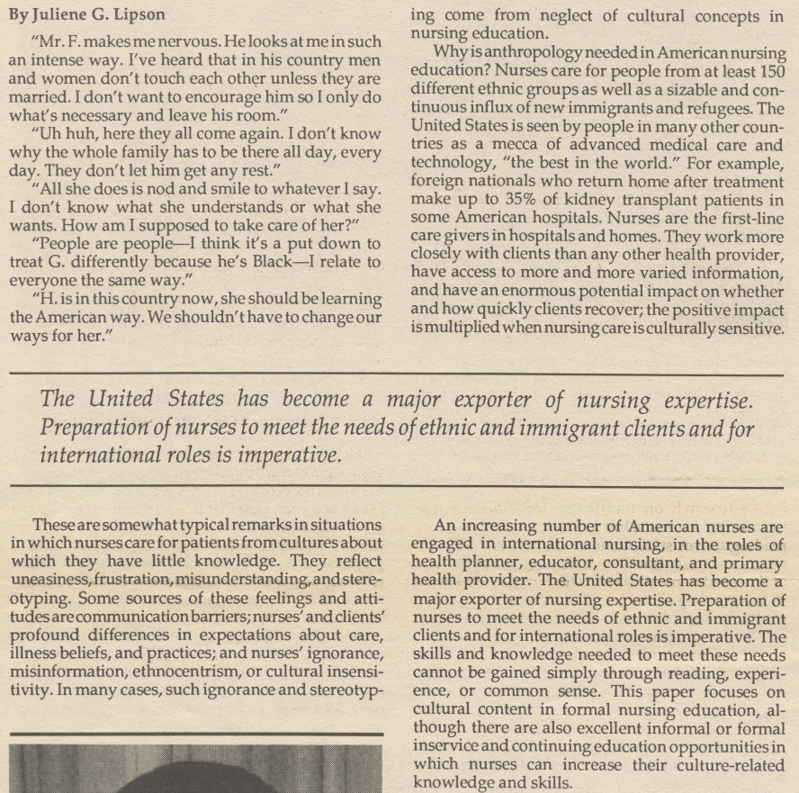
(Lipson, 1988, p. 4).
As seen above, the information follows a paragraph format based on how a reader may potentially read the paper. The second article, “Promoting Cultural Sensitivity in Nursing Practice” (1993), follows a very similar format. However, instead of being focused in lines horizontally, it is read in slimmer, vertical columns. I have attached another example below:
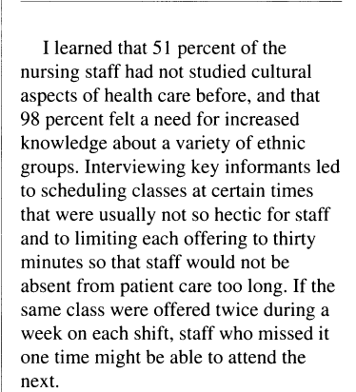
(Sharma, 1993, p. 31).
The author, Sharma, utilizes this paragraph format throughout the rest of her paper, as opposed to using proper headings. The articles may have deviated from the traditional IMRaD format as the writers may not have considered them scholarly papers, despite the fact they exist in an academic journal. Therefore, using an IMRaD format would be inappropriate.
Secondly, the natural sciences almost always follow a strict IMRaD format, as the data are usually quantitative. However, the articles that I analyzed do not reflect such an arrangement. Instead, they lay out the information in easy-to-read paragraphs with very few, if any, headings. The first article I analyzed, “Black Holes” (2001), has several headings appropriate to discuss the multiple topics in the essay. A couple of examples of these headers are "The Galaxy's Central Supermassive Black Hole" and "X-Ray Binaries and Microquasars” (Brügmann, Ghez, & Greiner, 2001, p. 10525). The second article, however, follows a very different approach. Instead of having headings, the report is split into paragraphs following a logical, essay-like format. I have included a screenshot for reference: 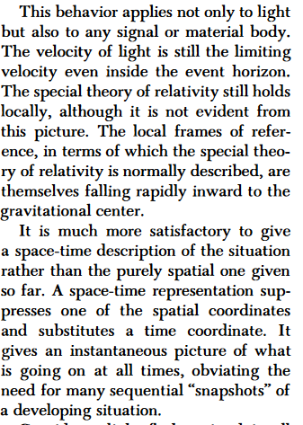
(Penrose, 1972, p. 40).
In this article, the information is divided into manageable chunks and reads more similar to an essay than a scientific paper. The authors' use of headers, if any, could potentially be due to the journals that the articles exist in. My first article exists in the Proceedings of the National Academy of Sciences of the United States of America, a mostly academic journal. The level of academic rigor could potentially explain the use of simple headings. However, the second exists in Scientific American, which appeals to the general public. Thus, chiefly academic headings could scare off readers, who could skim the article, and, seeing these headings, determine the material too difficult for them to read.
Finally, the social sciences have varied structural organization. Depending on the data collected in a study, a social scientist could choose to use IMRaD, especially if the data are quantitative. However, other structures are acceptable if the researcher deems it appropriate. The first article, “Sociology in the 1980s: The Rise of Gender (And Intersectionality)” (2016), follows one such alternative structure reminiscent of the minimal-heading based style used by “Black Holes” (2001). The authors use alternative headings to introduce new ideas without confusing the reader. A couple of examples of this structuring technique are "Austerity, Assessments, and Advances" and "Theorizing Gender and Patriarchy." (Roth & Dashper, 2016, pgs. NP2-NP6). The second article, “Patterned Fluidities: (Re) Imagining the Relationship between Gender and Sexuality” (2007), follows a similar structure. The author chose to use a header titled “Introduction,” but aside from this, she uses headings of her own design. However, these headings are logical and make sense to introduce a new idea. Several examples utilized in this article are "Complex Interimplications" and "Knots, Grids, Tangled Webs, or Patterned Fluidities?" (Richardson, 2007, pgs. 464-469). The use of alternate headings in these articles is likely because they did not use quantitative data – instead, their data was mostly qualitative. Therefore, IMRaD would not have been appropriate.
Several similarities and differences are present between the applied fields, natural sciences, and social sciences. Both the applied fields and natural sciences aim to follow an IMRaD format, and to a lesser extent, so do the social sciences. However, none of the articles I observed follow such a structure, with some choosing to use alternative headers, such as Roth and Dashper (2016) and Brügmann, Ghez, and Greiner (2001), and others, such as Sharma (1993) and Penrose (1972) using none at all. The way they design their structures is another point of comparison. Both of the reports from the social sciences used headings, whereas the articles from the applied fields did not. This difference could potentially be due to differences in the topics of the materials, as the ones in the applied fields read more like personal narratives than academic essays. However, the ones in the social sciences are more scientifically based. The natural sciences are a little less easily compared. They are scientific and discuss the implications of black holes, but neither uses IMRaD format. One (1972) does not even use headings at all. In this way, it is mostly similar to the articles used in the applied fields, which also generally follow an IMRaD format.
Language
To begin, I analyzed two samples of writing on cross-cultural nursing from the applied fields. It is important to remember that language can vary significantly among genres, so it is challenging to state common themes. However, it is common for those in the applied fields to write among other like-minded professionals. As such, articles can often be full of jargon and terms that may be difficult for the layperson to understand. However, the articles I read do not show such a focus on complex language. For example, in the essay "The Cultural Perspective in Nursing Education” (1988), Lipson offers real-world examples in easy-to-understand wording. Lipson states, "Uh huh, here they all come again. I don't know why the whole family has to be there all day, every day. They don't let him get any rest" (Lipson, 1988, p. 4). While the article may serve to educate nursing professors, the term usage shows that anyone could read this article and understand it, which is uncommon for the applied fields. A similar technique is present in my second article, “Promoting Cultural Sensitivity in Nursing Practice” (1993). The author relates her personal experiences and statistics to consider how nursing and anthropology can affect each other. She also does this in language that a layperson can understand, by stating: "I learned that 51 percent of the nursing staff had not studied cultural aspects of health care before, and that 98 percent felt a need for increased knowledge about a variety of ethnic groups" (Sharma, 1993, p. 31). This language use could potentially be because the articles are in a journal focusing primarily on anthropology, which is a social science. In comparison, nursing is an applied field. Therefore, jargon that a nurse may understand would not apply to the audience of anthropology experts. This language use is significant as it allows nurses or anthropologists to draw conclusions about the other field. They analyze how one impacts the other without being confused by complicated jargon.
Next, I considered the natural sciences through the evaluation of astronomy articles, particularly those considering black holes. The natural sciences often follow rigid conventions and write in neutral, yet complicated jargon. The first article, “Black Holes” (2001), follows these standards closely. “Although optical/IR spectroscopic measurements of the velocity of the companion star can readily determine the mass of the black hole, x-ray measurements promise to be a sharper and even more flexible diagnostic tool as they reach down to the inner edge of the accretion disk at a few Schwarzschild radii of the black hole” (Brügmann, Ghez, & Greiner, 2001, p. 10525). As shown in this quote, the article uses jargon that one could find within the astronomy field. Additionally, the report is neutral, as the authors share the most likely outcome without inputting their own beliefs. However, in the second article, also titled "Black Holes" (1972), the author uses a different tactic. While Penrose is still as neutral as possible in his writing, he uses minimal jargon in his report and instead explains the concept in simple to understand English. This language use is similar to the articles I reviewed in the applied fields, as they utilized this simple-English approach. However, it contrasts with the social sciences as they often use jargon as well. Penrose states, "A black hole is a region of space into which a star (or a collection of stars or other bodies) has fallen and from which no light, matter or signal of any kind can escape" (Penrose, 1972, p. 39). This language use could potentially be because the article exists in Scientific American, a journal that does appeal to the layperson. As such, the use of complicated jargon would not be appropriate and could alienate audiences. In contrast, Brügmann, Ghez, and Greiner's (2001) follows the conventions more closely as it was published in a journal discussing the National Academy of Sciences. A layperson would probably not read this. Therefore, the use of jargon would be appropriate.
Finally, I considered the social sciences through the lens of sociology. I was primarily interested in the differences that are present in gender and sexuality articles and how they compare to writing in other fields. In the social sciences, the use of the passive voice is normal, and abstracts exist to introduce a writer to the topic. Also, hypotheses, or more rarely, research questions, can often be found in these papers. The first article, “Sociology in the 1980s: The Rise of Gender (and Intersectionality)” (2016), exemplifies these in many ways. An abstract begins the paper to explain the topic of the article briefly. I have attached a screenshot of the abstract for analysis. In the abstract, one can note the use of passive voice, such as the use of the phrase "have changed.” (Roth & Dashper, 2016, p. NP1).
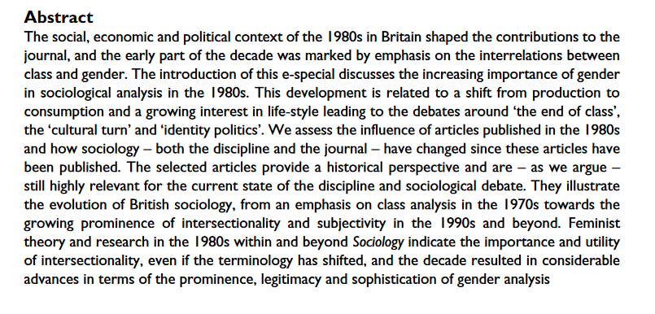
(Roth & Dashper, 2016, p. NP1).
Also, the authors include several research questions guiding their study. They state these as, “What can we gain from a selection of articles addressing gender that were published in Sociology about 30 years ago? What influence did these articles have? How has sociology – both the discipline and the journal – changed since these articles have been published?” (Roth & Dashper, 2016, p. NP2).
The second article also follows both of these standards. An abstract begins discussing the main topic of the paper. I have attached this abstract below as well for analysis. The use of passive voice is exemplified through phrases like "are identified" and "is proposed." (Richardson, 2007, p. 457).
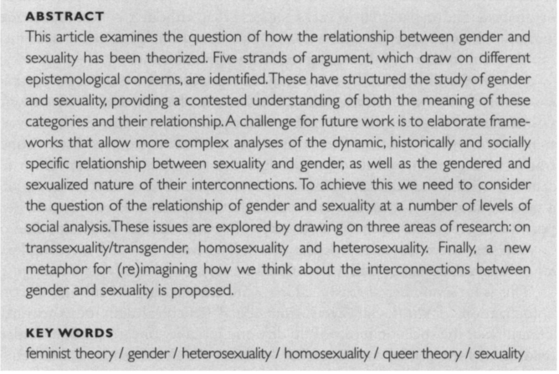
(Richardson, 2007, p. 457).
Also, the author of this article, Richardson, presents a research question in the introduction of the paper. She states, "This article examines the question of how the relationship between gender and sexuality has been theorized” (Richardson, 2007, p. 457). The similarities of Roth and Dashper (2016) and Richardson (2007)’s articles could be because they exist in the same journal, despite them being nine years apart in publication dates. Therefore, articles formatted similarly would make sense to ensure continuity with the journal's image of professional sociology.
Many comparisons can be drawn between these articles, beginning with the use of jargon in the applied fields and natural sciences. While it is expected for fields in this discipline to use highly technical jargon, the articles found for the applied fields were fascinating, as they did not include any at all. In comparison, the studies from the natural sciences consistently used jargon to communicate. The natural sciences and social sciences can also compare. The social sciences put a high emphasis on abstracts. However, those in the natural sciences rarely, if ever, use them. All four articles from both the social sciences and natural sciences reflect this use of abstracts, as the social science articles utilize them, whereas the natural sciences do not. The social sciences and applied fields, however, cannot be compared as easily, as the language in applied fields can vary significantly from genre to genre. However, jargon is utilized in the social sciences, but not to the extent present in the applied fields. For example, the articles from the social sciences utilized some jargon to make their points, whereas the articles from the applied fields did not use any.
Reference
Reference is one of the most apparent indications of a field's reliance on others and emphasis on collaboration. Through collaboration, one can note if the authors received outside help, such as through the use of a secondary author. Also, through the use of references, readers can note if an author often relies on the work of others or prefers to make their points unaided.
The applied fields’ references are generally reliant on collaboration and reference. Collaboration between authors is widespread in the applied fields, and it is not uncommon to see articles with pages upon pages of footnotes or multiple authors. The first article, “The Cultural Perspective in Nursing Education” (1988), however, is an exception to because Lipson, the author, does not quote any help from other authors, and does not include any footnotes or citations at all. She does mention several educators, however, that developed programs to introduce cultural competence in educating nurses. “Another example of a multi-pronged approach is an assignment developed by Lucile Brown when she taught at UCSF, which has had superb results in the "Cultural Concepts" class” (Lipson, 1988, p. 5). Here, one could argue referencing is present as Lipson supports her claim by drawing on the strategies of others. However, this is done indirectly without citing the original authors. The second article, “Promoting Cultural Sensitivity in Nursing Practice,” (1993) is very similar, in the way that no footnotes or citations are present, nor is a reliance on another author. Additionally, in comparison to Lipson, Sharma, the only author, does not even include references to other nurses or their ideas. I have included an example of Sharma’s writing in a screenshot below:
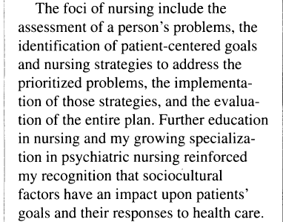
(Sharma, 1993, p. 31).
While Sharma admits that her training in psychiatric nursing increased her knowledge of sociocultural issues, she does not quote anything that led her to this decision. It is difficult to say why, in Sharma's case, the article does not include any references. However, the lack of footnotes and other citations could be a result of the materials existing in an anthropology journal. Therefore, lots of footnotes and citations could become an eyesore on the page or drive up printing costs. The lack of references may be because Sharma found them unnecessary for the topic of her article. This reference use is uncommon for the applied fields.
The natural sciences also follow a trend of collaboration and reference among scientists. It is common for articles to have multiple authors and many citations. To begin, my first article, "Black Holes" (2001), has three authors, therefore encouraging the idea that collaboration is present. Also, they have a small section of endnotes on the final page, citing multiple other authors and written works. I have attached a screenshot of part of the article below for analysis:
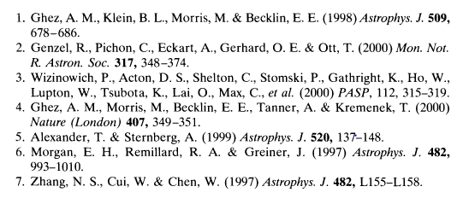
(Brügmann, Ghez, & Greiner, 2001, p. 10526).
Here, the authors mention their previous works, as well as the actions of others. This section correlates with superscripted numbers in the main text, symbolizing that the authors relied on them to create this work. The second article, also titled "Black Holes" (1972), however, formats collaboration differently. The author, Penrose, works alone without consulting other authors, reminiscent of the single-author tactic used by both Nursing articles. However, the author does not include a footnotes section and does not cite sources within the body of the paper. However, a separate document lists his bibliography, so I will use this as proof that he did, in fact, use references. I have included another screenshot of the bibliography for reference.
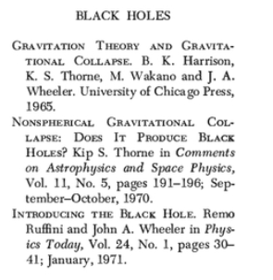
(Penrose, 1972, p. 138).
When one considers the use of the bibliography, one can notice that there are a minimal number of citations. The use of comparatively few citations in this article is uncommon for the natural sciences, as one can reasonably expect for a natural scientist to use many citations. This lack of reference and collaboration could be because Penrose got everything he needed from these three sources. Alternatively, he could have been an expert in the field, and therefore drew from his knowledge. It could also explain why he chose not to collaborate with another author – he knew what he was doing.
Finally, the social sciences follow similar trends as the other fields in terms of collaboration and reference. It is encouraged for social scientists to work together to form their conclusions, and it is not uncommon to see pages upon pages of references or acknowledgments to other authors. My first article, “Sociology in the 1980s: The Rise of Gender (and Intersectionality)” (2016), follows these expectations closely. There are two authors, therefore showing collaboration as they worked together to form the material. Also, the authors include an acknowledgments section thanking others for their assistance in crafting the report. Finally, the authors include two full pages of references. I have included a screenshot of part of the references section below:
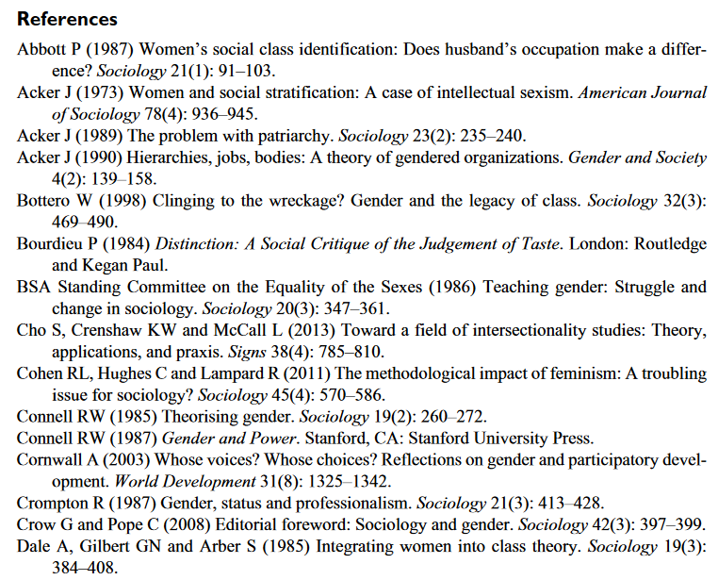
(Roth & Dashper, 2016, p. NP10).
This screenshot encompasses only a small section of their references. Therefore, we can say with certainty that the authors of this article follow the standards of the social sciences carefully. The second article, Patterned Fluidities: (Re) Imagining the Relationship between Gender and Sexuality” (2007), however, is a bit different. While there is an even longer reference page, the author chose to work alone – that said, she did not collaborate with another author. She did, however, include an acknowledgments section. I have included a screenshot of it for analysis.
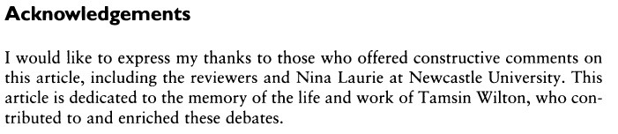
(Richardson, 2007, p. 471).
Here, we can also see that the author follows traditional expectations for the social sciences, aside from working with a secondary author. This lack of use of another author could be because the writer did not feel that taking another was necessary. In her acknowledgments, she states that Tamsin Wilton had contributed to the making of the article. The author could also be an expert in her field, so taking another author would be redundant.
Many similarities and differences present themselves between the three fields in terms of reference. It is common to see large amounts of citations present in the applied fields, natural sciences, and social sciences. However, in my research, only the social sciences and one of the natural science articles had a significant amount, and the applied fields quoted none at all. Additionally, collaboration is a present concept in all three disciplines. However, none from the applied fields and only one from both the natural and social sciences used multiple authors. Finally, the use of acknowledgments is uncommon for all disciplines except the social sciences, and this held true. In reality, both of the articles from the social sciences included acknowledgments, whereas the others did not.
Discussion
This assignment has taught me a significant amount about writing across the curriculum (WAC). Firstly, I have learned that WAC can have a hugely influential role both in and out of the classroom. It can even extend to the collegiate and professional level, as exemplified in these articles. Secondarily, I have learned that WAC is present in almost every field, which was surprising to me, as I didn’t think that nursing, for example, would use it often.
My study has several implications for the field of WAC. While others have come before me to state the similarities and differences between fields, it remains unclear as to how well other writers have connected my three chosen fields. My study will contribute knowledge in this way. Additionally, my review will serve to further support the idea that WAC is prevalent in all fields across the university, and encourage its use in college curricula.
The opportunity is always available to present more research. Some future research that may be helpful are analyses on WAC’s use in more obscure majors, such as theater and the fine arts. These insights may inspire those within those majors to consider the use of WAC. Also, more research could be conducted on the elements of WAC that apply from one course to the next, such as critical thinking skills being relevant in many classes.

References
Anson, C. M. (2010). The intradisciplinary influence of composition and WAC, 1967–1986. The WAC Journal, 21, 5-19.
BIBLIOGRAPHY. (1972). Scientific American, 226(5), 138-140. Retrieved April 4, 2020, from www.jstor.org/stable/24927349
Brügmann, B., Ghez, A., & Greiner, J. (2001). Black Holes. Proceedings of the National Academy of Sciences of the United States of America, 98(19), 10525-10526. Retrieved March 26, 2020, from www.jstor.org/stable/3056569
Lipson, J. (1988). The Cultural Perspective in Nursing Education. Practicing Anthropology, 10(2), 4-5. Retrieved March 26, 2020, from www.jstor.org/stable/44247064
Luthy, K. E., Peterson, N. E., Lassetter, J. H., & Callister, L. C. (2009). Successfully incorporating writing across the curriculum with advanced writing in nursing. Journal of Nursing Education, 48(1), 54-59.
McCarthy, L. P. (1987). A stranger in strange lands: A college student writing across the curriculum. Research in the Teaching of English, 21(3), 233-265.
McLeod, S., & Maimon, E. (2000). Clearing the air: WAC myths and realities. College English, 62(5), 573-583.
Penrose, R. (1972). BLACK HOLES. Scientific American, 226(5), 38-47. Retrieved March 26, 2020, from www.jstor.org/stable/24927336
Richardson, D. (2007). Patterned Fluidities: (Re) Imagining the Relationship between Gender and Sexuality. Sociology, 41(3), 457-474. Retrieved March 28, 2020, from www.jstor.org/stable/42857007
Roth, S., & Dashper, K. (2016). Sociology in the 1980s: The Rise of Gender (and Intersectionality). Sociology, 50(6), NP1-NP12. doi:10.2307/26556422
Sharma, S. (1993). PROMOTING CULTUR3AL SENSITIVITY IN NURSING PRACTICE. Practicing Anthropology, 15(1), 31-32. Retrieved March 28, 2020, from www.jstor.org/stable/24780792
Stout, R. P. (2010). "Hello, I'm carbon.": Writing about elements and compounds. Journal of Chemical Education, 87(11), 1163-1165.

