Charlotte Potts
Dr. Guler
ENGL 400-16
18 October 2018
eSports: Turning a Pastime Into a Sport
For a long time, sports have been thought of as a physical activity, from running around a track to catching a ball, but with the evolution of technology and the constant change of the society, this has allowed for video games to become an actual sport. ESports has become a multi-million-dollar industry and this has allowed for the world of competitive gaming to be considered a main-stream sport. This has led to a new generation of athletes, including both the collegiate and professional world and a change in what many people play. Video games have evolved from games like Mario, Pac-Man, and Pong to games like Pokémon, Overwatch, Fortnite, and Counter Strike: Global Offense. These games have become some of the largest gaming events in the field of competitive sports and has led to the belief in eSports being an actual sport. This has also changed the way people view the gamers and have allowed the old stereotype of a gamer to transform into that of a superstar. When thinking of the players of these games, it used to be assumed that they are reclusive, nerdy, stereotypical gamers, but now gamers are seen as the next collegiate athlete. ESports has been able to grow because of the rhetorical arguments and being used to target multiple angles of audiences and businesses.
Method
These articles incorporate the Aristotelian idea of rhetorical argument, by using logos, ethos, and pathos in order to bring awareness of eSports as a legitimate sport through multiple ways. According to Heinrichs, logos is the argument that made with logical information (Heinrichs, 39) such as statistics, facts, logical reasoning, and evidence to support the idea. Ethos is the “argument by character, employs the persuaders personality, reputation, and ability to look trustworthy…In rhetoric, a sterling reputation is more than good.” (Heinrichs, 40). Pathos is the argument by emotion and is using things and using the audience’s concerns for the topic (Heinrichs, 40, 46). These three rhetorical arguments are useful for analyzing all of the articles because it serves to show the credibility of eSports through several aspects and viewpoints. Other concepts include commonplace, or “a view point your audience holds in common” (Heinrichs, 112), and identity strategy, or making the audience be able to identify with the argument (Heinrichs, 250). Finally, these articles use induction or the “argument by example” (Heinrich, 148). An inductive argument starts with specific examples and uses it to help build up to a general principle. The goal is to describe smaller pieces of a puzzle to create the main idea (Heinrichs, 148). The use of these rhetorical arguments has allowed for the ability to show how eSports can become an actual sport and allows the manipulation of the audiences through multiple ways and creating an effective argument.
Analysis
In “Jobs and Careers in The ESports & Video Gaming Industry Continue to Grow” by Mai-Hanh Nguyen points out the financial benefit to multiple groups (players, event location, companies, etc.) with eSports. The article points how eSports benefits both the companies and the players, helping build an industry that is worth hundreds of millions of dollars. This gives momentum to the movement of eSports because it shows the financial success that can occur. This article also discusses another financial point, event planning for eSports competitions. This includes arenas and convention centers that are used to not only hold the games, as well as the production and the conceptualization of the competition. Nguyen states, “As the growth and success of eSports leagues continue to rise, the execution of tournaments and competitions requires thorough planning and precise detailing.” (Nguyen). This means that the more people watch, the more money and viewership that is in the growing eSports industry and it creates a more captive audience. Another point of logos is the statistics seen in both the article from Syracuse, “With Viewership and Revenue Booming, ESports Set to Compete with Traditional Sports”. Syracuse’s article gives statistical analysis from the consulting firm Activate stating, “In 2017, more than 111 million people watched the Super Bowl, traditionally one of the most popular sporting events on television...ESports, also known as electronic sports or professional video gaming, has been booming. More than 250 million people follow the competitions, according to the technology consulting firm Activate, and most of those viewers also play.” (Syracuse). The statistical analysis given in an infographic (Image A) also shows that by 2020 it is estimated that eSports will beat viewership of the MLB by close to six million viewers and is expected to be the second most viewed professional sports league, beating traditional sports leagues like the MLB, NHL, and NBA (Syracuse). With viewership also Nguyen discussed the facts of how this has become a financial empire and also talks about how streaming video game play on streaming platforms such as YouTube and Twitch has increased over the years, giving a statistical analysis on viewership of gameplay and competitive matches, “Newzoo projects that figure to grow to 345 million by 2019. As an audience, eSports viewers are highly engaged, so projections indicate that 213 million people will watch competitive gaming this year.” (Nguyen). All of this statistical data builds credibility of eSports, claiming that it will eventually surpass some of the largest sports leagues in the United States, with the growing in viewership there would also have to be a financial growth to also back the idea of eSports as a real sport. This can be seen in René Guzman’s, article “College Athletic Departments Go Recruiting For Gamers For eSports Teams”, which uses the information from the analytical firm Newzoo to show how it is expected to financially grow, “The market research firm Newzoo, which focuses on global games and eSports, expects worldwide eSports market revenue to hit $906 million for 2018 and nearly $1.5 billion by 2020. This is big business, and it’s becoming a recruiting tool for colleges.” (Guzman). This shows the financial integrity of eSports and how it has grown into a large business.
Guzman’s article also uses ethos by having an actual competitive gamer, Daniel De Jesus Turgeon, as a credible source, when talking about how eSports is becoming a college sport as well. The reputation as a competitive player can help improve the source and the argument, especially when Turgeon is quoted as saying that he “is cashing in on all those hours of computerized carnage with a four-year, $40,000 scholarship from Schreiner University, where he’ll game on as part of the Kerrville school’s new varsity eSports program.” (Guzman). While numbers and facts that give solid information are helpful, using the ethos, or character, can help give eSports life. This give it a life of its own and allows for others to see it as a tangible idea by allowing testimonies and real-life examples to serve as a reasoning for the legitimacy of eSports. Another example of ethos Travis Hoium’s article “ESports Is Quickly Becoming a Big Business for Game-Makers”. He points out that companies like Blizzard Entertainment, “create the games and can, therefore, create the sports leagues as they choose.” (Hoium). Blizzard Entertainment is one of the leading gaming companies that has created competitive games like “Overwatch” and “StarCraft II” and Hoium relies on the name of a prestigious and famed gaming company to give credibility to his article. Hoium ends his article saying, “As the eSports business grows, it could become a meaningful driver of Activision Blizzard and Electronic Arts' businesses long term as it opens up a plethora of new revenue streams and keeps players engaged.” This still works with ethos because Hoium is still using the credibility and the reputation of these companies to show how this will keep the eSports industry from disappearing for a while. The Walt Disney Company is also using their reputation to back the airing of eSports competitions on their network channels. Another artifact that uses ethos is by the Entertainment and Sports Programming Network or ESPN. They published an article stating what channels would feature the Overwatch League and had observed its popularity and state, “We've had an interest and have been watching pretty closely…Clearly by the way we're going to be covering it starting with the playoffs and the finals this year certainly speaks volumes to our excitement and our enthusiasm overall for eSports moving forward.” (ESPN). With a major sports network airing competition, this will allow for not only a steady flow of viewership, but also shows companies, like Disney, using their reputation and name, using ethos, to bring eSports into the main stream.
The web series, “Good Game” by Dan Harmon gives a pathos argument. This series features a more comedic approach of the eSports world. The main premise of the show is the underdog team of misfits form a team to compete in a large eSports competition for a game called Killcore, a parody of the game Defense of the Ancients 2, or Dota 2. (Harmon, Good Game). This serves as a pathos argument because it resonates with the frustrations competitive sports, with the realism that eSports is not just playing video games for fun and becoming a champion is easy. “Good Game” points out the difficulties with competitive gaming, from not getting along with team mates to the intense training and stress that comes with it. This show serves its purpose in legitimizing the eSport world because, much like how football and baseball athletes get frustrated and can become stressed with the sport they play in. “Good Game” also shows the intense amount of training, time, and pressure these competitive gamers face. This builds empathy with those who are training to become competitive gamers as well as those who have played another sport and still find it difficult believe that eSports should be considered a sport. All of these resonate and can convince those who have been through the motions of being an athlete the idea of eSports being an athletic event.
We can see in the artifacts, like Nguyen’s article, also use identity strategy for businesses trying to connect to those looking to be a part of the competitive gaming field. This serves as identity strategy because it calls the large group of people and businesses that participate in eSports an industry. She points out that the marketing alone allows for “brands and marketers, there are huge opportunities to build new fan bases and engage with this growing audience…As a marketer, assets such as naming rights, branded content, experiential activation, tech integration, jersey branding, and so forth are available for brands willing to invest in the eSports space.” (Nguyen). This gives them a group identity as marketers and helps legitimize the idea of competitive gaming.
All of the artifacts are small pieces to the puzzle that is the eSports industry. They all show the multiple parts that are part of competitive gaming by using an inductive argument. They show the financial, statistical, and actual active portions of competitive gaming. These articles show how the growing eSports empire works through smaller portions and all of it is just a small part of the multi-billion-dollar gaming industry itself, showing that the gaming industry is entering the world of sports. These artifacts also all serve as a commonplace for the audience. While they all target various audiences, the main audience is those interested in eSports. ESPN uses the interest to their advantage by showing it on their parent company, The Walt Disney Company’s, channels; the young adult channel Disney XD, ESPN, and ESPN 2 (ESPN). These articles also use commonplace to show the similarities of physical athletic sports fans and eSports fans. Another commonplace is also pointed out in Guzman’s article. With eSports there are currently no collegiate conferences. This has allowed for universities of different natures like Schreiner and Harvard, to play against each other (Guzman). This is commonplace it tells the audience who want to play eSports at a collegiate level that everyone can play as equals.
Conclusion
The use of rhetoric in the promotion of eSports being considered legitimate sport has allowed for it to open a whole new window to players who are not the current idea of athletic in a collegiate level. This has allowed for the multi-million-dollar industry to gain a substantial number of viewers and also convince others to view it as a legitimate sport. ESports has allowed for people to not only play on an even field but also change their perspective on sports and observe the growing idea of competitive gaming.
Images
Image A: The statistical growth of eSports viewer ship (Syracuse)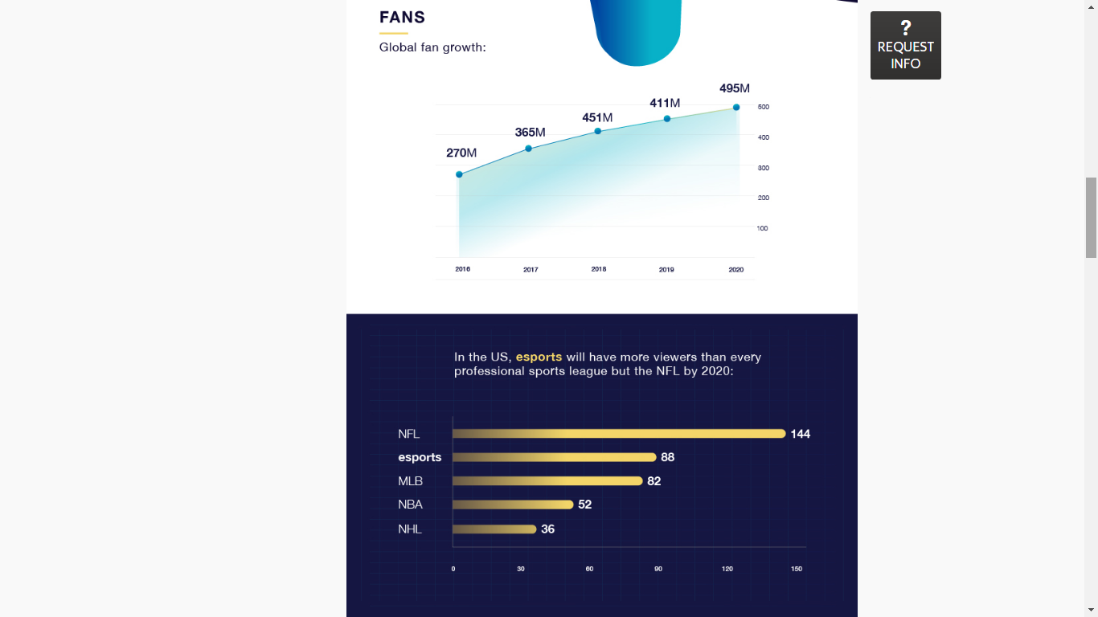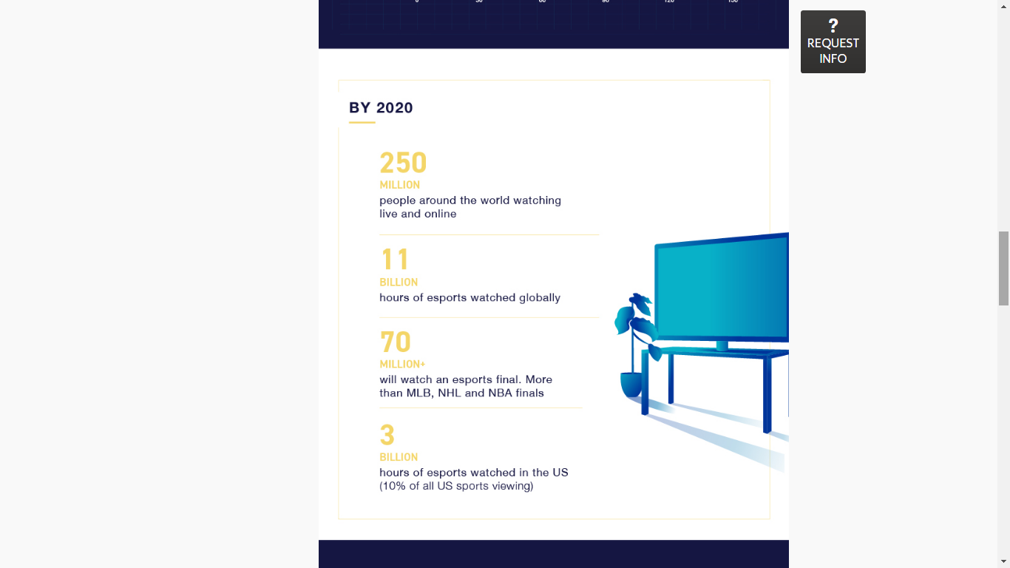

Work Cited
Guzman, René A. “College Athletic Departments Go Recruiting for Gamers for eSports Teams.” ExpressNews.com, Express-News, 24 Aug. 2018. Web.
Harmon, Dan, director. Good Game. YouTube, YouTube, 30 Aug. 2017.
Heinrichs, Jay. Thank You for Arguing: What Aristotle, Lincoln, and Homer Simpson Can Teach Us about the Art of Persuasion. Three Rivers Press, 2017.
Hoium, Travis. “ESports Is Quickly Becoming a Big Business for Game-Makers.” Back to Index, 19 Sept. 2017. Web.
“Overwatch League Comes to ESPN, Disney and ABC.” ESPN, ESPN Internet Ventures, 11 July 2018. Web.
Nguyen, Mai-Hanh. “Jobs and Careers in the ESports & Video Gaming Industry Continue to Grow.” Business Insider, Business Insider, 8 Dec. 2017. Web.
“With Viewership and Revenue Booming, ESports Set to Compete with Traditional Sports.” Blog, Syracuse University, 2 Oct. 2017.

