protecting human safety  Acknowledgements  The Free from Harm brochure was produced by Physical Assault Prevention & Recovery Advocates (PAPRA).  Mariah Strock is a Bachelor of Social Work candidate, with an expected graduation in May 2019 from Longwood University in Farmville, VA. Originally from Virginia Beach, VA, Ms. Strock plans to pursue a career in school social work after graduation. Her hobbies include exercising, spending time with family and friends, cooking, and volunteering.  Alizaih Suarez is a Bachelor of Anthropology candidate, with an expected graduation in May 2019 from Longwood University in Farmville, VA. Ms. Suarez is originally from Puerto Rico. She plans to pursue a career as a Forensic Anthropologist. Her hobbies include watching movies, playing the clarinet, and spending time with family and friends.  Charlotte Potts is a Bachelor of English candidate, with an expected graduation in May 2019. Ms. Potts is currently working as an intern a film company and plans to go overseas to teach English after graduation. In her free time, Ms. Potts enjoys film writing and spending time with friends and family, including her twin sister.  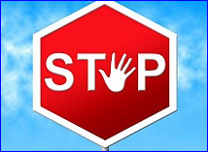 | Protecting human safety  Further Resources  preventing violence  Centers for Disease Control and Prevention.  (2017, May 8). Data and statistics: Key injury  and violence data. Retrieved from https://www.  https://www.cdc.gov/injury/wisqars/overview  /key_data.html  David-Ferdon, C., Haileyesus, T., Liu, Y.,  Simon, T., & Kresnow M. (2018). Nonfatal  assaults among persons aged 10-24-United  States, 2001–2015. MMWR Morbidity and  Mortality Weekly Report, 67, 141–145. Doi:  http://dx.doi.org/10.15585/mmwr.mm6705a1  Fuller, G. (2015). The serious impact and  consequences of physical assault. Trends and  Issues in Crime and Criminal Justice  (electronic resource), 496, 1-8.  Katz, J. Rich, H. (2015). Partner co-  victimization and post-breakup stalking,  pursuit, and violence: A retrospective  study of college women. Journal of Family  Violence, 30, 189-199. Doi:  10.1007/s10896-014-9665-7 | Protecting human safety  Free from Harm  physical assault is more than just hitting
protecting human safety  understanding physical assault  Do you know what it is?  Many people have an idea in mind when they think of physical assault. Physical assault is defined as an act of inflicting physical harm or unwanted physical contact upon a person. This assault can be fatal or non-fatal and can result in criminal and/or civil liability.  Physical Assault Prevention & Recovery Advocates (PAPRA) supports a definition of assault that includes a threat or attempt to commit physical harm, even if the victim is not actually physically harmed.  How would you feel if you or someone you care about is physically harmed or is fearful because of threats of harm? It doesn’t seem fair, does it? No one has the right to threaten, attempt, or cause physical harm to someone else. No one should have to live in fear of assault. Threats or attempts to harm still causes harm to victims and others. | protecting human safety  Who’s at risk?  YOU. Did you know that as a young adult, you are at greater risk of being a victim? While people of all ages, races, and genders can be physical assault victims, young adults ages  20–24 years old are at greater risk.  Don’t be a victim  Who’s to blame?  Perpetrators. Victims may try to downplay assault by describing it as an incident, confrontation, or argument and may say things like, “it was just a push,” “it was my fault,” or “I should not have provoked him.” Physical assault is never the victim’s fault. Perpetrators are responsible for their own behaviors.  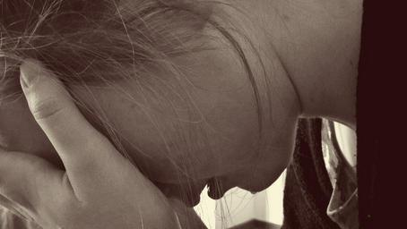  it’s not your fault | protecting human safety  Why should you care?  Physical assault is a serious public health problem that can have negative effects on victims, families, communities, and society. Victims can be impacted physically, socially, and psychologically, with immediate and long-term consequences. Victims typically experience one or more of the following symptoms: anxiety, post-traumatic stress disorder (PTSD), depression, fear, low self- esteem, sleep disruption, difficulty trusting others, and relationship problems. Physical assault can negatively change peoples’ lives.  How can YOU be part of the change?  YOU can facilitate change by:  - Including threats or attempt to harm in your personal definition of physical assault, and advocating for this expanded definition;  - Understanding the impact of assault, and raising awareness of the issue;  - Not blaming the victim;  - Withdrawing yourself or others from dangerous situations when possible; and  - Reporting assault to the appropriate authorities.  For victims, assault is more than just hitting or pushing. Assault can leave physical and emotional scars. Protect yourself and others. Understand assault. Be a part of the change.

