Jesse Plichta-Kellar

Dr. Lettner-Rust

ENGL 210-50

10/1/2019

Project 1

1st paragraph Introduction and Context

To my understanding, MLK’s intent was to rebuke the clergymen, defend his own actions, and inspire change. The original intent and impact was multifold: to defend his own actions of peaceful protest, to question the clergymen’s assumptions, and to call for more nonviolent and effective action. While im jail, King was able to craft a nuanced, well-cited, and rhetorically effective letter. The letter genre has many allowances that worked in King’s favor, allowing a flow of formality and informality while not restricting length. The original form is really impactful. The genre I chose to use essentially focuses on King’s more general audience (not just the clergymen specifically) but otherwise tries to be thematically consistent and include representative content.

2nd section. Artifact Dissection

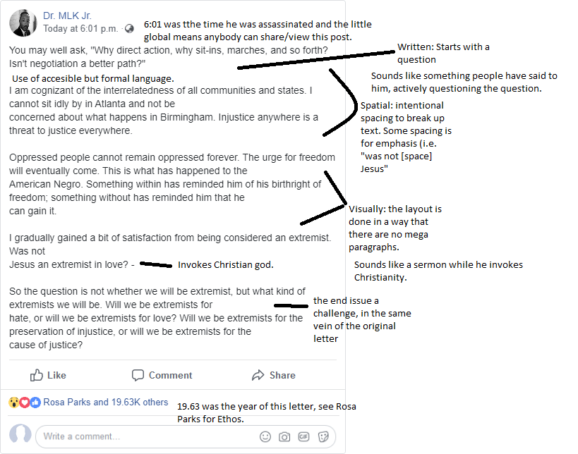

3rd section Intended Effect

My intended effect was to efficiently communicate some of the more quotable parts of MLK’s letter. The idea was to boil it down to a lengthy but manageable FB post. The questions included in particular were meant to stir the reader, as if to ask themselves what the answer was while reading it. I attempted to keep the tone of the original letter intact in this process. His original letter comes off as a lengthy, well-cited sermon to me so I was trying to preserve that call-to-action and invocation of King’s Christian roots.

4th section Affordances

This genre has several affordances and weaknesses. The weaknesses are those that impact any social-media based genre: length limitations (socially enforced), algorithm issues (completely out of your control), visibility, and saturation. The strengths are the shareability, capacity to publicly comment, control over content, and instant distribution. Something that I had not thought of before other folks commented it on mine was how useful the spacing of the format itself can be. I had thought about how my spacing and how that was important, not how the inherent spatial properties of the genre may come into play.