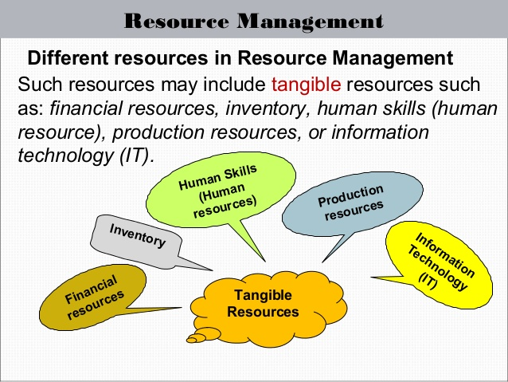
Managing School Operations and Resources
The principal manages school operations and resources to ensure a safe and caring, and effective learning environment.
The principal:
- Effectively plans, organizes and manages the human, physical and financial resources of the school and identifies the areas of need
- Ensures that school operations align with legal frameworks such as: state legislation, regulation and policy; as well as school authority policy, directives and initiatives
- Utilizes principles of teaching, learning and student development to guide management decisions and the organization of learning.

Managing your specific school involves:
- Understanding school finances (how money is spent, received, and disbursed)
- Effective communications to reach the students, teachers, parents, and stakeholders (inclusive of the use of Websites, email, telephone services, interpreters, regular mail, and correspondence to others at all levels)
- Managing your time and managing others’ time agendas (inclusive of calendars and what’s ahead)
- School employment (appointing staff, payroll, performance reviews, hiring and dismissals)
- Understanding attendance (to remain in compliance with compulsory attendance laws)
- Understanding school property (polices and procedures; property management)
- Planning and Reporting
- (to the school board, stakeholders, and state and federal governing bodies, and general public)
- Preparation for state and federal visits (to check on procedures, records, files, and compliance to the law)
- Updating and revising school improvement plans and procedural manners

