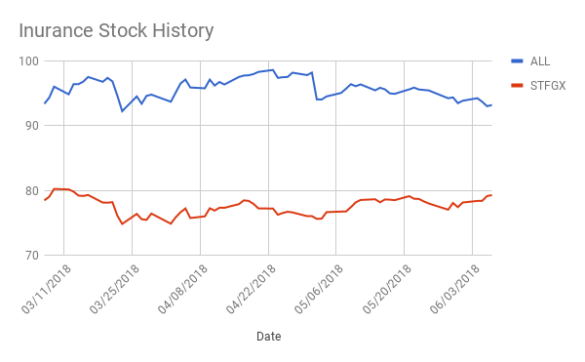

Above you can see my graph on the data I collected on stock values of insurance companies. I used the links below to access the closing stock values every day for the past three months for All State and State Farm. You can see the red line is State Farm and the blue line is All State.
I picked these data sets to analyze because I don’t know much about insurance or stock and wanted to get a little more familiar with them. I am planning on buying my own insurance soon so I wanted to use this as a way to compare these two popular insurance companies.

https://www.nasdaq.com/symbol/stfgx/historical
https://www.nasdaq.com/symbol/all/historical

I found it interesting on how steady the stock prices were from day to day and how it only varied between ten points per day for each company. However, I found it interesting how All State was consistently ten to fifteen points higher than State Farm. After conducting this analysis, I’m curious to see what factors go into stock values. Based off of these data sets I would go with All State for my insurance but maybe my opinion would change if I knew the factors that go into stock values.

