Autism Speaks: Extending Grammar
in the Classroom to Students with Autism
Bailey Nixon and Ashley Schweizer
Longwood University

Developing sentence variety and elaboration are important skills for all students, so we wanted to create grammar lessons to help children with autism with these critical skills. After assessing a group of lesson plans found in Amy Benjamin and Joan Berger’s (2014) book, Teaching Grammar: What Really Works, we adapted lesson plans to cater to the needs of students with autism. We used strategies such as modeling, think-alouds, Applied Behavior Analysis, and the Discrete Trial Teaching Method. We created our lesson plan revisions in order to provide teachers with the best resources to create an inclusive environment within their classrooms.

Introduction
After discussing participles in our college grammar course, we began to wonder how grammar lessons could be applied to students with autism. Both of us are passionate about learning and are studying to become teachers. After graduation, we plan on having inclusive classrooms where learning is not limited to just general education students. In order to do this and gain the best skills possible, we wanted to delve into research about students with autism and how to provide them with an effective education. Since grammar is such an important topic in every grade, we decided to research and enhance a grammar lesson that teachers could easily adapt and use with their students--whatever their learning abilities.

What Methods Are Helpful for Instruction of General Education Students?
In order to effectively teach grammar, lessons must be deliberately put into the curriculum, allowing time for students to fully grasp the concepts. Grammar is important to students’ learning; it greatly expands students’ ability to communicate their ideas in advanced ways. First, it is important to follow a routine in your grammar lessons. For each new topic, you must provide an introduction. For example, if teaching participles, it is important to first explain to students how to recognize them in various texts. In fact, it is worthwhile to have teachers do think-alouds with their students, explaining out loud how they identify participles. Next, try working examples as a class, providing modeling and examples from professional writing. Allow students to work in small groups or individually to practice imitating model sentences with participles in them. Once students are comfortable with this, have them slowly start to create their own sentences individually or in small groups, demonstrating where participial phrases are located in their work. With a scaffolded procedure such as this, students will understand participles from beginning to end.
What Methods Are Helpful for Students with Autism?
Children with autism often struggle with social, communication, and language skills, so it is important for teachers to adapt lessons and discover what learning methods work best for their students. Some techniques that have been proven effective by other teachers are using simple language accompanied by visual aids to support these students and allow them to process what they are learning more quickly. Additionally, teachers should give students clear choices when asking them questions; giving students multiple answers that are similar confuses them and makes solving problems more difficult (“Techniques for Teaching Students with Autism Spectrum Disorder,” 2020).
Another method that is considered effective is the use of Applied Behavior Analysis (ABA). This method requires teachers to observe the behavior of students with autism and provide them with help/instruction on any missing skills. During the process of learning the task, students will get rewarded upon completing the appropriate skills. This creates a reward system and a positive reinforcement for the process of learning the skill (Warber, 2020).
A less known but still effective method would be the Discrete Trial Teaching Method (DIT). Similar to ABA therapy, DIT uses a reward system but breaks up the steps of the skill into several parts which are introduced to students individually. Students only begin working on the next step of the skill once the prior one is mastered. This allows students to slowly learn the new skill and ensure that they will fully understand and remember it (“Techniques for Teaching Students with Autism Spectrum Disorder,” 2020).

What Are Participles?
Participles are words that can function as verbs or adjectives. Present participles phrases always end in -ing while past participles (referred to as the -en form) end in -ed except for irregular verbs. When participles serve as verbs, they require a helping verb, for example, “They are eating; they have eaten,” and they cannot be removed from the sentence. Participles are not to be confused with verbs or gerunds, which also end in -ing but function as nouns and cannot be removed from a sentence (Ex., Singing is difficult.). When participles function as single adjectives, they come in front of the noun they modify, for example, “the singing bird, the beaten wrestler.” Participial phrases are not single words, often including prepositional phrases following the participle, are usually moveable, and can be removed from a sentence. An example of this would be “Issac sat in his room, slowly waiting for the arrival of his dog.” The participial phrase can be moved like this: “Slowly waiting for the arrival of his dog, Issac sat in his room.” The sentence can function without the use of the participle, slowly waiting for the arrival of his dog, qualifying this as a participial rather than a verb (Killgallon, & Killgallon, 2010, p. 101). Our lessons focus on participial phrases.
Adapted Lesson Plans
Lesson 1: Identifying Participles. To begin the unit on participles, day one will focus primarily on recognition. The objective of this lesson will be for students to identify participial phrases in the real world and appreciate their effect. Begin the lesson by reminding students of what participial phrases are and how to spot them. Be sure to explain that participles can function as adjectives or verbs and either end in -ing or -ed. In the present tense, participial phrases always end in -ing while in the past they end in -ed. After running through the basics of participles, read students a book, such as The Napping House, which is full of participles and participial phrases. Point out examples as you read and allow students to identify them as well. Ask students how the participles affect their enjoyment of the book. Following this activity, in order to get students more accustomed to the topic, invite an additional teacher into the room and have a conversation with one another using participial phrases. Identify the phrases used and then complete another conversation and have the students identify the phrases.
Continuing with the lesson, introduce students to the song “Don’t Stop Believing” by Journey. Pull up lyrics to the song and help students identify examples of participial phrases (Ex. “Just a small town girl, living in a lonely world”). Have the students identify other participial phrases in the song. End day one by emphasizing the ideals of seeing participial phrases in the real world, demonstrating how they add detail to all forms of writing. For additional practice, print lyrics to David Bowie’s “Starman” song and allow students to identify participial phrases on their own.

Lesson 2: Using Participial Phrases in Sentences. For lesson two, the objective is for students to learn to identify and write sentences with participial phrases that add elaboration to writing. To introduce the lesson, have students watch the video Ing x Ed- Practice Participles as Adjectives with Scenes from TV series, which can be found on YouTube. These videos feature real-life examples of participles in famous TV shows such as Grey’s Anatomy, Drop Dead Diva, and Big Bang Theory.
Following the video, review the basic principles of participles. Once again, discuss how participles and participial phrases can be in the past or present. Participles will end in -ing if in the present form or -ed if in the past form. Additionally, participles function as adjectives and are not to be confused with verbs or gerunds. After reviewing participles, provide examples similar to the video, writing sentences on the board (Ex. Tearing open her present, Alexis was excited to see a new doll in her hands). Here is a great moment to discuss with students how to form a sentence with participial phrases. Ask students to identify the main independent clause is the sentence, which is “Alexis was excited to see a new doll in her hands.” Next, ask students to picture this moment: How did Alexis open her present? How did she feel opening the present? To answer how she opened the present, you could say she tears open her present. Ask students how they think they could turn this phrase into a participial phrase; ask them about the main components of a participial phrase. Model how you can add -ing to the word tear, turning it into “tearing open her present.” Next, demonstrate to students how you connect the phrase to the independent clause, completing the sentence with the addition of a participial phrase: “Tearing open her present, Alexis was excited to see a new doll in her hands).
Now, as a class, play a game of silent charades. Have students pick a card out of a jar and read the participial phrase on the card. Cards can have phrases such as “tearing the paper” or “passing a note.” Students will then think of ways they can act this out for the class or a partner. Once students guess the correct phrase or provide another suitable participial phrase, have students write complete sentences using the phrase and the method discussed above. Be sure to help write the first couple of sentences walking them through the process of creating participial phrases then adding independent clauses; then allow for student collaboration.
Have students look at the sentences they have created in their charade game and again point out where the participial phrases are and what is similar about each sentence. Here, explain to students that they will be working more in-depth with participial phrases to add elaboration, or extra details, to their own writing.

Lesson 3: Positioning Participial Phrases. Moving to day three, the objective will be for students to discover and discuss positions of participial phrases in a sentence, examining the effect of these positions. Start the lesson by asking students what they remember about participial phrases. Explain to students here that another advantage of participial phrases is their ability to be moved in a sentence, adding to sentence variety. With appropriate punctuation, many participial phrases can be moved to the beginning, middle, or end of a sentence as long as they border the phrase they are modifying. For example this sentence, “Waving at this friend, Alex walked toward the classroom,” could also be switched to “Alex, waving at his friend, walked toward the classroom.” Both sentences are grammatically correct and will demonstrate to students how participial phrases do not have to stay in one spot.
On the board, place two posters containing sentences without participial phrases in them. For example, “Alice sees a pen on the ground. She bends over to pick it up.” Ask the students if they see a participial phrase in the sentence. Once they say no, ask them to brainstorm ways they could transform one sentence into a participial phrase. Students may come up with various answers, but you can suggest this if they are stuck: “Seeing a pen on the group, Alice bends over to pick it up.” Point out the -ing present participial phrase to the students.
In order to further their knowledge on the mobility of participial phrases, students will rearrange various phrases on their desks to complete sentences with participles . Give students multiple example sentences to work with. For each sentence, separate the subject, participial phrase, and verb phrase. Students will work to create complete sentences with the cards. Have students see if they incorporate the participial phrases in various places. For example, you can give students three small cards that say “Monica,” “unwrapping her candy,” and “shows off to everyone.” Using these cards, students can move the phrases around to create different sentences such as these: “Unwrapping her candy, Monica shows off to everyone”; “Monica, unwrapping her candy, shows off to everyone”; or “Monica shows off to everyone, unwrapping her candy.” Have students try moving participial phrases within multiple examples until they understand how they are able to move around in sentences.
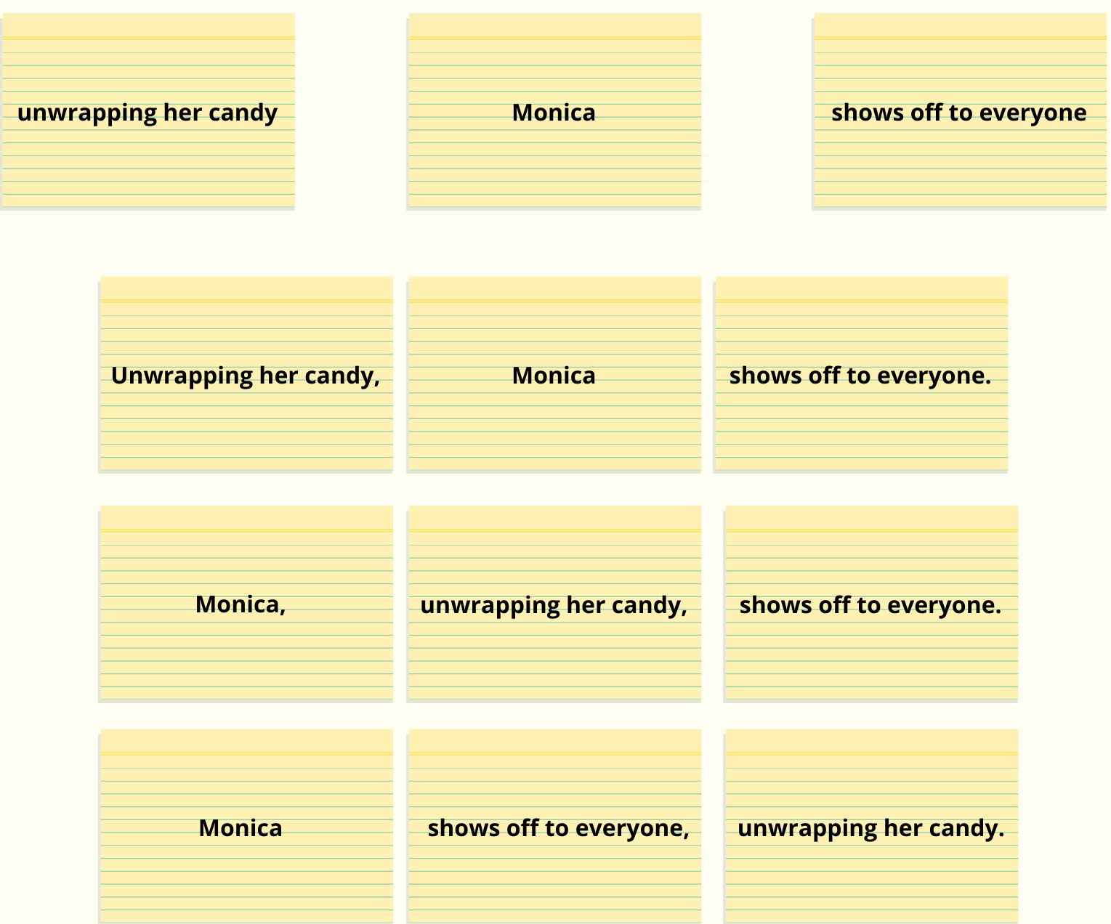
End the lesson by again asking students everything they know about participial phrases. Allow students to state their knowledge. Review the importance of elaboration and how moving participial phrases in sentences can improve style and variety.

Lesson 4: Writing a Paragraph Using Participial Phrases in a Group. Day four’s objective is to have the students collaborate in groups to write a paragraph using participial phrases. As mentioned earlier, some students with autism struggle with communication skills, so it is important to incorporate practicing these skills in lessons. We would begin the lesson by revisiting the characteristics of participial phrases. During this time, we would also pair students in groups strategically, ensuring students are paired with students who will challenge them. It is important to pair students strategically to assure they are grouped with students who will help them succeed. Inform the class that they will be writing about the zoo, so they can start brainstorming.
After this you will demonstrate a participial phrase by writing examples on the board; an example one may use could be “Peering through the glass, we saw a monkey eat a banana.” Allow students the opportunity to give examples and write them on the board.This opening lesson allows children with autism another opportunity to physically see and hear a participial phrase, better equipping them to work effectively in their group. Continuing, as a class have students create sentences about the zoo using participial phrases. After you model, split the students into their groups, and allow them to begin writing about the zoo. Remind students to incorporate what they just learned into their paragraphs and encourage everyone to fully participate in their group. During this time, circulate the room and provide any guidance to students who look like they are struggling.
Once all the groups are done, have each one read their paragraph out loud and have other students identify the participial phrases they used. This can be seen as a great closing to the lesson, allowing the students to get feedback not only from their peers but also their teacher on how they did.

Lesson 5: Write Paragraphs Using Participial Phrases Independently. Day five would focus on the ability of students to write a paragraph using participial phrases independently.Open the class period by having the students remind you what a participial phrase is and how to identify one. Next, write a few phrases on the board such as “Leaning over the rail, the bear fell. She fell after leaning over the railing.” Have students come up to the board one by one and identify the participial phrase. Then, give students the opportunity to explain why the participial phrase is an example. The second sentence does not have a participial phrase; the phrase begins with the preposition after and leaning is a gerund functioning as the object of the preposition.
As guided practice, you will create a “minute to win it” type setting, but keep the fun light. Give students twenty minutes to create a paragraph about zoos, adding participial phrases in various positions. The student with the most correctly used participial phrases could receive a no homework pass or other reward. If your students are time sensitive, eliminate the time aspect. You might also have them work on this in groups.

Lesson 6: Comma Placement with Introductory and Nonessential Elements. Use day six to focus on how to use commas to punctuate nonessential and introductory elements in participial phrases. Introductory elements occur before the main or independent clause and are separated from the main clause by a comma. Introductory elements introduce the sentence to readers, provide sentence variety, and change the flow of a sentence (Benjamin, & Berger, 2014, p. 112). Nonessential elements in participial phrases are separated from the rest of the sentence by two commas to show that they are extra information (Benjamin, & Berger, 2014, p. 137). To begin the lesson, explain how to use commas with these phrases. Explain how introductory elements use commas to separate the phrase from the rest of the sentence while nonessential phrases are typically located in the middle of the sentence and require commas before and after it. While teaching the students this, write examples on the board such as “Finishing my math test, I left for band practice. Jane, finishing her math test, left for band practice.” Clearly label the phrases as nonessential or introductory and highlight the placement of the commas. After demonstrating this, write some more examples on the board and have the class label them as introductory or nonessential and explain why commas are placed where they are. After class discussion, see if students are able to create their own examples.
Finishing off with some individual guided practice, have the students go back to their paragraph from the day prior and check their use of commas. Give them the handout attached below for them to reference during this activity. Have students explain why they are placing commas where they are. During this practice, circulate and help any students who need one-on-one help. Finally, have students select a piece of their own writing that they can add participial phrases to. This allows students to apply what they have learned to their own work.

Revising Your Individual Paragraph
Reminder: Introductory participial phrases occur before the main or independent clause and are separated by a comma (Benjamin, & Berger, 2014, p. 112). Nonessential participial phrases are separated by two commas to show that they add extra, nonessential information to the sentence. You add commas before and after the nonessential elements to separate them from the main clauses of the sentence (Benjamin, & Berger, 2014, p. 137).
Examples of Introductory Participial Phrases:
- Eating too many snacks, I was no longer hungry for dinner.
- Walking on the beach, I saw a dolphin swim by.
Examples of Nonessential Participial Phrases:
- Joseph, chewing gum, spoke to his professor.
- Abby, eating breakfast, left for school.
Notice the placement of the commas and the difference between the two. Now, it’s your turn to try! Your job is to correctly place commas and explain why you are placing the commas where you place it in your paragraph from yesterday. Also, add a few new sentences to your paragraph using an introductory or nonessential clause to really get a chance to practice your new skill! Let’s look at your paragraph from yesterday ….

Conclusion
Amy Benjamin and Joan Berger, in Teaching Grammar: What Really Works, provide teachers with lessons that can be easily implemented in all classrooms. Our adapted lesson plans provide students with autism with methods that will help them succeed, using recursive learning and enabling students to fully understand the concepts in ways that are applicable to them. Teaching participial phrases is important to developing the important skills of elaboration and sentence variety, so they should be accessible to every student.

Day | Learning Goal | Activity | Practice/Homework
1 | Identify participial phrases | Using the song “Don’t Stop Believing” by Journey, students will find examples of participial phrases | Have students continue to identify other phrases on their own in the song “Starman” by David Bowie
2 | Identify participial phrases and write sentences with participial phrases | Students will play a game of silent charades acting out cards with participial phrases on them. Students will then create sentences from the participial phrases used | None
3 | Discuss the positions of participial phrases and examine the effect of various positions | Students will rearrange three seperate cards, one being a participial phrase, in order to make as many complete sentences as possible | None
4 | Work collaboratively in a group and write a paragraph using participial phrases | Work as a class to come up with sentences about the zoo using participial phrases. Then group students up and have them write a paragraph using these phrases about the zoo | Have each group read their paragraph ouloud and have other groups identify the participial phrase
5 | Be able to write a paragraph using participial phrases independently | Create a “minute to win it” type setting. Give students twenty minutes to write a paragraph using as many participles as possible. | None
6 | How to use commas to punctuate nonessential and introductory clauses in participial phrases. | Class presentation of what these elements are and how to identify them. Provide examples and have students try. | Have students go back to their writing from day 5 and properly place commas and add examples of introductory and nonessential clauses using participial phrases into their paragraph. Have students revise an old piece of their writing to include participial phrases.

References

Benjamin, A., & Berger, J. (2010). Teaching grammar: What really works. Larchmont, NY: Eye on
Education.

Killgallon, D., & Killgallon, J. (2010). Grammar for college writing: A Sentence-Composing
Approach. Portsmouth, NH: Heineman.

Learn with Videos. (2018). Ing x ed: Practice participles as adjectives with scenes from TV series
[Video]. https://www.youtube.com/watch?v=DMZduL7AFK8.

Techniques for Teaching Students with Autism Spectrum Disorder. (2020). Saint Joseph University
Online. https://online.sju.edu/graduate/masters-special-education/resources/articles/
techniques-for-teaching-students-with-autism-spectrum-disorder

Warber, A. (2020). Teaching methods for autistic children. Love to Know.
https://autism.lovetoknow.com/Teaching_Methods_for_Autistic_Children

