Nikki Marzolf
Final Draft
A Night on the Water
(After Starry Night over the Rhone by Vincent van Gogh)
Glistening stars in the sky,
the lights of the city reflect on the water,
gentle rocks of the boats on the river.
Looking through a telescope
the stars fall in and out frame,
as though the boat is the last rock in the galaxy
and it is pushing and pulling the stars
with each gentle movement.
The motion making all the stars appear to be shooting, flying
across the sky in the eye of the telescope.
The city lights dulling the lesser stars,
casting the remaining into stark relief
against the murky blank slate of the night heavens.
Sighing, I turn from the immortal splendor of the stars.
Time to return to life
and leave the speckles in the sky
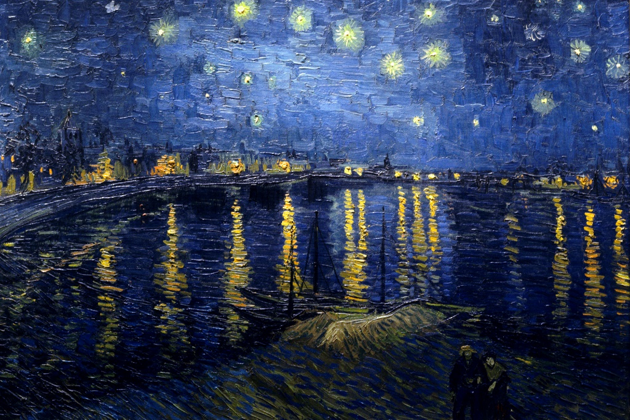
until next time. I know they will be waiting.

