**Fall 2016 ● NOON-1 PM ● MAUGAN’S VIRGINIA ROOM**

**BLACKWELL TALKS**

**OCTOBER 10: Dr. Hua (Meg) Meng**

“Naughty and Nice: Dimensions of Scent Personality”

Department of Management and Marketing

**OCTOBER 17: Ms. Lindsey Stokes, MSEd, LAT, ATC**“Integration of Critical Appraisal into Health Care Education”  
Department of Health, Athletic Training, Recreation, and Kinesiology

**OCTOBER 24: Dr. Lissa Power-deFur & Dr. Jake Milne**“The Identity Negotiation Process among Adults with a Hearing Loss”

Department of Social Work and Communication Sciences and Disorders  
and the Department of Sociology, Anthropology, and Criminal Justice Studies

**OCTOBER 31: Dr. Sarai Blincoe & Dr. Catherine Franssen**

“A rewarding disconnection: Going cell phone-free for extra credit”

Department of Psychology

**November 7: Dr. Doug Dalton**

“A Report on Anthropological Fieldwork in Papua New Guinea”

Department of Sociology, Anthropology and Criminal Justice Studies

**November 14: Ms.** **Courtneay Kelly**“Before They Teach: Pre-Service Teachers’ Perceptions of Planning Differentiated Literacy Instruction”  
College of Education and Human Services



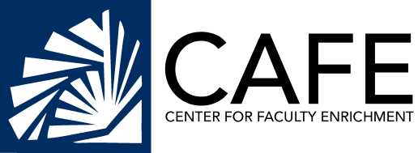

**SPONSORED BY:**College of Education & Human Services ● Cormier Honors College   
●Cook-Cole College of Arts & Sciences ● College of Business & Economics   
● Greenwood Library ● and the College of Graduate & Professional Studies