Natalie Wood
Shanyia Chandler
12/06/19

7000 years of cosmetics, 7000 years of cancerous cells?

Parabens have been found in a multitude of cosmetic products, possibly being linked to causing carcinogenesis because of the estrogen binding ability the paraben possesses. We want to understand if the length of the ester chain can affect the paraben's ability to kill bacteria as well as becoming a safer chemical property in cosmetics. Five paraben derivatives were synthesized with varying esters while being analyzed for minimum inhibitory concentration using dilution assays. The results consist of an overall percent yield of 20.8% that present how successful the reactants were converted to products. It was found that the longer ester chain lengths increased activity against bacterial growth, therefore Octyl presented to be the best ester chain length with a MIC value of 1. In conclusion, newly synthesized paraben derivatives with longer carbon chain lengths improved antimicrobial activity, but we recommend further research to observe the most effective ester chain that can result in parabens' ability to bind to estrogen receptors to replace current parabens in cosmetic products.

Since the 1930’s parabens have been a key ingredient in cosmetics, but later found as a possible component acting to activate breast cancer cells by binding to the estrogen receptors. Products such as lotions and deodorants that are applied topically are absorbed through the skin possibly causing a greater chance that the parabens can mimic estrogen and bind to the estrogen receptor. Since these products are used primarily by women, the statistics of developing breast cancer increase among females². The upper outer quadrant of the breast is the most frequent site of carcinoma due to underarm cosmetics being applied without being washed off and allows them to penetrate through the skin easily. This absorption can allow the paraben to easily bind to the estrogen receptor. There is evidence that parabens can mimic the action of oestrogen and can stimulate the growth of oestrogen-dependent human breast cancer cells in culture². As a result of parabens mimicking estrogen by binding to the estrogen receptors, they are potentially turning on the growth hormone receptors causing a rate increase of duplicating cancerous cells. Parabens affect the structure of normal breast cancer cells allowing the growth of abnormal cells which leads to an increased risk of breast cancer³. Although we can detect parabens in human breast material by both thin-layer chromatography (TLC) and liquid chromatography followed by mass spectrometry (LC/MS–MS), such studies cannot identify the source of the parabens because the human population is exposed to parabens through many thousands of food, pharmaceutical and cosmetic products².

Cosmetic products contain parabens to act as preservatives and are used in a wide range of products to contribute their antimicrobial properties. They have inhibitory effects on microbial membrane transport, mimicking estrogen that is binding to the estrogen receptors. Parabens are classified as a series of parahydroxybenzoates with differing ester chains. The ester chain length can be a determining factor in the antimicrobial properties of the paraben. Antimicrobial activity increases with the length of the alkyl grouping from methyl to n-buthyl³. Interaction energy values vary depending on chain length. The paraben with the lower interaction energy is favorable, therefore, Nonylparaben is the favored ester. Nonylparabens have 9 carbons in the ester chain and because of its favorability, it can be theorized that the longer the chain the better ability of binding to a protein¹. The longer length also aids in the antimicrobial effect, meaning the ability to kill bacteria effectively.

Parabens act as estrogen being able to bind to estrogen receptors. Modifying the structure of the molecule can prevent the molecule from binding and result in an increase of cancerous cells. The ester chain length has great influence on the antimicrobial properties of parabens. Parabens with shorter or unbranched side chains have less estrogen-like activity than those with longer or branched side chains⁴. By altering the chain length, we could potentially figure out the most effective safe brominated paraben that is still able to be antimicrobial as well as non-cancerous. Substituting next to the phenol adding two big atoms, not allowing the paraben to bind to the estrogen receptor hoping it doesn't turn off the antimicrobial properties. This study aims to create a safer paraben that still possesses anti-microbial properties that will not bind to the estrogen receptors due to substitution on the brominated paraben. Brominated parabens are substituted next to the phenol blocking the paraben from the estrogen receptor. We are changing the ester to understand the antimicrobial change. If the parabens kill bacteria, then the trend that the carbon length is longer will possess enhanced antimicrobial properties.

Scheme 1. Synthesis of dibrominated parabens of varying ester functions

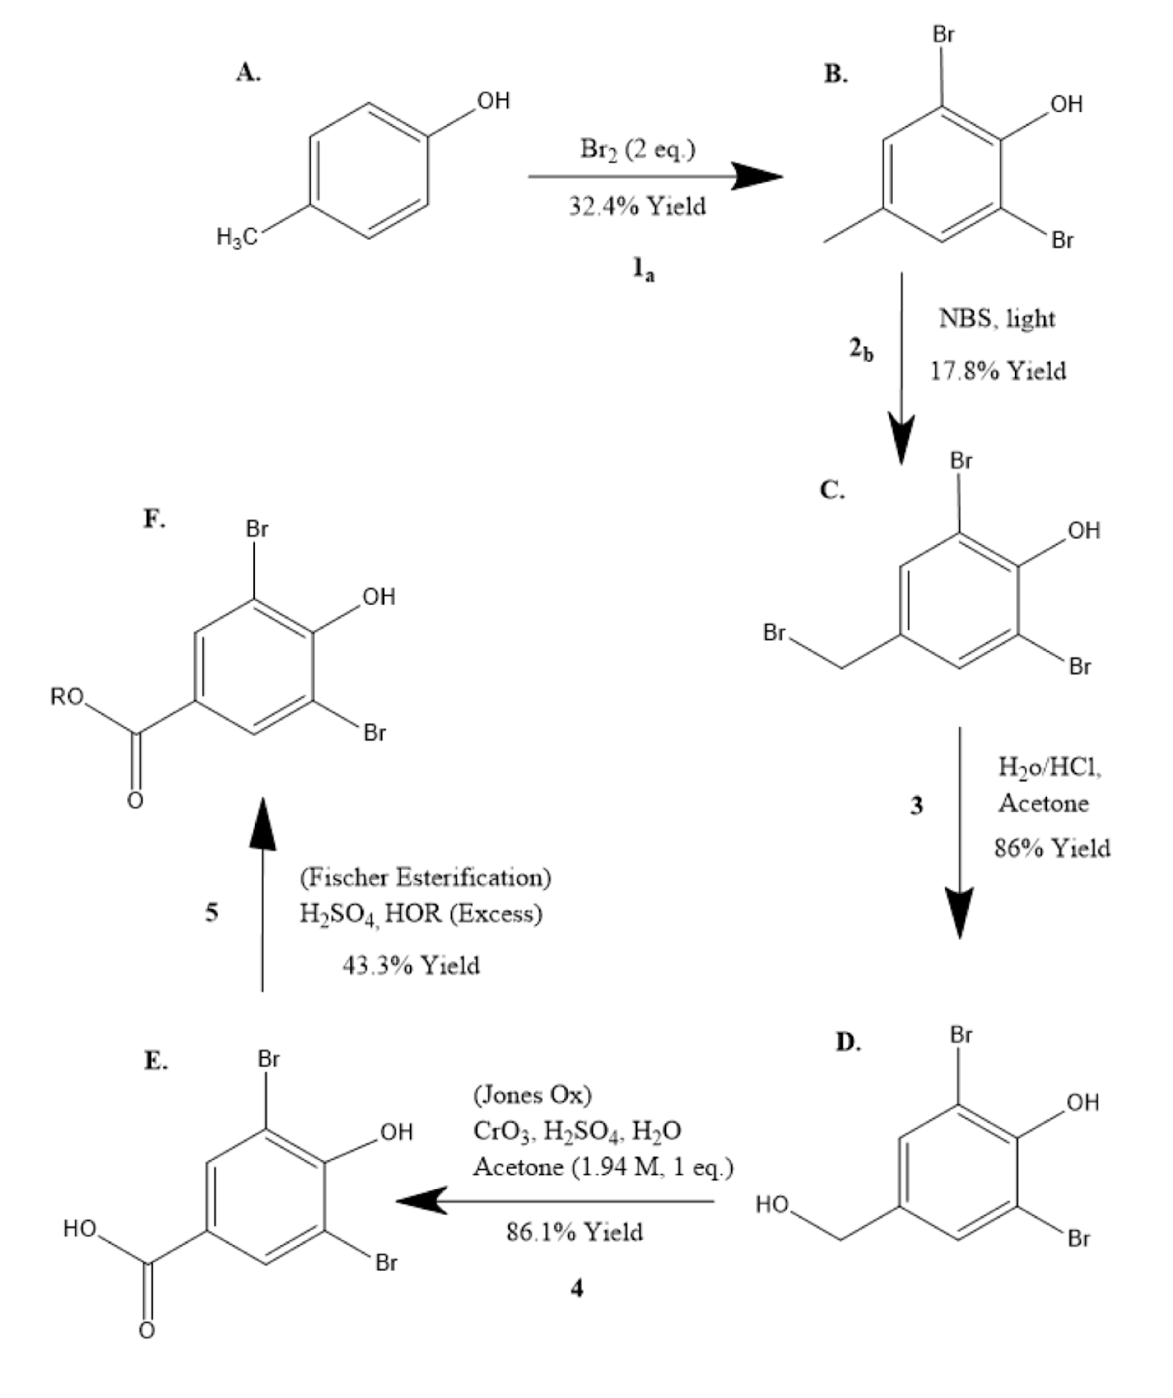

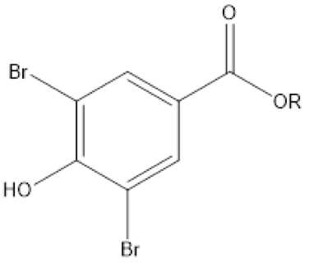
Table 1. Results for MIC assay of brominated parabens with varying carbon chain lengths

Compound (R) | MIC (μg/mL) | Positive Control | MIC (μg/mL)
1. Methyl | >256 | a. Me Paraben | >256
2. Ethyl | >256 | b. Et Paraben | >256
3. Propyl | >256 | c. PrParaben | >256
4. Butyl | 128 | d. BuParaben | 128
5. Pentyl | 32 | e. isoBuParaben | 128
6. Hexyl | 8 | f. Erythromycin | 0.125
7. Heptyl | 2 | g. Amphicillin | 2
8. Octyl | 1 | - | -
9. Isobutyl | 128 | - | -
10. Secbutyl | 128 | - | -
11. Isobutyl | 64 | - | -

It was found that after synthesizing the 6 brominated parabens, percent yields were calculated to show the success of reactants to products. Low percent yields at reactions 1a, 2b, and 5 in Scheme 1 had less product recovered, meaning there could have been simple errors during the experimental performance. The highest percent yields are found between reactions C and D as well as between D and E in Scheme 1 which had more product recovered. The overall percent yield from A to F was 20.8%. Although there were low percent yields shown, the reactions overall are considered successful with products being produced from each reactant.
After various parabens were tested against S. salivarius, antimicrobial activity was determined by finding the MIC using dilution assays. We were able to compare the SAR between ester chain length and antimicrobial properties of brominated parabens. Esters containing longer carbon chain lengths like Hexyl, Heptyl, and Octyl, in Table 1 had the greatest decrease in bacterial growth with low MIC values, with Octyl showing the greatest increase overall. In Table 1, compound 1,2 and 3 (methyl, ethyl, and propyl) had high MIC results of >256 which demonstrated a very little increase in the antimicrobial properties. The positive controls, erythromycin and ampicillin, were meant for comparison between the compounds and it was found that the paraben with the shorter carbon chain length was not as effective in killing bacteria. To compare, compounds 1, 2, 3, a, b, and c (Methyl, Ethyl, Propyl, Me Paraben, Eth Paraben, and PrParaben) had the same MIC value as well as compounds 4, 9, 10, e, and d (Butyl, Isobutyl, Secbutyl, isoBuParaben, and BuParaben) had the same MIC value.
In conclusion, we have produced an effective synthesized brominated paraben with increased antimicrobial activity. It has been shown that the Octyl carbon chain has increased antimicrobial effects and can perhaps be vitalized as a substituted paraben in various cosmetic products. The brominated paraben substitutions resulted in the lack of binding to the estrogen receptor and allowed the carbon chains to lengthen which led to improved antimicrobial activity. The lack of binding and lengthening of carbon chains can result in a decrease in the activation of cancerous cells. Future studies include testing on mice to determine if various brominated parabens will bind to the estrogen receptor in a viable host to determine the antimicrobial property effects.
2,6-dibromo-4-methylphenol
P-cresol was weighed to 2.99 grams and dissolved in 5 mL of glacial acetic acid then 2.1 mol equivalents of pyridinium tribromide was added. In a 100 mL round bottom flask, reagents, p-cresol, acetic acid, and pyridinium were added and heated at reflux for 30 min, then cooled to room temp. Meanwhile, approximately 50 mL of 0.5 M HCl was added to an Erlenmeyer flask and cooled in an ice bath with a stirring rod on the heating mantle. Once cooled, the reaction solution was added dropwise to the cold HCl until a white precipitate persists on the acidic aqueous solution with the remainder of the reaction solution added after. The precipitate was vacuum filtered until dry and the mass of the beaker,product, and percent yield were recorded, and transferred to the tarred beaker once 2,6-dibromo-4-methylphenol became dry. The crude material was then purified by flash chromatography (typically 20-50% EtOAc in Hexanes) to provide the product as a white solid (7.45g, 32.4%). The product showed in GC-MS m/z 264, both Br weighing 79 [(M+H)+; calculated mass for C7H6OBr2+: 264 amu].

2,6-dibromo-4-bromomethyl phenol
2.084 g was dissolved in a 50 mL of chloroform in a round bottom flask. 1.05 mole equivalents of N-bromosuccinimide was added slowly to the round bottom and placed under UV light for 7 days. The benzylic bromination reaction solution was added to a 125 mL separatory funnel and rinsed with 5 mL dichloromethane. The organic layer was washed in 3 stages with 50 mL portions of 1 M hydrochloric with a brine wash performed after the washes. The organic layer was poured into a 125 mL Erlenmeyer flask and dried with magnesium sulfate and filtered into a tared 100 mL round bottom flask. The solvent was removed under a vacuum using a Rotary Evaporator and the mass of the flask as well as the dried product was recorded, calculating the percent yield.

4,6-dibromo-4-hydroxymethyl
16 mL of acetone and 8 mL of HCl was added to the crude 2,6-dibromo-4-bromomethyl phenol in a round bottom flask to set for 7 days. The reaction was then poured into a separatory funnel and 75 mL of ethyl acetate was added and shaken. The organic layer was washed with 3 separate 25 mL portions of deionized water and after was poured into a 125 ml Erlenmeyer flask and dried with magnesium sulfate. The solution was filtered through fluted filter paper into a tared 250 mL round bottom flask and the solvent was removed under a vacuum using a Rotary Evaporator. The flask and dried product, 4,6-dibromo-4-hydroxymethyl, were weighed as well as the percent yield collected.The crude material was then purified through filtration and TLC examination (typically 20 -50% EtOAc in Hexanes) to provide the product as a white solid (2.207g, 86%). 1H NMR (DMSO, 60MHz) Delta 9.768 (s, 1H), Delta 7.509 (s, 2H), Delta 4.6 (s, 1H), Delta 4.445 (s, 2H).

2,6-dibromo-4-hydroxymethylphenol
3 grams of purified 2,6-dibromo-4-(hydroxymethyl)phenol was dissolved in acetone. 1.5 equivalent of 2.0 M Jones reagent was added dropwise and stirred for an hour. In a separatory funnel, 100 mL of ethyl acetate was added and the organic layer was washed in 3 separate 50 mL portions of deionized water then the products were dried with magnesium sulfate and filtered out with the product placed in a round bottom flask removing the solvent using the Rotary Evaporator. Mass was 2.207 g with a percent yield of 86.143%. Melting points ranged from 239-250 Celcius.

Heptyl 3,5-dibromo-4-hydroxybenzoate
In a 10 mL round bottom flask, approximately 300 mg of 3,5-dibromo-4-hydroxybenzoic acid, 1 mL of heptanol, and 5 drops of H2SO4 were added and refluxed for an hour. The material was then purified by flash chromatography (typically 10% EtOAc in Hexanes). To perform the MIC assay, a 96 well plate was prepared for the positive control and negative control. 1 mL of the inoculated broth was pipetted into a sterile test tube with the sample added, making the solution have a concentration of 256μg/mL. The solution was then vortexed and 200μL of the positive, negative, and sample solution was put into the top rows of the well. Every well underneath was filled with 100μL of broth with 100μL of each row taken and mixed 6 times. The 100μL from the previous well was mixed into the next well and so on until the last well. These steps were repeated for the positive control. Once the dilution was complete the plate was sealed and put into a plastic container with a damp paper towel and placed in an incubator at 37°C for 16 hours. The product showed in GC-MS m/z 392, both Br weighing 79 [(M+H)+; calculated mass for C14H18Br2O3+392 amu]. 1H NMR (CDCl3), 60MHz) Delta 8.122 (s, 2H), Delta 6.468 (s, 1H), Delta 4.393 (s, 2H), Delta .0932 (s, 1H). IR (CDCl3) 3487, 3373, 2958, 2928, 2857, 1700, 1685, 1588, 1560, 1555, 1476, 1473.

MIC bioassay
Brain Heart Infusion was inoculated (5 x 105 CFU mL-1) with Streptococcus salivarius. The resulting bacterial suspension was aliquoted (5 mL) into culture tubes and test compound (from its DMSO stock) was added to give the final concentration to be tested. Bacteria tested with inoculum served as the negative control. After sitting for 30 min at room temperature, 1 mL of each sample was transferred to a new culture tube and broth was added from 128 mg mL-1water stock to give a concentration of 128 µg mL-1. Rows 2-12 of a 96-well microtiter plate were filled with 100 µL/well from the remaining 3 mL bacterial subcultures, allowing the concentration of compound to be kept uniform throughout the antibiotic dilution procedure. After standing for 10 min, the samples containing antibiotic were aliquoted (200 µL) into the corresponding first row wells of the microtiter plate. Row 1 wells were mixed 6 to 8 times then 100 µL was transferred to row 2. Row 2 wells were mixed 6 to 8 times, followed by a 100 µL transfer from row 2 to row 3. This procedure was repeated to serially dilute the rest of the rows of the microtiter plate, with the exception of the final row, to which no antibiotic was added. The plate was then sealed with GLAD Press n’ Seal®and incubated under stationary conditions at 37 °C. After 16 h, minimum inhibitory concentration (MIC) values were recorded as the lowest concentration of antibiotic at which no visible growth of bacteria was observed.

¹Byford, J.; Shaw, L. Drew, M. Pope, G. Sauer, M. Darbre, P. 2001. Oestrogenic activity of parabens in MCF7 human breast cancer cells. Journal of Steroid Biochemistry & Molecular Biology. 49-60.

²Darbre, P. 2003. Underarm Cosmetics and Breast Cancer. Journal of Toxicology.23, 89-95.

³Darbre, P. Aljarrah, A. Miller, W. Coldham, N. Sauer, M. Pope, G. 2004. Concentrations of Parabens in Human Breast Tumours. Journal of Applied Toxicology. 24, 5-13.

⁴Hussein, S. Muret, P. Beard, M. Makki, S. Humbert, P. 2007. Assessment of principal parabens used in cosmetics after their passage through human epidermis-dermis layers (ex-vivo sudy).Experimental Dermatology. 16, 830-836

