Longwood University

Evolution
Understanding the relationship between Theropods and modern birds

Natalie Wood
Evolution 399
Dr. Franssen
June 14, 2019
INTRODUCTION
Approximately 700 different species of dinosaurs roamed the earth millions of years ago of different sizes, geological homes, anatomy, behaviors, and mode of transportation. Every year, scientists discover something new that takes our breath away. It could be the discovery that dinosaurs had feathers (Wang, 2017) or the similarity of bone structure in fish and tetrapod’s (Yano, 2013). Discoveries that transform the way we view our evolutionary history. In 2017, paleontologist Roland Pöschl discovered a slab showing a right wing of a primordial bird, but in 2018 this wing was identified as a part of the thirteenth specimen of Archaeopteryx named Alcmonavis poeschli. This finding can be a missing link in the early evolution of birds.
When it comes to the topic of dinosaur discoveries, most will readily agree that these fossils offer great insight on dinosaur evolution and that relation to modern animals. Many thought that dinosaurs went extinct, but after careful review of the literature, many scientists are now convinced that an entire lineage evolved and are represented by modern birds. It seems clear that when looking at the recent discoveries and evolution of dinosaurs, we as scientists can for certain relate animals like, birds and reptiles back to the prehistoric era. This paper is a review of newly discovered fossils like Alcmonavis poeschli and relate them to our prior knowledge of dinosaur evolution that has changed the way we think about evolution.
RECENT FIDNINGS
Over the past few hundred years’ fossils of many different kinds have been found. With many discoveries happening every year, this past year something interesting has been uncovered. When the first skeleton of the ‘Urvogel’ Archaeopteryx was discovered in 1861 (Fig. 4), it represented the first skeletal evidence for a pre-Tertiary bird (Rauhut, 2018). In 2018 Alcmonavis poeschli was uncovered in southern Germany. However, in 2019 this fossil has been classified as a basal bird genus during the late Jurassic period and one of its kind. It is similar to the Archaeopteryx species. This new specimen consists of partially disarticulated, but an associated skeleton of the right wing of an avialan theropod (Rauhut, 2019). The humerus, ulna, radius, carpus, metacarpus, and digits are all intact in the rock they were found in (Fig. 3). This is pivotal evidence to further study this genus, especially because it is the only species of its genus. Fortunately, Alcmonavis shows several notable characters that could help to elucidate the early stages of osteological evolution of the bird wing. Identification of several muscle attachment areas in the forelimb implicates our understanding of the early evolution of avialan flight musculature (Rauhut, 2019). In recent birds, the main muscles of flight are in the pectoralis and supracoracoideus which lifts the forelimb and a role in rotation of the humerus. The tuberculum bicipitale radii is a notable muscle attachment and in most dinosaurs the insertion of the biceps brachii is only noted by a rugose patch, but no marked tubercle is present (Rauhut, 2019). However, birds have a well-developed tubercle which is present in Alcmonavis as well as other Mesozoic birds. With the discovery of this new fossil, scientist can easily compare the similarities and differences among other bird-like fossils.
EARLY FEATHERED THEROPODS
Dinosaurs walked the earth for millions of years and have evolved in many ways since their start on this planet, Archaeopteryx is one of them during the Jurassic period. The discovery of this dinosaur is one of the greatest findings in the 19th century. These bird-like dinosaurs resided in what we now know as southern Germany, approximately 150 million years ago. The so-called ‘Solnhofen limestones’ of southern Germany have long been known for their exceptionally preserved fossils (Rauhut, 2019).
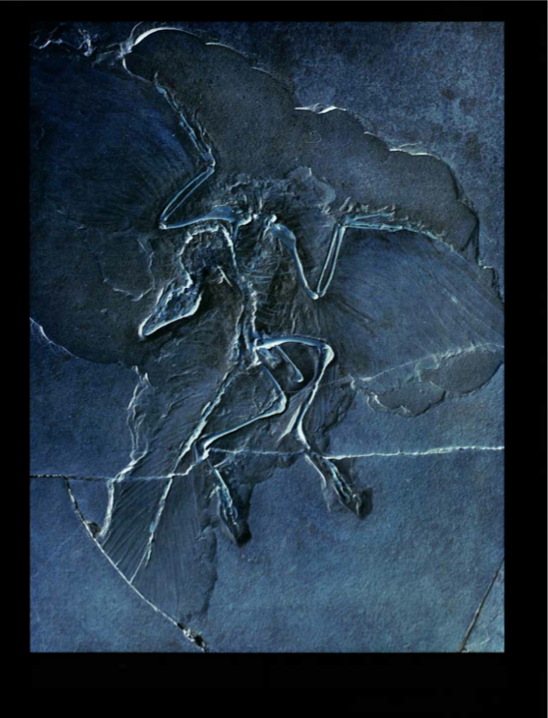
Figure 4. An overview of the transitional fossil Archaeopteryx. A complete head-to-toe fossil intact including limbs and evidence of feather imprints.

Historically, most fossils reported from these rocks come from the Altmühltal Formation, as these were subject to intensive quarrying for several commercial purposes, from construction to lithography, probably since Roman times (Rauhut, 2019). In 1861 a fossilized skeleton with imprints of feathers was discovered in the limestone quarry at Solnhofen in Bavaria (Wellnhofer, 1990). This fossil was named Archaeopteryx meaning “old wing” and lithographica coming from limestone, the lithographic slate, during the 19th century (Wellnhofer, 1990). The stone was hard, compact and fine-grained which made for a great preservative for these fossils. The imprints of the bones and feathers were preserved with great clarity and detail. Archaeopteryx is just one of many discoveries that have tied modern animals to the prehistoric era.
Anchiornis is similar to older 4-winged paravian theropod to the Archaeopteryx. This genus is a transitional fossil that provides great detail on the physical aspects of the transition from theropod to birds. The body outline confirms existing skeleton and feather-based inferences and supports EPB-based studies of leg and tail shape (Wang, 2017). The propatagia suggest Anchiornis could produce a straight arm, a posture found in many living gliding birds (Wang, 2017). Its second and third manual digits formed a didactyl hand, which is extremely common among birds and helps Anchiornis stiffen the postpatagium. This is possibly compensated for its aerodynamically inferior arm feathers, providing an example that basal paravians may have evolved different solutions to locomotor needs and challenges (Wang, 2017). The symmetry of the arm feathers and their arrangement suggest that the arms were possibly not used in a comparable way to modern birds, although the similarities in propatagium shape and chamber (Wang, 2017). All these findings suggest that feathering including symmetry, size differentiation, and spatial arrangement, was significant towards how basal paravians utilized their arms for aerodynamic benefits. The body outline is very similar to asymmetrically feathered basal paravians like Archaeopteryx based on their skeletal similarities. These findings build a strong foundation for determining the aerodynamic of Anchiornis and other transitional theropod dinosaurs.
Different aspects of the dinosaur ‘culture’ like reproduction, diet, and migration pattern have been studied which can lead to the evolution of birds. To understand these findings and observe their relation in evolution, have been an on-going goal for the science community. With the technology, fossils, and data we are to piece together prehistoric evolution and follow their development through time.
EVOLUTION OF MODERN BIRD MORPHOLOGY
Just like modern birds, dinosaurs laid eggs. However, scientist take a closer look at these dinosaurs to understand more than just their eggs, but their reproduction. Three specimens of Mesozoic birds from the Tianyu Natural History Museum, China, have been found to contain mature ovarian follicles preserved in their body cavity (Fig. 1) (Zheng, 2013). Living archosaurs—crocodilians and birds—differ greatly in their reproductive habits in terms of clutch size, nesting behavior, degree of parental care and developmental strategy of young, posing the evolutionary questions of when, how and why derived avian reproductive traits evolved within Dinosauria (Zheng, 2013). In all vertebrates and living archosaurs, the female reproductive system is divided into two separate parts: ovary and oviduct. Birds are quite unique and have two ovaries and oviducts, but only the left are functional in adulthood. The kiwi differs from other birds in that both the left and right ovaries develop, although it is only the left oviduct that develops (Zhang, 2013). Living birds lost their right ovary and oviduct and are unclear why. It is hypothesized that it was related to the need to reduce weight in flight during the reproductive season, the female having to carry only a single egg inside rather than two, although loss may also have been to alleviate the demands for calcium during ovulation (Zhang, 2013). This is clearly an indication of evolution occurring in early theropods. The loose of an ovary might be one of the reasons why birds are able to fly. The closest-related dinosaurs are known to have two functioning oviducts, which is believed that the loss of function in the right ovary occurred between non-avian to avian transition. The ovarian follicles preserved in these Early Cretaceous birds reveal new clues regarding basal bird reproduction (Zhang, 2013). With this information, the evolution of the ovaries and oviduct in birds can be traced back to non-avian dinosaurs with the help of transition avian dinosaurs.
EVOLUTION OF MODERN BEHAVIORS
Another evolutionary aspect that has been noted is incubation. Norell states that the incubation behavior of birds “is implicitly tied to the warm blooded metabolism of living birds” and implies that the presence of such behavior in Oviraptor indicates endothermy in these dinosaurs (Ruben, 2003). He admits that this behavior and endothermy are not necessarily correlated, but conclude modern avian brooding behavior was present in maniraptoran theropods (Ruben, 2003). Incubation and nest protection in many dinosaurs was more crocodilian-like than birdlike, but there is still little known about many aspects of reproduction in dinosaurs. One pattern we can observe is prenatal care in bird-like dinosaurs. Several authors suggested that male care evolved before female care in birds or their recent ancestors (Burley, 2002). It’s been assumed that mating systems typical of palaeognaths evolved from the condition of no parental care and that mating systems typical of neognaths derived from them, but there is no good phylogenetic support for this (Burley, 2002). Burley proposes that female-only care coevolved with increasing egg size in the ancestors of birds; biparental care followed; and from biparental care, a wide radiation of mating systems has taken place (Burley, 2002). There are many hypotheses to parental care in non-avian dinosaurs, therefore little can be known. However, with all the information present, further information can be considered.
Modern birds are known for their migration patterns. During seasonal changes, they either go north or south making way to a different climate. The question is have these migration patterns always been present in bird lineages and evolved over time or has natural selection taken its course in more recent years. Little is known about dinosaur migration. There is little evidence that dinosaurs had a need to migrate for any reason similar to that of birds. However, it’s been defined that avian migration is a regular, controlled, seasonal return movement of birds between breeding and non-breeding areas, while dispersal is a one-way movement, not regular in terms of a cyclic change of sites, and not controlled endogenously with respect to time and direction (Bruderer, 2008). According to Rappole, there is extensive evidence that indicates migratory traits are parts of an integrated system, and separating a set of such traits can bias analyses. This tells us that the analysis of migratory behavior separately can produce results is doubtful. Although understanding the evolution of bird migration could possibly lead to the understanding of dinosaur migration, avian migration only dates back so long. With further research on the area of fossil to determine habitat, ingestion of nutrients to determine the type of prey, and relatives to determine possible migration through evolution, more can be known about why and how dinosaurs settled in their environment.
EVOLUTIONARY EVIDENCE FROM DIET
Another aspect that could lead to understanding evolution could be through their diet. When looking at the stomach contents and a gastric mill of coelurosaurians, these features display morphological evidence of the herbivory diet and was relatively rare and potentially secondarily derived (Zanno, 2010). In order to investigate common patterns of herbivorous traits during the evolution of theropods, Zanno ranked the order of appearance of CHT’s with n of theropods, we ranked the order of appearance of CHTs with independent originations in the herbivorous coelurosaurian subclades Ornithomi mosauria, Therizinosaur. Although results of concordance analyses detect consistencies of some CHTs, it’s clear that individual coelurosaurian subclades met the challenge of an herbivorous diet by convergent adaptations and constrained patterns as well as anatomical innovations and subtle variations in herbivorous trait accumulation (Zanno, 2010). To prior knowledge of theropods it is known that they were a carnivorous species, but these findings suggest that there is evidence of herbivorous. Data supports two significant conclusions: (i) the evolution of dental features basally optimized by MP are inconsistent with hypercarnivory and suggest an ancestral origin for dietary diversification within Maniraptora--specifically, the incorporation of plant fodder into the diet; and (ii) these data combined with the presence of features correlative with direct evidence of herbivory in basal ornithomimosaurs, therizinosaurs and oviraptorosaurs are indicative of, at minimum, an omnivorous common ancestor (Zanno, 2009). Evolution of select herbivorous features may be guided by intrinsic developmental or functional constraints.
To understand these aspects is to better understand recent findings. Fossils like Alcmonavis poeschli have little known, but observing evidence from older fossils and comparing to newer ones can help identifying patterns and aspects.
PHYSIOLOGICAL FEATURES BETWEEN THEROPODS AND BIRDS
There are many common physical traits that dinosaurs and modern birds have in common. Looking at these similarities will help scientists make a better comparison between the two. They can also better understand evolution among birds by making the evaluation, knowing that there is a relation between the two.
Fossils discovered in China over the past few decades have provided paleontologists with fossil evidence demonstrating the presence of filamentous integumentary structures on theropod dinosaurs. These discoveries, and complementary data such as the presence of quill knobs indicating feathers on Velociraptor forearms, are providing convincing evidence that species from a number of theropod clades possessed feathers during at least some of their life stages (Dimond, 2011). These discoveries have helped close the gap in evolution between theropods and modern birds, but have also complicated questions about the evolution of feathers, especially in regards to the initial adaptive function for which early feathers developed (Dimond, 2011). The three hypotheses for early feathers in theropods are flight, thermoregulation, and visual display. All of these hypotheses are present in modern birds and if proven can help in relating the species. The visual display hypothesis focuses on the adaptive function of early feathers, by definition it must propose that the initial stage of feather development aided in some form of visual display and thermoregulation and flight were later exaptations (Dimond, 2011). These visual displays aided in hunting, avoiding predators, and mating. Dimond believes the most plausible scenario for the development of early feathers in theropods is when feathers evolved to facilitate a preexisting display behavior. This could have included male-male competition based on posturing and size, which is very plausible giving previous knowledge of competition among dinosaur species. Without behavioral data, it is difficult to test such hypotheses. There is still more information needed to support that early feathers served to function visual display as opposed to other functions.
ORIGIN OF FLIGHT
Flight in birds has been studied for hundreds of years. Looking at wings we can connect feathered dinosaurs and modern birds. Reconstructing the functions of forelimb feathers in theropod dinosaurs is key to understanding the origin and evolution of birds and bird flight (Fig. 2) (Heers, 2014). There is evidence that feathers debuted in basal theropods as filamentous feathers. These feathers first appeared as fans on distal tails and as small protowings on distal forelimb (Heers, 2014). Pennaceous feathers distributed in many paravians, particularly in avialans, forming larger and more birdlike wings (Heers, 2014). Understanding protowing-to-wing progression is central to the evolutionary aspect of bird flight. However, there is a limited understanding of the relationship between wing and feather morphology. It has been suggested that symmetric feathers would have been useful during drag-based aerial behaviors and paravians had layered wing feathers (Heers, 2014). Using a protowing-to-wing developmental transition to model the protowing-to-wing evolutionary transition among theropod dinosaurs and aerodynamic theory provides the first experimental evidence to suggest feathered dinosaurs choosing to flap their incipient wings would have been capable of producing useful aerodynamic forces (Heers, 2014).
With the help of fossils and technology, scientists are able to compare modern birds to theropods and bird-like dinosaurs. There have been many similarities between the two like feathers, wing, and use of both. Alcmonavis poeschli has seen to have similar physical appearances to prehistoric theropods. Although no feathers or impressions are preserved, some of the pedal unguals show remains of their horny sheaths (Rauhut, 2019). From previous knowledge of flight, we know there are two theories, arboreal and cursorial (Erickson, 1990). Understanding a more detailed aspect of what their wings were for giving rise to bird evolution. With further discoveries and studies, more can be inferred between birds and bird-like dinosaurs.
CONCLUSION
After careful consideration and review of literature from the past few decades, scientist can conclude that modern birds are heavily linked to bird-like dinosaurs like Alcmonavis poeschli. With these findings, making evolutionary connections makes it easier for scientists to relate birds to their ancestors. There is physical fossil evidence of similarities in bones like the humerus and ulna between birds and Alcmonavis poeschli. By piecing together crucial evidence, we are able to get a better understanding of bird evolution.

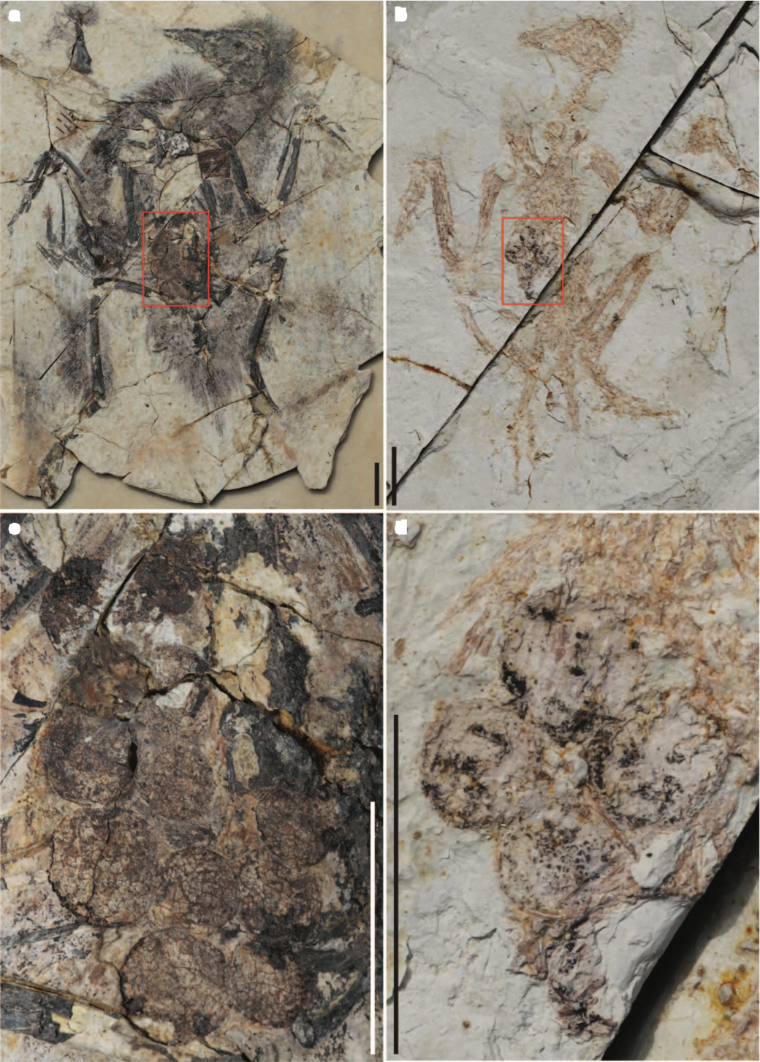
Figure 1. Preservation of mature ovarian follicles in dorsal view.
Zheng X, O’Connor J, Huchzermeyer F, Wang X, Wang Y, Wang M, Zhou Z. 2013. Preservation of ovarian follicles reveals early evolution of avian reproductive behavior. LETTER.

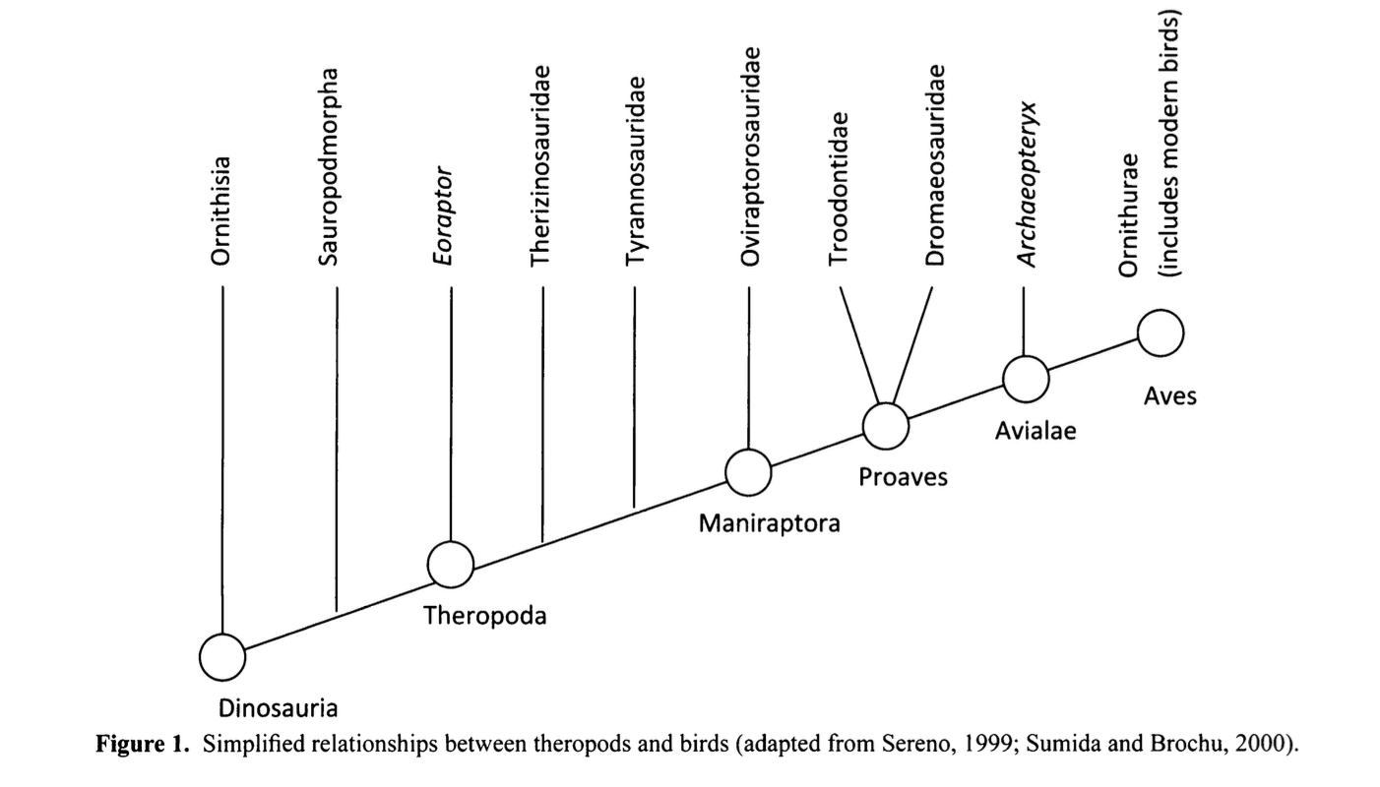

Figure 2. Dimond C, Cabin R, Brooks J. 2011. Feathers, dinosaurs, and behavioral cues: defining the visual display hypothesis for the adaptive function of feathers in non-avian theropods. Bios. 82(3) 58-63.

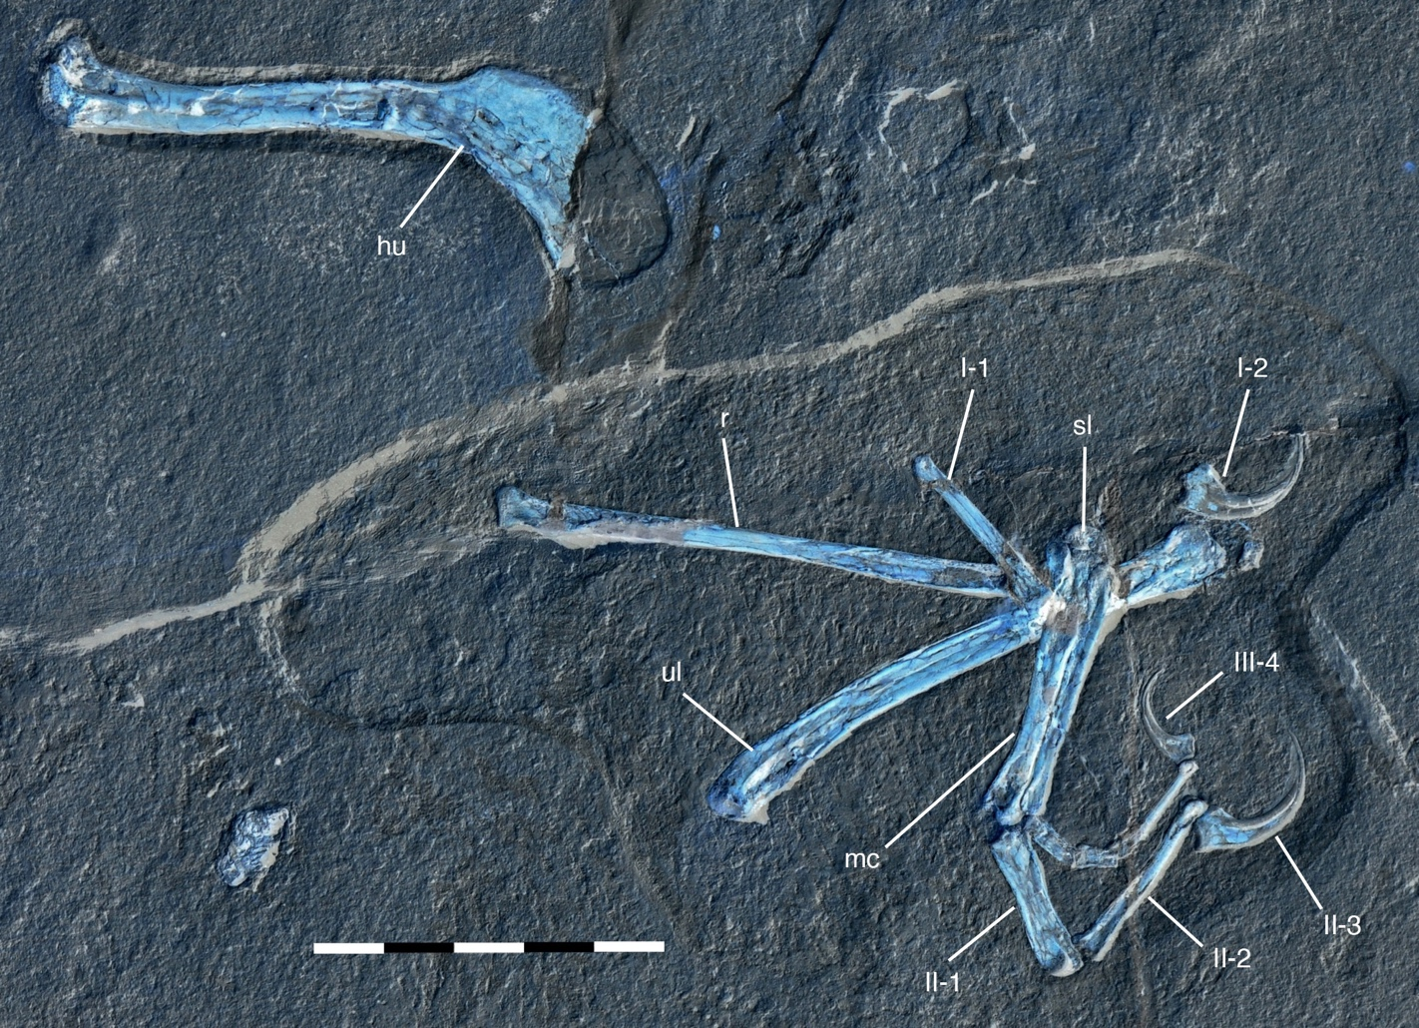

Figure 3. Overview of the humerus, metacarpals, radius, semilunate carpals, and ulna of Alcmonavis poeschli. Roman numerals represent the digits and phalanges.
Rauhut O, Tischlinger H, Foth C. 2019. A non-archaeopterygid avialan theropod from the Late Jurassic of southern Germany. eLife. Doi:https://doi.org/10.7554/eLife.43789.

Figure 4. An overview of the transitional fossil Archaeopteryx. A complete head-to-toe fossil intact including limbs and evidence of feather imprints.
Wellnhofer P. 1990. Archaeopteryx. Scientific American, INC.

Literature Cited
Bruderer B, Salewski V. 2008. Evolution of bird migration in a biogeographical context. Journal of Biogeography. 1951-1959.
Burley N and Johnson K. 2002. The evolution of avian parental care. The Royal Society. Doi:10.1098/rstb.2001.0923.
Dimond C, Cabin R, Brooks J. 2011. Feathers, dinosaurs, and behavioral cues: defining the visual display hypothesis for the adaptive function of feathers in non-avian theropods. Bios. 82(3) 58-63.
Erickson W. 1990. On the Origin of Dinosaurs and Mammals.
Heers A, Dial K, Tobalske B. 2014. From baby birds to feathered dinosaurs: incipient wings and the evolution of flight. Paleobiology. Doi: 10.5061/dryad/7pg3d.
Rappole J. 2003. An integrative framework for understanding the origin and evolution of avian migration. Journal of avian biology. 124-128.
Rauhut O, Foth C, Tischlinger H. 2018. The oldest Archaeopteryx (Theropoda: Avialiae): a new specimen from the Kimmeridgian/Tithonian boundary of Schamhaupten, Bavaria. PeerJ. Doi: 10.7717/peerj.4191.
Rauhut O, Tischlinger H, Foth C. 2019. A non-archaeopterygid avialan theropod from the Late Jurassic of southern Germany. eLife. Doi:https://doi.org/10.7554/eLife.43789.
Ruben J, Jones T, Geist N. 2003. Respiratory and Reproductive Paleophysiology of Dinosaurs and Earl Birds. Physiological and Biochemical Zoology. 76(2):141-164.
Varricchip D, Martin A, Katsura Y. 2007. First trace and body fossil evidence of burrowing, denning dinosaur. Proc. R. Soc. B. doi:10.1098/rspb.2006.0443.
Wang X, Pittman M, Zheng X, Kaye T, Falk A, Hartman S, Xu X. 2017. Basal paravian functional anatomy illuminated by high-detail body outline. Nature Communications. Doi:10.1038
Wellnhofer P. 1990. Archaeopteryx. Scientific American, INC.
Yano T, Tamura K. 2013. The making of differences between fins and limbs. Journal of Anatomy. Doi:10.1111.
Zanno L, Gillette D, Albright L, Titus A. 2009. A new North American therizinosaurid and the role of herbivory in ‘predatory’ dinosaur evolution. Proc. R. Soc. B. doi:10.1098/rspb.2009.1029.
Zanno L, Makovicky P. 2010. Herbivorous ecomorphology and specialization patterns in theropod dinosaur evolution. PNAS. doi:10.1073.
Zheng X, O’Connor J, Huchzermeyer F, Wang X, Wang Y, Wang M, Zhou Z. 2013. Preservation of ovarian follicles reveals early evolution of avian reproductive behavior. LETTER.

