Natalie Wood

4/6/17

Bio

**Results**

**Bacteria Color:**

After 42 hours of letting the plates sit, we observed the bacteria in each plate. We observed and compared the two sites. Each site had similarities and differences when it came to color and form. As shown in Figure 1A. There were 3 colors observed from the Appomattox river. The same 3 colors were shown in the plates from Figure 1B (Buffalo creek), but on each plate there were different amounts of each collective color.

**Bacteria Form:**

When it came to form of bacteria in Figure 2. circular, punctiform, and filamentous mostly occurred with the bacterial shape, but it also included irregular which was only observed once from Buffalo creek. We also noticed a most of the blotches ad a convex and flat elevation.

**Purification and Digestion:**

After performing the genomic DNA extraction, we used the Nanodrop to find out the kind of DNA of the bacteria and we received 260/280 = .85 worth of data from Appomattox river while Buffalo creek had 260/280 = 1.77 and worth of data. The data after observation was taken to a lab to be purified and digested and used in the nanodrop again resulting in 260/280 = .08 and 260/230 = .44 in data from Appomattox river. Buffalo creeks results were 260/280 = -8.49 and 260/230 = .80. As shown in the Gel electrophoresis as shown in figure 3 the results did not show much feedback when it came to sequencing or PCR product but it did show the base pair that the data was found. We had to then use Dr. Shanles data as shown in figure 4. After she purified and digested the product she got a Gel electrophoresis using 100 bp to start.

**Top strains:**

Using 900 bp of her sequence, her data was run through BLAST to find strains of the bacteria found. The top 5 showed up as mostly Bacillus Megaterium but the top came out to Bacillus aryabhattai which is shown in figure 5.

**Discussion**

This experiment aimed to test the difference in pollution in both the Buffalo Creek and Appomattox River and the different diversity of microbes found in each body of water from 2 different sampled surfaces (rock). It was hypothesized that buffalo creek would contain greater pollution thus causing a greater microbial diversity on the sampled surface (rock) than the surface from the Appomattox river. It was said in one of the articles that the highly contaminated sediment in their experiment showed high levels of microbial activity (Pratt, 2012) which gave us more thought to our hypothesis and question. It was unfortunate that our experiment did not get as much data as we liked so it’s hard to compare the only piece of data we have to our question and hypothesis especially because we only got data for the Appomattox river and not Buffalo creek.

The thought is that through countless lab sessions there was an error my partner and I most likely made. I believe the fault was somewhere in mixing products and messing up some steps that caused the lack of data. What we did get was a result in the PCR Product and MspI which was still not enough data. What my partner and I ended up having to do was to use our teacher’s data that she collected as “our” result. Her result came out to be 99% Bacillus aryabahattai, but we did discover that he diversity of the Bacillus strains were found in soil samples (Yadav, 2011). This strain showed to promote the growth of soybean (Park, 2017).

Some limitations to this study is not using the same type of rock when sampling which could be a more helpful thing when it comes to getting exact data. Another limitation is the lack of data. If more data was available different/more results would have been found and been a better comparative experiment. The last limitation would be that when we sampled the bottom of a rock there was a collection of soil on the bottom which we sampled. We were comparing pollution in water and not in soil, so for better study instead of comparing water there can be a comparison for soil.

**Conclusion:** In conclusion we got a very small amount of data through 10A, but it was not strong enough to use. We unfortunately could not compare the hypothesis or question because of this. We did end up using Dr. Shanle’s data that had a PCR product and MspI result. For further study having the same variables (surface etc.) would better compare the data and having more data would help as well.

**Literature cited**

# Sponza D., Karaoglu N. 2002. Environmental geochemistry and pollution studies of Aliaǧa metal industry district. Environmental International. (27): 541-553.

Pratt B., Riesen R., Johnston C. 2012. PLFA Analyses of Microbial Communites Associated with PAH-Contaminated Riverbank Sediment. Environmental microbiology. (**64): 680–691.**

Yadav, S., Kaushik R., Saxena A., Arora D. 2011.Genetic and functional diversity of *Bacillus* strains in the soils long-term irrigated with paper and pulp mill effluent. The journal of General and Applied Microbiology. **(57): 183-195.**

Park Y., Mun B., Kang S., Hussain A., Shahzad R., Seo C., Kim A., Lee S., Oh K., Lee D., Lee I., Yun B. *Bacillus aryabhattai* SRB02 tolerates oxidative and nitrosative stress and promotes the growth of soybean by modulating the production of phytohormones. Journal PLOS ONE. **1-28.**

Surapat W., Pukahuta C., Rattanachaikunsopon P., Aimi T., Boonlue S. Characteristics of Phosphate Solubilization by Phosphate-Solubilizing Bacteria Isolated from Agricultural Chili Soil and Their Efficiency on the Growth of Chili (Capsicum frutescens L. cv. Hua Rua). Chiang Mai Journal of Science. (**40): 11-25.**

**Figures and Legend**



**Figure 1.** **Site (A) The percentage average of both color and shape of colonies from the Appomattox river**. There were so many colonies found in each plate that the percentages were added and divided by the plate number to get their average. **Site (B) The percentage average of both color and shape of colonies from the Buffalo creek.** The same process was done to figure out the average in site B. An irregular shape was found only in site B and not site A resulting in only a yellow percentage in site B.

**Figure 5. The percentages of identification of the top 5 strains from Dr. Shanle’s bacteria sequence**. The bacteria were sequenced and put through BLAST. BLAST gave the top 5 strains which came out to be Bacillus strains. All were which 99% identified in the sequence.

**Figure 2. Site B (Buffalo creek) and Site A (Appomattox river) comparing percentages of the colony forms found in the plates.** There were 4 observed forms from the colonies. On the graph, one represents circular form, two represents punctiform, three represents filamentous from, and Four represented irregular form. For site A there were no found irregular forms in the colonies.

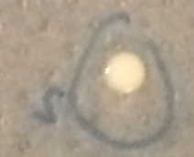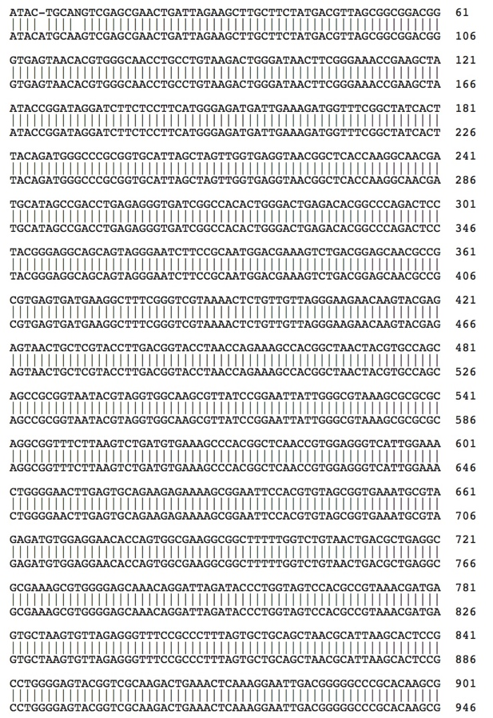 B)





C)

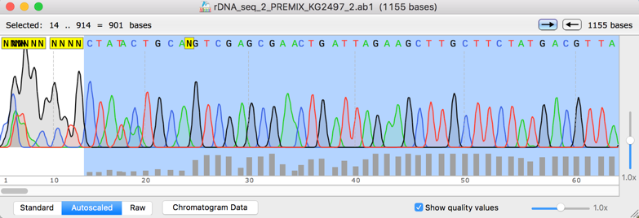

D)

**Figure 4. Identification of Bacillus Aryabhattai from the water sample at Site A.**  (A) Colony picture from the water sample. (B) Placement of the sequenced DNA from the colony and Bacillus Aryabhattai rRNA gene sequence. (C) Gel electrophoresis of 16S rRNA PCR product. (D) High quality chromatogram results. BLAST was performed for further analysis.

PCR Product

MspI

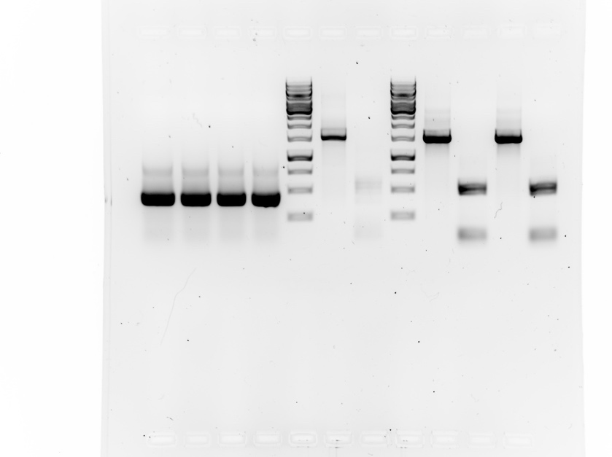**bp**

1000

250

**Figure 3. Gel electrophoresis of 16S rRNA PCR Product from Natalie and Angelicas sampled data**. This data is from the Appomattox river and was the only viable data from our experiment that showed 250+ base pairs. The darker lines show every 1000th and 1500th bp. Our PCR Product was shown mostly at the 1250th base pair.