Natalie Wood
Shanyia Chandler
11/22/19

7000 years of cosmetics, 7000 years of cancerous cells?

Parabens have been linked to binding to estrogen receptors possibly causing Carcinogenesis. We want to understand if the length of the carbon chain can affect the parabens ability to kill bacteria as well as becoming a safer chemical property in cosmetics. The brominated parabens were synthesized with varying esters while being analyzed for minimum inhibitory concentration. The results consist of an overall high percent yield of 20.8%that will present how impure the product is with the present bacteria. The longer the carbon chain the better the brominated paraben is at killing bacteria. We recommend further research to observe the most effective ester chain that can result in parabens ability to bind to estrogen receptors.

Introduction

Parabens have been shown to be a key ingredient in the cosmetic and hair industry. Products like lotion, deodorant, and shampoo contain parabens to act as preservatives and are used in a wide range of products to contribute their antimicrobial properties. They have inhibitory effects on microbial membrane transport, mimicking estrogen that is binding to the estrogen receptors. Parabens are classified as a series of parahydroxybenzoates with differing of ester chains. The ester chain length can be a determining factor in the antimicrobial properties of the paraben. Antimicrobial activity increases with the length of the alkyl grouping from methyl to n-buthyl ³. Interaction energy values vary depending on chain length. The paraben with the lower interaction energy is favorable, therefore, Nonylparaben is the favored ester. Nonylparabens have 9 carbons in the ester chain and because of its favorability, it can be theorized that the longer the chain the better ability of binding to a protein ¹. The longer length also aids in the antimicrobial effect, meaning the ability to kill bacteria effectively.

Cosmetic products such as lotions and deodorants that are applied topically are absorbed through the skin causing a greater chance that the parabens can mimic estrogen and bind to the estrogen receptor. Since these products are used primarily by women, the statistics of developing breast cancer increase among females ². The upper outer quadrant of the breast is the most frequent site of carcinoma due to underarm cosmetics being applied without being washed off and allows them to penetrate through the skin easily. This absorption can allow the paraben to easily bind to the estrogen receptor. There is evidence that parabens can mimic the action of oestrogen and can stimulate the growth of oestrogen-dependent human breast cancer cells in culture ². As a result of parabens mimicking estrogen by binding to the estrogen receptors, they are potentially turning on the growth hormone receptors causing a rate increase of duplicating cancerous cells. Parabens affect the structure of normal breast cancer cells allowing the growth of abnormal cells which leads to an increased risk of breast cancer ³. Although we can detect parabens in human breast material by both thin-layer chromatography (TLC) and liquid chromatography followed by mass spectrometry (LC/MS–MS), such studies cannot identify the source of the parabens because the human population is exposed to parabens through many thousands of food, pharmaceutical and cosmetic products ².

Parabens act as estrogen being able to bind to estrogen receptors. Modifying the structure of the molecule can prevent the molecule from binding and result in an increase of cancerous cells. The ester chain length has great influence on the antimicrobial properties of parabens. Parabens with shorter or unbranched side chains have less estrogen-like activity than those with longer or branched side chains ⁴. By altering the chain length, we could potentially figure out the most effective safe paraben that is still able to be antimicrobial as well as non-cancerous. Substituting next to the phenol creating two big molecules, not allowing the paraben to bind to the estrogen receptor hoping it doesn't turn off the antimicrobial properties. This study aims to create a safer paraben that still possesses anti-microbial properties that will not bind to the estrogen receptors due to substitution on the paraben. Brominated parabens are substituted next to the phenol blocking the paraben from the estrogen receptor. We are changing the ester to understand the antimicrobial change. If the parabens kill bacteria, then the trend that the carbon length is longer will possess enhanced antimicrobial properties.

Experimental
Brain Heart Infusion was inoculated (5 x 105 CFU mL-1) with Streptococcus salivarius. The resulting bacterial suspension was aliquoted (5 mL) into culture tubes and test compound (from its DMSO stock) was added to give the final concentration to be tested. Bacteria not treated with the tested 2-AI derivative served as the negative control. After sitting for 30 min at room temperature, 1 mL of each sample was transferred to a new culture tube and oxacillin was added from 128 mg mL-1water stock to give a concentration of 128 µg mL-1. Rows 2-12 of a 96-well microtiter plate were filled with 100 µL/well from the remaining 3 mL bacterial subcultures, allowing the concentration of compound to be kept uniform throughout the antibiotic dilution procedure. After standing for 10 min, the samples containing antibiotic were aliquoted (200 µL) into the corresponding first row wells of the microtiter plate. Row 1 wells were mixed 6 to 8 times then 100 µL was transferred to row 2. Row 2 wells were mixed 6 to 8 times, followed by a 100 µL transfer from row 2 to row 3. This procedure was repeated to serially dilute the rest of the rows of the microtiter plate, with the exception of the final row, to which no antibiotic was added. The plate was then sealed with GLAD Press n’ Seal®and incubated under stationary conditions at 37 °C. After 16 h, minimum inhibitory concentration (MIC) values were recorded as the lowest concentration of antibiotic at which no visible growth of bacteria was observed.
2,6-dibromo-4-methylphenol
P-cresol was weighed to 2.99 grams and dissolved in 5 mL of glacial acetic acid then 2.1 mol equivalents of pyridinium tribromide was added by funnel. In a 100 mL round bottom flask, reagents, p-cresol, acetic acid, and pyridinium were added then the funnel began to heat up in a heating mantle at reflux for 30 min. The reflux was lifted off the heat and cooled to room temp. Meanwhile, approximately 50 mL of 0.5 M HCl was added to an Erlenmeyer flask and cooled in an ice bath with a stirring rod on the heating mantle while stirring. Once cooled, the reaction solution was added dropwise to the cold HCl until a white precipitate persists on the acidic aqueous solution with the remainder of the reaction solution added after. The precipitate was vacuum filtered until dry and the mass of the beaker was recorded as well as the product which was transferred to the tarred beaker with a percent yield calculated once 2,6-dibromo-4-methylphenol became dry. The crude material was then purified by flash chromatography (typically 20-50% EtOAc in Hexanes) to provide the product as a white solid (7.45g, 32.4%). The product showed in GC-MS m/z 264, both Br weighing 79 [(m+H)+; calculated mass for C7H6OBr2+: 264 amu].

2,6-dibromo-4-bromomethyl phenol
2.084 g was dissolved in a 50 mL of chloroform in a round bottom flask. 1.05 mole equivalents of N-bromosuccinimide was added slowly to the round bottom and placed under UV light for 7 days. The benzylic bromination reaction solution was added to a 125 mL separatory funnel and rinsed with 5 mL dichloromethane. The organic layer was washed in 3 stages with 50 mL portions of 1 M hydrochloric with a brine wash performed after the washes to remove cloudiness. The organic layer was poured into a 125 mL Erlenmeyer flask and dried with magnesium sulfate and filtered into a tared 100 mL round bottom flask. The solvent was removed under a vacuum using a Rotary Evaporator and the mass of the flask as well as the dried product was recorded calculating the percent yield. The crude material was then purified by flash chromatography (CDCl3).

4,6-dibromo-4-hydroxymethyl
Sixteen mL of acetone and 8 mL of HCl was added to the crude 2,6-dibromo-4-bromomethyl phenol in a round bottom flask to set for 7 days. The reaction was then poured into a separatory funnel and 75 mL of ethyl acetate was added and shaken to extract the product into the organic layer. The organic layer was washed with three separate 25 mL portions of deionized water and after was poured into a 125 ml Erlenmeyer flask and dried with magnesium sulfate until the solid tumbles freely. The solution was filtered through fluted filter paper into a tared 250 mL round bottom flask and the solvent was removed under a vacuum using a Rotary Evaporator. The flask and dried product, 4,6-dibromo-4-hydroxymethyl, were weighed as well as the percent yield. With the 1 mL of solution a TLC was analyzed and run on a silica gel plate by eluting the sample with 25% ethyl acetate in hexanes. Three mL of ethyl acetate was added to the 2,6-dibromo-4-(hydroxymethyl)phenol and one hundred mL of slurry was added to the silica gel with 20% ethyl acetate/hexanes to the column. The solution was added dropwise onto the silica/sand surface and two hundred mL of 20% ethyl acetate/hexanes was poured into the column. Liquid was collected in the test tubes and once the liquid reaches the sand, 300 mL of 30% ethyl acetate was added then repeating the step with 200 mL of 50% ethyl acetate. A silica gel plate was spotted with the solution from even tubes 2-30 then the plate was eluted with 20% ethyl acetate/hexanes with the TLC plate observed under the UV light. Test tubes 20-26 were poured into a round bottom flask and kept for the following lab.The product is white solid (2.207g, 86%). 1H NMR (DMSO, 60MHz) Delta 9.768 (s, 1H), Delta 7.509 (s, 2H), Delta 4.6 (s, 1H), Delta 4.445 (s, 2H).

2,6-dibromo-4-hydroxymethylphenol
Three grams of purified 2,6-dibromo-4-(hydroxymethyl)phenol was dissolved in acetone. One and a half equivalent of 2.0 M Jones reagent was added dropwise and stirred for an hour. In a separatory funnel 100 mL of ethyl acetate was added and the organic layer was washed in three 50 mL portions of deionized water then the products were dried with magnesium sulfate and filtered out with the product placed in a round bottom flask removing the solvent using the Rotary Evaporator. Mass was 2.207 g with a percent yield of 86.143%. Melting points ranged from 239-250 Celcius.

3,5-dibromo-4-hydroxybenzoic acid
In a 10 mL round bottom flask, approximately 300 mg of 3,5-dibromo-4-hydroxybenzoic acid, 1 mL of heptanol, and 5 drops of H2SO4 were added and refluxed for an hour. The material was then purified by flash chromatography (typically 10% EtOAc in Hexanes). To perform the MIC assay, a 96 well plate was prepared for the positive control which was butyl paraben and negative control which was the inoculum. One mL of the inoculated broth was pipetted into a sterile test tube. The sample tested was added making the solution have a concentration of 256μg/mL. Solution was then vortexed. 200μL of both the positive and negative solution was put into the top rows of the well. Every well underneath was filled with 100μL of broth. 100μL of each row was taken from the positive control and was mixed 6 times. The 100μL from the previous well was mixed into the next well. These steps were repeated down each column for the positive and negative controls. Once the dilution was complete the plate was sealed and put into a plastic container with a damp paper towel and placed in an incubator at 37°C for 16 hours. The product showed in GC-MS m/z 294, both Br weighing 79 [(M+H)+; calculated mass for C7H4Br2O3+:264 amu]. 1H NMR (DMSO, 60MHz) Delta 8.122 (s, 2H), Delta 6.468 (s, 1H), Delta 4.393 (s, 2H), Delta .0932 (s, 1H). IR (CDCl3) 3487, 3373, 2958, 2928, 2857, 1700, 1685, 1588, 1560, 1555, 1476, 1473.

Results
Scheme.

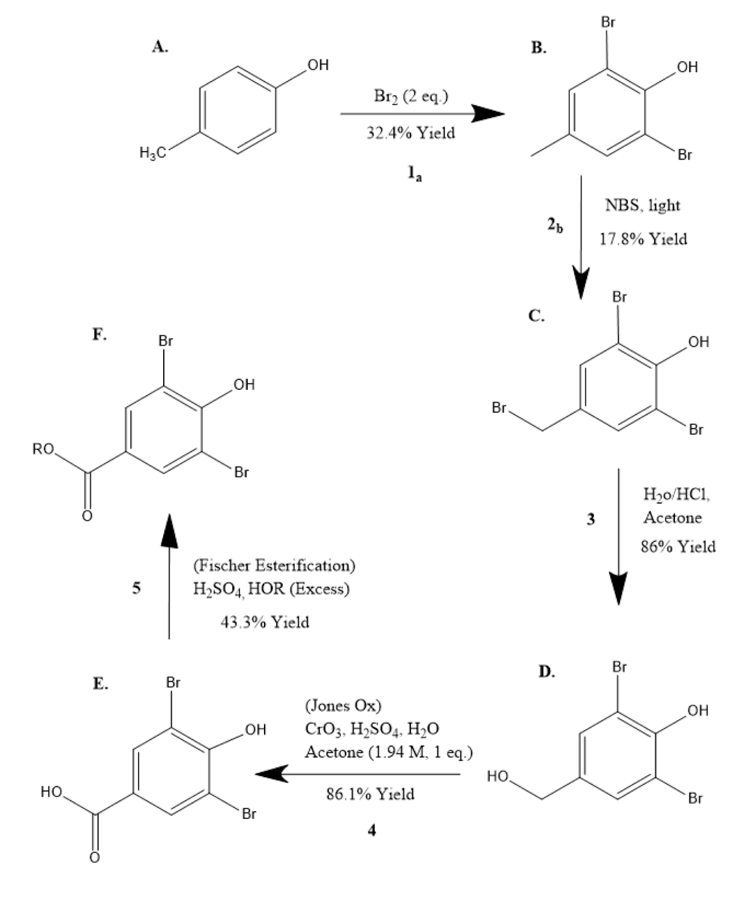

Table.

Compound | MIC (μg/mL) | Positive Control | MIC (μg/mL)
1. Methyl | >256 | a. Me Paraben | >256
2. Ethyl | >256 | b. Et Paraben | >256
3. Propyl | >256 | c. PrParaben | >256
4. Butyl | 128 | d. BuParaben | 128
5. Pentyl | 32 | e. isoBuParaben | 128
6. Hexyl | 8 | f. Erythromycin | 0.125
7. Heptyl | 2 | g. Amphicillin | 2
8. Octyl | 1 | - | -
9. Isobutyl | 128 | - | -
10. Secbutyl | 128 | - | -
11. Isobutyl | 64 | - | -

It was found that after synthesizing each paraben our overall percent yield was 20.8%. This means that errors occurred at Scheme reactions 1a, 2b, and 5 resulting in low percent yields. The highest percent yields are found between Scheme C and D as well as between D and E. After various parabens were tested against S. salivarius, antimicrobial activity was determined by finding the MIC using dilution assays. We were able to compare the SAR between ester chain length and antimicrobial properties of brominated parabens. Esters containing longer carbon chain lengths like Compounds 6,7, and 8, in Table 1 had the greatest increase in bacterial growth with low MIC values, with Octyl showing the greatest increase overall. Compounds 1,2 and 3 (methyl, ethyl, and propyl) had high MIC results of >256 which demonstrated a very little increase in the antimicrobial properties. The positive controls were meant for comparison between the compounds and it was found that the paraben with the shorter carbon chain length was not as effective in killing bacteria.
In conclusion, we have produced with our synthesized parabens effective antimicrobial properties. The brominated paraben substitutions resulted in the lack of binding to the estrogen receptor and allowed the carbon chains to lengthen which led to improved antimicrobial activity. The lack of binding and lengthening of carbon chains resulted in a decrease in the activation of cancerous cells. Future studies include testing on mice to determine if various brominated parabens will bind to the estrogen receptor in a viable host to determine the antimicrobial property effects. It has been shown that the Octyl carbon chain has increased antimicrobial effects and can be vitalized as a substituted paraben in various cosmetic products.

¹Byford, J.; Shaw, L. Drew, M. Pope, G. Sauer, M. Darbre, P. 2001. Oestrogenic activity of parabens in MCF7 human breast cancer cells. Journal of Steroid Biochemistry & Molecular Biology. 49-60.

²Darbre, P. 2003. Underarm Cosmetics and Breast Cancer. Journal of Toxicology.23, 89-95.

³Darbre, P. Aljarrah, A. Miller, W. Coldham, N. Sauer, M. Pope, G. 2004. Concentrations of Parabens in Human Breast Tumours. Journal of Applied Toxicology. 24, 5-13.

⁴Hussein, S. Muret, P. Beard, M. Makki, S. Humbert, P. 2007. Assessment of principal parabens used in cosmetics after their passage through human epidermis-dermis layers (ex-vivo sudy).Experimental Dermatology. 16, 830-836

