Investigating the diversity of microbes on a surface from Buffalo Creek and Appomattox River

Natalie Wood

Biology 250

Spring Semester 2017

Introduction

Pollution is an ongoing problem. Phosphorus and nitrogen are the most common pollutants that have been affecting creeks and rivers. Some other common types of pollution are road run-off, land use change (Carpenter, 1998), and contaminated sediments with polycyclic aromatic hydrocarbons(PAHs) (Pratt, 2012). In Farmville, the run-off from farm animals affects the pollution levels of the surrounding waters such as Buffalo Creek and the Appomattox River. Phosphorus and nitrogen are known to pollute the water quality and the eutrophication, thus studying the effects of pollution in water is important. Nonpoint sources such as run-off from farms are looked at to determine the change of pollution (Carpenter, 1998). This can affect microbial diversity in water because phosphorus and nitrogen contain different numbers of microbial types and when in contact with the water, phosphorous and nitrogen can cause the increase of microbial diversity. Contaminated sediment with PAHs is commonly spread in aquatic ecosystems (Pratt, 2012). The most distinctive observation with PAH contamination is with high microbial activity (Pratt, 2012).

Overall, these factors for pollution are increasing at a high rate and need to be changed. With the right study and data, there can be a solution on how to decrease water pollution. This experiment aimed to test the difference in microbial diversity in both Buffalo Creek and Appomattox River. It was hypothesized that Buffalo Creek would contain greater microbial diversity on the sampled surface than Appomattox River because Buffalo Creek is closer to run-off from farms. The goal of this study was to see whether Buffalo Creek or Appomattox River contains the greatest microbial diversity.

Materials and Methods

***Site and Sample Collection***

Three samples were collected from each site (Buffalo Creek and Appomattox River) by swabbing a submerged rock with a sterile swab dipped in sterile water. Each swab was then taken to a lab and swabbed onto an agar plate. The plates were then incubated at 30°C for 5 days while being checked on for the first 18-24 hours.

***Genomic DNA extraction***

After 7 days of the bacterial plates being incubated, genomic DNA was extracted. One colony was selected from each site to perform DNA analysis. A microcentrifuge tube was labeled for each of the colonies and 300uL of microbead solution was added to each tube. The colony was collected with a sterile toothpick by sliding it across the colony. The toothpick was then carefully put in the sterile labeled tube and swirled around for 15 sec. The solution and the cells were then transferred to a microbead tube. Fifty microliters of solution MD1 was added to each microbead tube then heated in a water bath to 65°C for 10 min. The microbead tubes were then vortexed horizontally on full speed for 10 min and centrifuged at 10,000 x g for 30 sec. After 30 sec, the supernatant was transferred to a clean 2 mL collection tube and 100uL of solution MD2 was added and vortexed for 5 sec then incubated at 4°C for 5 min. The tubes were centrifuged at room temperature for 1 min at 10,000 x g. The entire volume of the supernatant was transferred to a clean 2 mL collection tube that was shaken and then 900uL of solution MD3 was added and vortexed for 5 sec. Seven hundred microliters were loaded into the spin filter and the tubes were centrifuged at 10,000 x g for 30 sec then the flow through was discarded. The remaining supernatant was added and the previous step was repeated. Three hundred microliters of solution MD4 was added and the previous step was repeated. The tubes were then centrifuged again for 1 min at 10,000 x g then were put in the spin filter in a new 2 mL collection tube, after which 50uL of solution MD5 was added to the center of the white membrane. Then it was centrifuged at 10,000 x g for 30 sec at room temperature. Then everything was incubated in a fridge.

***PCR and Gel electrophoresis***

After 7 days, reactions were set up for each colony using PCR and the tubes were kept on ice during set up. The PCR tube had 15uL of nuclease-free water, 25uL of one*Taq* 2X Master Mix and 2.5uL of primer mix added. The Primer Mix contained DNA polymerase, deoxynucleotides, and primers to effectively amplify the PCR substance, which were -5’ GAGTTTGATYMTGGCTC-3’ and -5’ URGYTACCTTGTTACGACTT-3’, within the samples. The pipette was used to mix the solution. Seven and a half microliters of the genomic DNA was added to the tubes and put into a PCR machine to begin thermocycling. The tubes were then incubated at 95°C. Two hundred and fifty microliters of binding buffer was added to a labeled 1.5 mL tube. Fifty microliters was added to the tube with the binding buffer and was mixed with the pipette. The mixture was added to a spin filter column and spun for 1 min at 13,000 rpm (16,000 x g). Two hundred microliters of DNA wash buffer was added to the spin filter column and spun for 1 min at 13,000 rpm. The previous step was repeated. The spin filter column was transferred to a labeled 1.5 mL tube and 30uL of sterile water was added to the center of the white filter and spun for 1 min. A 20uL pipette was used for the DNA concentration collection and measurement using a nanodrop. The PCR products and a tube of MspI enzyme, which is a restriction enzyme that cuts DNA out at CCGG, were mixed together with tango buffer to start a reaction while using a pipette to mix and then the solution was incubated for 45 min at 37°C. Five microliters of 5X loading buffer was added into each tube. The electrophoresis chambers were filled and covered in the gel with 1X TAE buffer. The gel chambers were filled with 4 samples starting with clean PCR then MspI, clean PCR, and MspI. The power was turned on for 30 min and then the PCR product and MspI data was collected in a gel electrophoresis.

***DNA sequencing and BLAST analysis***

The purified PCR product from the Appomattox River colony was submitted for DNA sequencing. Snap Gene Viewer was used to visualize the DNA sequence results which showed red(T), black(G), blue(C) or green(A) peaks that indicated where the identified base pair was. BLAST (basic local alignment search tool) takes the chromatogram sequence and aligns the searched sequence to different sequences that will then show a list of the most compatible sequences and provide the strains the bacteria contains.

Results

***Diversity:***

Each site had similarities and differences when it came to color and form. As shown in Figure 1 site (A), there were 3 colors observed from the Appomattox River. The same 3 colors were shown in the plates from Figure 1 site (B), but on each plate there were different amounts of each collective color. When it came to form of bacteria in Figure 1, circular, Punctiform, and filamentous were mostly observed, but Buffalo Creek showed an irregular form which Appomattox River did not show. Most of the blotches had both a convex and flat elevation.

***Abundance:***

On each of the plates, there were too many numbers of colonies that could not be correctly counted. There was a high abundance of each colony on each plate.

After performing the genomic DNA extraction, the Nanodrop was used to find out the kind of DNA of the bacteria, and what was received was 260/280= .85 (ng/uL) from Appomattox River while Buffalo Creek received 260/280= 1.77 (ng/uL). This data was then taken to a lab to be purified and digested, and the Nanodrop was used again and showed 260/280= .08 (ng/uL) and 260/230= .44 (ng/uL) from Appomattox River. Buffalo Creeks results were 260/280= 8.49 (ng/uL) and 260/230= .80 (ng/uL). Buffalo Creek did not get a result in a Gel electrophoresis, but as shown in Figure 3, Appomattox River got results that unfortunately did not show much feedback when it came to sequencing or PCR product, but the data did show a base pair at 1500, and with that got a high quality chromatogram shown in Figure 2. There was an alternative sample that was used for identification as shown in Figure 4. From the alternate identification, 900bp was used and ran through BLAST to find stains of the bacteria found. The top 5 strains came up mostly of *Bacillus Megaterium* except for thetop strain came out as *Bacillus Aryabhattai* shown in Figure 5.

Discussion

It was hypothesized that Buffalo Creek(10B) would contain greater pollution, thus causing a greater microbial diversity on the sampled surface (rock) than the surface from the Appomattox River(10A). When observing the plates, 10B showed more diversity of shapes than 10A as shown in Figure 1, thus confirming the hypothesis. It was said in one of the articles that the highly-contaminated sediment in their experiment showed high levels of microbial activity (Pratt, 2012) which gave us more thought to our hypothesis and question.

The thought is that through 14 lab sessions, there was an error that occurred which resulted in a lack of data. The belief was the fault happened when mixing products and messing up a few steps in the process. A result that was received was in the PCR Product and MspI which was not enough data and an alternative sample was used for identification. The *Bacillus* *Aryabhatta* strain was the identified strain as shown in Figure 4 from the alternative sample which is found in soil (Yadav, 2011) and shown to promote the growth of soybean (Park, 2017). *Bacillus Megaterium* which was the second strain found in the top 5 was shown to be a cytochrome P450BM3 mutant that was used for modifications of umbelliferone, which is a natural product that absorbs ultraviolet light at several wavelengths (Chu, 2017).

One limitation to the study was not using the same type of rock when sampling which could be more helpful when it comes to getting exact data. Another limitation was the lack of data. If more data was available, different/more results would have been found and been a better comparative experiment. The last limitation was that, when the sampling process was happening, the bottom of the rock that was swabbed had soil on it and was accidentally a part of the sample. The mistake was sampling the soil when the comparison of pollution was with water and not soil, so for better study instead of comparing water there can be a comparison for soil or water.

In conclusion, because there was more than 1 colony that was detected in the sequence, 10A showed a lack of usable data shown in Figure 2. There was not any data recognized for 10B, however 10A did manage to get PCR and Msp1 results as shown in Figure 3, thus proving the hypothesis.

Figures and Tables



**Figure 1.** **Site (A) The percentage average of both color and shape of colonies from the Appomattox river**. There were so many colonies found in each plate that the percentages were added and divided by the plate number to get their average. **Site (B) The percentage average of both color and shape of colonies from the Buffalo creek.** The same process was done to figure out the average in site B. An irregular shape was found only in site B and not site A resulting in only a yellow percentage in site B.

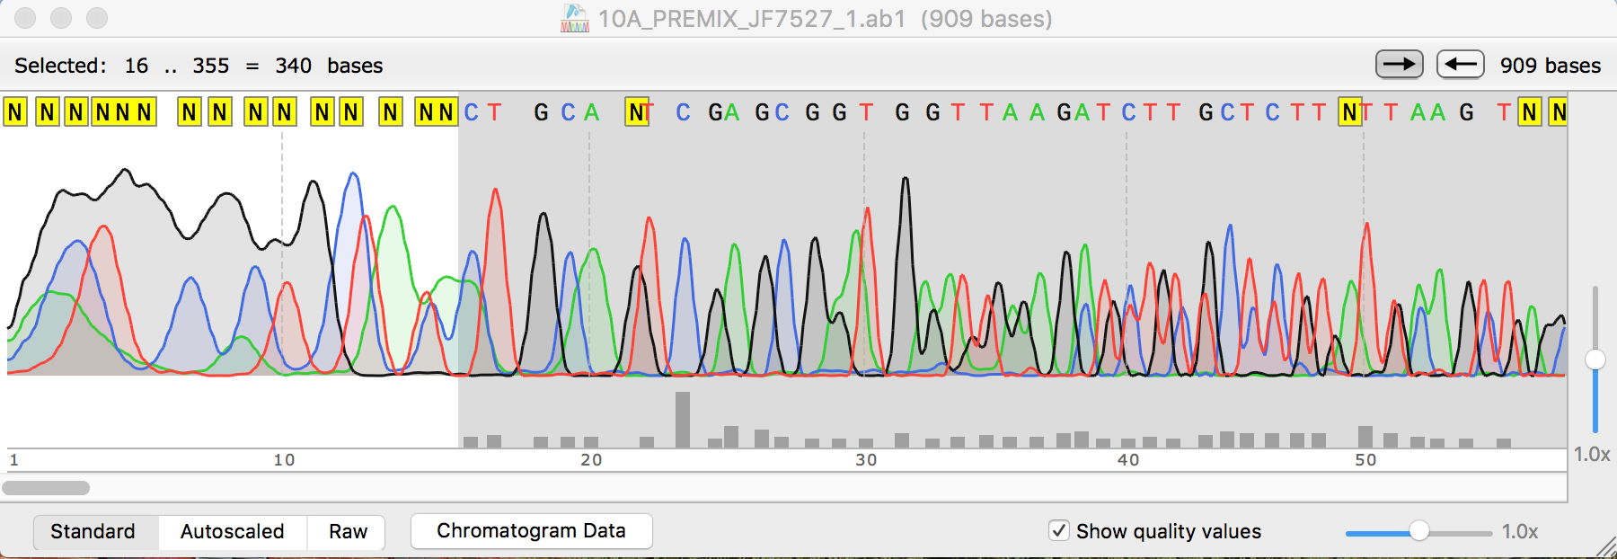

**Figure 2.** This is a high quality chromatogram.

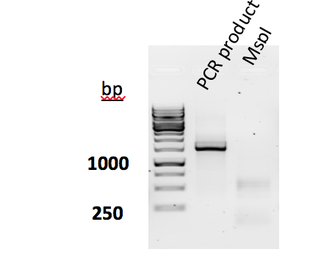

**Figure 3. Gel electrophoresis of 16S rRNA PCR Product from the sampled data**. This data is from the Appomattox river and was the only viable data from our experiment that showed 250+ base pairs. The darker lines show every 1000th and 1500th bp. Our PCR Product was shown mostly at the 1250th base pair.

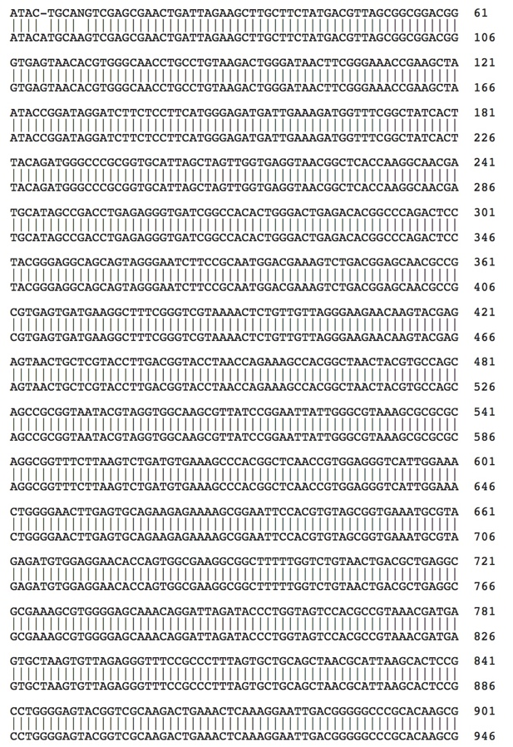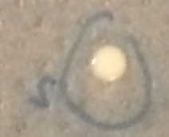

1. B)



C)

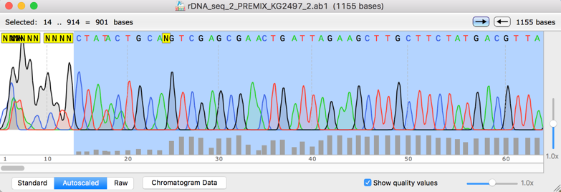

D)

**Figure 4. Identification of Bacillus Aryabhattai from the water sample at Site A.**  (A) Colony picture from the water sample. (B) Placement of the sequenced DNA from the colony and Bacillus Aryabhattai rRNA gene sequence. (C) Gel electrophoresis of 16S rRNA PCR product. (D) High quality chromatogram results. BLAST was performed for further analysis.

**Figure 5. The percentages of identification of the top 5 strains from Dr. Shanle’s bacteria sequence**. The bacteria were sequenced and put through BLAST. BLAST gave the top 5 strains which came out to be Bacillus strains. All were which 99% identified in the sequence.

References

S.R. Carpenter, D. Ludwig, W.A. Brock. "Management of eutrophication for lakes subject to

potentially irreversible change." Ecological society of America (1999).

Chu L. L., Pandey P. R., Lim N. H., Jung J. H., Thuan H. N., Kim T., Sohng K. J. 2017. Synthesis of umbelliferone derivatives in *Escherichia coli* and their biological activities. Journal of biological engineering. **11:15**

Park Y., Mun B., Kang S., Hussain A., Shahzad R., Seo C., Kim A., Lee S., Oh K., Lee D., Lee I., Yun B. *Bacillus aryabhattai* SRB02 tolerates oxidative and nitrosative stress and promotes the growth of soybean by modulating the production of phytohormones. Journal PLOS ONE. **1-28.**

Pratt B., Riesen R., Johnston C. 2012. PLFA Analyses of Microbial Communites Associated with PAH-Contaminated Riverbank Sediment. Environmental microbiology. (**64): 680–691.**

Yadav, S., Kaushik R., Saxena A., Arora D. 2011.Genetic and functional diversity of *Bacillus* strains in the soils long-term irrigated with paper and pulp mill effluent. The journal of General and Applied Microbiology. **(57): 183-195.**