Comparison of Periphyton in the Appomattox River and Buffalo Creek
Becca Aylor, Megan Curry, Aliyah Panizzi, Natalie Wood

Longwood University
201 High St
Farmville, VA 23909

Abstract
The Appomattox River and Buffalo Creek are major bodies of water in Farmville, Virginia. They are greatly influenced by the surrounding aquatic life that can affect the water quality, like periphyton diversity. Three days were selected for sampling from the Appomattox River and Buffalo Creek. During these collection days, items such as periphyton brush, specimen containers, and a dissolved oxygen sensor were used to collect data. Based on the results of the study we conducted in Prince Edward County, it was suggested that the population and diversity of periphyton can be determined by factors like temperature, oxygen, light, and flow of location. In addition to our findings, further experimentation can be examined by making a more accurate study consisting of bigger collections, longer testing periods, and various bodies of water not only in Virginia but the US. This could improve aquatic life and better educate scientists in this field of study.

Key Words
Author keywords: Abundance, Diversity, Diatoms, Species Richness, Temperature, Oxygen, flow location

Introduction
This study was conducted to observe the differences between two major bodies of water in Farmville Virginia and its periphyton effects on aquatic life in Prince Edward County. Periphyton are organisms that attach to objects located above the bottom sediments in the water, serving as a food source to many organisms such as tadpoles, invertebrates, and various fish.
When highly abundant, Periphyton can negatively affect water, habitats, biodiversity, and degrade the recreational aesthetic (Hoyle et al. 2017). This being said, although Periphyton can serve as a nutrient to certain organisms, its high abundance can affect the surrounding bodies of water. Factors such as temperature, oxygen, light, and river flow can influence the abundance of periphyton (Biggs et al. 1998). These factors were conducted and tested over the course of 3 weeks, by sampling rocks from Buffalo Creek(BC) at Lancer Park and the Appomattox River(AP) located off of Interstate 460 in Farmville, Virginia. Run and riffle were also considered as part of the factors that could contribute to periphyton diversity.
It was hypothesized that the population and diversity of the periphyton found will be greater in the Appomattox River than in Buffalo Creek. This could be because BC is a tributary that runs into AP and AP has a larger surface area that can easily absorb heat from the light. Which means light is a considerable factor as well as tributaries.

Materials and Methods
Sample Collection
Periphyton samples were collected from rocks in Buffalo Creek (BC) and Appomattox River (AP) in Farmville, Virginia. Buffalo Creek is located behind Lancer Park and Appomattox River is located off interstate 460 near High Bridge Trail. Rocks were chosen from both bodies of water, each from a run and riffle location. These samples were collected during a three week period on three separate days throughout September – October 2017.
The first round of samples from Buffalo Creek and the Appomattox River were collected on September 23. The water depth was measured where each rock was collected with a meter stick in cm. A rock was then scraped on the top and bottom on a 5.08cm by 2.54cm area, with the correct periphyton brush. The brushed area along with the periphyton brush were rinsed into the specimen container using spray bottles containing water from Buffalo Creek and the Appomattox River. Each container was then filled with approximately 30 milliliters of water.
Each step was then repeated for the run and riffle of each collection site. After completing each collection, all samples were stored in the lab in a slightly shaded area for approximately three days until observation, with the tops slightly ajar giving any possible micro-organisms the oxygen needed for survival.
The second day of collection was on September 30th at Buffalo Creek for samples 2 and 3. Due to technical constraints, Buffalo Creek was the only site sampled that day, making sure to repeat previous steps. The third and final day of collection was on October 3rd, on this day samples 2 and 3 were obtained from Appomattox River. These collections, however, were placed in the EEC for 7 days until further observation.
Twelve samples in total were collected from all three collection days, having six from BC and six from AP. For the samples 2 and 3 of AP and BC, a dissolved oxygen sensor was used to measure the oxygen and temperature levels of the water.

Identification of Periphyton
A compound microscope was used to identify all micro-organisms, using three slides per sample. A micropipette set at .05 microliters was used to place a droplet of specimens from the container onto the slides for observation. Organisms were then identified to the genus level of classification with the assistance of field guides and identification keys. The abundance of each genus was counted or estimated, having a few unidentified species that were recorded as such.
.
Data analysis of collected samples
After all data was recorded and observed, the quantitative data was analyzed using the JMP software at Longwood University. This software analyzed the given numbers and computed the mean, standard error, and P-value for comparison between bodies of water, flow location, temperature, oxygen, species richness, water depth, and diversity. These means and standard errors were used to develop graphs and to further understand the significance in P-value. The P-value is the importance of the study after consideration that there was not enough evidence to get any reliable results other than differences in significance.

Results
As mentioned previously, the goal of this experiment was to determine which body of water contained the higher amount of periphyton diversity and population when comparing the Appomattox River and Buffalo Creek. Including factors such as run and riffle.
Species Identification
After days of observations, the total number of species found were approximately 42 including 9 unidentified species (Table.1). Out of those 34 identified species, the 3 most abundant species were Navicula, 10 that were found in only Appomattox, Paramecium, 15 were found in both bodies of water, and Cladophora, 31 were also found in both bodies of water. Those were our initial results from the EEC lab time, but the results we used to obtain our graphs were oxygen, temperature, diversity, and species richness. The mean, standard error, and P-value for each result were calculated using the T-test. The overall purpose of performing the T-test was to find the P-value because it states whether or not there is a significance between the quantitative data collected from each result. Because there is so little data found, the only observation that we could form is the differences in significance.
Comparisons between bodies of water
For species richness, the T-test of the Appomattox River showed, mean + SE:7.83 + 1.78, for Buffalo Creek it showed, mean + SE:4 + .632 (fig.1). The P-value showed that P=.0433 < .05, this means that because P<.05 there is a significant difference between AP and BC when it comes to species richness. For diversity between bodies of water, for Appomattox showed, mean + SE: 1.175 +0.117 and BC showed mean + SE: 1.014 + 0.122 (fig. 5) For flow location, the Runs test showed, mean + SE:6.833 + 1.887, but for Riffle it displayed, mean + SE:5 + 1.304 (fig.2). The P-value was determined to be P= .7888>.05 which means that between the flow location there was no significance.
For temperature and oxygen levels of AP, mean + SE:14.65 + .2021 and mean + SE:82.55 + .3175, for BC mean + SE: 16.85 + .0289 and mean + SE:9 + .0346 (fig. 3 & fig.4). The P value for these were P=.0001 and P=.0001. The only significant factors for bodies of water were temperature and oxygen.
Comparisons between flow location
For the water depth in run and riffle, there was a mean + SE:25.823 + 3.734 and mean + SE:14.342 + 2.960. Water depths P-value was P=.8326. The P-value for water depth, temperature, and oxygen between flow location were P=.0367, P=.6745, and P=.9875. Between all three, water depth was the only factor that was significant.

Discussion
Through our experiment, we could not conclude much about the movements of periphyton or what environmental factors affect them the most. We did although, support our idea that Appomattox River had a greater biodiversity than Buffalo Creek resulting from our p-values for water depth, temperature, oxygen and their significance. It can be found that biofilm growth is mainly controlled by light, temperature, velocity, etc (Wilhelm 2015). This could give some evidence to the notion that these components could affect the diversity and population of periphyton.
We don’t know this for certain, but we can also assume that one of the reasons that AP had a higher diversity is because BC is a tributary that flows into AP. Knowing that BC is highly diverse in its aquatic life, it could provide the Appomattox River with not only its own diversity but with that of Buffalo Creek as well. Therefore. the high species richness of the Appomattox River could be due to Buffalo creek’s contribution to habitat heterogeneity (Algarte et al. 2017).
We, as scientists, could make the assumption that depending on the hospitable environment, periphyton could possibly decide to thrive on any surface in which they land. Periphyton tends not to grow on plant species because of the plants need to consume all of the available resources. Plants, native or non-native, limit the growth of periphyton ultimately making them a limiting factor (Grutters et al 2017). Based on other experiments, it could be possible that other macrophyte species in the water could be a main predictor in species richness of periphyton (Algarte et al 2017). Conversely, a study performed by scientists at the National Institute of Water and Atmospheric Research in New Zealand, it was concluded that periphyton abundance and how they grow can be directly attributed to sediment mobility. Their results showed that sediment mobility is the best determiner of periphyton abundance and all other factors are only relevant when the frequency of removal is low (Hoyle et al. 2017).
The overall conclusion based on our findings during this experiment is only a small set of answers to a wider-range of questions. In order to answer those questions, further tests would need to be conducted and performed in the right manner. Testing different bodies of water, having a higher sample collection, and running many tests would help to accurately determine the effects of periphyton on its surrounding environment.

Acknowledgements
We would like to thank Dr. Lehman for all of the help and outside work she did with us. We would also like to thank our families and close friends for their support.

Literature Cited

Algarte, V. M., T. Siqueira, V. L. Landeiro, L. Rodrigues, C. C. Bonecker, L. C. Rodrigues, N. F. Santana, S. M. Thomaz, and L. M. Bini. 2017. Main predictors of periphyton species richness depend on adherence strategy and cell size. Plos One 12.
Grutters, BMC. E.M. Gross, E. van Donk, E.S. Bakker, May 2017. Periphyton density is similar on native and non-native plant species. Web of Science 62:906-915
Hoyle, J. T., C. Kilroy, D. M. Hicks, L. Brown. 2017. The influence of sediment mobility and channel geomorphology on periphyton abundance. Freshwater Biology 62:258-273.
Wilhelm, L., K. Besemer, L. Fragner, H. Peter, W. Weckwerth, and T. J. Battin. 2015. Altitudinal patterns of diversity and functional traits of metabolically active microorganisms in stream biofilms. The ISME Journal 9:2454-2464.

Figure/Table Legends
Fig. 1 Species richness periphyton found attached to rocks in Appomattox River and Buffalo Creek. The values shown represent the standard error (error bars) and mean (blue bars) for both the Appomattox River and Buffalo Creek. The mean and standard error for species richness in Appomattox River was analyzed and showed mean + SE: 7.83 + 1.78 . The standard error and species richness for Buffalo Creek’s species richness was mean + SE:4 + .632.
Fig. 2 Species richness of periphyton between flow location in Appomattox River and Buffalo Creek. The values shown represent the standard error and mean for the quantitative data from both the run and riffle. The mean and standard error for AP was mean + SE:6.833 + 1.887. The mean and standard error for BC is mean + SE:5 + 1.304.
Fig. 3 Temperature differences between Appomattox River and Buffalo Creek. The values shown represent the standard error and mean for the collective values of both the Appomattox River and Buffalo Creek. The standard error and mean for Appomattox River’s temperature is mean + SE:14.65 + .2021. The standard error and mean for Buffalo Creek’s temperature is mean + SE:82.55 + .3175.
Fig. 4 Oxygen levels between the Appomattox River and Buffalo Creek. The values shown represent the standard error and mean for the collective values of both the Appomattox River and Buffalo Creek. The standard error and mean for Appomattox River’s oxygen levels is mean + SE:82.55 + .3175 . The standard error and mean for Buffalo Creek’s oxygen levels is mean + SE:9 + .0346 .
Fig. 5 Comparing diversity between Appomattox River and Buffalo Creek. The values shown represent the standard error and mean for the collective values of both the Appomattox River and Buffalo Creek. The standard error and mean for Appomattox River’s diversity is mean + SE: 1.175 +0.117. The standard error and mean for Buffalo Creek’s diversity is mean + SE: 1.014 + 0.122.
Table 1. A total number of different types of periphyton Genera, in alphabetical order, found from the collected 12 samples. The numbers next to each species represents the total number of individuals found.

Figures/Tables
Figure 1
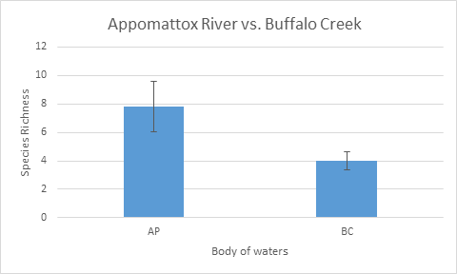

Figure 2
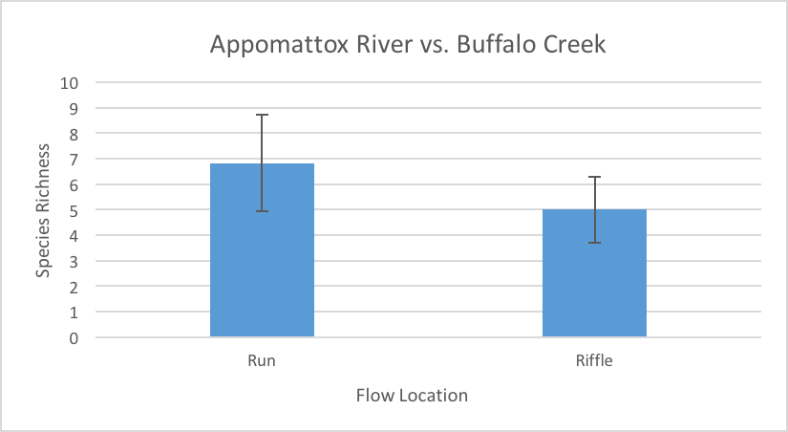

Figure 3
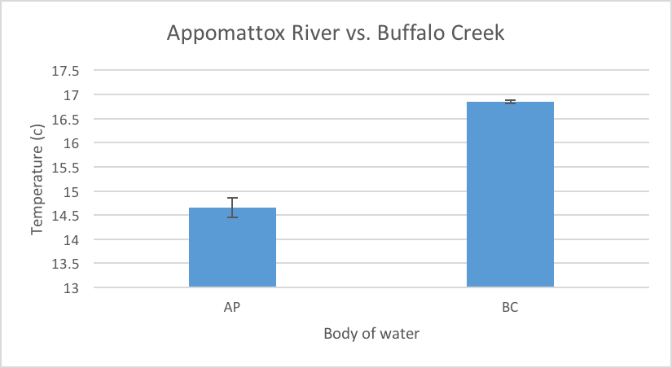

Figure 4
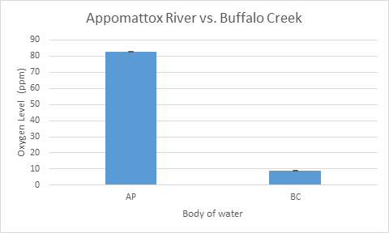

Figure 5
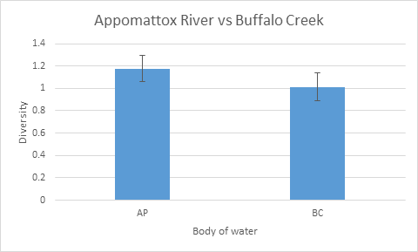

Table 1

