Comparison between various table cleaners: How well do they work?

Natalie Wood
Carrie Reaver
Katie Wyman
Brandon Hastings

Longwood University
Microbiology 305
Introduction
In today’s world there are so many different types of cleaning products out there. Whether they are home remedies from online or chemical disinfectants, everyone who uses them is asking the same question, which household cleaning will disinfect the best? People in a household want to protect their loved ones from the different types of bacteria that can grow on household surfaces. These bacteria can later be transferred to their loved ones, food, and other objects used in their home. “Escherichia coli is a common bacterium that is found in the intestines of humans and animals and also can be found in foods and the environment around you. Although there are many strains of the bacteria that are harmless, there are some strains that can make people extremely sick” (E. coli Bacteria, 2015). E. coli causes disease when the bacteria produces a toxin called Shiga toxin and these bacteria that make this toxic are referred to STEC which means Shiga toxin-producing Escherichia coli (CDC, 2019). People with a compromised immune system are especially at risk for contracting this bacterium, for example, pregnant woman, the elderly, babies, and those undergoing chemotherapy. Some ways to protect against becoming infected by E. coli is to practice good hand hygiene, cook meat thoroughly, wash fruits and vegetables when using, and wash cutting board and utensils thoroughly after cutting raw meat (CDC, 2019). Although E. coli is mainly contracted by eating a food infected with the bacteria, cutting boards that have been in contact with raw meat that has been contaminated with E. coli can live on the cutting board for a few hours to a few days depending on the environment. Between all the cleaning supplies and home remedies that claim to kill all the bacteria this study looked at a few of those options to see which ones killed the most bacteria. In a study done by Goodyear et al. (2015), they looked at how three cleaning supplies did against Escherichia coli and Staphylococcus aureus.
This study used two store bought products one of which contained bleach, sodium hydroxide and sodium hypochlorite while the other product was an EP product containing thymol. The last cleaning was a DIY remedy that consisted of club soda, TTO, and white vinegar. The results showed that bleach was the most effective cleaner on stainless steel but on a ceramic surface none of the cleaners met the minimum standard which was an 85% reduction in bacteria (Goodyear, 2015). In another study done by Rusin et al. (2008), wanted to see which surfaces of the house between the kitchen and bathroom had the most faecal coliform, coliform and heterotrophic plate count (HPC) bacteria along with what cleaning supplies and instructions cleaned the areas the best. The households were told to use their own cleaning products and clean how they normally would for the first 10 weeks. During the second 10 weeks, household cleaners Clorox Liquid Bleach, Clorox Clean-up Spray, Clorox Clean-up Dilutable, Soft Scrub Bleach, Clorox Toilet Bowl Cleanser, Tilex Instant Mildew Remover, Ultra Dawn Dishwashing Detergent, and Windex Glass Cleaner were the only products that they were allowed to clean their house with. And during the last 10 weeks they were given a specific way to clean their house using a certain chemical with a list of instructions. The results showed that the areas that had the highest contamination were in the kitchen. These spots included the sponge/dish cloth, the cutting board, the kitchen faucet, the fridge handle and, and the kitchen counters (Rusin, 2008). In another study done by Johnston et al. (2016), they looked at organic ways to clean Staphylococcus aureus on yoga mats. Used to clean the yoga mats were “Super Yoga Mat Wash”, “Grodi Yogi Yoga Mat Spray”, and a DIY spray which consisted of water, willow-bark extract, tea tree oil, and lemongrass oil. The study also used Lysol multi-purpose cleaner as a control. The results showed that the control, Lysol, was the most effective cleaner while the others proved to be ineffective (Johnston, 2016).
This study was conducted to see which household or home remedy cleaning products work best against E. coli. This is important because people want to know which products are the best when cleaning their house so they can protect themselves and their loved ones from the dangers of E. coli and other bacteria. In our study, we used three common household cleaners (Lysol spray, Lysol wipes, and 409 cleaner) along with a home remedy of vinegar. Lysol spray and Lysol wipes claim to kill 99.9% of bacteria on the packaging; 409 spray also claims to kill 99.9% of bacteria on the bottle. Vinegar is a multi-purpose item that many households have on hand. When researching DIY cleaning remedies, vinegar was a common theme among the many items that appeared in our search.
In this experiment we used Lysol spray, Lysol wipes, 409 spray, and vinegar to see which killed the most E. coli on the surface on a laboratory table. Escherichia coli was spread along the section of a table that was previously sectioned off into five sections. One for each cleaning product along with a section for the control which we did not touch. After the sections were cleaned, we swabbed each section twice and inoculated a two different plates per section and later looked back at the plates to see which plate had grown the most E. coli. Our hypothesis was that the Lysol spray would be most effective in killing the most E. coli while vinegar would be the least effective.
Experimental

Escherichia coli was isolated and inoculated nutrient agar to create a spreadable aqueous solution. A non-porous surface was disinfected with Ethanol using a cotton pad and taped off in 5 small sections on the table with sections labeled control, vinegar, 409, lysol wipes, and lysol spray. A sterile cotton pad was used to spread the nutrient broth evenly across each taped off section, waiting approximately 10 mins to let dry. A single sterile cotton pad for each treatment was evenly spread across each corresponding section in a uniform manner. Immediately after disinfection, a sterile cotton swab was used per treatment to swab the area and smeared onto the nutrient agar plate. For each treatment a second trial, using the cotton swabs, was collected onto the plates with a total of 9 plates including the control which was swabbed once. The plates were then incubated at 37 °C with 24 and 48 hour result checks.

Results
Of the four cleaning products tested, all the plates showed microbial growth after 5 days, but only 2 showed fast growth within 24 hours of incubation. After testing on an EMB plate, we found that E. coli was not grown on any plates, including the control. After 24 hours of incubation, 409 had 2 colonies on plate one and no colonies on plate 0, while Lysol showed a continuous streak of growth on one plate and no growth on the second plate. After 5 days of incubation microbial growth was seen on all plates. The control had 21 colonies, 409 had 2 colonies, Lysol wipes had 3 colonies, Lysol spray had a continuous streak of growth, and vinegar had 57 colonies. While the Lysol spray plate did show microbial growth, it was uncountable growth because of differences in plating technique.
Discussion
In our evaluation of Lysol spray, Clorox wipes, all-purpose 409 cleaner, and vinegar, we found inconclusive results due to probable contamination in the ethanol we used to clean our test surface. Therefore, we were unable to draw any conclusions from our experiment and could not assess the effectiveness of our products against E. coli. Nonetheless, the different cleaners performed differently against whatever contaminants were in the ethanol, thus indicating that there are discrepancies between the disinfecting abilities between each of the four products we tested. In order to best advise the public on how to best protect themselves against common household bacteria, further work is required to elucidate the abilities of various common cleaning products.
As holistic approaches to health are becoming more popular among consumers, it is important to assess how well home remedies disinfect surfaces compared to popular store-bought or lab-grade cleaners. Especially for individuals who are sensitive to harsh chemicals or those with personal preference for home remedies, studies evaluating more non-traditional cleaners, such as vinegar in our experiment or the organic DIY yoga mat cleaner study by Johnston (2016) are essential for keeping these individuals healthy. The use of harsh chemical disinfectants in the home pose a risk for families with young children or pets so finding novel but effective natural remedies may provide useful, more safe alternatives for cleaning products. More research is needed in this field as natural products may have great potential in limited our exposure to harsh cleaning chemicals.
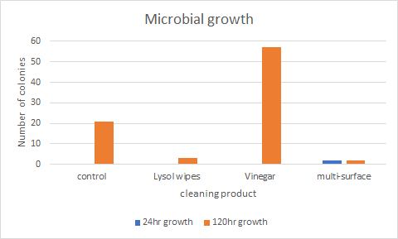

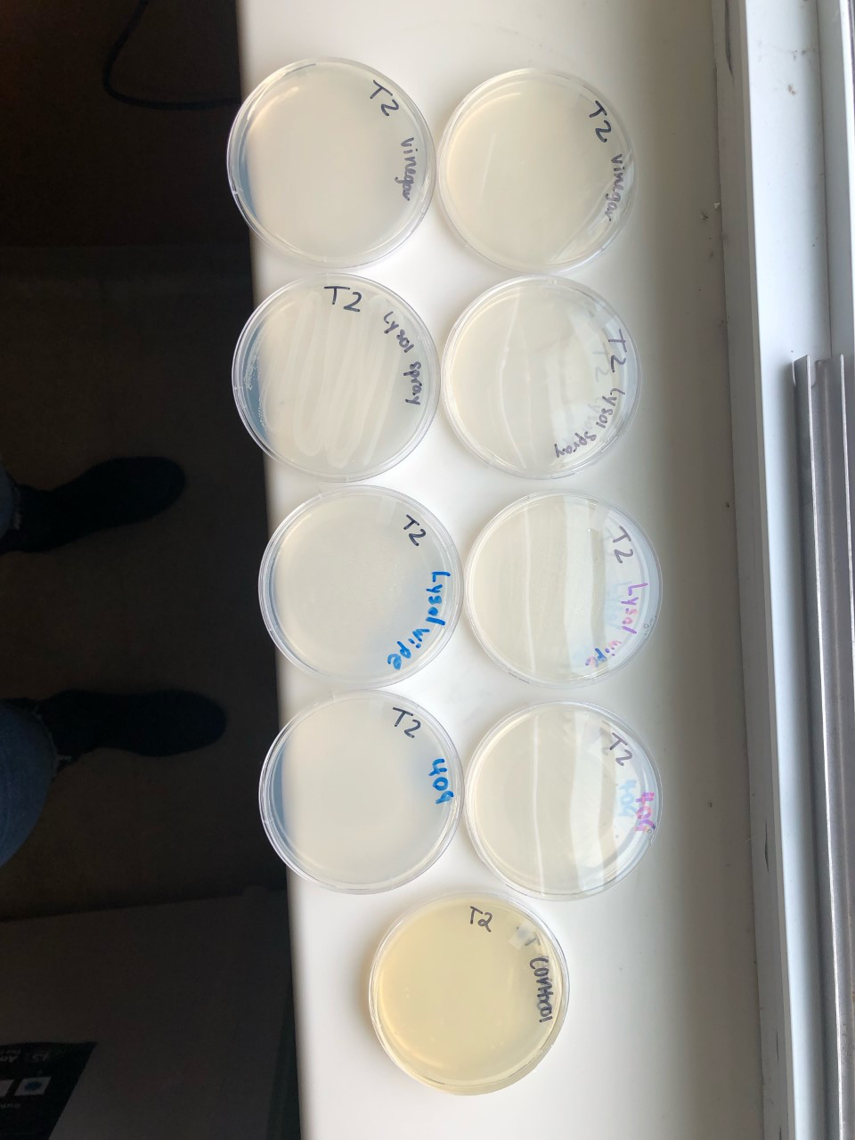

References
E. coli (Escherichia coli), E. coli (Escherichia coli) (2019). Retrieved from https://www.cdc.gov/ecoli/index.html
E. coli Bacteria, E. coli Bacteria (2015). Retrieved from http://www.health.gov.on.ca/en/public/publications/disease/ecoli.aspx
Goodyear, N., Brouillette, N., Tenaglia, K., Gore, R., & Marshall, J. (2015). The effectiveness of three home products in cleaning and disinfection of Staphylococcus aureus and Escherichia coli on home environmental surface. Journal of Applied Microbiology, 119, 1245–1252.
Johnston, L. B., Cox, G. M., Skov, N. M., & Anderson, K. L. (2016). Evaluation of the effectiveness of essential oil-based cleaners against Staphylococcus aureus. Beta Beta Beta Biological Society, 8(3), 110–116.
Rusin, P., Orosz-Coughlin, P., & Gerba, C. (2008). Reduction of faecal coliform, coliform and heterotrophic plate count bacteria in the household kitchen and bathroom by disinfection with hypochlorite cleaners. Society for Applied Microbiology, 85, 819–828.
Shigeharu, O. & Akira, K. 1996. Microbial contamination of antiseptics and disinfectants. American Journal of Infection Control, 24(5): 389-395.

Norbäck, D., Björnsson, E., Janson, C., Widström, J., & Boman, G. 1995. Asthmatic symptoms and volatile organic compounds, formaldehyde, and carbon dioxide in dwellings. Occupational Environmental Medicine, 52: 388 395.

