Michael Dougherty
Dr. Elif Guler
English-400-18
18 March 2018
Gentrify This: Rhetorical Strategies in Showtime’s Shameless
In the United States, the gentrification of lower-income neighborhoods has become a harsh reality for those who live in them. Gentrification is defined as a process where obsolete housing in residential areas is replaced and upgraded, which leads to a rise in cost of living in that area (Siegel, 2017). Showtime’s popular television series, Shameless, provides a social commentary that highlights the struggles of living in an area affected by poverty and gentrification. Frank Gallagher, played by Emmy award-winning actor William H. Macy, is a single father of six children living in the south-side of Chicago. Frank is an alcoholic, drug addict, and a deadbeat father who picks and chooses when he wants to be a parent, leaving his oldest daughter, Fiona to take over the parenting role most the time.
At the end of season seven, Liam Gallagher, the youngest sibling, and the only African American member of the family, is about to be enrolled at his local public elementary school and begin the first grade. Unfortunately, Liam’s plans are ruined when the family discovers that the public school has closed down due to lack of student enrollment. Due to the gentrification of the area, a new private school opens and Frank shows up to protest. To his surprise, the school offers Liam a free spot in the school. While it may seem like offering a free spot to Liam was an act of kindness, we find out in the beginning of season eight that the ulterior motive behind his enrollment was to create an allusion of diversity for prospective students and families. Liam is pulled from tests, projects, class so he can play on the playground and wave to families when they come and tour the school. In this television series, the writers appeal to pathos and logos by highlighting the issues created by gentrification that lead to the marginalization of lesser-privileged communities.
In the scenes where Liam is on the playground playing in front of a tour group, there are signs and banners everywhere that display children from different racial backgrounds. One of the larger banners in the background displays, “Celebrating excellence and diversity in the heart of the city.” The principal, Ms. Seery is conducting the tour and expressing to the tour group that, “racial, economic, and cultural diversity are the hallmarks of a Hopkins Academy of Education” (Wells, 2017). After talking about diversity, the principal always turns the focus of the group to Liam and say hello to him while he is ‘playing’ on the playground, alienating him even further. Liam starts to become irritated because he does not know why they are forcing him to play on the playground all day instead of learning like he wants to. 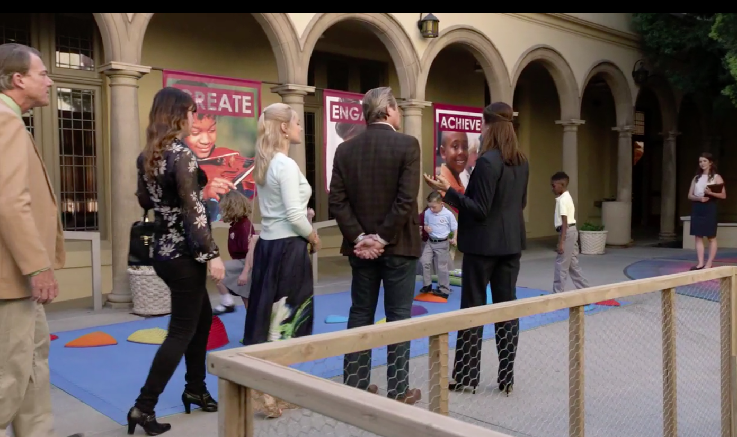
In this picture, we can see Liam on the playground in the right side of the picture, standing by signs that promote diversity. This picture is important because it shows how Liam is being exploited for the color of his skin so the school can seem more diverse to the parents of prospective students.
In this example, the writer is appealing to pathos to spark an emotional response from the viewers. When the viewers watch Liam being pulled out of class several times a day to play on the playground, they may find it humorous initially because of the filming and editing style of the show. Then, it really sinks in that the teachers are taking full advantage of him and not teaching him anything, which benefits the school at Liam’s expense.
This example from the show illustrates the hegemonic society we live in. In a hegemonic society, the upper-class elites have social control on the values of society over the lower-class citizens (Fritch, Ice, & Palczewski, 2016), and it is shown through the way the teachers treat Liam. When the viewer realizes that the teachers are exploiting Liam for his skin color at the expense of his education, their emotion evolves from laughter to anger. Liam is already on the wrong end of the hegemonic class by being a young African American in a poor neighborhood, and is being put at an even further disadvantage because he is not getting the same opportunity to learn like the other students.
An example of the writers appealing to logos comes from episode five of season eight of Shameless. Gentrification not only affects people socially and financially, it also affects many educationally. In episode five of season eight, Frank goes to Liam’s school to pick him up, when he is unpleasantly greeted by the principal, Ms. Seery, who informs Frank that Liam had failed his exam that day with a score of two out of ten. Liam tells Ms. Seery that he did not understand the questions. Ms. Seery tells Frank that the exam was on ‘basic word association’. Her diction is important, because by saying ‘basic’ word association, she is implying that all students should know the answers. She would be correct, if she only handed out the exam to students with a wealthy background.
Frank begins to flip through the exam and reads the first question, “Jennifer blanked the glue and finished the project” (Wells, 2017). The choices were ‘applied’, ‘kicked’, or ‘sliced.’ Liam scribbled out the words and wrote in, ‘sniffed.’ Frank stands up for his son and tells the teacher that it technically works, then starts reading the next question, “The front door is to the foyer as the back door is to the blank” (Wells, 2017). Liam scribbled out the options and wrote in, ‘penis’. Frank becomes irate, and asks Ms. Seery, “how the hell would he know what a foyer is, what are we, the Rockefeller’s?” (Wells, 2017).
In this example, Liam did not know the meaning of the word foyer because he is a resident of a rough neighborhood, and has never been to a house with a foyer. He associates different words with meanings that may be different to some, but just because they are different does not mean they are incorrect. When Frank says, “what are we, the Rockefellers?”, this is also an appeal to pathos because to the wealthy upper class, having a room like a foyer is not so much a luxury, but more of a standard. This reference can serve as an eye-opener for viewers if they need to be reminded of their privilege.
Ms. Seery quickly responds after Frank’s comment, stating that the questions are standardized across the public-school curriculum, and Frank angrily responds that the questions are in place, “…to favor the students who understand the references. This is cultural bias! You’ll put his face on your brochure, but you ignore his background” (Wells, 2017).
This is an excellent example of the writers appealing to logos and pathos because Frank calls attention to an issue that is prevalent all over the country. The tone of Frank’s voice is stern and heartfelt, and was extremely effective in creating an emotional response because we know Frank is standing up for his son. When underprivileged students are presented the same opportunity as privileged kids, they are not given the chance to fully succeed. Standardized testing is a method used in the United States as a baseline test for all students to be graded on the same scale. The problem with standardized testing is not everyone comes from the same background, and people’s experiences in life affect what type of knowledge they have. Also, Liam was not even supposed to a student at this school; he was forced to go to school there because he had nowhere else to go. He was supposed to go to public school until his area was gentrified by wealthy upper-middle class families, so why does he have to take the same test as everyone else when he is clearly at a disadvantage? Liam comes from a poor family and does not understand the references and lifestyle of the upper class. Therefore, it would be logical to alter the questions on the test so that they apply to everyone.
Another example of applying pathos was after Frank makes it clear to Ms. Seery that he is upset with the way things were handled, and she tells him she understands his concerns. Then, Frank abruptly cuts her off at the end of her sentence and says, “Great. What are you going to do about them?”
William H. Macy did a great job in this scene because he shows that he is fed up with the disrespect and marginalization that is occurring toward his son, and provides an example of what everyone should do when they are staring oppression in the eyes. Another reason why this scene is memorable is because of the props used in the background, notably the banner promoting diversity on the front of the school. The banner is ironic because the message of the school is to practice diversity and accept others, but in reality, they are doing the exact opposite and being oppressive towards Liam because he is vulnerable and does not know any better.
It is important to closely analyze content such as Shameless, because there are many messages and symbols in the show that require extra thought and are important to understand. Messages can sometimes be overlooked through other outlets, television helps to deliver clear messages. Television shows may not always be accurate, but they allow people to deliver messages to large audiences and influence many people. Issues such as gentrification, marginalization, and racism are a harsh reality of life. They are topics that have traditionally been avoided or spoken about with care. Shameless is taking a different, more blunt approach and attacking important issues head-on rather than beating around the bush.
Season eight of Shameless reminds us that gentrification is a growing harsh reality for people living in residential areas and cities, particularly low-income areas. Writer Sheila Callaghan does an excellent job of using pathos to appeal to the emotions of the audience by defending his son from oppression and miseducation at his school. Viewers can tell how much Frank cares for Liam by listening to him defend him against the principal. Callaghan also does a good job applying logos through the character of Frank by addressing the problem with standardized testing: cultural bias. This scene is powerful because Frank confronts the principal for exploiting his son, and gets the message across that what she is doing is wrong. Frank is not exactly a man of high morals, but he does protect his family when needed. Shameless is an excellent example of people using their platform to raise awareness on social issues in a manner that is both entertaining and insightful.

References
Abbott, P. (Creator), Callaghan, S. (Writer), MacDonald, I. (Director), & and Wells, J. (Developed for American Television by). 2017. The (Mis)Education of Liam Fergus Beircheart Gallagher [Television Series Episode]. In J.Wells (Producer), Shameless. Los Angeles, CA: Warner Brothers Television.

Palczewski, C. H., Ice, R., & Fritch, J. (2016). Rhetoric in Civic Life (2nd ed.). State College, PA: Strata Publishing, Inc.

Siegel, L. J. (2017). Criminology: Theories, Patterns and Typologies (13th ed.). Boston, MA: Cengage Learning.

