**Website Application for Dog Adoption Centers**

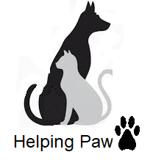

Prepared for:

Helping Paws Dog Adoption Center

Marketing/ Web Design Departments

Prepared by:



April 30, 2019



703 School Street

Farmville, Va 23901

April 1, 2019

Tristan Motz

Co-Chief Consultant

Website Advancement Consulting Knowers

3415 Church Street

Vienna, Va 22182

Dear Mr. Motz:

Subject: Helping Paws Website Consultation

The marketing and web design departments of Helping Paws dog seek to find a home for every dog that comes through our doors.  Many of those who come to adopt with us find their canine companions over the internet. We would like to make this experience as simple and compelling as we can.

We would like to commission your firm to conduct a study of two animal adoption websites.  With the information that you collect, we would like you to make recommendations so that we can become a better business and, most of all, help more dogs.

It is our goal to have our new and improved website ready for use by September 1, 2019.  In order for our web designers to meet this deadline, we would need your recommendations to be formally submitted by April 30, 2019.

We look forward to reading your report.  If we can assist you in any way, please contact me at (555) 555-5555.

Thanks,

Bruce Banner



Bruce Banner

HR representative

3415 Church Street

Vienna, Va 22182

April 30, 2019

Bruce Banner

Human Resources Representative

Helping Paws Adoption Center

703 School Street

Farmville, Va 23901

Dear Mr. Banner:

Subject: Helping Paws website report completed

We are pleased to present you with the Helping Paws website report that you asked for in your letter from April 1, 2019.  Our report looks into the following two websites:

* Southside SPCA
* Adoptapet.com

As requested, these two websites show how a website can help animals on a large scale.  Our analysis describes the useful elements that were present in both of these websites.

If you have any questions or comments about our findings, we would be pleased to meet and discuss the ideas further.  I can be reached at (444) 444-4444.

All the best,

Tristan

Tristan Motz

Co-Chief Consultant

WACK

Table of Contents

Title Page1

Letter of Authorization2

**Letter of Transmittal3**

Table of Contents4

List of Figures5

Executive Summary6

Introduction7

**Analysis of Southside SPCA8**

Analysis of Lynchburg Humane Society10

Conclusions12

**Recommendations13**

List of Figures

Figure 1: User Satisfaction Survey…………………………………………………………7

Figure 2: Southside SPCA Homepage…………………………………………………….8

Figure 3: Lynchburg Humane Society Homepage……………………………………….10

Executive Summary

In the modern world, it is important that all businesses are equipped with the best uses that technology has to offer.  This statement is never more true in the case of animal adoption centers. A prudent use of websites can allow for said centers to save more animals and place them into happy homes.

The internet is full of websites that offer examples of what an adoption centers can do online, but it is difficult to decipher which are more reliable and which attract more adopters.  Helping Paws asked WACK to recommend two websites that show an effective use of the online platform in the animal adoption setting. We wanted to find websites that appealed to those looking to adopt, made it easy to find a desired breed, and effectively showed both what was available and where they could be found.

The websites were examined and analyzed on the following basis:

* Visual Appeal: inspiring depictions, color choices, absence of advertisements;
* Search bars: ease of access, use, and placement;
* Comprehensibility: simple navigation, easy to find necessary parts.

Our conclusions, which are further detailed in our report, were founded in our personal experience in consultation as well as in a survey of public opinions about the following websites:

* Southside SPCA
* Adoptapet.com

Our report sought to find the most effective and stimulating way for Helping Paws to utilize their website and to find as many prospective adopters as possible.

Introduction

Helping Paw is an animal conservation and adoption center that specializes in working with dogs.  In recent years, Helping Paw has seen the potential benefit of having an online presence. Through the use of a new website for their company, Helping Paw hopes to increase the number of potential adopters that they can reach so that more dogs can find happy homes through their business.

In order for a website to suit their needs, it has to exhibit features that are aesthetically pleasing, while remaining functional and easy to use.  The inclusion of these traits in a new website is critical because it is so easy for viewers of the website to click their ways to different sites, and by extension, adopt from different sources.

Although Helping Paw connects people with animals in need every day through walk-ins, they, like many animal activists, seek to do more.  They need their website to reach people who are looking online, as opposed to in person. For this reason, the website must exemplify all that it means to be a dog adoption center.

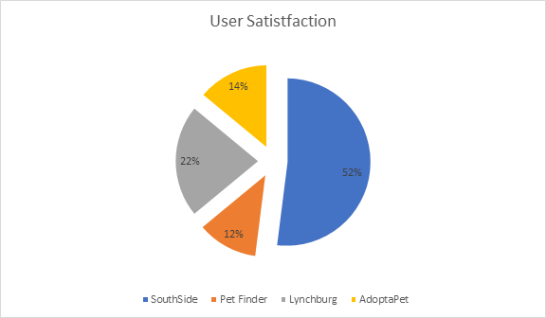

(Figure 1: User Satisfaction Survey)

Helping Paw asked for Website Advancement Consulting Knowers (WACK) to analyze two different website, in the same field, to find what features and other inclusions should be added to their new website.

In order to determine which adoption-based websites were appropriate to complete this task, WACK administered a survey to 100 people, that asked them to determine which, out of four websites, was the most satisfying to use (see Figure 1).

WACK then chose to analyze the two highest rated websites, in user satisfaction, and examined them based on how they contained the following:

* **Aesthetic:** Key images, color-schemes, structuring, general visual appeal;
* **Important Features:** helpful inclusions to the website; and
* **Functionality:** Ease of use, intuitive navigation, overall applicability.

Analysis: Southside SPCA

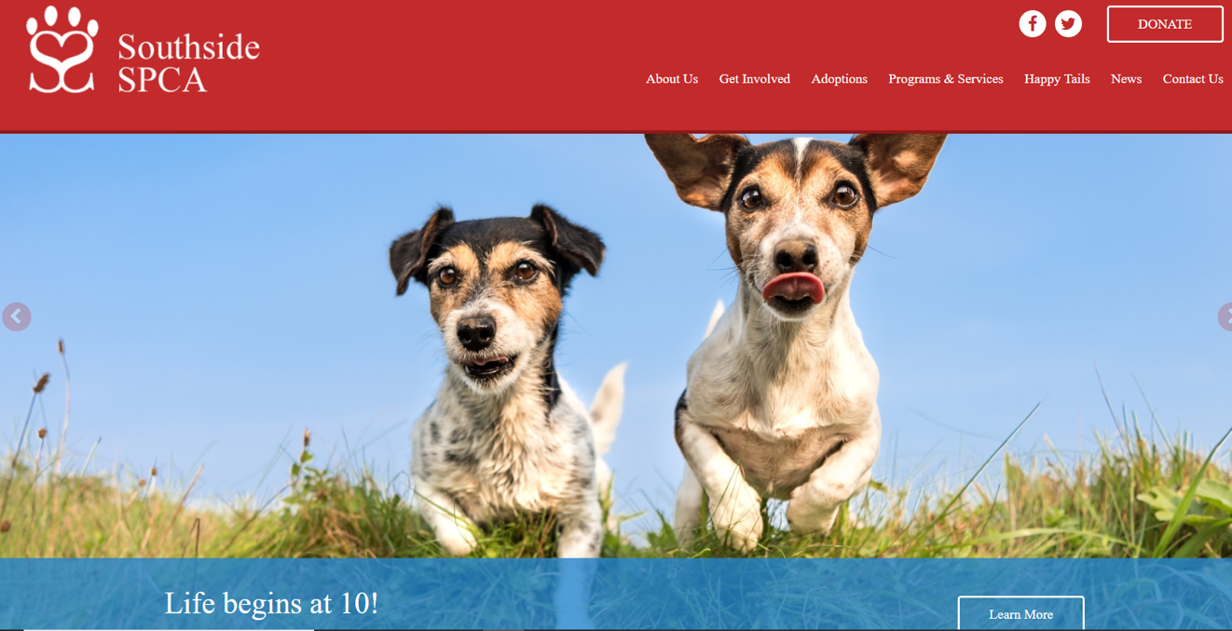

**(Figure 2: Southside SPCA Homepage)**

**Aesthetic**

The Southside SPCA website is a perfect example of what it means to be aesthetically pleasing without filling its pages with purposeless pictures.  Its home page is framed in big red and blue lines which artistically draw the eye to a large slideshow. The slideshow scrolls through happy pictures that are on brand with animal adoption and service while promoting different events that the organization runs.  This style of homepage is successful in asserting what the company cares about and represents as a whole.

**Important Features**

The features that the Southside SPCA website utilizes can always be found within the bright red header that always accompanies every page.  This allows users to switch between different pages and categories with relative ease. These features each fulfill the different needs of three different types of people that would visit the website.  These people are either animal adopters, volunteers, or just people that are browsing. The constant and bright task bar makes it simple for all three categories of users to quickly find the part of the site that they wish to view and then gain the information that they want.  This is a crucial aspect in web design, as the internet offers a multitude of other website options, and a website that is difficult to navigate can be substituted with another in three clicks of the mouse.

An area where the Southside SPCA website thrives is in its dog adoption.  When the user clicks on “Adoption” in the task bar and selects “Dogs” in the drop-down menu, they are greeted with pages of individual Dog profiles.  Each profile is equipped with a picture of the Dog along with its name, size, breed, and age. This gives the user a fast way to find a dog that they would be interested in.  Once a dog is chosen, the user can click on the profile to find a larger description of the dog that outlines its personality, needs, and whether it is up-to-date on shots. When adopting a dog, all this information is imperative to learn, and the Southside SPCA website makes these important facts easy to find and comprehend.

**Functionality**

With the afore-mentioned color scheme, large central photos, and framing blocks on the home page; the user’s eyes are drawn to the aspects of the website that matter most.  This applies both to the website’s aesthetic and its functionality as it makes the website appealing to the eye, but it also makes it simple to find what the user is looking for.

With that said, the website’s key features each tackle important needs of different users that would visit the Southside SPCA website.  These add to the functionality as well because they are central in the website’s construction, and the features are simple for any individual to find and then capitalize upon.

This leaves the Southside SPCA website with an impressive showcase of functionality.  It is easy on the user’s eyes, while also meeting the needs of numerous different types of individuals.  Also, if the user ever wants to switch from one page to another, each page can be quickly switched to from the drop-down menus, and the homepage can be accessed from any page by simply clicking the company logo at the top left.

Analysis: Lynchburg Humane Society

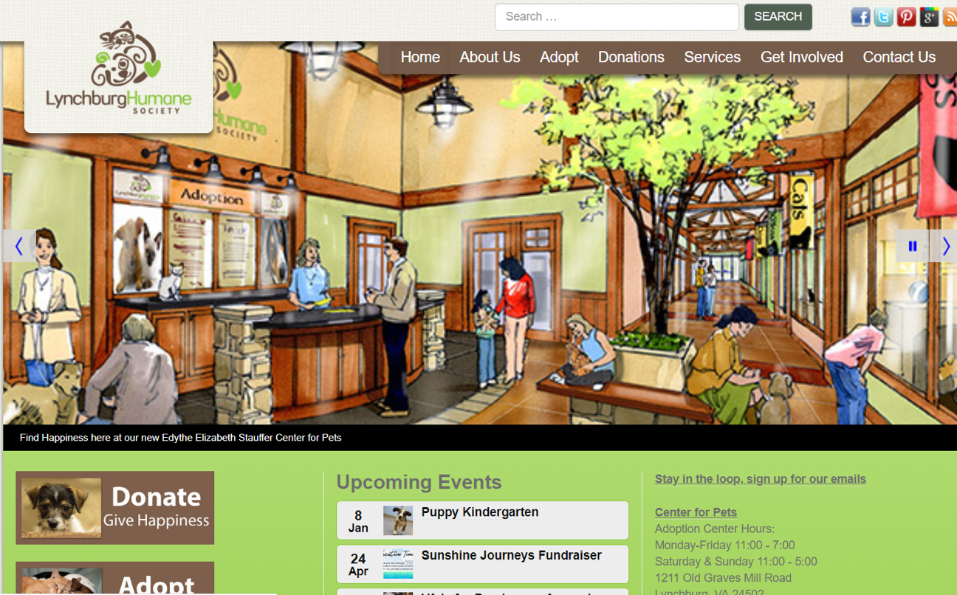

(Figure 3: Lynchburg Humane Society Homepage)

**Overall Aesthetic Design**

The overall design of Lynchburg’s website exudes competence and orderly conduct. Their layout is bright, but overbearing of design and details.  The style of the website fits with all bungalow design and familiarity. Their photo gallery on the homepage of their website maintains a constant image which doesn’t updated to reflect current awareness events. It is not disturbing and fits into the overall layout and theme.

However, the events and links are split into three sections as you scroll down to the home page. The home page follows the rule of thirds design principle, but they have both links for Adopt and Donate on the top and the left side of their website as well on the bottom.

Most images and text adhere to the horizontal, left to right path across the screen. It drags the eyes of the viewer in the same direction. A critic of this format would argue that it lacks cohesion and innovation. It doesn’t allow the content nor this website to be noticeable for any discernible reason.

**Adoption Portfolio**

As to be expected with a local adoption center, Lynchburg has information about the caring for and general upkeep for taking care of their pets. This massive list and accurate information are one every local animal shelter should contain. Not only does it ease the anxieties of potential adopters, it also educates the masses on the importance of spaying/neutering their animal and proper vaccination for them. There are some articles which details the experiences and aftermath of the recently adopted dogs. It creates a sense of community and lets potential adopters know they are not alone in this process.

This Animal shelter know that not all adopts will be forever as many animals are return to the shelter for behavior reasoning, therefore, it is imperative that animal shelters provide long lasting support and information for first time adopters. Every shelter wants all of their animals to have a final home.  Lynchburg makes this certain to any potential adopters by provide common dog behaviors when first introduce to the home. In doing so, they create a safe and welcoming home for the new member of their family.

Once the Pet Behavioral tab is clicked from the Lynchburghuman.org homepage, a list of resources is brought up, as well as information about pet friendly homes. It also has a list upcoming event. These events, which are regularly sponsored by Lynchburg are a fantastic advertisement for new pets.

**Ease of Accessibility**

Lynchburg’s site is adequate in navigating around.  The basics of circumnavigating the site maintain the logo on every page which links back to the homepage upon clicking. All the links listed on the site don’t have the 404-error page and is active. Lynchburg Humane website meets all rudimentary qualifications for making an easy user interface website.

Where Lynchburg succeeds, its links is maintaining within Lynchburghumane’s website maintains on the server. One of the areas where the LynchburgHumane’s website can improve is by increasing the font size for those who have trouble visually discernible between letter. There appears to be a large portion of dead space which could be filled with appropriate pictures and information. The empty space highlights an unprofessional design. A few modification can fix these minor issues.

Conclusions

Helping Paw is an animal conservation and adoption agency that specializes on the adoption of dogs in particular.  While they have a strong local presence that has allowed them to function and pair many dogs in need with suitable homes, they would like to be able to reach a wider audience. Through the use of a greater web-presence, Helping Paw would quickly be able to find more people who are looking to brighten their homes with a canine companion.

The internet is rife with websites that seek to do just that, so it is important that, if Helping Paw looks to create a website, they create one that stands out.  Helping Paw asked WACK to analyze two websites that show what it means to be a good animal adoption source over the internet. After an in depth survey was made and completed by 100 people, the two websites that were found to have the highest user satisfaction were for the Southside SPCA and the Lynchburg Humane Society.

We analyzed these two websites by focusing on their individual aesthetics, important features, and overall functionality.  This allowed us to see what made them so satisfying for users as well as what made them good websites as a whole.

We found that both websites had clear, central, pictures of animals.  This immediately appeals to the website users, and subtly reminds them of the reason that they are on the website.  Each website also had bold, yet appealing colors that focused the user’s eye to the information and features that each page held.  This added to each pages usability and overall functionality by decreasing stress on users and not making them strain themselves by searching through too much information and advertisements.

Furthermore, the two websites had important features such as search bars, calendars, dog profiles, and clear directional menus that made user’s more able to navigate the websites and find the animals that they were inclined to adopt.

These features and website designs made the Southside SPCA and Lynchburg Humane Society websites better for users as a whole, while exemplifying what an animal adoption website should be.

Recommendations

We recommend that Helping Paws include the following aspects in their new website so that they can expand their pool of potential adopters and grow their business:

* Open Layout (non-cluttered)
* Clear Directional Menu
* Social Media Feed
* Event Calendar
* Specified Search Bar
* Central Pictures of Dogs