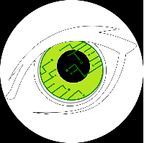

**Optimax: Intelligent Subtitles**

March 3, 2018- FOR IMMEDIATE RELEASE

Optimax Intelligent Subtitles: Instant translations!

No longer are the days where a translator is needed to converse with others who speak different languages. Through the advancements in modern technology, Optimax Intelligent Subtitles has created a way for translations to be instantly made and displayed on the wearer’s contacts. All that the user has to do is clip the small microphone unit to the front of their shirt, put in the Optimax Intelligent Subtitles contacts just as you would any other form of contact, and start listening.

As the microphone hears one of its comprehended languages, it instantly translates words spoken to the user and displays them to the user in a format that resembles subtitles in a movie. Many people have already begun testing out this product. Steven Smith, a recent retiree and new user of Optimax Intelligent Subtitles says, “Optimax has been invaluable to me, while traveling abroad. It has helped make my retirement stress free, as I can navigate cities and understand languages like one of the locals.” He is not alone in his feelings, as many other people have found Optimax Intelligent Subtitles to be easy to use and applicable to many different situations.

-30-

For further information, please contact Tristan Motz

At 555-555-5555, email tristanmotz@hotmail.com