NEWS RELEASE

For Immediate Release
Contact: Jennifer Conley Sexton
Volunteer & PR Coordinator
Office: (540) 777-8706, Cell: (540) 400-5825
JSexton@RoanokeCountyVA.gov
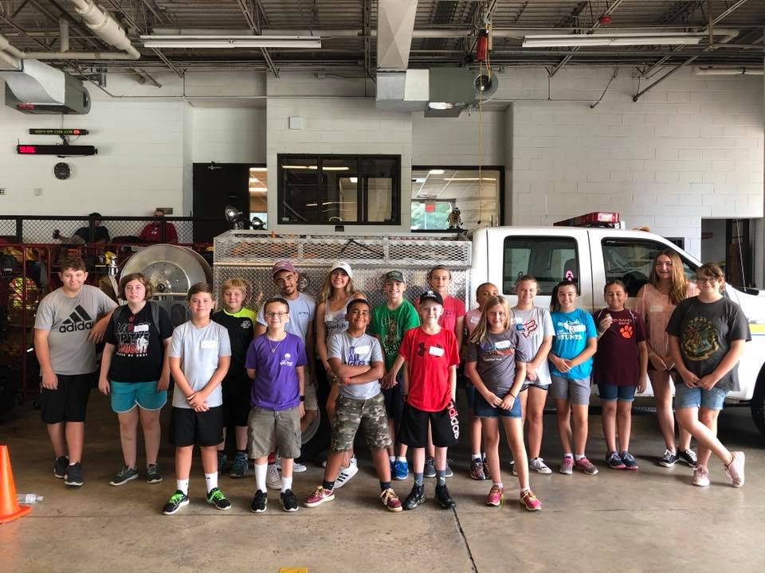
14th Annual Character Academy

The group of 15 campers and 4 junior counselors after they finished learning about Roanoke’s Heavy Technical Rescue unit.
(ROANOKE COUNTY, VA—August 1, 2018)—The Roanoke County Fire Marshal’s Office hosted the 14th annual Character Academy for kids from July 25 through July 27. The three-day camp aims to teach middle school aged youth about fire and life safety while emphasizing character fundamentals that can be applied during the camp and even after the students leave.
On Wednesday, fifteen campers from around the Roanoke Valley and beyond spent Wednesday at Fort Lewis Fire and Rescue Station where they learned about the equipment, trucks, and gear firefighters and paramedics use to keep the community safe. They were also able to take a station tour and see what fire and rescue personnel do throughout the day. Mission BBQ provided lunch for the students and staff, and after lunch, Captain Tuck demonstrated how the Heavy Technical Rescue unit would rescue a person who was injured in an incident such as a building collapse or flood. Throughout all of these demonstrations, fire and rescue personnel incorporated character traits such as trustworthiness and responsibility.
On day two, the campers headed to the Roanoke Valley Regional Fire and EMS Training Center on Kessler Mill Road where they broke into groups to rotate through stations such as a maze trailer created from an old train car, a high line campers could rappel off of from a five-story training tower, and a demonstration of how to safely exit a building filled with non-toxic smoke. Students then took a basic CPR class taught by Captain Blank where they learned how to perform chest compressions and help a person who may be choking. To finish out the day, campers participated in various teambuilding challenges that focus on respect, fairness, and caring.
On the final day, campers went to Splash Valley for a quick swim and then headed to the Public Safety Center located on Cove Road. Here, they toured the Emergency Communication Center (or 9-1-1 Center) and ate pizza for lunch with Chief Steve Simon. After lunch, the group headed back to the Fort Lewis station for a graduation ceremony that included a recap of everything the campers learned throughout the camp, a certificate of participation and a Roanoke County Fire & Rescue water bottle.
The camp is held annually and the cost was $__ this year.
###

