Introduction:
The early establishment of English colonies in North America during the late-1500s and early-1600s was a process of trial-and-error, where colonists faced various obstacles, and learned how to overcome them, which aided in establishing later colonies that persevered, like Jamestown. However, the focus on Jamestown as the most significant settlement in Virginia during this early colonial period often overshadows the history that had occurred at other locations. The Citie of Henricus is one such location. Though the exact location of the site has been lost and most likely destroyed due to development in the area, a living history museum, called “Henricus Historical Park,” has been working in recent decades to commemorate the settlement; however, the constant threat of being forgotten still looms large over the site.
History of Henricus:
Before the establishment of the “Citie of Henricus” by the English in 1611, the area had been inhabited for thousands of years by American Indians, who had relied on agriculture and resources offered to them by the nearby rivers and surrounding environment. The growth of food rather than solely foraging led to the establishment of semi-permanent villages, some of which are included in John Smith’s 1612 Map of Virginia. The Indians who lived in the area that would become Henricus were known as the “Arrohateck,” named after their head chief who had been friendly with the English during their James River exploration in 1607. This tribe was also one of the many groups under the Powhatan Chiefdom, which he earned either by inheritance or warfare throughout the late-16th century or early-17th century.
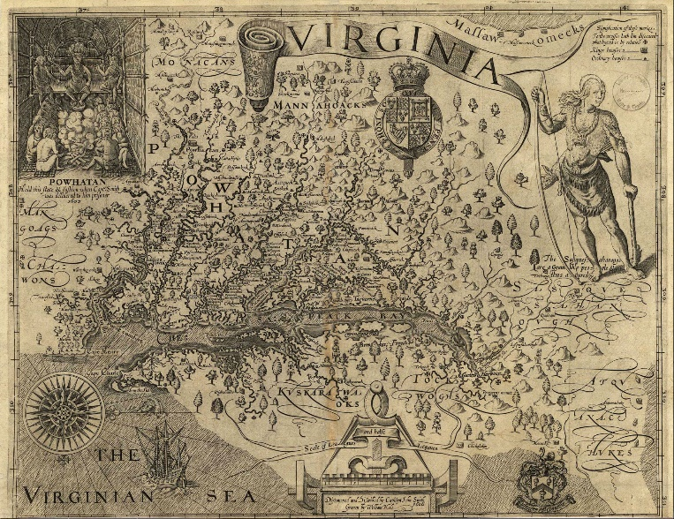
Captain John Smith’s 1612 Map of Virginia (Courtesy of nps.gov/cajo)

In 1611, Sir Thomas Dale was tasked with determining a more hospitable location for a settlement in Virginia; when he reached North America, he continued up the James River and decided upon bluffs overlooking the river, establishing the Citie of Henricus—named for Henry, Prince of Wales. This “citie” was the colony’s capital during the years of marital law from 1611-1614, and where Pocahontas lived with the Henricus minister, Reverend Alexander Whitaker, after she was captured by Captain Samuel Argyll in 1613. During her time at the site, Pocahontas converted to Christianity, became “Rebecca,” and met and married John Rolfe, which marked the start of a period of peace between the waring English and Powhatan.

Sir Thomas Dale’s intention with the Citie of Henricus was to make it the new principal city of the English colony, as it was in a safer location to ward off Spanish attacks, and the environment was healthier than that at Jamestown. Within a few years of its establishment, new policies and institutions were introduced, making it a more advanced settlement in comparison to other English towns in North America. Such programs and organizations included: the first public hospital in the English colonies, called Mt. Malady; the start of private land ownership; and the planning and building of the “Colledge of Henricus” for colonists and Indian children.

Unfortunately, the town never grew to its full potential. The Citie of Henricus was mostly abandoned following the attack of Powhatan’s younger brother and successor, Opechancanough, in March 1622, which marked the start of the second Anglo-Powhatan War. The raid killed much of the population, destroyed majority of the town, and many of those who survived sought refuge in other towns or plantations. The town never recovered from the attack, and in 1637, the land the site was located was included in a 2,000-acre tract possessed by William Farrar, and the peninsula became known as “Farrar’s Island.”

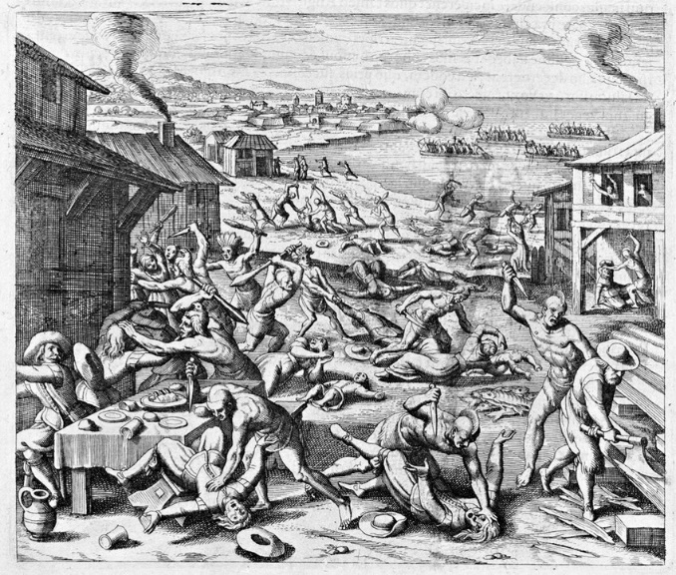
Massacre of the Settlers by Mätthaus Merian (Courtesy of EncyclopediaVirginia.org)

The Controversy:

While the site has most likely been destroyed as a result of time and the building of the Dutch Gap during the Civil War, Henricus Historical Park works to commemorate the town between its time of establishment and abandonment. The living-history museum primarily focuses on demonstrating English colonial life during the early 17th-century, as well as American Indian culture, where professionals display the use of tools, daily life, build period-objects, cook, and explain medicine of the time-period. The park has multiple events throughout the year, such as Halloween programs, education programs, outdoors programs, and anniversary celebrations to commemorate the various populations and cultures that have had an impact on the town, primarily the colonists, Indians, and Civil War soldiers.

Though the park may face interpretive difficulties regarding the lives and cultures of both the Indians and colonists, along with the fact that the site has been lost, the major issue is the nearby Dominion power station. When a visitor goes inside the fort, they are transported back in time to the Citie of Henricus, surrounded by persons in costume, wander among replica buildings, and are in a remote location away from most of civilization; that is, except for the smoke-stacks and constant noise of the plant nearby.

Although the smoke-stacks in the background of the town may be creating water-vapor clouds that are no threat to an individual’s or the environment’s health, the real problem lies with the coal-ash and other by-products that are leaking into the nearby water-ways. Coal-ash, which is made by the burning of coal to produce electricity, has been found to contain heavy metals, such as arsenic, lead, mercury, chromium, and cadmium. There have been multiple lawsuits regarding the pollution in the area, primarily the water, and how it affects the surrounding environment. However, the damage already done cannot be easily reversed.

Though the station is necessary, as it creates and provides power for much of the population, the Chesterfield power station poses a constant threat to Henricus Historical Park. Not only does the byproducts and pollution obviously present a hazard and ward away visitors who may have certain health problems, but the smoke, noise, and overall complex take away from the experience offered by the living museum. The station’s proximity denies visitors the full knowledge of what life was like during the town’s prime. Additionally, though it is highly unlikely, Dominion Power may one day own the park, and destroy it for the purpose of exploiting the land for expansion of the station.

Conclusion:

In total, it is not difficult to imagine what archaeological and historical opportunities the station has denied Henricus Historical Park. More importantly, one can only imagine what threats lay ahead that could destroy the commemoration of and education about an important aspect of American history. By thinking about the future of Henricus Historical Park in relation to Chesterfield Power Station, an individual can start to plan and act in defense of the park, ensuring that further destruction does not occur and that its history can be fully recognized and commemorated.

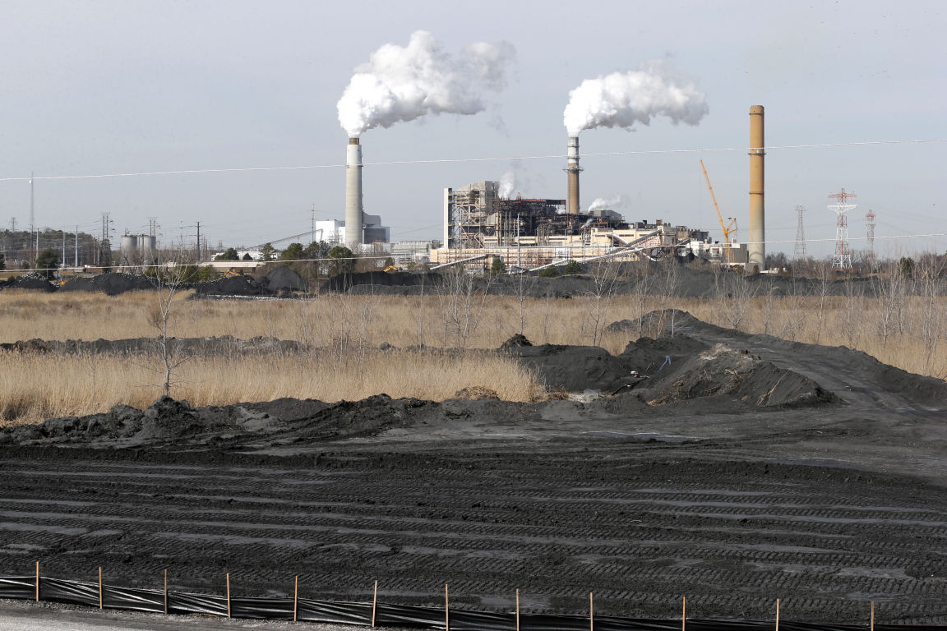
Chesterfield Power Station of Dominion Power (Courtesy of Richmond-Times Dispatch)

Timeline:

September 1611 – Sir Thomas Dale and new settlers establish the Citie of Henricus

1612 – Mt. Malady is built near Henricus; it was the first public hospital in the American Colonies

July 1612 – By this time, John Rolfe is estimated to have started growing Spanish tobacco, which would become the first cash crop

1613 – Captain Samuel Argyll abducts Pocahontas, starting her year in captivity

1614 – Sir Dale starts policy of private ownership, where each man was given three acres and had to give two barrels of food for the food store each year

April 1614 – Pocahontas marries John Rolfe; Powhatan signs a peace treaty with the English

1616 – About fifty people were living within the town walls while many lived on private farms lining the James River due to the introduction of private land ownership introduced by Sir Dale

1619 – The Virginia Company of London begins to establish the first university in English North America near to Henricus for colonists and American Indians, known as “The Colledge of Henricus”; plans for the college were heard at the first meeting of the Virginia Assembly at Jamestown later that year

March 22, 1622 – Opechancanough, Powhatan’s successor and younger brother, leads an attack on the English settlements on the James River, destroying large portions of them and causing some to either be entirely abandoned or only parts abandoned, Henricus included; unknown number of colonists died and the college was destroyed

May 1625 – Only about twenty-two people were said to have still been living in the ten houses at Henricus because of failed attempts to rebuild the town after the raid in 1622

August 1864 – Construction under orders of Union General Benjamin Butler begin; Federal soldiers were to dig a canal at Henricus to aid Federal naval forces achieve safer passage to Richmond; canal was two-thirds finished by mid-November

January 1, 1865 – bulkhead of canal project is blown up, but dirt falls back into the hole and the project is not finished until after the war; the canal attempt most likely went through the Henricus settlement and destroyed most evidence of the colonial town

Bibliography:

“Citie of Henricus.” Vanderford Family. 1998. http://www.vanderfordfamily.com/html/henricus.htm.

“Henricus Fort and Indian Village.” Henricus Historical Park. http://henricus.org/henricus-fort-and-indian-village/.

“Historic Chesterfield – Act for Dividing the County of Henrico into Two Distinct Counties.” Chesterfield County. http://www.chesterfield.gov/content.aspx?id=2976.

“History of Henricus.” Henricus Historical Park. http://henricus.org/history/.

Marshall, Michael. “Blue Ridge Naturalist: A Visit to Henricus Historical Park and Dutch Gap Conservation Area.” Crozet Gazette. October 5, 2013. https://www.crozetgazette.com/2013/10/05/blue-ridge-naturalist-a-visit-to-henricus-historical-park-and-dutch-gap-conservation-area/.

McConnell, Jim. “Dominion Under Fire for Coal Ash Disposal in County, State.” Chesterfield Observer. February 3, 2016. http://www.chesterfieldobserver.com/news/2016-02-03/News/Dominion_under_fire_for_coal_ash_disposal_in_count.html.

Richmond.com Staff. “Citie of Henricus Historical Park.” Richmond-Times Dispatch. July 30, 2009. http://www.richmond.com/recreation/citie-of-henricus-historical-park/article_c23f1e5a-d03c-523c-9e58-34a8a2145ecd.html.

Rolfe, John. “Transcript of Letter from John Rolfe to Sir Thomas Dale (1614).” Encyclopedia Virginia. June 1, 2012. https://www.encyclopediavirginia.org/Letter_from_John_Rolfe_to_Sir_Thomas_Dale_1614.

Salmon, Emily Jones. “Bermuda Hundred during the Colonial Period.” Encyclopedia Virginia. October 27, 2015. https://www.encyclopediavirginia.org/Bermuda_Hundred_During_the_Colonial_Period#start_entry.

Theobald, Mary Miley. “Henricus: A New and Improved Jamestown.” Colonial Williamsburg Journal Winter 2004-05. Accessed October 21, 2017. http://www.history.org/foundation/journal/winter04-05/henricus.cfm.

Weaver, Elle. “Kidnapping of Pocahontas E-48.” Fredericksburg, Stafford, Spotsylvania Historical Markers. March 12, 2008. http://fredmarkers.umwblogs.org/2008/03/12/kidnapping-of-pocahontas-e-48/.

Zullo, Robert. “Environmental Group Finds Coal-Ash Contamination Near Dutch Gap.” Richmond-Times Dispatch. September 13, 2016. http://www.richmond.com/news/local/chesterfield/environmental-group-finds-coal-ash-contamination-near-dutch-gap/article_ebde78ec-2560-5192-9af0-e2b117c7fe37.html.

Further Reading:

Childs, David. Invading America: The English Assault on the New World 1497-1630. Great Britain: Seaforth Publishing, 2012.

Griggs Jr, Walter S. Historic Richmond Churches & Synagogues. Charleston: The History Press, 2017.

Grizzard, Jr., Frank E., and D. Boyd Smith. Jamestown Colony: A Political, Social, and Cultural History. Santa Barbara: ABC-CLIO, Inc., 2007.

United States National Park Service. Explorers and Settles: Historic Places Commemorating the Early Exploration and Settlement of the United States, Edited by Robert G. Ferris. United States: Division of History Studies, 1968.

Young, David. An English Seed. Pittsburgh: RoseDog Books, 2007.

