A Day in a Sloth’s life
Megan Curry
BIO 288
Leech
1 March 2018

Introduction:
In Brazil, parents often tell their children tales of a sly sloth that plays tricks and leaves his friends behind, or bedtime stories of sloths doing courageous acts with superhero capabilities. The irony of these stories is that sloths spend most of their days sleeping and eating in the tree tops. Sloth’s only come down to the ground roughly once or twice a week to rid themselves of feces and look around for potential predators. Many would wonder which predators would attack a superhero sloth, but it is statistically known that humans are the largest predators to sloths. Deforestation and human interference, such as poaching and colonization, are some of the largest issues that are affecting their population. That leads me to question: how do humans affect sloth’s population, health, and role in the natural habitat?

Population:
Human interactions with sloths cause many issues to their population. Our need for natural materials and expansion causes a large decrease in the sloth population. As shown in Figure 1, deforestation and lumber extraction results in the loss of food supply and shelter. Expansion and growth calls for more materials and space. Charcoal production, plantations, and cattle pastures are also posing a threat to the sloth habitats. It was found in Costa Rica that the two biggest death threats to sloths are poaching for their fur and power lines because they are similar in looks to a tree. In a study conducted by Silva and his colleagues they found that the main risks were road network, domestic dogs, and electrical shocks.
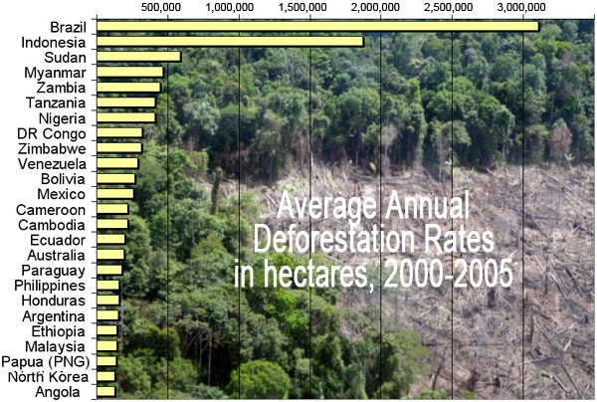
Figure 1. Deforestation rates throughout years. Deforestation has dramatically increased as shown above. This causes a decline in shelter and food supply for multiple animals.

Health:
Captivity is one of the largest health concerns to sloths. When in captivity, sloths are restricted to small spaces, and there is constant pressure from zoo visitors and keepers. This in turn causes them to become very stressed which can lower their immune systems and make them more prone to diseases and illness. When restricted from resources they were accustomed to in the rain forest, sloths become vulnerable and uncomfortable, and adding high amounts of stress to their vulnerability causes mental illnesses to arise. A 20-year study by Diniz and Oliveria was conducted to show the effects that captivity has on them. Their results showed that 81 clinical disorders were found, and displayed disorders including nutritional, digestive, respiratory, and injury. All of these disorders were derived from human contact, interference, and captivity.

Role in Natural Habitat:
Sloths play an important role in their natural habitat. First, their fur collects dirt and fungi which leads to a habitat for algae. In return, the algae can turn their fur green and help camouflage and protect the sloths. Second, due to their slow metabolic rates and algae they can emit larger amounts of carbon into the forest. Lastly, sloths play a leading role in multiple mutualism processes. For instance, three-toed sloths house moths, large amounts of inorganic nitrogen, and algae. Sloths will consume the algae on their fur and then leave the tree to defecate; while doing this they transport the moths to a new habitat in the sloth feces (Figure 2).
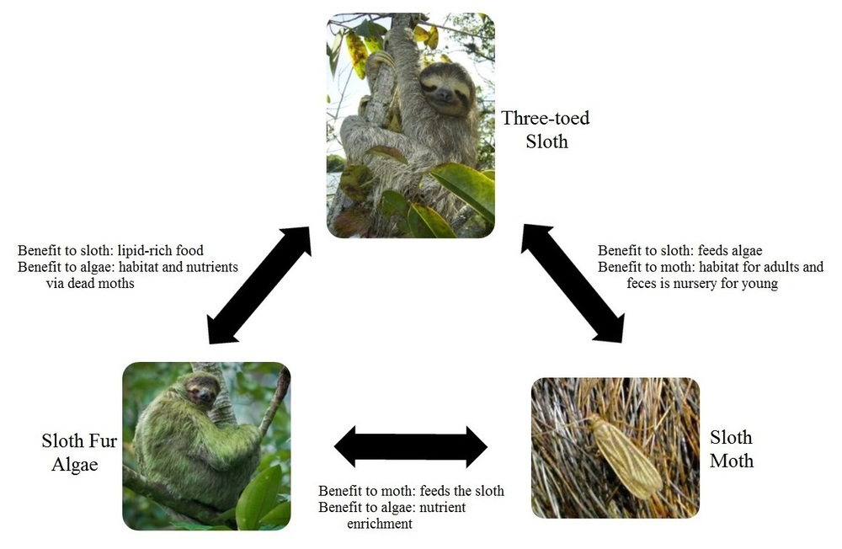
Figure 2. Sloth mutualism. As shown above the figure shows the mutualism between the moth and algae. It describes the benefits that each species gets from each other.

Conclusion:
Thus, human impacts on sloth health and population is increasing and dramatically affecting their lifestyles and extinction rates. Deforestation, captivity, poaching, and urban lifestyles have been the largest threats to the sloth community and their habitat. It is important for governments and other wild life recreations to start taking charge. Sloths may keep to themselves and seem like sluggish animals, but they play a crucial role in their ecosystems and communities. Mutualism and carbon emission are all just simple factors that they play a part in in the rain forest. I think it is very important that we view these factors and other ones closely and use them to our advantage. Sloths may be simple, but their networks and contributions are larger than we know.

Future research:
There is still a large area of research that we don’t know about sloths. We know why they produce carbon, but we don’t know what the ecosystem around them are using it for. We also don’t know other health factors of a sloth’s internal functions. We know the disorders that have arose from captivity, but we don’t know what disorders can arise from natural causes. Further research could be done on internal factors, metabolic pathways, future human impacts, naturally caused disorders, and what the ecosystem is mutually benefitting off the sloths.

Citations:
http://ljournal.ru/wp-content/uploads/2017/03/a-2017-023.pdf. 2017.
Dgallagher. 2013 Oct 11. 10 Things You Probably Didn't Know About Sloths. TheFW. [accessed 2018 Mar 1]. http://thefw.com/10-things-you-probably-didnt-know-about-sloths/
Diniz LS, Oliveira PM. 1999 Mar. Clinical problems of sloths (Bradypus sp. and Choloepus sp.) in captivity. Journal of zoo and wildlife medicine : official publication of the American Association of Zoo Veterinarians. [accessed 2018 Mar 1]. https://www.ncbi.nlm.nih.gov/pubmed/10367647
Pauli JN, Mendoza JE, Steffan SA, Carey CC, Weimer PJ, Peery MZ. 2014 Jan 22. A syndrome of mutualism reinforces the lifestyle of a sloth. Proceedings. Biological sciences. [accessed 2018 Mar 1]. https://www.ncbi.nlm.nih.gov/pubmed/24452028
Pauli JN, Carey CC, Peery MZ. 2017 Jan 17. Green sloths and brown cows: the role of dominant mammalian herbivores in carbon emissions for tropical agro‐ecosystems. Mammal Review. [accessed 2018 Mar 1].
Silva. 2014 Jul 16. Contribution of wildlife governmental centers to conservation and biological study of sloths Bradypus variegatus. Natureza & Conservação. [accessed 2018 Mar 1]. https://www.sciencedirect.com/science/article/pii/S1679007314500138
Shamsul. 2012 Jul 6. Sloths. Costa Rica. [accessed 2018 Mar 1]. http://www.costaricajourneys.com/sloths/
SLOTH. [accessed 2018 Mar 1]. http://www.worldanimalfoundation.org/articles/article/8948301/181107.htm
World Animal Foundation. SLOTH. [accessed 2018 Mar 1]. http://www.worldanimalfoundation.org/articles/article/8948301/181107.htm

