Megan Curry
Bio 370
11/2/2018

Evolutionary Ecology of Death Valley Pupfishes

Introduction
Death Valley pupfishes otherwise known as Cyprinodon, have lived in Death Valley for over thousands of years. These pupfishes are known to be a species flock, meaning that they are a group of closely related species that have a common ancestor and are isolated to a certain region (Helfman, 2009). Death Valley pupfishes have been cited as extremely rapid post-Pleistocene evolution. There were five subspecies in Death Valley including diabolis, salinus/milleri, mionectes, pectoralis and amargosae/shoshone/nevadensis, but there are more species and subspecies that populated due to connecting water systems (Martin, 2016). Three species and seven extant subspecies were reported to occupy the Pleistocene Lake Manly and the Amargosa River, located in southern California and Nevada and flowed into Death Valley (Figure 1) (Duvernell, 1999). In the more distant past, C. radiosus and C. macularius, inhabited river systems that connected to Death Valley (Bruce, 1973). Currently diabolis only live in Devil’s Hole which is an isolated “cave” in Death Valley.

Evolutionary Aspects

Pupfish have multiple evolutionary aspects and adaptations. It was studied that the stem divergence of Death Valley pupfishes was approximately 10,000 years ago. This was hypothesized because of the flooding of the Death Valley basin 10-35,000 years ago. Death Valleys water supply increased and formed large lakes during the melting glacial period, creating more areas to live and breed. Due to the flooding and formation of lakes, a mixing of populations started and resulted in the pupfishes sharing a common ancestor with the Northeastern Mexican and Atlantic coastal populations. Due to gene flow, it was found that if all the Death Valley populations of pupfish were put together, they would express the same high genetic diversity as the coastal population. It was also found that diabolis and many other subspecies have shown many important adaptations and characteristics. The first adaptation shown is the lack of a pelvic fin in some subspecies. It is hypothesized that this occurs because of a restricted diet. Second, they show traits of sexual dimorphism which includes distinct differences in size and differences in the sexual organs between the sexes (Stark, 2004). Third some subspecies are able to live in high salinity areas, an adaptation from their ancestors, and withstand high temperatures.

Ecological Aspects
Pupfish have limitations and different behavioral characteristics. First, pupfish have been limited to certain habitat areas. This limitation has been occurring over thousands of years, and it is hypothesized that the main issue arises from the local climate becoming drier. This hypothesis is supported by many attributions, such as lakes and rivers that have disappeared over the years (Reed, 2014). Second, pupfish also very different behavioral characteristics. Most male pupfish are not territorial or aggressive, they only show such signs during mating, and they mainly guard their female from other males. The females can recognize the males through chemical and visual cues (Stark, 2004). There are not many studies on the actual niche partitioning or roles of the members due to the lack of availability.

Isolation
The main isolation that the Death Valley pupfish undergo is allopatric speciation. This occurs when their geographical area changes or new obstacles prevent the pupfish from mating or interacting. Examples of the issues include: dried rivers, dried lakes, or even human interaction and prevention. A direct example of allopatric speciation within the pupfish is the Devil’s Hole pupfish. They are isolated in a single aquifer-fed thermal pool (Beissinger, 2014). The pool keeps this subspecies of pupfish isolated in one area. This restricts genetic variation, and gene flow. No new species or subspecies can leave or enter the pool. Due to this, the pupfish population is declining.

Threats
Most pupfish do not have predators mainly because they are the largest animals to survive in the extreme conditions of the water. The main threats to pupfish is humans and temperature. First, Native Americans used to use pupfish as a source of food, but since then humans have posed an even bigger threat (Reed, 2014). Second in 1960 and 1970, groundwater pumping was used for agriculture and dropped water levels in Death Valley (Lema, 2008). Third, temperatures rising is causing rivers and lakes to dry up and result in less habitats for the pupfish.

Conservation
The diabolis subspecies of pupfish are currently listed as endangered (Lema, 2008). They are only located in Devil’s Hole and are slowly declining in numbers. A study was done to determine the probability of their extinction and how fast it would occur. The minimum probability of them surviving is 7 years and the maximum is 100. The mean time is roughly 31 years. It is also shown that the pupfish are more likely to go extinct during the Fall than the Spring (Figure 2). Devil’s Hole is under critical watch right now, with scientists and conservationists consistently surveying the area. Many ideas have been proposed to save them such as attempts to take the fish out of the hole and relocate them, but fear of harming them even more is prevalent. A relocated area will be even harder to find because the pupfish are strictly adjusted to their extreme environments.

Discussion
The Death Valley pupfish are a small and unique species. They possess abilities to withstand different harsh temperatures and very high salinity. Understanding their lifestyle is hard because the pupfish are a very understudied group of flock species. They have been alive for thousands of years but are slowly declining in population. The species should be studied and analyzed more in order to insure that they don’t go extinct. The fear of killing more pupfish during scientific analysis is present, but that fear shouldn’t keep the scientists and conservationists from the possibility of preventing their extinction.

Figures

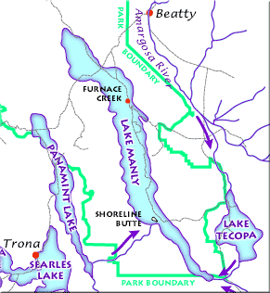
Figure 1. Pupfish locations. Lake Manly centered in the middle was one of the main contributors to the pupfish populations and habitat. The Amargosa River, which is still present today, was another large contributor to the pupfish populations.

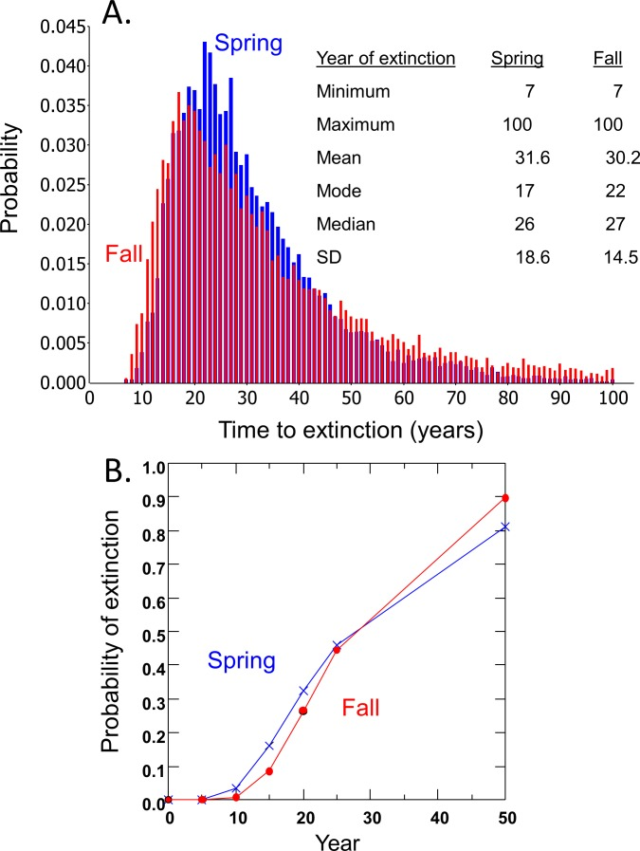
Figure 2. Extinction of pupfish. Part A and B show the estimated extinction rate of the pupfish in Devil’s Hole for the Fall and Spring sessions. It is more probable that the pupfish will go extinct during the fall session.

Citations:
Beissinger, SR. 2014. Digging the pupfish out of its hole: risk analyses to guide harvest of Devils Hole pupfish for captive breeding. PeerJ, 2:e549.
Bruce J Turner. 1973. Genetic divergence of Death Valley pupfish species: biochemical versus morphological evidence. Wiley: https://onlinelibrary.wiley.com/doi/epdf/10.1111/j.1558- 5646.1974.tb00748.x
Christopher H. Martin, Jacob E. Crawford, Bruce J. Turner, and Lee H. Simons. 2016. Diabolical survival in Death Valley: recent pupfish colonization, gene flow and genetic assimilation in the smallest species range on earth. Proceedings B, 283:20152334.
David D. Duvernell, Bruce J. Turner. 1999. Variation and divergence of Death Valley pupfish populations at retrotransposon-defined loci. ResearchGate: https://www.researchgate.net/profile/Bruce_Turner/publication/228601647_Variation_an d_Divergence_of_Death_Valley_Pupfish_Populations_at_Retrotransposon- Defined_Loci/links/00b4951793ba363ae8000000/Variation-and-Divergence-of-Death- Valley-Pupfish-Populations-at-Retrotransposon-Defined-Loci.pdf
Gene Helfman, Bruce B. Collette, Douglas E. Facey, Brian W. Bowen. 2009. Explosive speciation and species flocks. Pages 308-312. 2en edition. John Wiley and Sons.
J. Michael Reed, Craig A. Stockwell. 2014. Evaluating an icon of population persistence: the Devil's Hole pupfish. NCBI, 281(1794):20141648.
Sarah Stark. 2004. Cyprinodon diabolis Devils Hole pupfish. Animal Diversity Web, Michigan. Available from: https://animaldiversity.org/accounts/Cyprinodon_diabolis/
Sean C. Lema. 2008. The phenotypic plasticity of Death Valley’s pupfish. American Scientist: https://web.calpoly.edu/~slema/Lema_Laboratory/Research_files/Lema%202008.pdf
Figure one:
https://www.nature.nps.gov/geology/usgsnps/deva/ftsho1.html

Figure two:
Beissinger, SR. 2014. Digging the pupfish out of its hole: risk analyses to guide harvest of Devils Hole pupfish for captive breeding. PeerJ, 2:e549.

