Plastic and its impact on modern day life

How plastic affects the world

Microplastics are tiny pieces of plastic used in everyday items such as toothpaste, beauty products, cleansers, and much more. They are made up of polyethylene, less than five millimeters long, and often contain toxins such as DDT and BPA. They can absorb or emit toxic chemicals as well¹. It is estimated that there are 15 to 51 trillion pieces of microplastics floating in the oceans². Microplastics affect many marine organisms such as small filter-feeding red crabs and larvaceans. These organisms transport and absorb microplastics in their mucus filters³. These filters become clogged and are shed; once shed the filters fall to the ocean floor and serve as a food source for other marine animals. This affects the food webs throughout the ocean whether it is surface or deep ocean waters⁴.

Naked pros

First, plastics make up a large portion of our everyday lives. It can be found in almost every product we use. In 2015 350 million tonnes of plastic was produced by companies⁵. This mass
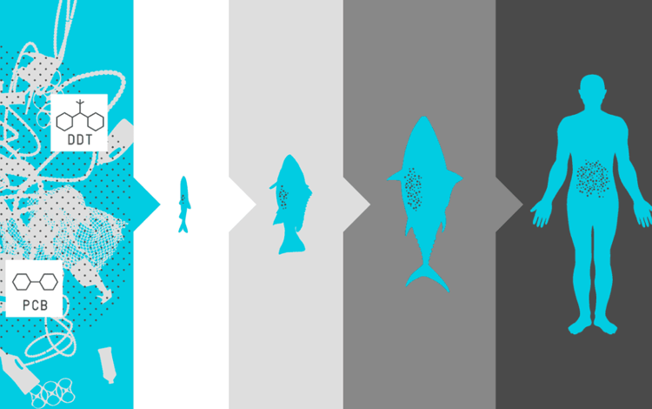
production allows for economic growth. It is estimated that plastic production alone produces ~600,000 jobs⁶. Second, plastic also allows for easy storage, protection, and transportation of items. Plastic can help aid in sanitization and the resistance of contamination by blocking out bacteria. Antimicrobial plastics are largely used for medical supplies and are polymers with antimicrobial activity. This means that they prohibit the growth of bacteria, mold, and fungi⁷. Lastly, plastic waste can be used to produce energy and heat. This can be achieved by burning plastic, which in turn allows for less plastic pollution and decreasing the need for burning fossil fuels⁸.

📸 © Think Bigger Be Better

Naked cons

First, it is estimated that the United States dumps 8 trillion microbeads into the oceans every day. Roughly 700 marine organisms are affected by this pollution, and at least 10% of those marine animals have ingested plastic⁹. The plastic that is ingested can reduce food consumption, reduce the amount of energy available for the organism’s growth, and kill or endanger an organism¹⁰. Second, plastic bottles are not as safe as they were once believed to be. It was found that plastic water bottles can emit different chemicals into your body. BPAs such as estrogen have been found in drinking water and many other liquids that are stored in plastic¹¹. Third, burning plastics can eliminate ground and water pollution, but dramatically increase air pollution. During the combustion noxious fumes are released into the air and atmospheres. This can cause adverse health effects due to the amount of carbon monoxide gas and carbon dioxide that is generated during the burning process¹².

Plastic definition: specifically: any of numerous organic synthetic or processed materials that are mostly thermoplastic or thermosetting polymers of high molecular weight and that can be made into objects, films, or filaments³³.

Why is it a pressing issue now?

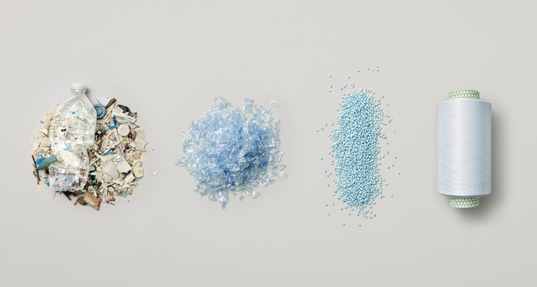
Plastic is one of the largest and easiest packaging options today. Products used to be packaged by metal, paper, wood, and glass. If there are so many options, then why use plastic? Plastic didnt start to be used as a packaging application until World War 2. Plastic is cheap, easy to make, and can be mass produced quickly. It has replaced most other packaging options because of its ability to be easily retained. The issue with replacing organic/easily recyclable materials such as wood and paper, is that plastic takes longer to degrade. Plastic is one of the largest pollutants in the world. It is hard to recycle, it can take up to 1,000 years to degrade, and it can harbor and emit harmful toxins. It is an issue now because plastic was hardly used before the 1930s and now it is used in everything¹³. With more and more research being done it is becoming drastically implied that plastic is causing issues in marine life, land and air pollution, as well as food chain destruction.

📸 © Tennis Express

The technological background of plastics

History of plastics

Plastic has a long history going back to where it started in the 1840s. A man named Charles Goodyear found that you could treat rubber with sulfur through vulcanization to give it properties we now know are plastic like. Goodyear patented this treatment and his discovery allowed others to learn how to create plastic¹⁴. This breakthrough came in 1907 when Leo Bakeland developed the first synthetic polymer, Bakelite. From here, multiple different types of plastics were produced, and mass production began in the 1940s¹⁵.

Types of plastic

We now have seven main types of plastics. They are polyethylene terephthalate (PET), High density polyethylene (HDPE), polyvinyl chloride (PVC), low density polyethylene (LDPE), polypropylene (PP), polystyrene or Styrofoam (PS), and other miscellaneous plastics. PET and HDPE are most commonly found in bottles. LDPE is used in grocery and bread bags while PP is used in yogurt and other food containers. PS is used for plates, cups and packaging while PVS, the plastic least common for pollution problems, is mainly used in plumbing and pipes¹⁶.

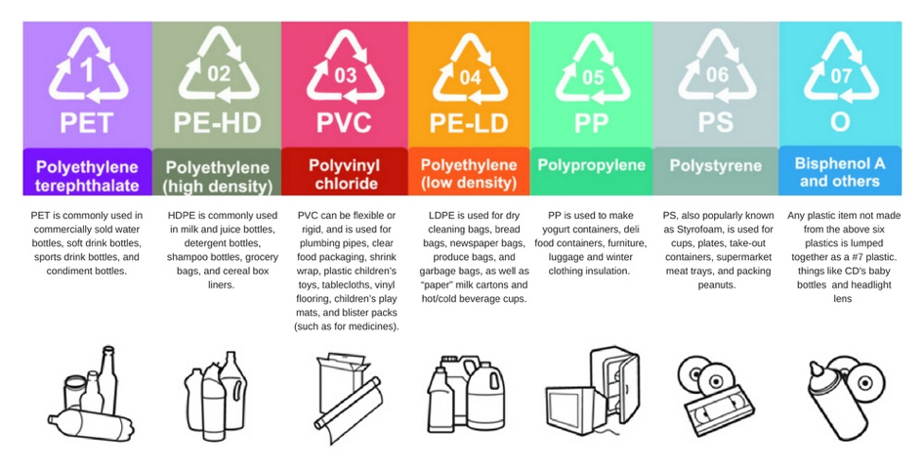
📸 © Quality Logo Products
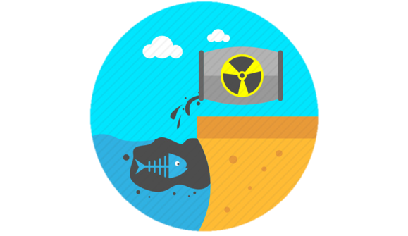
How does plastic break down

While it takes a long amount of time, it is possible for plastic to be broken down through photodegradation. However, the amount of time this takes depends on what type of plastic is being degraded. Polyethylene and polypropylene are the plastics most resistant to photodegradation and take the longest to break down. Once plastic is degraded, it becomes dissolved organic carbon (DOC) which is healthy and utilized by marine bacteria. 📸 © Clipartmax
The amount of DOC released as a byproduct of photodegradation depends on the chemistry of the plastic types. This is because the different plastic types are composed of different polymers, mass units of a single material, and each polymer affects the byproducts of photodegradation. Along with DOC, polyethylene can also release leachates which are a byproduct that can stop microbial growth and negatively impact the oceans’ microbes¹⁷.

Ocean pollution and microplastics

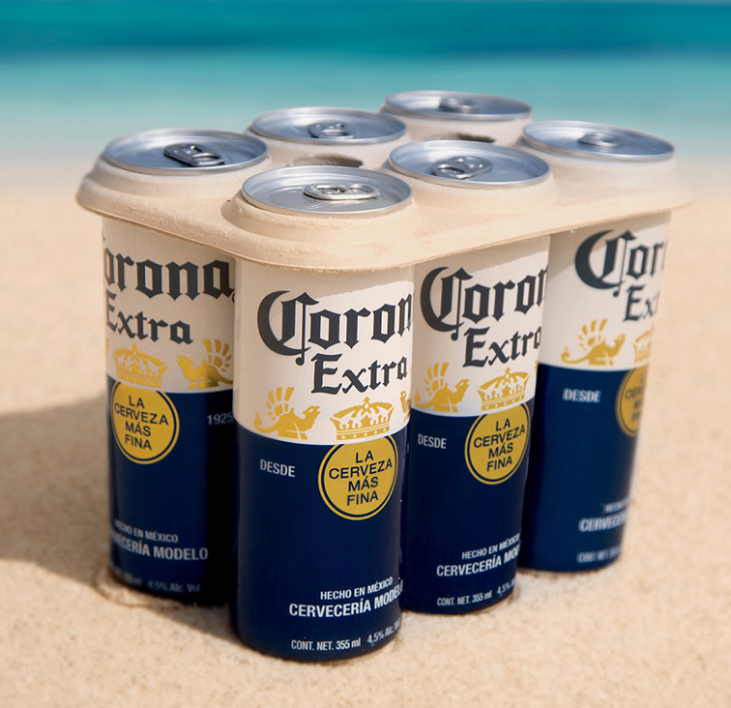
Along with these leachate byproducts, plastic pollutes the environment in more obvious ways as well. In 2011, the annual production of plastic reached 280,000,000 tons. Only 20% of this plastic was recycled leaving the rest as waste. This waste can then get into the ocean after getting caught in sewage drains, rivers, wind, floods, and other things¹⁸. Once in the ocean, the plastic breaks down due to photodegradation as already mentioned. Unfortunately, this plastic waste breaks down into microplastics through that process long before it fully degrades. These microplastics are capable of absorbing toxic chemicals and other pollutants which can kill marine life when ingested. Even when technically harmless, the microplastics can build up in an animal’s digestive system until it forms a block and can lead to the organism’s death¹⁹. Aside from harming marine wildlife, microplastic is also potentially harmful to humans. Microplastic can escape into the air and has been found in human lungs. They can serve as a respiratory irritant and cause lesions in the lungs, lead to disease in the interstitial tissue, and are a possible contributor to cancer if its already absorbed toxins. People with preexisting respiratory conditions are more at risk for microplastics to cause harm in their respiratory system. This could become a more serious problem as the amount of microplastics in the air increases²⁰.
Photocreds: Packaginginsight

Modern-day applications of plastics

Use of plastics

Modern plastics have been around for the past century, but what was the need for the first start of plastics. Going back thousands of years before Christ, the Olmecs in Mexico played with balls made of a natural polymer – rubber. Years since there have been countless discoveries and uses of polymers, but the first use of modern synthetic plastics started in the early 1900s²¹. By the 1930s the plastic industry was booming due to the war effort. They were used for military vehicles to radar insulation, but unfortunately after world war II the industry faced a halt. Soon after, products like Tupperware and drink bottles were being produced for every household. Modern-day plastics are found in almost every household ranging from bed frames to kitchen spoons. Plastic has become an everyday use for humans and the thought of a different reality is hard to imagine.

Use of recycling

Recycling has become a worldwide movement involving discussions in schools, communities, and politics. It has been implemented in our daily lives, but what does the process involve? There are two main methods for breaking down plastics: mechanical and chemical. Mechanical recycling includes collection, sorting, washing, and grinding of plastic material, order depending on the origins and composition of the waste²². Although mechanical is the most common method of recycling there are disadvantages thus the method of chemical recycling. Chemical recycling converts the polymers into small molecules very similar to thermochemical and catalytic conversion processes²². Producing fuels from plastic waste is a very attractive route because it is an efficient breakdown of plastics while utilizing its properties. One thermochemical conversion process is a thermal degradation method where larger polymeric chains and biomass are broken into small hydrocarbons²³. This approach has huge potential to cut down experimental time and material needed for optimization.

Biodegradable alternatives

Although recycling plastic is a better option than the alternative, landfills or waterways, plastic alternatives like plant-based, biobased, and biodegradable material could be a safer, more environmentally friendly option. Natural proteins exhibit interesting properties as fibers or adhesives. Cellulose and starch show properties of toughness, strength, and elasticity. PHAs are a group of biodegradable macromolecules that are synthesized by microorganisms are utilized by packaging and coatings of plastics²⁴. There are three main groups based on the production of biobased and biodegradable polymers. (1) chemical polymerization of monomers stemmed from biological processes, (2) biosynthesis of polymers in microorganisms, (3) modification of natural polymers²⁵. These developments have been in place, although, will most likely remain less superior due to cost and material. However, biodegradable and biobased materials are superior for environmental safety as well as sustainability.

Alternative materials

The best alternative would be reusable plastics and materials. This will cut costs and production by half or more. Materials like glass and metal are becoming more common among environmentally safe products. Metal straws became a fad and increasingly popular among the younger generation due to social media trends. According to USA Today, 500 million drinking straws are thrown away daily²⁶. Other popular alternatives are bamboo, silicone, acrylic, paper, and pasta. Unfortunately, the energy used to produce these alternatives posts greater than plastic straws, but with maximum use and storage, these alternatives should have a net positive impact.
Microplastic: small pieces of plastic, less than 5mm in length, that occur in the environment as a consequence of plastic pollution. Microplastics are present in a variety of products: cosmetics, synthetic clothing, plastic bags, and bottles.³⁴

Future Questions

The future of plastics

The future of continued plastic use and its effects on the environment are unknown as of right now. As of right now, the only efforts we have been informed about that can have a positive impact on the environment are recycling, replacing single-use plastics with reusable plastics, or using eco-friendly alternatives. One commonly used alternative is biodegradable plastics, these plastics are made from biological sources such as starch, cellulose, fatty acids, sugars, and proteins. Many people have begun taking steps towards lowering their plastic consumption, such as using metal or silicone straws rather than plastic and using reusable metal bottles. Others have chosen to use paper or cloth shopping bags, several places such as Hawaii, California, and New York have banned the use of plastic bags²⁷.
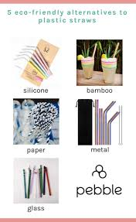
📸 © Pebble Magazine

One very helpful change would be switching to bipolymer packing rather than plastic packaging, tests show that biopolymer packaging has higher attributes such as being better for thermal packaging²⁸. Biodegradable plastics could end up having a high positive outcome because they can easily be consumed by microorganisms, which will lower the amount of pollution that continues to build-up with the continuous use of plastics. These materials could also lessen the bioaccumulation of microplastics in the food web as well as the casualties that occur in species such as turtles, fish, and birds.

3D-Printing

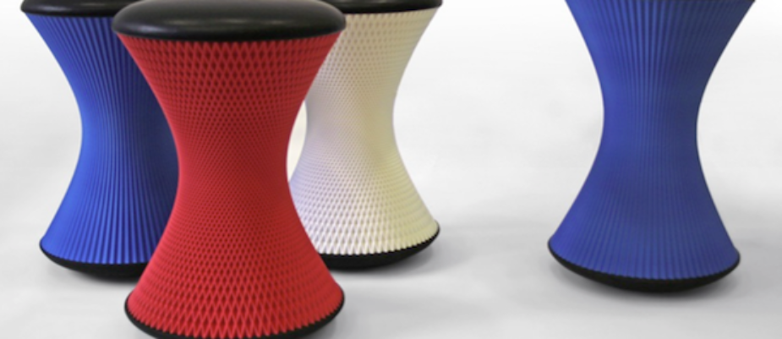📸 © WOW Magazine

A new advancement that could help with plastic pollution is 3D printing since this is such a new technology we still have more to learn about its benefits. One benefit we know for sure is that 3D printing can be used to make plastic easier and cheaper very quickly. It doesn’t take many workers and it doesn’t have as large of a workload as plastic factories, making it very affordable²⁹ . Although 3D printers most commonly create plastic objects they are able to use biodegradable material such as PLA (polylactic acid), which is made up of corn starch making it very environmentally friendly³⁰.

Comparison to recall system

Some states have the “National beverage container deposit legislation” this bill says that with every bottle purchased by a consumer, the retailer receives a deposit. Once the consumer recycles the empty bottles at the retailer or a different redemption center they will receive a refund. If the consumers decide to not redeem the deposit it is returned to the state, distributor, or by the program administrators³¹. If all states implemented this system it could be more of an incentive to recycle plastics, which would lower pollution rates enormously. One big conflict that would need to be fixed if we quit using plastics completely is the economy. Currently, the plastic industry employs approximately 600K jobs³². Along with employment, the movement of less plastic use and the possible definite end of plastics has a lot of challenges to overcome. These challenges include natural resource consumption, capital requirements, litter, solid waste, environmental quality, convenience, and prices. If we can overcome these challenges with different alternatives, the step to using fewer plastics and reversing the present environmental damage will be easier to take and accomplish.

What now? Where do we stand?

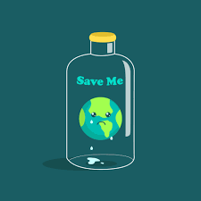
As of right now, people are conflicted when it comes to taking a stand on the debate about plastics. Many people are trying to do their part by slowly replacing plastic in their lives by replacing plastic straws with alternatives or replacing plastic shopping bags with paper or reusable cloth bags. Plastic is the safest method of storing food and other things like sterile medical tools, so before we can get rid of them we need to find other safe alternatives for storage. The best way to lower plastic pollution in the environment is by switching to biodegradable plastics, which would also keep plastic out of the food chain. Most people aren’t using biodegradable plastics because they are more expensive, lowering the price would be a beneficial incentive. As of right now, we are trying to increase the use of plastic alternatives but, we have a way to go before we can put a dent in worldwide plastic pollution. Making plastic alternatives a top priority needs to happen before the damage caused by plastic pollution cannot be reversed

📸 © Vecteezy

Citations:

- Microplastics: Your Environment, Your Health | National Library of Medicine. 2017 May 31. U.S. National Library of Medicine. https://toxtown.nlm.nih.gov/sources-of-exposure/microplastics

- Woodward A. 2019 Jun 6. More plastic pollution is swirling in the deep ocean than in the Great Pacific Garbage Patch. It's even showing up in the intestines of sea creatures. Business Insider. https://www.businessinsider.com/plastic-pollution-microplastics-pervade-surface-deep-ocean-2019-6

- Katija K, Choy CA, Sherlock RE, Sherman AD, Robison BH. 2017 Aug 16. From the surface to the seafloor: How giant larvaceans transport microplastics into the deep sea. Science advances.
https://www.ncbi.nlm.nih.gov/pmc/articles/PMC5559207/

- Setälä O, Fleming-Lehtinen V, Lehtiniemi M. 2013 Nov 9. Ingestion and transfer of microplastics in the planktonic food web. Environmental Pollution. https://www.sciencedirect.com/science/article/pii/S0269749113005411

- Ritchie H, Roser M. 2018 Sep 1. Plastic Pollution. Our World in Data. https://ourworldindata.org/plastic-pollution
- Plastics Product Manufacturing - May 2018 OES Industry-Specific Occupational Employment and Wage Estimates. 2019 Apr 2. U.S. Bureau of Labor Statistic. https://www.bls.gov/oes/2018/may/naics4_326100.htm

- Antimicrobial polymer. 2020 Mar 15. Wikipedia. https://en.wikipedia.org/wiki/Antimicrobial_polymer

- Kalargaris I, Tian G, Gu S. 2017 May 8. The utilisation of oils produced from plastic waste at different pyrolysis temperatures in a DI diesel engine. Energy. https://www.sciencedirect.com/science/article/pii/S0360544217307818#fig1

- Gall SC, Thompson RC. 2015 Feb 10. The impact of debris on marine life. Marine Pollution Bulletin. https://www.sciencedirect.com/science/article/abs/pii/S0025326X14008571

- Watts AJR, Urbina MA, Corr S, Lewis C, Galloway TS. 2015. Ingestion of Plastic Microfibers by the Crab Carcinus maenas and Its Effect on Food Consumption and Energy Balance. Environmental Science & Technology 49:14597–14604.
https://pubs.acs.org/doi/abs/10.1021/acs.est.5b04026

- Lubick N. 2009. More bad news about plastic containers? Environmental Science & Technology 43(10), 3406-3406. doi: 10.1021/es900885t https://pubs.acs.org/doi/full/10.1021/es900885t

- Kuti R, Nagy A. 2016 Jul. The Environmental Impact of Plastic Waste Incineration. https://www.uni-nke.hu/document/uni-nke-hu/aarms-2016-3-03-nagy-kuti.original.pdf

- www.performans.com PITS. History of Packaging. Packaging Manufacturers Association. http://ambalaj.org.tr/en/environment-history-of-packaging.html

- Richardson C. G. (2010). Redefining vulcanization: Charles Goodyear, patents, and industrial control, 1834-1865. Technology and Culture, 51 (2): 357-387.
- Thompson R. C., Swan S. H., Moore C. J. and Saal F. S. V. (2009). Our plastic age. Philosophical Transactions, 364 (1526): 1973-1976.
- Mertes A. 2019. What are the different types of plastic. Retrieved from https://www.qualitylogoproducts.com/promo-university/different-types-of-plastic.htm.
- Romera-Castillo C., Pinto M., Langer T. M., Alvarez-Salvgado X. A. and Herndl G. J. (2018). Dissolved organic carbon leaching from plastics stimulates microbial activity in the ocean. Nature Communications, 9: 1-7.
- Reisser J., Shaw J., Wilcox C., Hardesty B. D., Proietti M., Thums M. and Pattiaratchi C. (2013). Marine plastic pollution in waters around Australia: characteristics, concentrations, and pathways. PLOS ONE, 8 (11): 1-11.
- Hall N. M., Berry K. L. E., Rintoul L. and Hoogenboom M. O. (2015). Microplastic ingestion by scleractinian corals. Marine Biology, 162: 725-732.
- Prata J. C. (2018). Airborne microplastics: consequences to human health. Environmental Pollution, 234: 115-126.
- Knight., L. 2014. A brief history of plastics, natural and synthetic. BBC News Magazine.

- Ragaert, K., et al. Mechanical and chemical recycling of solid plastic waste. Waste Management (2017), http://dx.doi.org/ 10.1016/j.wasman.2017.07.044

- Kunwar., B. Moser., B. Chandrasekaran., S. Rajagopala., N. & Sharma., B. 2016. Catalytic and thermal depolymerization of low value post-consumer high density polyethylene plastic. Energy.884-892.

- Scheller., J. & Conrad., U. 2005. Plant-based material, protein and biodegradable plastic. Science Direct. 8: 188-196.

- Sudesh., K. & Iwata., T. 2008. Sustainability of Biobased and Biodegradable Plastics. Clean. 36(5-6, 433-442.

- Aspergren., E. 2019. Plastic straws are trash. Are there alternatives that don’t suck? USA Today.

- Woodward, A. (2019, April 3). In some countries, people face jail time for using plastic bags. Here are all the places that have banned plastic bags and straws so far. Retrieved from https://www.businessinsider.com/plastic-bans-around-the-world-2019-4

- Silva, N., & Blumberga, D. (2019). Why Biopolymer Packaging Materials are Better. Environmental and Climate Technologies, 23(2), 366–384. doi: 10.2478/rtuect-2019-0074

- Schultz, J. (n.d.). State Beverage Container Deposit Laws. Retrieved from https://www.ncsl.org/research/environment-and-natural-resources/state-beverage-container-laws.aspx

- Plastics Product Manufacturing - May 2018 OES Industry-Specific Occupational Employment and Wage Estimates. (2019, April 2). Retrieved from https://www.bls.gov/oes/2018/may/naics4_326100.htm

- 3D Printing As A Circular Technology. (2018, September 18). Retrieved from https://plasticoceans.org/3d-printing-as-a-circular-technology/

- Canessa, E., Fonda, C., Zennaro, M., & Deadline, N. (2013). Low-‐cost 3D printing for science, education and sustainable development. Low-Cost 3D Printing, 11.
- "Plastic."Merriam-Webster.com. Merriam-Webster, 2011.Web. 8 May 2011.
- (Rogers K. 2019 Apr 22. Microplastics. Encyclopædia Britannica. [accessed 2020 Feb 25]. https://www.britannica.com/technology/microplastic

