Does Armadillidium vulgare Prefer Wet or Dry Substrate?
Rayven Brown, Nikki Copenhaver, Megan Curry, Reece Theakston
Longwood University

Introduction

The terrestrial isopod Armadillidium vulgare are small in size, but play a vital role in the ecosystem, gardening soils, and many agricultural aspects. Common names such as the pill-bug, potato bug or roly-poly come from their capability of conglobation. Conglobation is the action of rolling up into a ball; they will do this to protect themselves from predators and reduce water loss from their body (Jacob et al. 2008). A vulgare was originally classified by Latrielle in 1804 (ITIS Report, 2019). They are native to Europe, but were brought over to the United States. They are typically found in temperate, tropical, or terrestrial habitat regions (Holland, 2014) . A. vulgare possess gills which leads them to be found more often in moist environments (Phipps, 2009). Most of these “moist” environments include fallen leaf litter and under rocks and stones.
Armadillidium vulgare are classified as detritivores. They are a vital part of many biogeochemical processes including: cycling nutrients such as nitrogen, carbon, and phosphorous throughout the ecosystem. These organisms feed orally on material from primary producers such as plants, but also on material from dead and decaying carnivores and herbivores, therefore, they are present throughout all trophic levels. Since A. vulgare eat plants, they are also considered to be a biological weed controller (Holland, 2014). As well as consuming detritus, A. vulgare also serves as a food source for secondary consumers, providing an essential component in the overall ecosystem energy cycle. A 2008 study conducted by Monteiro et al found that through bottom up regulation, isopods like A. vulgare actually serve as an important source of cadmium to their predators on higher trophic levels.
Farmers and gardeners are constantly trying to keep pests away from their crops and plants. A. vulgare have been found to feed on seedlings and plant roots. They can also be found feeding on crops such as tomatoes, lettuce, peas, beans, and radishes. Since they feed on a variety of crops and products that farmers value, A. vulgare have been labeled as pests. However, there have been studies that show how beneficial A. vulgare can be. In one study, done in a hardwood forest in central Florida, they found that there was an increase in pH, phosphorous, potassium, and nitrogen and an increase of excess carbon removal in soil with A. vulgare present and helping with decomposition (Frouz et al. 2008). Another study done, showed similar results with double the amount of nitrogen, a 1.2 increase in phosphorus and a 25% decrease in carbon in soil with A. vulgare present compared to the control (Tripathi et al. 2006). The amount of phosphorous, carbon, potassium, and nitrogen and pH levels are all important factors in growing plants.
The presence of A. vulgare improves soils to create a better environment for growth. This ability makes these organisms especially useful in the restoration of perturbed soils (Snyder and Hendrix, 2008). If farmers and gardeners want to use A. vulgare for beneficial effects they need to know what type of environment they prefer. The specific aim of this study is to determine if A. vulgare prefers a moist substrate over a dry substrate. It is hypothesized that if A. vulgare is put in an arena with two habitat options, one filled with a moist substrate and one with a dry substrate, then A. vulgare will spend the majority of the observed time in the habitat with a moist substrate. It was hypothesized that they would prefer the moist substrate because they do possess gills, and need water to live.

Methods

Substrate moisture preferences for Armadillidium vulgare were tested using an artificial environment consisting of a plastic tray with two arenas- one containing moist potting soil and one containing dry potting soil. Twenty milliliters of room temperature tap water was added to the potting soil in the arena designated to have wet substrate and no treatment was given to the soil in the arena designated to have dry substrate. Substrate type and amount of water added to the wet side were kept constant for each trial. No cover, such as paper towels or sponges, was provided to the pill-bugs during trials for ease of data collection and consistency.
Five pill-bugs were used during each trial for a total of fifteen individuals in the sample population. Prior to placing the subjects into the artificial environment for a five minute acclimation period, pill bugs’ carapaces were marked using colored nail polish so researchers could more easily differentiate between individuals. The five individuals in each trial were marked as having one of the following: one small dot, one giant blob, one stripe, two small dots, or remaining completely unmarked. Data was collected using scan sampling over three consecutive periods of fifteen minute increments. During each observation period researchers counted the time each individual spent in each arena in seconds and recorded it on a shared spreadsheet. Results for pill-bug substrate preferences were then calculated based on this data using the matched sign test. More than seven minutes spent in an arena was considered positive for the sign test and less than seven minutes spent in an arena was considered negative.

Results

According to data analyses, 80% of the time, pill-bugs stayed in dry substrate longer, while only 20% of the time pill-bugs spent more time in the wet substrate (Fig 1). This is contrary to the original hypothesis that pill-bugs would spend the most amount of time in moist substrate. Based on the data from tables one, two, and three, the least frequent sign was negative. This was consistent across all three trials and had only three exceptions in which subjects spent more time in wet soil, therefore x=3. The number of pairs that showed a difference was 15, therefore, N=15. With an x value of 3 and an N value of 15, p= 0.018. Since p=0.018 < p=0.05, the null hypothesis- the amount of time in seconds spent in the wet arena will be the same as the number of seconds spent in the dry arena- can be rejected in favor of an alternate hypothesis.

Trial 1
SUBJECT | TIME IN WET | TIME IN DRY | SIGN OF DIFFERENCE
1 Dot |  | 15 MIN 0 SEC (900 s) | +
Giant Blob | 4 MIN 20 SEC (260 s) | 10 MIN 40 SEC (640 s) | +
1 Stripe |  | 15 MIN 0 SEC (900 s) | +
2 Dots |  | 15 MIN 0 SEC (900 s) | +
Unmarked | 10 MIN 30 SEC (630 s) | 4 MIN 30 SECONDS (270 s) | -
Table 1. Amount of time Armadillidium vulgare spent in wet versus dry substrate during trial one
Trial 2
SUBJECT | TIME IN WET | TIME IN DRY | SIGN OF DIFFERENCE
1 Dot | 1 MIN 29 SEC (89 s) | 13 MIN 31 SEC (811 s) | +
Giant Blob | 5 MIN 9 SEC (309 s) | 9 MIN 53 SEC (593 s) | +
1 Stripe | 5 MIN 38 SEC (338 s) | 9 MIN 27 SEC (567 s) | +
2 Dots | 1 MIN 32 SEC (92 s) | 13 MIN 28 SEC (808 s) | +
Unmarked | 5 MIN 40 SEC (340 s) | 9 MIN 24 SEC (564 s) | +
Table 2. Amount of time Armadillidium vulgare spent in wet versus dry substrate during
trial two

Trial 3
SUBJECT | TIME IN WET | TIME IN DRY | SIGN OF DIFFERENCE
1 Dot | 4 MIN 47 SEC (287 s) | 10 MIN 18 SEC (618 s) | +
Giant Blob | 6 MIN 35 SEC (395 s) | 8 MIN 30 SEC (510 s) | +
1 Stripe | 12 MIN 0 SEC (720 s) | 3 MIN 0 SEC (180 s) | -
2 Dots | 2 MIN 25 SEC (145 s) | 12 MIN 30 SEC (750 s) | +
Unmarked | 11 MIN 32 SEC (692 s) | 3 MIN 28 SEC (208 s) | -
Table 3. Amount of time Armadillidium vulgare spent in wet versus dry substrate during trial three.
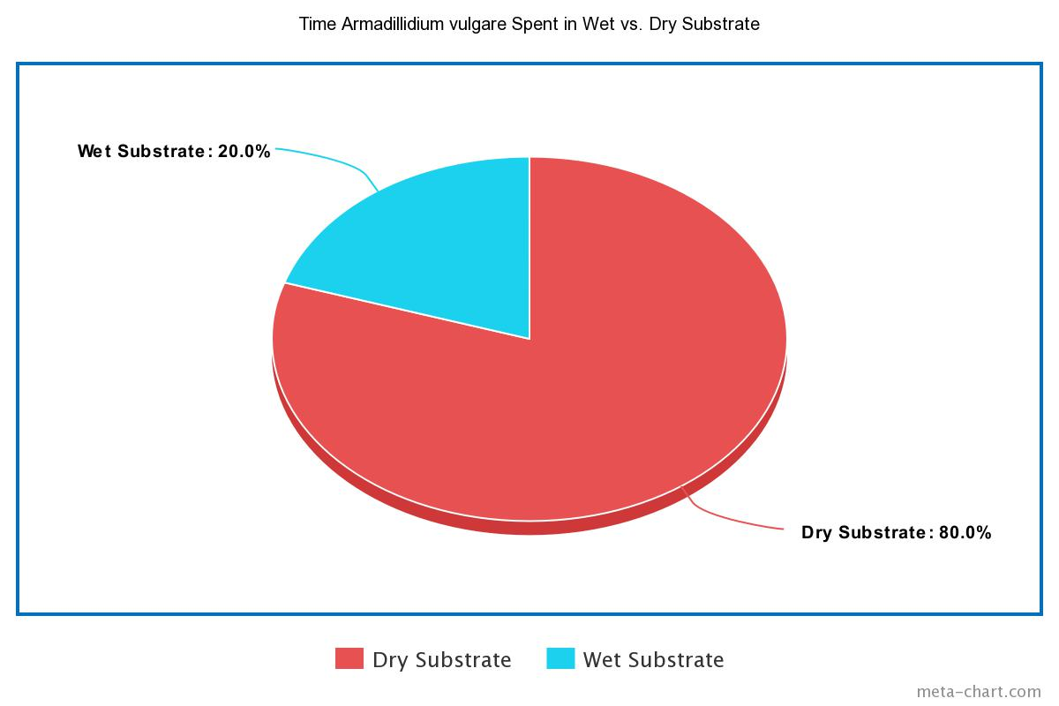
Fig 1. This pie chart depicts the substrate preference of pill-bugs based on the sign of difference used during the matched sign test.

Discussion
In this experiment Armadillidium vulgare were put into an arena with two cells, each containing a substrate with different amount of moisture, one dry and one wet. This was done to determine which substrate Armadillidium vulgare preferred. The conclusion of this experiment is that Armadillidium vulgare preferred the dry substrate over the wet substrate which does not support our original hypothesis. This conclusion was reached by measuring the amount of time spent in each substrate for five different pill bugs for three, fifteen-minute trials.
This experiment was conducted in order to determine which substrate Armadillidium vulgare preferred, dry or moist substrate. It was hypothesized that Armadillidium vulgare would prefer moist substrate due to the fact that Armadillidium vulgare have gills as respiratory organs.
Once the experiment was finished the data came back and the results showed that Armadillidium vulgare spent the most time in the dry substrate over the moist substrate spending about 80% of the time in the cell with dry substrate (Figure 1). A reason that Armadillidium vulgare spent the most time in the dry substrate could be due to the reason that the moisture level in the dry substrate was more similar to the moisture level in the substrate of the habitat that Armadillidium vulgare were being held in. Also, another possibility as to why Armadillidium vulgare could that the high level of moisture could have been too moist to the point that it could be harmful to Armadillidium vulgare (Phipps, 2009). One of the limitations of this experiment are that there were posted notes used to close off other cells which Armadillidium vulgare were possibly attracted to the cover the posted notes provided. Another limitation is that the moisture level was never properly measured leading to an unknown moisture level.
Armadillidium vulgare helps to consume decaying vegetation, helps redistribute nutrients back into the soil, and does not inflict any damage to plants, which in turn helps crops grow (Frouz,2008). Determining which substrate Armadillidium vulgare prefers could be used to benefit farmers and gardeners by allowing people to create a preferred habitat for Armadillidium vulgare to increase the amount of nutrients being put into the soil so as to produce better crop yields. This could be down my monitoring and controlling soil moisture.

Work Cited
- Frouz, J., Lobinske, R., Kalcík, J., & Ali, A. (2008). Effects of the Exotic Crustacean, Armadillidium vulgare (Isopoda), and Other Macrofauna on Organic Matter Dynamics in Soil Microcosms in a Hardwood Forest in Central Florida. Florida Entomologist, 91(2), 328–331. doi: 10.1653/0015-4040(2008)91[328:eoteca]2.0.co;2
- Holland, A.2014. Armadillidium vulgare pillbug. Animal Diversity Web
- Jacob T. Smigel, Allen G. Gibbs, Conglobation in the pill bug, Armadillidium vulgare, as a water conservation mechanism, Journal of Insect Science, Volume 8, Issue 1, 2008, 44, https://doi.org/10.1673/031.008.4401
- Latrielle, 1804. ITIS Report. Armadillidium vulgare. Integrated Taxonomic Information System.
- Monteiro, M.S., C. Santos, A. Soares, R. Mann. 2008. Does Subcellular Distribution in Plants Dictate the Trophic Bioavailability of Cadmium to Porcellio dilatatus (crustacea, isopoda)
- Phipps E. 2009 Apr 22. Habitat Preferences of terrestrial Isopods: a study of comparing moist and dry substrates. Holly Taylor's Web Spot
- Snyder, B. A. and Hendrix, P. F. (2008), Current and Potential Roles of Soil Macroinvertebrates (Earthworms, Millipedes, and Isopods) in Ecological Restoration. Restoration Ecology, 16: 629-636. doi:10.1111/j.1526-100X.2008.00484.x
- Tripathi, G., Ram, S., Sharma, B. M., & Singh, G. (2006). Fauna-associated changes in soil biochemical properties beneath isolated trees in a desert pastureland of India and their importance in soil restoration. The Environmentalist, 29(3), 318–329. doi: 10.1007/s10669-008-9196-y

