**Hypothesis and Question**

The hypothesis that was posed stated that Sprite’s nutrients will help the plants grow more than just tap water. Therefore, the main concern was what are the effects of tap water compared to Sprite on plant growth?

**Results**

The purpose of this experiment was to test the effects of Sprite saturation for plant growth compared to normal watering methods. Three variables, root length, stem length, and number of flowering buds, were measured and then averaged. In Figure 1, the subjects tap water (control) and Sprite (experiment) fed plants, were measured by their root lengths and then charted. Tap water’s average root length was 56mm, and Sprite’s was 7mm. Comparably the tap water caused the roots to grow the longest, making the average’s difference 49mm. (Fig. 1).

The subjects in Figure 2 were measured by their stem lengths (from top of root to the end of the plant). Tap water’s average stem length was 98.125mm, and Sprite’s was 26.5mm. Clearly showing, the tap water caused the stems to grow the longest, making the average’s drastic difference be 71.625mm. (Fig. 2).

The subjects in Figure 3 were measured by their number of flowering buds (fully bloomed buds). Tap water’s average number of flowering buds was about 3.75mm, and Sprite’s was about 3.5mm. In the graph, it drastically shows the tap water growing a larger amount of flowering buds, but the average’s difference was only .25mm. (Fig. 3).

**Figure 1. Averages of root lengths for plants fed with tap water or Sprite.** The data is shown for the control plants, which were fed with tap water, and the experimental plants, which were fed with Sprite. The difference between the two plants averages were roughly 49mm, thus showing that the tap water fed plants successfully thrived more than the Sprite fed plants.

**Figure 2. Averages of stem lengths for plants fed with tap water or Sprite.** This graph compares the relationship of the experimental groups average stem length to the control groups average stem length. The difference between numbers shows the trend that the control group of plants thrived more.

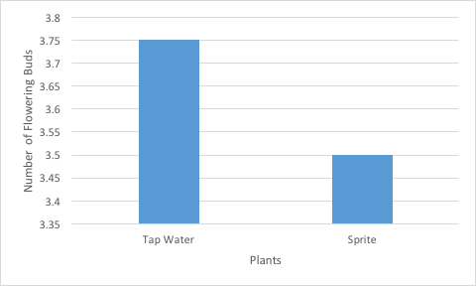

**Figure 3. Average number of flowering buds for plants fed with tap water of Sprite.** The data is shown for the control plants, which were fed with tap water, and the experimental plants, which were fed with Sprite. The difference between the two plants averages were roughly .25mm. The figures show that the tap water plants produced barely a few more flowering buds than the Sprite fed plants.

**Figure legends 2 & 3, were used from other student’s data in the group. We thought it would be more uniformed if we all had the same figure legends.**