Shawna McCann

Dr. Guler

English 400-16

October 17th, 2018

Fighting Child Abuse with Mall Advertisements

Child abuse is a major social issue in today’s society. Most children who are being abused are abused by somebody close to them, either a family member or a close friend. Because of this sad reality, many children are too afraid to report abuse or do not know to whom they can report the abuse to. When an abuser is somebody that is in a caregiver position, it can be difficult to know who are the people to turn are in order to get help. When a parent is the abuser, children can be scared to report anything because they still love that parent and do not want to lose them, on the other hand the child may also not realize abuse is happening or that it is something that is not okay.

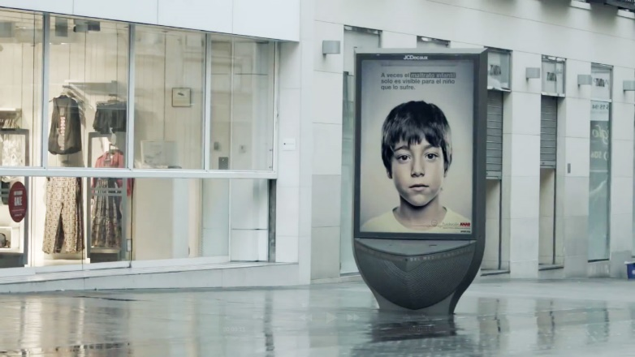ANAR, Aid to Children and Adolescents at Risk Foundation, is a not-for-profit organization in Spain that is dedicated to protecting children. They have established two programs to do this through, ANAR home and ANAR telephone. ANAR telephone is the program that the artifact being analyzed is based off of. ANAR decided to take an original and unique approach to spread the message to children that child abuse is not okay and that they can reach out for help. ANAR created a visual advertisement, which could also be classified as a public service announcement. The advertisement was set up in an outdoor shopping center in Spain. The artifact shows a male boy with words in Spanish around him, the unique aspect is that it shows a different image to people of different height. To anybody above four feet and five inches you see a sad child with the saying “sometimes, child abuse is only visible to the child suffering it”, but to anybody under four feet and five inches you see an image of a child with bruises and a message that says “if somebody hurts you, phone us and we will help you” and then it lists the foundation’s telephone number.

The purpose of this artifact is to bring an important message to children without their abuser knowing they are receiving help. An abuser may want to keep children shielded from ways to get help because they do not want to get in trouble for the abuse that they are perpetrating onto the child, so by making this advertisement show different messages to children and adults, the adults do not know that the children are getting help.

**Method**

In order to analyze this artifact, ethos, pathos and logos will be used. “Logos is argument by logic (Heinrichs, p. 39, 2017).” Logos is appealing to reason and making a series of claims that support your proposition. An important aspect of logos is to use concession since it uses the opponent’s argument to your advantage. Logos is useful when analyzing this artifact because it can help reveal why the child abuse public service announcement is effective. It can also help understand the reasoning behind the way they made the announcement. Pathos is appealing to somebody’s emotion. Heinrichs states that “a successful persuader must learn how to read the audience’s emotions (p. 40, 2017).” One thing that is useful to pathos is sympathizing, aligning yourself with your listener’s pathos, or emotion. Using pathos will be useful to analyze this artifact because it can help explain why they did certain aspects of the imagery used in the announcement. Ethos is an appeal to credibility and authority. It can also be used as an argument by character, since it employs the persuader’s personality, reputation, and ability to look trustworthy says Heinrichs (p. 40, 2017). Ethos is typically the most significant appeal to make since it can hold the most implications for somebody.

Decorum is a tool used in arguments to express to your audience that they should not only do what you say, but also do what you do. It can make the speaker sound like they are the joint voice of everyone When decorum first came around, it was described as someone who was “covering voice control, gestures, clothing, and timing, as well as manners”. These same descriptive actions have been associated with concepts on how to be successful in life and how to be a strong manager and leader (Heinrichs, pg. 48, 2017).

**Analysis**

In the artifact being analyzed, logos is used because the organization who put out the public service announcement states certain claims that are appealing to logic. They make their claims to logic through the words and sentences in the announcement. These claims support their cause that child abuse is not okay. By stating that child abuse may only be visible to the children suffering from it, they are stating facts that will help them get people to realize how big of a problem child abuse is. By only pointing out facts on the public service announcement the artifact is giving an understanding of the issue they are advocating for and how important it is that people start to do something about child abuse. In the point of view that adult see, the words shown are “sometimes child abuse is only visible to the child suffering it”, and this is a form of logos since they are pointing out how someone may not see the effects of the abuse, that does not mean it is not happening.

In terms of pathos, ANAR uses the appeal to emotion by showing a picture of an abused child. Seeing such an emotion provoking image can stir up sentiments within a person and cause them to want to make a change or advocate for a change. Because the image is only a sad boy from an adult perspective, they may not see the extremes that can come from child abuse but they can see the distress in the child’s eyes and wish to help them. Not only does the image of an upset child appeal to emotion it also helps paint a picture of what the child is going through which makes it easier for a person to comprehend the severity of child abuse. Seeing the image can formulate emotions such as sadness, anger, frustration or even guilt. By getting somebody’s emotional reaction, they are then more likely to want to help or make a difference to stop child abuse from happening. It is useful to analyze this artifact by using pathos because when dealing with child abuse, it is not supposed to be easy to see or talk about so by appealing to a person’s emotions, can make the point stronger. In the image shown from the public service announcement in the child’s perspective you see a young boy with bruises on his face and a cut lip. This helps appeal to a person’s emotions because a child can see the hurt and by showing the real effects of child abuse, they can see just how horrific it can be. In making the photo so real and lifelike, they are appealing to the children’s emotions because after seeing such a raw image, the child may afraid that it could happen to them next and get that physical. It shows the child that they may not be alone in what they are going through and that somebody is out there to help and care for them.

In terms of ethos, ANAR uses the creditability appeal by putting their name on the public service announcement and that can show people passing by that they are a reliable source. Through their name they are stating that they are knowledgeable about the subject matter since they are a foundation that is specifically for helping children at risk. When someone reads a child abuse public service announcement from a foundation that focuses on helping children, then it is plausibly assumption to think they know what they are talking about. Another way the public service announcement uses an ethos appeal is by posting their hotline number on it for the children to see. Instead of just putting an office number or even no number, they put a hotline number showing that they want to provide direct assistance. The public service announcement also uses ethos by using language fit for their audience. They know the audience that they are trying to get their message to and they formulated their sentences around that. For the section in which children could see, they use small, common words that children can comprehend since they are the target audience. It would not be useful to use big, elaborate words since most children would not know them or understand them. In the section that is for adults, they use direct language without avoiding stating their purpose. This is an ethos appeal because it shows that ANAR has the credibility to know how to speak to their audiences and get them to have the reactions that they desire. It is useful to use the ethos appeal for this artifact because since they are trying to make a difference and help children who could be suffering, it is important for those children to know that they are aware of what they are doing and actually do know how to help. On the other hand, it is important for the adults to understand that this warning is coming from a credible source and by a group that knows and is educated in child abuse.

Decorum is used in this public service announcement because while they are telling their audience about how child abuse is apparent and painful to the children experiencing it, they are also making a stance against it and telling the audience how to do something against it. By giving the children’s point of view a phone number to call, children experiencing abuse can then know that this organization is speaking up and taking the measures to help, if they reach out. From the adult point of view, adults are shown a message, seeing that ANAR is doing what they are saying, making more adults motivated to report child abuse or stop abuse that they may be perpetrating onto children. It is useful to use this decorum approach because while you may be inclined to do something because somebody suggested doing something but since they are also doing something about the problem then you will be even more persuaded and take a stance.

**Conclusion**

This artifact uses ethos, pathos, and logos in order to gain the support of its audience. It uses ethos by stating their name and giving a hotline number to show their credibility and authority to be speaking on this subject. For the pathos appeal, by showing an image of a sad and then an abused child, it pulls on the audiences’ emotions since it can be a very hard to look at. When showing the very realistic aftermath of abuse it is using logos by making a claim of what abuse looks like, in conjunction with the image, ANAR also uses logos by stating the facts on child abuse.

The child abuse public service announcement gives a warning message to adults or a child abuser that child abuse is not okay and that although you may not know you could be doing it, it is still visible for the child suffering from it. For the child, it gives a message of hope stating that there are people out there who want to help you and do whatever they can in order to get the help you need. The effect this artifact has on its audience is being a sense of hope for the suffering children. While the child may not completely understand what or why this is happening to them, the public service announcement image can show that they are not alone and there is someone to turn too. It effects the older audience by telling them that it is never okay to abuse a child and that the abuse you could be perpetrating onto them has its consequences. The implications that this public service announcement has on society is that child abuse is relevant to their community and that it is a concern. By having to put up a public service announcement, it shows that this problem is serious and that it should not be taken lightly. It also implies that not only is child abuse prevalent, but that there is something that needs to be done about it. ANAR is trying to get a message across that states that this problem needs to addressed as well as that society, as a whole, needs to do better to stop child abuse from happening.

Works Cited

Grey Group Spain. *YouTube*, Grey Group, 24 Apr. 2013, www.youtube.com/watch?v=6zoCDyQSH0o.

Heinrichs, Jay. *Thank You for Arguing: What Aristotle, Lincoln, and Homer Simpson Can Teach Us about the Art of Persuasion*. Three Rivers Press, 2017.

“Quienes Somos.” *Fundacion ANAR: Ayudas a Ninos y Adolesecents En Riesgo*, ANAR , www.anar.org/.