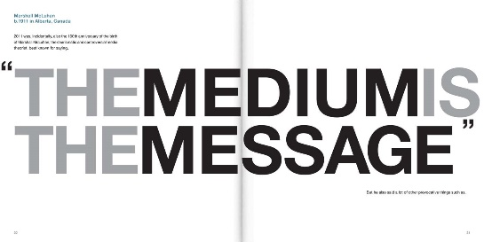Chapter 25 talks about using the right medium. Mediums are the form you use to get your message across, it could be anything from face-to-face, letter, website, announcement or multiple other options. When choosing your medium, Heinrichs talks about how it is important to consider timing, the kind of appeal being used and the gesture you are trying to make on page 292. Timing refers to how fast your audience expects a response from you and how long the message should last. The kind of appeal is important to consider because each sense you may use uses a different form of appeals. Sound uses a logos appeal, sight is mostly pathos and ethos and smell, touch and taste all use a pathos appeal. When speaking about gestures it can refer to figurative or literal gestures. For example, it can be a smile or a bonus check. I think knowing about these tips in choosing the right medium is important because it can help strengthen your argument and help convince your audience that you are right.

Chapter 28 is about writing a persuasive essay and the tools needed to write it well. Those tools are ethos, pathos and logos. The best persuasive essays are the personal ones, and that’s where ethos comes in. Using seduction techniques with an ethos appeal you can get your audience to like and trust you which can help them agree with you. Heinrichs makes a point to say twice on page 334 that even if your essay is about you, it is not about you, it is about your audience. Sometimes it is difficult to notice the differences when using pathos versus ethos because both of them make you sympathetic and empathetic as well as give you feelings about a character. Although pathos emphasizes spreading the love. The last tool is logos, which is how you get into your audiences’ head. You do this by telling them how your audience will benefit from your decision and that it is to their advantage. Even though when writing an essay your technique will be subtler.