Chapter 13 talks about how you can use an enthymeme to start to convince your audience of your argument. The enthymeme uses the commonplace to help enhance your argument by combining it with the conclusion that you want. Jason Heinrichs says on page 139 that an enthymeme is something in the mind. I think using an enthymeme would be helpful in any argument because then you can use the premise of what your audience agrees with, and formulate it to the conclusion that you desire.

Chapter 14 talks about the three deadly sins of arguing. The first one is the false comparison. One page 153, Jason Heinrichs talks about how people oftentimes pairs things together in unison, when in reality they have nothing to do with one another. When you do this, you make your audience think you are incompetent and do not know what you are talking about. The second deadly sin is the bad example. If you do not use an example that connects with the audience, they are not going to understand and then not get the point you are trying to make. I believe this to be true because when someone gives a bad example for an argument, I am less likely to join their side since they do not support what they are saying. The last deadly sin is ignorance as proof. 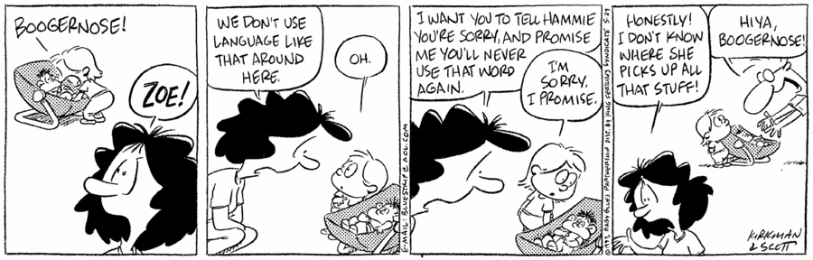This does not help your argument because if you simply cannot prove something to be true, that does not make it true. There is a disconnect in your argument and proof which causes people to not believe you.

Chapter 16 is about how you need to know who can trust. Jason Heinrichs talks about how a salesman gets his job off of his ability to lie and convince you that you are always making your best purchase. When somebody makes it a point to state their character then you are more likely to believe them since they gave you more knowledge about themselves. Salesman are oftentimes concerned about your choices which makes you feel like he is on your side, but in reality, you are falling into his argument. I think this works extremely well because if it seems like somebody is concerned about the choices you are making, then you automatically assume that they have your best interest at heart, which most of the time they do not.