Abbey Mays
Prof. Tena Ewing
Kins 215
November 22, 2019
Physical Activity Experiences
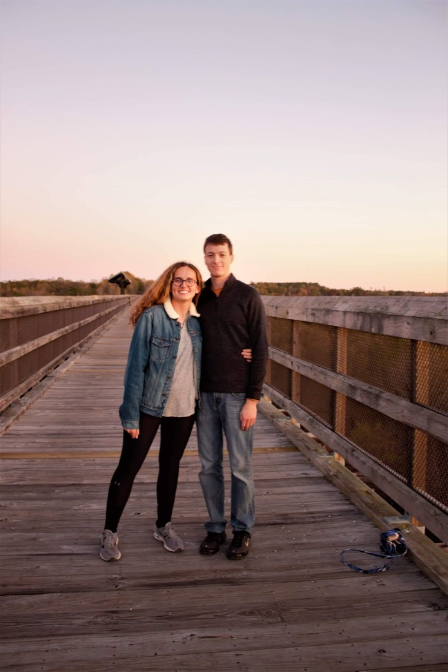
High Bridge Hike- 5 points
On November 3rd I went with my friends to High Bridge State park to go for a walk and take pictures. I go out there to think about important decisions on my life and to be in nature, so this did not get me out of my comfort zone a lot. This activity can be for any one because the trail is fairly flat, and it is a short distance from the parking area. This activity can be improved trying to get more people to come with to experience nature.

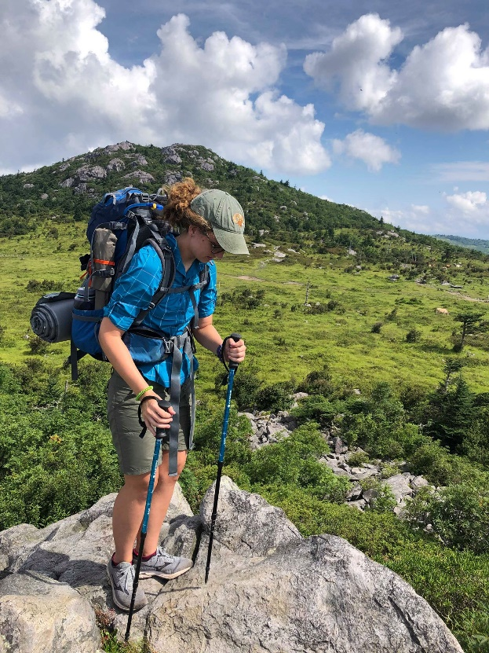
Grayson Highlands State Park- 5 points
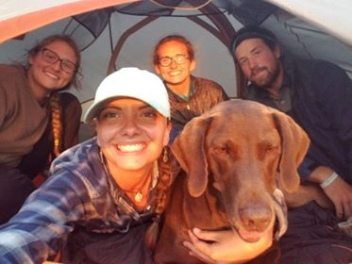
I went on a backpacking trip with friends to Grayson Highlands State Park. We covered twenty miles in two days, which brought me out of my comfort zone a lot. Although I had gone on a backpacking trip; this was the first one that I had completely planned and coordinated. I think that people who are in shape could participate in this activity. It was a lot of hard work so this would not be recommended for older adults. This activity could be improved by doing the loop that we did backwards so that you “save the best for last” because we had the best views the first day.

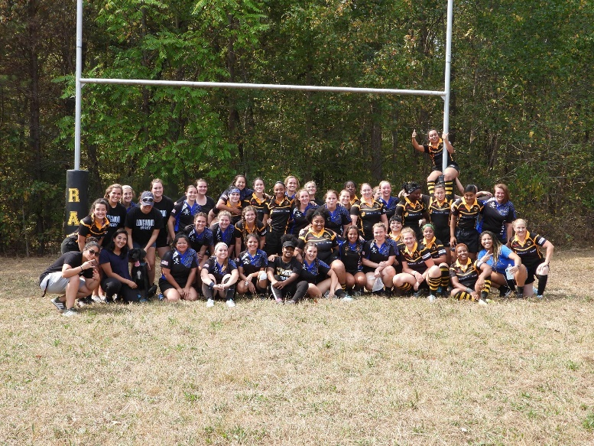
Longwood Rugby- 5 points
I am apart of the Longwood Women’s Club Rugby team. I have been for a total of three semesters. This has been one of the most difficult things that I have ever done. Before this I participated in cross country and track, so I was used to non- contact more individual sports. While this sport can be for a lot of different people; it should not be played by those with previous injuries that could be agitated by contact. This activity can be improved by providing an inclusive environment so that everyone can try out their rugby skills.
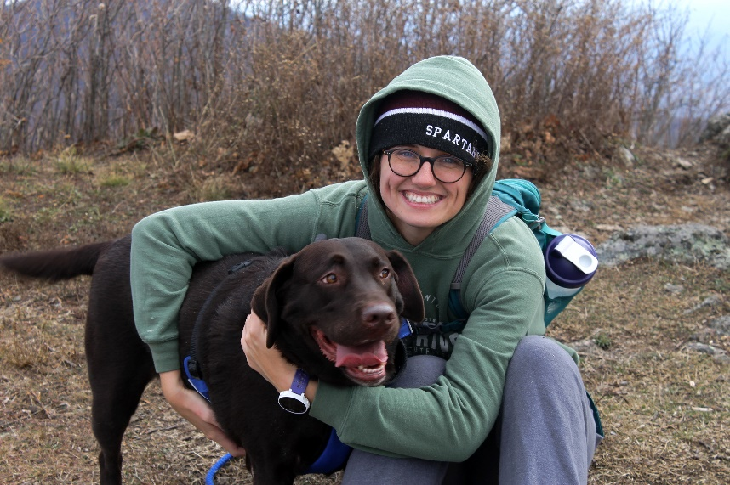
Cole Mountain Hike- 5 points
On November 9th I went with a bunch of my friends to Cole Mountain in Buena Vista. This got me out of my comfort zone because it was the first time that I had brought my dog on a hike off leash. I was worried that she was going to run up to other hikers, but she stayed with us the entire time. This was a short hike that could be done by most people, but it was steep hike. This activity could be improved by doing it during a warmer time.
