Mary Anderson

ART 160-02

Professor Morgan

April 10th, 2016

Frida Kahlo

Frida Kahlo was a Mexican painter born in 1907, in Mexico City. Her work strongly reflects Mexican culture and tradition. Her paintings have also been celebrated by feminists for her portrayal of the female form and experience. Kahlo’s mother was a Roman Catholic from Mexico, and her father was a German who immigrated to Mexico (“Frida Kahlo Biography”). Kahlo’s mixed heritage is often reflected in her paintings. Frida Kahlo married Diego Rivera when she was just twenty-two years old (Tibol, 2). They divorced after a few years but shortly remarried.

Throughout her short life, Kahlo suffered many physical and emotional injuries, which can be seen represented through her artwork. When Kahlo was young, she suffered polio in her right leg, which left her slightly crippled; so she wore long skirts which can be seen in her famous self-portrait paintings. When she was eighteen, Kahlo was affected by an accident which left her bedridden and in pain for the rest of her life. Frida Kahlo married Diego Rivera when she was just twenty-two years old (Tibol, 2).

“Kahlo is perhaps best known for her self-portraits, which comprise up to a third of her artistic output” (DeWitte, Larmann, Shields, 676). After her accident, Kahlo was in a lot of pain so she turned to painting self-portraits in order to cope. Kahlo said, “I paint myself because I am often alone and I am the subject I know best” (“Frida Kahlo Biography”). Kahlo is said to “[reflect] on her identity by combining depictions of her physical appearance with metaphorical references to her feelings” (DeWitte, Larmann, Shields, 676). Kahlo’s paintings are a form of self-expression; she uses painting as a way to tell the viewer about her feelings and to tell viewers a story.

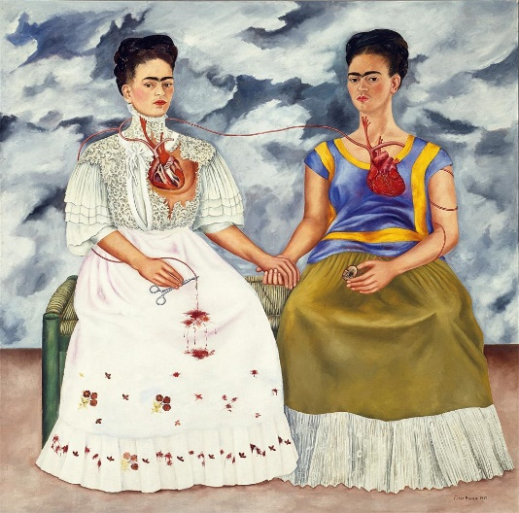 Frida Kahlo (1907 – 1954) lived during several artistic movements in history. Kahlo was born at the emergence of cubism in art. During her lifetime, dada, constructivism, and surrealism were all art movements that gained popularity. Some say that Kahlo’s paintings can be classified at surrealism due to her use of symbolism and metaphors. However, Kahlo denied that she was a surrealist painter. She once said, “I never painted dreams. I painted my own reality” (“Frida Kahlo Biography”). Other surrealist artists that lived and worked during Kahlo’s lifetime include Salvador Dali, Man Ray, Pablo Picasso, and Joan Miro.

The Two Fridas

*The Two Fridas* is a self-portrait painting by Kahlo. It was created in 1939. The painting is 567’ x 567’ and is an oil painting. The painting is of two women who appear to be mirror images of each other. They are seated on a bench outside, holding hands. The women’s hearts are visible and joined together. Kahlo made this painting while she was divorcing Rivera so it is believed to be an emotional representation of the divorce. Kahlo’s mixed heritage can be seen represented in the dresses of the women. The woman in the white dress on the left is wearing a European gown, which represents her father’s German background. The woman on the right is wearing a Mexican gown, which symbolizes her mother’s Mexican background. The woman in the white dress is holding scissors to signify the cutting off of ties between the two women, while the artery is bleeding onto her dress. On the other hand, the woman on the right has a broken heart and is also holding a small picture of Kahlo’s husband, Rivera (DeWitte, Larmann, Shields, 677). This symbolizes the heartbreak and pain that Kahlo was suffering from during the divorce. The painting portrays Kahlo as two women, heartbroken and bleeding, cutting off 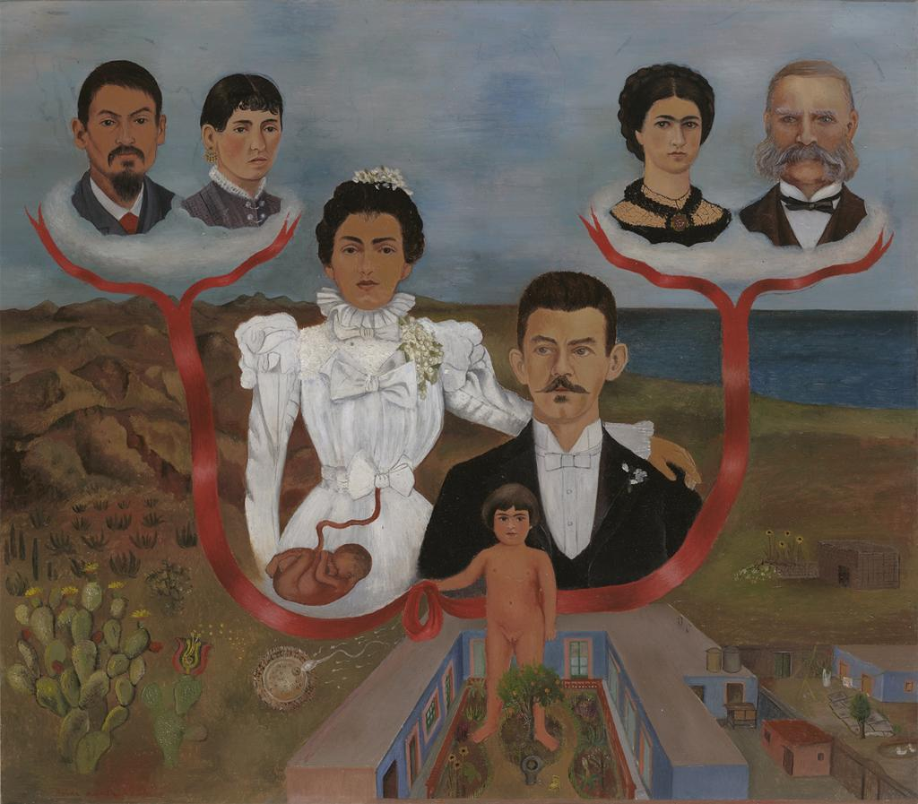ties, which suggests that Kahlo felt as if she was losing half of herself when she and Rivera divorced.

My Grandparents, My Parents, and I (Family Tree)

This painting is of Kahlo’s family tree. It is 12 1/8” x 13 5/8” and the medium is oil and tempura on zinc. Frida is the young girl at the bottom holding the red ribbon as a way to show that her family is connected by this bloodline. The loop of the ribbon is right under where her parent’s overlap. Also, Kahlo’s mother appears larger than her father, and her arm is draped around his shoulder. This suggests that her mother was the dominant parent and had more power in the household than Kahlo’s father. On Kahlo’s mother, you can see a fetus in her womb and underneath her, there is an egg with sperm swimming to it. This may be a suggestion to her mother’s fertility or sex life. Kahlo’s grandparents on her father’s side were European and her father immigrated to Mexico from Germany. In the painting, her fraternal grandparents are positioned over water, portraying how they were from overseas. Her maternal grandparents and mother were from Mexico, and are positioned overtop of rugged mountains which is similar to the terrain of Mexico. The red ribbon traces from the grandparents, from overseas and Mexico, to Frida in the middle holding the ribbon while standing in the courtyard at her home. The home which Kahlo stands by has one point perspective. If you follow the lines of the building, they lead to converge at Kahlo’s face. This is the focal point of the painting.

Kahlo was a very talented Mexican painter who was strongly influenced by her heritage. Her paintings were often self-expressionist self-portraits. They often were very emotional and involved a lot of symbolism and metaphors. Kahlo’s paintings can be classified as surrealist paintings; they depict dream-like scenes.

Works Cited

Tibol, Raquel. *Frida Kahlo*. Albuquerque: University of New Mexico Press, 1993. Print.

"Frida Kahlo Biography". *Frida-kahlo-foundation.org*. N.p., 2016. Web. 11 April 2016.

Kahlo, Frida. *The Two Fridas.* 1939. *ARTstor.* Web. 11 April 2016.

Kahlo, Frida. *My Grandparents, My Parents, and I (Family Tree).* 1936. *ARTstor.* Web. 11 April 2016.

Dewitte, Debra J, Ralph Larmann, and M. Kathryn Shields. *Gateways To Art*. 2nd ed. New York: Thames & Hudson, 2015. Print.