Mary Anderson

Dr. Fink

BIOL 114-50

22 September 2015

Cancer Research Paper

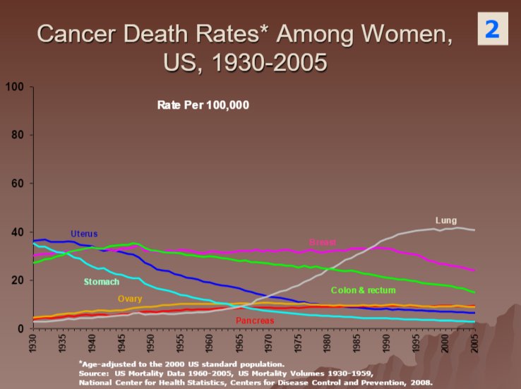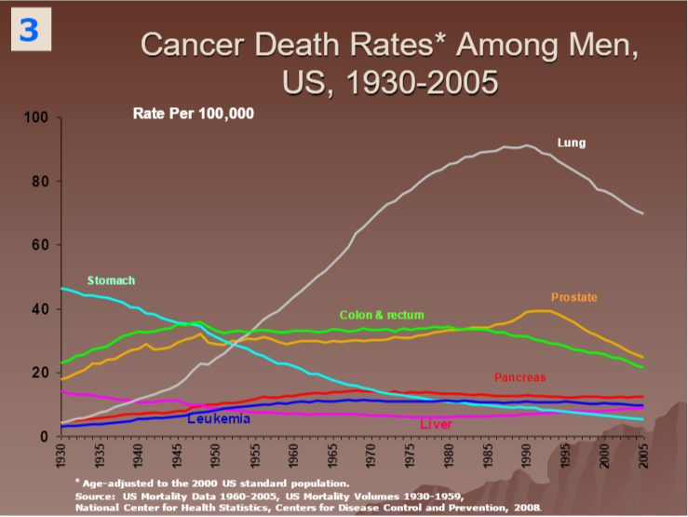Cancer is the second leading cause of death in the United States. Up until the 1930’s, stomach cancer was the leading cause of cancer deaths. In the news today, we do not hear many cases of stomach cancer. In fact, there has been a large decrease in stomach cancer death rates in both men and women, as shown in light blue in the graphs below. My hypothesis is that stomach cancer death rates are declining due to better nutrition and medical advancements..

In our stomachs, there is a bacteria called *Helicobacter pylori*. This bacteria has been identified by scientists to be a leading cause of stomach cancer. Thanks to advancements in technology and medicine, we have many more antibiotics and other kinds of medications. Antibiotics are used frequently by many people and it is shown that antibiotics kill the bacteria *H. pylori* in the stomach. The decreased levels of this bacteria in the stomach results in decreased cases of stomach cancer. Therefore, scientists believe that the increased use of antibiotics is one explanation for the decrease in cases of stomach cancer (Goho).

Changes in processing and storing food have led scientists to believe that certain foods and preservation methods can cause stomach cancer. In the 1920’s, the United States changed its ways of curing meat. Meat was cured using potassium nitrate and this caused the meat to contain extremely high levels of nitrite. The Department of Agriculture changed the procedure and cured meat using sodium nitrite, instead of nitrate. The cured meat then contained much lower levels of nitrite. This change of practice occurred about 10 years before the sharp decline in stomach cancer, leading scientists to believe that the nitrite levels may have been a cause. Also, using refrigeration to store and preserve foods rather than salting, pickling or smoking has helped lower rates of stomach cancer (American Cancer Society). Smoked or salted foods are linked to an increase risk of stomach cancer (Goho). As refrigeration became more popular in the United States, there was a decrease in the number of preserved meats consumed and an increase in the consumption of fresh fruits and vegetables (Paik). Fruits and vegetables are high in anti-carcinogenic antioxidants (Paik), unlike preserved meats so they are much healthier and safer to consume.

A well balanced diet is essential to protect yourself from stomach cancer. As previously mentioned, fruits and vegetables are extremely important. People should eat about 2 ½ cups of fruits and vegetables a day. Also, it is essential to eat whole grains rather than refined grains and eat fish, poultry, and beans instead of processed meats (American Cancer Society). It has been shown in some studies that if people with poor diets take vitamins and minerals, it may reduce their risk of stomach cancer but some studies do not show any signs of benefit (American Cancer Society).

Unfortunately, some cases of stomach cancer are inherited. There is a gene connected to it and the genetic condition is called *hereditary diffuse gastric cancer syndrome*. Those who have inherited this gene must have the stomach removed entirely to prevent stomach cancer from developing (American Cancer Society).

Stomach cancer was once a very deadly cancer in the United States but has now in recent years hit a dramatic decline. There is no one single treatment or prevention method that will prevent any case of stomach cancer, but there are things that people have started doing that decrease the risk of developing stomach cancer. Better nutrition and diets, food processing and preservation techniques, and medical advancements have all contributed to the sharp declines in stomach cancer.

Works Cited

"Can Stomach Cancer Be Prevented?" *Can Stomach Cancer Be Prevented?*N.p., n.d. Web. 21 Sept. 2015.

"U.S. Has Seen Sharp Decline in Stomach Cancer Rates." *- Cancer Today*. N.p., n.d. Web. 21 Sept. 2015.

"International Journal of Epidemiology." *The Epidemiological Enigma of Gastric Cancer Rates in the US: Was Grandmother's Sausage the Cause?* N.p., n.d. Web. 21 Sept. 2015.