Mary Anderson

Bi-weekly Report Dates: 9/13 – 9/19 & 9/20 – 9/26

Steps Week 3 Total: 71,718 Low day: Sunday 9/18 (6,632 steps) High day: Friday 9/16 (15,072 steps)

Steps Week 4 Total: 70,271 Low day: Friday 9/23 (7,536 steps) High day: Sunday 9/25 (12,432 steps)

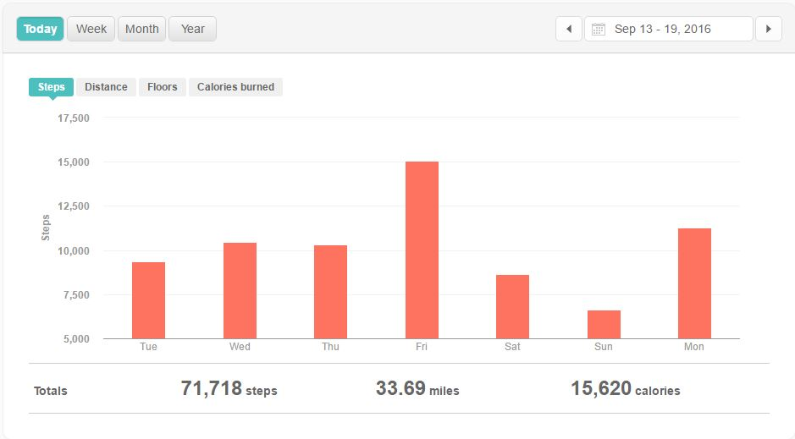Week 3 Outlook:

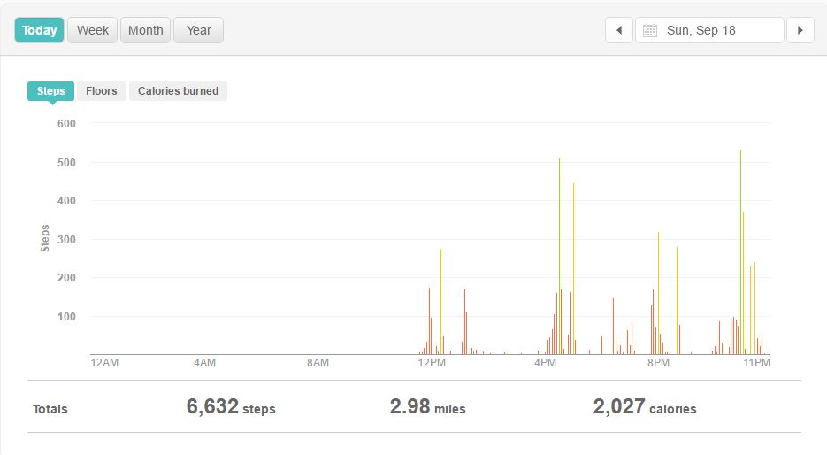Week 3 Low day:

Week 3 High Day:

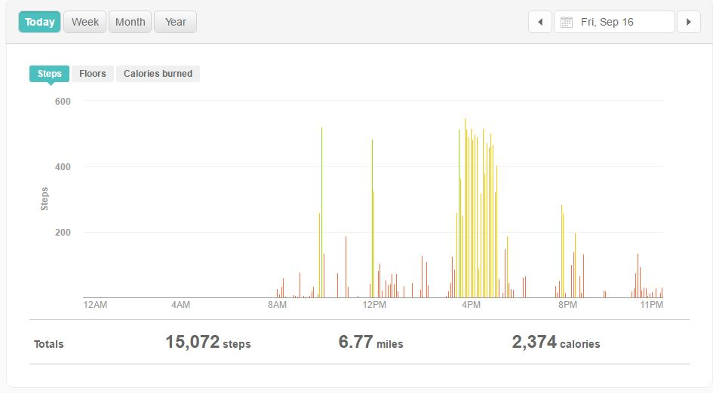

Week 3 Reflection:

* On my low day, I attended initiation for my service fraternity which involved us sitting inside socializing for a few hours. I did not walk around much so I did not get many steps.
* On my high day, I biked 9 miles on the high bridge trail which registered as a lot of steps.
* Most of my steps are together in one large spike for my high day.

Week 4

Weekly Outlook:

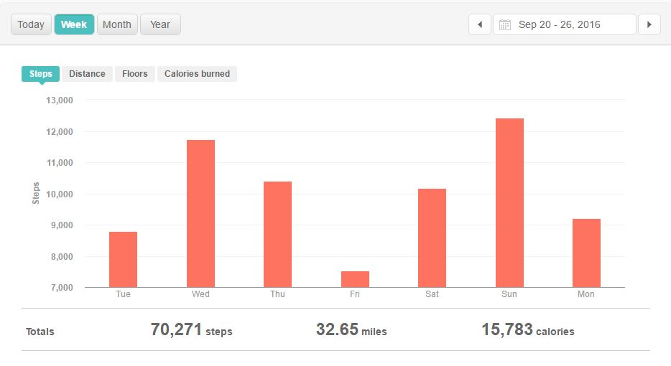

Low day:

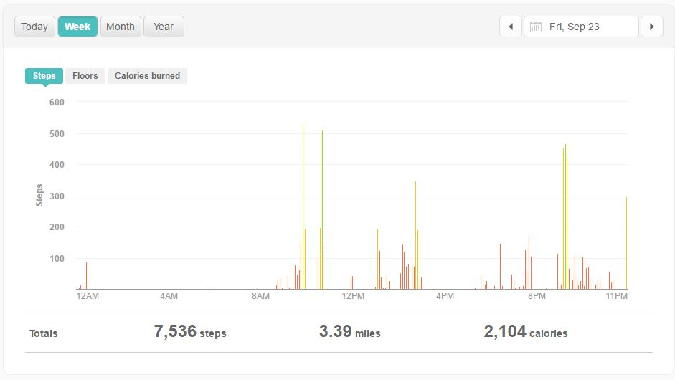

High day:

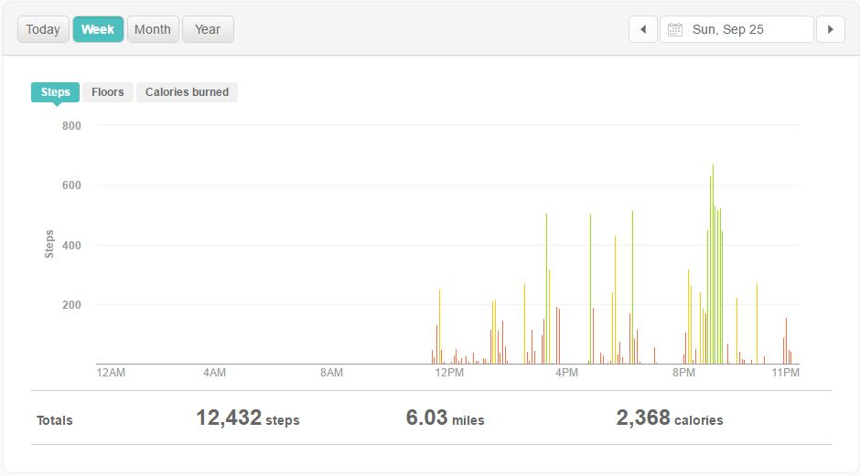

Week 4 reflection:

* On my low day I only had one class since one of them was cancelled. Therefore, I was not walking around campus as much as I normally do.
* I napped for a long time in the afternoon on my low day so I was not walking and getting steps for a while.
* On my high day, my steps were mostly spread out in bursts from when I was walking around campus during the day.
* I went to shopping at Walmart Sunday night and got a lot of steps from walking around the store for a long time, which is why there is a large burst.