Hi Alopecia Family,
Are you a parent of a child suffering from alopecia? Is your child with alopecia struggling in school? Is your child afraid to open up about their disease?
My name is Mackenzie Tabler and I am grateful for the opportunity to write a post in this blog to reach parents with young children with alopecia. I am in the process of creating a transferable alopecia education program to be employed in schools. This lesson will inform and teach your child’s classmates about kindness, acceptance, and alopecia. Knowledge is power! Even if your child is younger, your child and their classmates will benefit from this lesson.
I was diagnosed with alopecia in middle school, so I understand how difficult being in school with this disease can be. Kids can be mean, sometimes not even intentionally, especially at a young age when they don’t know the affect. I remember never talking to anyone about my disease, as I was afraid to be the slightest bit different. Fitting in can be a child’s biggest fear, and going into school with a bald spot or completely bald will cause that fear to come to the surface. I hid behind my wig for years, and now, looking back, I wish that I had just went without and embraced who I was. Having my classmates know about alopecia would have probably helped this transition in school. That is why I have decided to create this lesson called Wacky Wig Wednesday to help children suffering with acceptance.
The main goal of this program is to teach children understanding and acceptance. Most everyone lives with some sort of difference, some more visible than others. Helping children respect and love others living with difference will help, not only your child with alopecia, but hopefully others seeking acceptance. The class will have the opportunity to wear funky wigs and hats to school that day. The lesson is about 1-2 hours long, and includes fun activities, a video about alopecia, children’s books about acceptance, and discussions about bullying, kindness, and alopecia. As you can probably tell, this lesson isn’t all about alopecia, so your child wouldn’t feel singled out. It will hopefully have an impact on the whole class.
This program is sent in a portfolio with all parts included, so no cost will come to you and the school. Feel free to contact me with any questions or if you are interested in this program. Thanks so much!!!

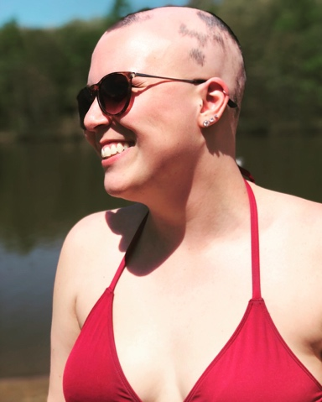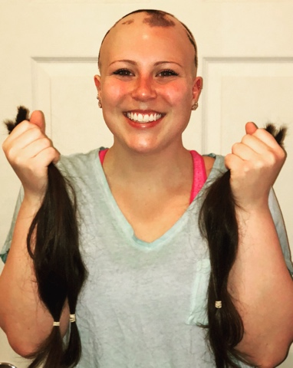
After my latest struggle with hair loss, I finally decide to take control of my alopecia.
Alopecia Strong!

