Galloping

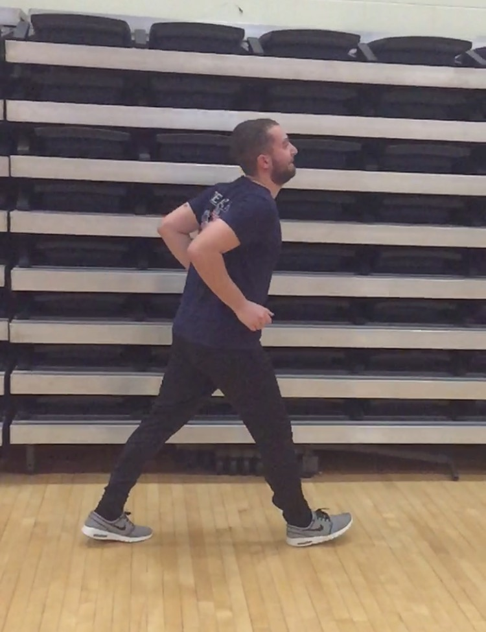step 1: Establish a lead and a trail foot, with your arms at 90 degrees.

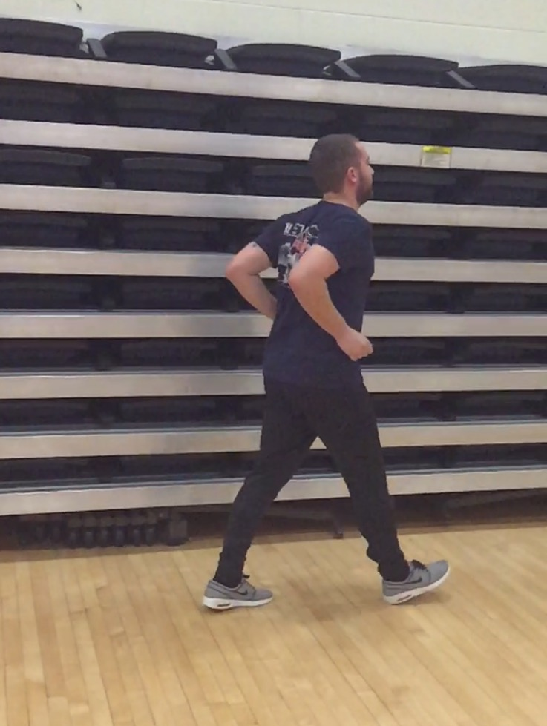 Step 2: Jump with lead foot still in front
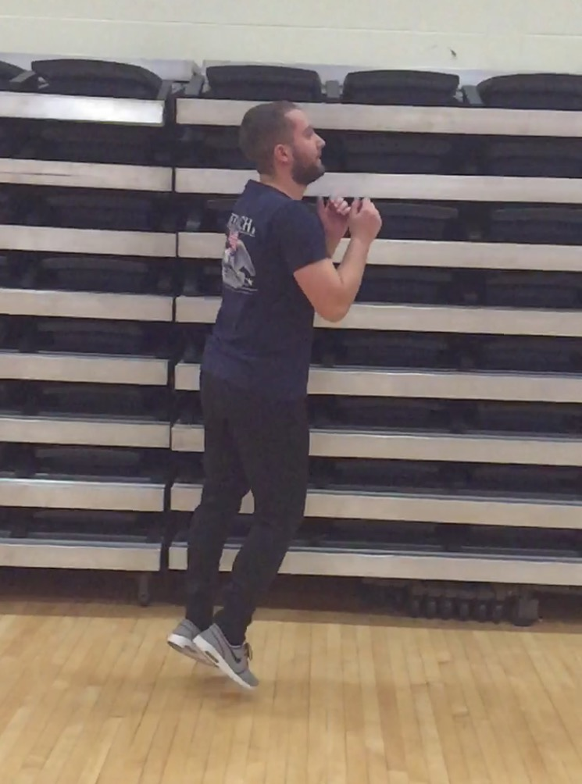 Step 3: Land back down with the trail foot.

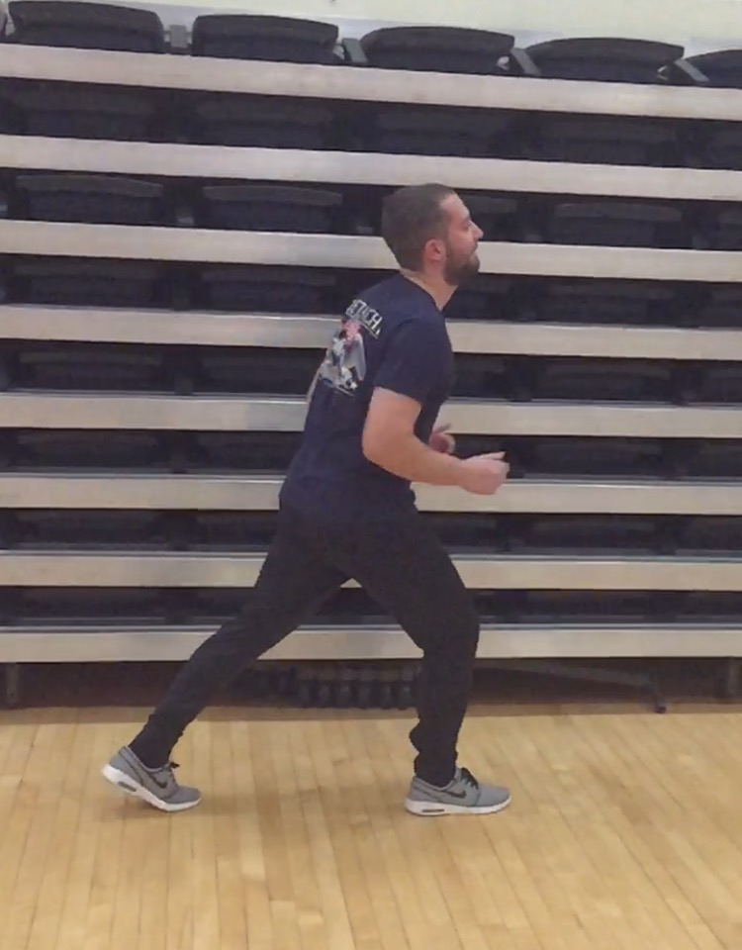 Step 4: Reach out with your lead foot and repeat.

