Ben Loucas
MUSC 224, Swanson
Word count: 1290
Traditional Mexican culture in the music of Carlos Chávez
Sharp notes from the piccolo arise as a trumpet brazenly cries out over rapid strings. All is quiet for a fleeting moment before rattling percussion and exotic drums join the strings and woodwinds. The melodies are triumphant and adventurous, sweeping high and low as the drums continue their powerful rhythm. The percussion is heavy with earthy tones: the rattle of dried plants as the wind carries them across a plain, the heavy hooves of roving herds of cattle plodding along. They speak of open scrub grass valleys between lofty mesas all simmering under a wide blue sky. They are a testimony to the landscape and to the people who live there: the indigenous people of Northern Mexico. Symphony No. 2 Sinfonía India is one of the most well-known works of Mexican composer Carlos Chávez and a prime example of the incorporation of traditional instruments and melodies in modern Mexican music. The uniquely Mexican sound of Chávez’s music can be traced to the nationalist zeitgeist of the Mexican Revolution and its emphasis on traditional arts and culture.

Carlos Chávez was born Carlos Antonio de Padua Chávez y Ramírez on June 13th, 1899 in Mexico City. Throughout his childhood, Chávez visited Tlaxcala in east-central Mexico. It was in this ancient city that he encountered the music of native Mexicans. He first began piano lessons with his brother Manuel before studying under the illustrious composers Manuel Ponce and Pedro Ogazón (Weinstock 436). It was under the tutelage of these composers that Chávez developed an appreciation for indigenous, classical, and romantic music. Chávez’s musical education coincided with the outbreak of the Mexican Revolution, a long and bloody conflict which lasted from about 1910 until the mid-1920s. The revolution came about as a result of widespread dissatisfaction with longtime president Porfirio Díaz whose elitist oligarchical regime favored the wealthy and industrialists (Gonzales 1-2) from militias of lower-class farmers, peasants, ranchers, and indigenous peoples, the revolution succeeded in ousting Díaz, but infighting amongst revolutionaries prolonged the conflict. During the revolution, Chávez composed prolifically in semi-classical styles which mostly neglected Mexican elements. However, Secretary of Education José Vasconcelos, a strong supporter of the Mexican artistic renaissance, commissioned Chávez to compose the 1921 ballet El Fuego Nuevo celebrating the Aztec fire ceremony (Weinstock 437). Drawing on the traditional Mexican Indian music he encountered in his youth, this would be his first work to significantly feature Mexican style. Chávez would go on to be appointed the director of the National Conservatory of Music in 1928 as well as the title of Chief of the Department of Fine Arts of the Secretariat of Public Education (Weinstock 438-439). His leadership in these positions helped to bring indigenous music to the forefront of Mexican music education.

The use of traditional music as source material for larger compositions wasn’t a new idea. For years the corrido, narrative songs or ballads, had been popular amongst the lower-class members of Mexican society. Corridos celebrated national defense and demonized interlopers, especially during years of foreign occupation by France and Austria (Vaughn and Velazquez). These corridos were usually performed by local brass bands who combined the corrido with preexisting styles such as the Mestizo son. Sones reflected a diverse range of inspiration and took on new names and characteristics shaped by local cultures (Vaughn and Velazquez). Chávez’s early revolutionary works reflected inspiration from revolutionary corridos. Examples of nationalism in his compositions are seen in the use of traditional melodies and instrumentations. Sinfonía India is comprised of three native Mexican melodies and heavily features native instruments in its percussion arrangements (Slonimsky 234). Chávez wrote the symphony whilst visiting the United States and it was first performed and broadcasted on January 23rd, 1936. The debut in Chávez’s native Mexico took place in July 1936. The symphony is structured in classical three-part sonata form. The exposition of Sinfonía India begins with three introductory themes. They are in the key of B flat with time signatures rapidly shifting between 5/8ths and 2/4ths in the first introductory theme, 5/8ths and 3/4ths in the second, and 5/8ths and 2/4ths again in the third. These introductory themes are played over each other in a rapid and repetitive manner with strong emphasis on rhythmic melodies.
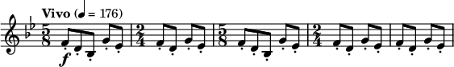
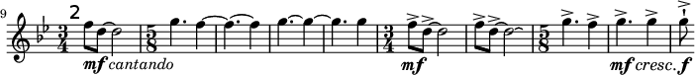
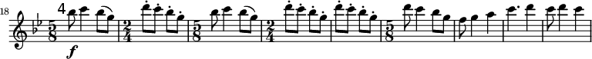
The first theme in the symphony is a strongly rhythmic melody taken from the Huichol people of western Mexico. Played on the oboes and the first violins, it is also played in B flat, though it does not feature the same drastic changes in time signature, being played only in 2/3rds time signature.
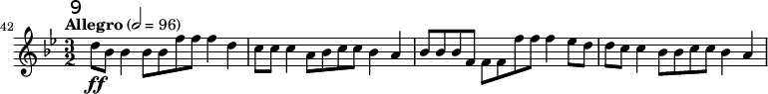

The second much more lyrical theme is a melody of the Yaqui people in the Sonora region of northern Mexico. This theme, in keeping with the structure of the sonata allegro form, is played in a higher key than the first theme. While the lyrical melody is handled by E and B flat clarinets, the percussion is managed by a tenor drum with a heavy, yet irregular rhythm.
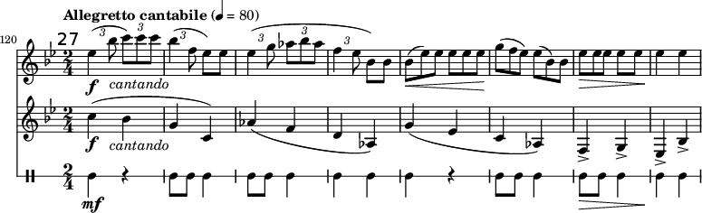

Additional themes include a second Sonoran melody and a melody from the Seri people of Tiburón Island in Baja California (Schwarm). As the development of the themes ends, the introductory themes return with the same high-energy as their first appearance to mark the transition between the development and the final theme.

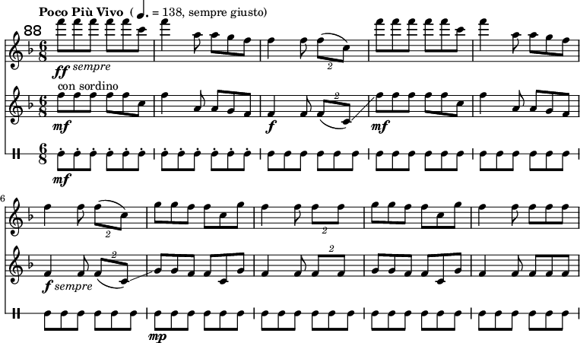
The final theme of the symphony enters abruptly after the recapitulation of the introductory themes. It consists of a triumphant fanfare on muted trumpets played in the key of F flat with a rapid 6/8ths time signature. The guiro provides a fast-paced percussive foundation for the strong brass section. Interspersed throughout the finale are interjections from other indigenous percussion pieces, specifically the drums which accompany the brass to the powerful ending notes. The use of these indigenous themes is a clear example of the nationalist influence of the revolution on the music of Carlos Chávez.

Further nationalist sentiments are found in the instrumentation of Sinfonía India which features a multitude of indigenous percussion instruments. The original composition was written for the jicara de agua, güiro, cascabeles, tenabaris, teponaxtles, tlapanhuéhuetl, and grijutian (Chávez). The teponaztli, also spelled teponaxtle, is a type of slit drum associated with Mesoamerican empires such as the Aztecs. The drum consists of a large section of tree trunk or stone with an aperture in its wall. Placed horizontally and struck on either side of the aperture, the teponaztli produces a low pitch similar to the kettle drum. The sides of the aperture usually differ by a minor or major third (Slonimsky 216). The teponaztli was considered sacred by the native Mexicans and played only for solemn occasions. Other percussion instruments reflect native Mexican ties to nature and its resources: jicara de agua, the “Mexican water drum” is made of halved gourds partially submerged and struck with a stick (Slonimsky 44). Other natural instruments include the tenabris and grijutian made of butterfly cocoons and deer hooves on a string, respectively. The tenabris would have been worn on the ankles of native Mexican dancers during ceremonies (Slonimsky 216). When the score was first written, Chávez requested that these indigenous instruments be used whenever possible. With its sonata structure and native themes, Sinfonía India artfully blends classical form with indigenous melodies and instruments to create a nationalist composition.

Brimming with adventure and heritage, Sinfonía India is a testament to the boundless beauty and freedom of the Mexican landscape. It pays homage to indigenous people from all over Mexico from the northern deserts to the western shores and the central eastern lands. Their culture is the forerunner to that of a modern Mexican nation. Sinfonía India serves as a gleaming example of the influence of the Mexican Revolution on the music of Carlos Chávez. Revolutionary nationalism can be heard through the use of traditional Mexican melodies and instrumentation in his music.

Bibliography
Weinstock, Herbert. “Carlos Chávez.” The Musical Quarterly, vol. 22, no. 4, Oct. 1936, pp. 435–445.
The Editors of Encyclopaedia Britannica. “Carlos Chávez.” Encyclopædia Britannica,
Encyclopædia Britannica, Inc., 29 July 2019, https://www.britannica.com/biography/Carlos-Chavez.

Gonzales, Michael. The Mexican Revolution 1910-1940. 2002. University of New Mexico Press
Velazquez, Marco and Vaughn, Mary Kay. Mestizaje and Musical Nationalism in Mexico. Nov. 2002.
Schwarm, Betsy. “Sinfonía India.” Encyclopædia Britannica, Encyclopædia Britannica, Inc., 17 Mar. 2016, https://www.britannica.com/topic/Sinfonia-India.
Slonimsky, Nicolas. Music of Latin America. 1945. Thomas Y Cromwell Company.
Chávez, Carlos. Sinfonía India. G Schirmer’s Edition of Study Scores of Orchestral Works and Chamber Music, no 56. 1950.

