**SPRING 2018 ● NOON-1 PM ● MAUGAN’S VIRGINIA ROOM**

**BLACKWELL TALKS**

**FEBRUARY 19 Dr. Onie McKenzie**

"Results from the National Survey of Student Engagement (NSSE) that would most benefit faculty"

**FEBRUARY 26 Dr. Alix Fink**"From Vision to Change: Catalyzing transformation in academic departments"

**MARCH 12 Dr. Sarah Porter, Dr. Melissa Rhoten, Dr. Benjamin Topham, and Dr. Andrew Yeagley**

"Assessing student course progress through course objective proficiencies"

**MARCH 19 Dr. Dina Leech**

"Intersection of Science and Society: What to do with 15+ years of water quality data for the Appomattox River Watershed?"

**MARCH 26 Dr. Troy Purdom**

“Using Lower Body Mobility Assessment to Evaluate Injury  
 in Athletics"

**APRIL 2 Dr. Catherine Franssen**"The Trials and Triumphs of Creating an Interdisciplinary Neuroscience Studies Minor"

**APRIL 9 Dr. Alec Hosterman, Dr. Naomi Johnson,   
and Dr. Ryan Stouffer**"The #MeToo Movement: Social Support Messages and Twitter Activism"



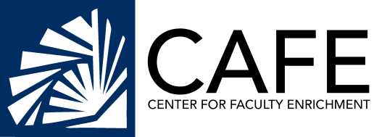

**SPONSORED BY:** 