My #AcWri strategies: Fill up paragraphs, one idea per paragraph
Sometimes I get random emails asking me “but, how do you do what you do?“. Most of these emails refer to my academic writing strategies. I’ve written about what I do to get my writing unstuck, what I do if I feel like I need to kickstart a writing session, and how I am disciplined about writing two hours every day and even how to procrastinate productively as an academic.
Although I should be very clear that my writing 2 hours every day often times means 4 blocks of 30 minutes, because it’s hard to find time to write for 2 hours every day. Even with how challenging it is to find time to write (and yes, I have two research assistants and a 0-2 teaching load, so I know my privilege), I do believe in the “even 15 minutes help” rule (see Jo Van Every’s challenge).
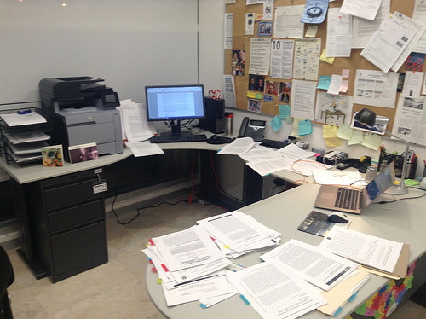
I’ve decided to start a series (also, to force me to find time to blog!) on how I write. My process is complex, as I often read up a lot, and then continue reading as I go. I also collect data and continue the process as I write up the paper. So, my process isn’t perfect (none of them are!).
The first strategy I thought I’d share is that I don’t focus as much on pages written, but in seeing paragraphs filled. More specifically, I write out an outline of what I want to say, and I map out broadly the main message of each particular section of the paper. I write a few “beginning sentences” that help me create a thread that allows me to craft the full paper. For example, if I am writing about “governance”, I usually start by defining what governance is, then what the main characteristics of governance are, then the main criticisms of using governance, and then my own specific definition. This creates four sub-sections of the paper.

Then I write (in the example I am using here) a few sentences that will in turn become paragraphs. I write a brief sentence related to what governance means to Author X, then what it means for Author Y. Then I know that if I want, I can write an entire paragraph comparing both authors, and then I can bring a third author either in that paragraph, or as a contrasting sentence that opens the next paragraphs.

I find that if I focus on adding more sentences to a paragraph rather than worrying about how many pages I need to write per day, I feel much less stress about what I need to complete, and I feel much more accomplished. And you can easily write a paragraph in 15 minutes intervals, a sentence at a time. For some excellent writing advice on writing paragraphs, I’d recommend Patrick J. Dunleavy and his Write 4 Research website.

