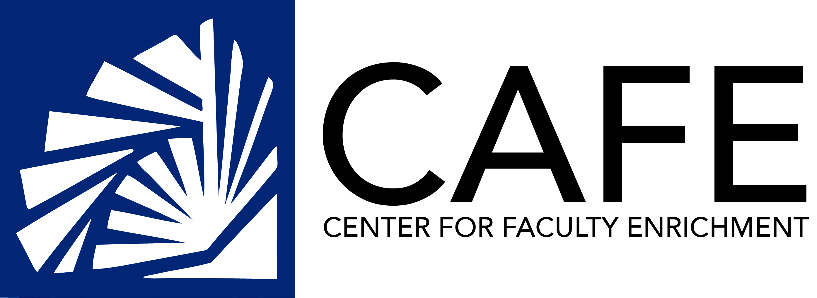

Blackwell Talks
2014-2015

September 22: Dr. Sarai Blincoe
“Growing the Scholarship of Teaching and Learning: An Invitation to the Longwood Community”

September 29: Dr. Don Blaheta
“Test-First Design in Introductory Computer Science Courses”

October 6: Dr. Kenneth Fortino
“The Connections between the Small and the Global: The Dynamics of Small Pond Carbon Cycling”

October 20: Dr. Sarah Southall
“Methods, Content, and Problem-Based Learning: A Reexamination of the Teacher Work Sample”

October 27: Dr. Renee Gutierrez &
Dr. Connie Koski
“Facing the Other: Teaching and Research at the Farmville Immigration Detention Center”

November 3: Dr. Alec Hosterman “Communicating Across Visual Borders: How Life Redefines the Comics Genre Using Tactile Storytelling”

February 9: Dr. Laura Farrell/Dr. Ryan Stouffer
“Tell Me and I Forget, Teach me and I Remember, Involve Me and I Learn”

February 16: Jenny Quarles
“Affinity Grouping: Creating Interpersonal Relationships in Online Educational Environments”

February 23: Dr. Jeffery Bardwell
“Exploring New Sources of Commercial Potential for Biochemistry within the Amazon Rainforest”

March 9: Dr. Pamela McDermott
“Romancero Gitano by Maria Castelnuovo-Tedesco: Research in Music Performance”

March 16: Dr. Wendy Hageman-Smith
“Turbo-charging Freshman Engagement in Introductory Courses through a 2-lecture Motivational Seminar on How and Why to Succeed at College Mathematics.”

April 6: Dr. Leigh Lunsford/Dr. Phillip Poplin
“Stats on Intro Stats @ LU”

Sponsored by: CAFE, Cook-Cole College of Arts & Sciences, Greenwood Library, College of Graduate & Professional Studies, College of Business & Economics and College of Education & Human Services

