Jackson Lockhart
HIST 150-50
11/18/18

Fear and Loathing in 15th Century Spain: A Savage Journey to the Heart of the Inquisition

It was most definitely a hard landing. Have you ever spent the day at an amusement park and then gone to bed that night and felt like you were still on a roller coaster? Multiply that by 17.2, and that’s about how it felt to be launched through time. Marty McFly sure made it look easy.
Me, my friends Jonathan and Chad, and my cousin Keagan had been landed somewhere in the Spanish countryside during the fifteenth century, the height of the Inquisition. We were all dressed in period clothes, which came with a complimentary case of jock itch due to their woolen material. We wanted to come off with the look of what we would now call the middle class. We were still peasants, yes, but we were peasants with a small amount of disposable wealth. We had agreed to leave anything modern behind, except for our recall buttons, running the risk of being accused of witchcraft if we were discovered with anything out of the norm. This was especially problematic for Chad and Jon as they both needed glasses to see. They were crafted rudimentary eyeglasses that fit the time, and although they initially kept bumping into stuff at the lab, they seemed to mostly do the job. Any medications we needed were ground into a fine powder and carefully hidden on our persons. Finally, we had all received surgery before our trip; the doctors implanting us with special translator chips that would allow us to easily understand and speak the languages and dialects we might encounter.
My friend Chad, being the bastard he is, immediately seized the opportunity to scream, not caring about the potential of anyone within earshot, “No one expects the Spanish Inquisition!” We immediately served him a hearty drink laced with cyanide. As Jon and Keagan built a bonfire to burn his body, I took out our map and compass in an attempt to orient ourselves. After much trepidation, I determined that we were approximately 6 miles outside of Toledo. We were relieved to find that we had landed close to one of our destinations, the other being Barcelona. We resolved to first explore Toledo and then linking up with a caravan to travel to Barcelona.
Once we were done burning Chad’s body, we quickly got a move on. Each of us carried a short sword for defense. which we had been trained to use. However, these were only to be used in the most dire situations. If we could get to Toledo before nightfall, we could likely avoid the threat of bandits. We encountered few other travelers, but as we got closer to Toledo, we encountered farmers and other peasant workers. Scattered at first, but with increasing frequency as time went on. We mostly kept our heads down, trying not to draw any attention to ourselves.
We reached the outskirts of Toledo at dusk and eventually came upon an inn. We went inside and asked the innkeeper the price of a room for the night. He told us it was eleven real if we were willing to share. As I was about to pay, Jon asked for the price of a drink. I realized how thirsty I was as well, and having drank all our water on the hike and used the rest to kill Chad, I ordered myself and Keagan an ale. Jon, bless his heart, just asked for some water. Presumably, it was him who kept going outside that night. He was lucky that unpurified water didn’t give him dysentery.
The next morning, we had a breakfast consisting of dried goat and bread.
This time, Jon got an ale.
After some talking with the innkeeper, we discovered that a caravan bound for Barcelona had just left last night, and would not be back for quite some time. The man, who said his name was Arnao, was quite friendly and ran his inn well. I told him I’d rate his place five stars, and he just looked at me with confusion. Dammit, I forgot about metaphors. No colloquialisms allowed, they could make us stand out, which is not what you wanted to do during the inquisition.
We paid for our breakfast and went back to our room. This was a serious setback. Going to Barcelona was a major part of our contract, if we could not, we’d be in some serious trouble. Jon had the idea of hiring mercenaries to escort us to Barcelona. This could be expensive, we each had only about forty reals, the doctors figured that this would be enough for us to get by on, but not enough to make us an obvious target for thieves or bandits. We had already spent about sixteen real, but Keagan seemed to figure we could sell Chad’s glasses, weapons, and clothes to boost our finances. I agreed that this was worth a shot, so we headed out into town.
The streets were narrow and crowded and smelled a lot like Jon did last night. As we neared the market square, it began to get louder and louder. Merchants tried to shout over each other, advertising their goods and wares, and especially their prices. After a failed attempt to haggle with several of the merchants for a better price, we ended up walking away with a lowly fourteen real for all of Chad’s stuff.
We didn’t know where we could find any mercenaries, so we figured the best source of local knowledge was Arnao, so we headed back to the inn. When we got back, however, the inn was empty. We immediately feared the worst for Arnao, and the sound of crying from the back of the inn all but confirmed our suspicions. We discovered Arnao’s wife, crying while clutching a Star of David. As it turns out, Arnao’s real name was actually Jacob, and that he was a conversos, or a Jew who had been forced to convert to Christianity. In secret, Jacob had continued to practice his faith. Obviously, the secret was out.
We all felt pity for Jacob and his wife, of course, but knew that there was nothing we could do to help him. The three of us could not possibly save him alone, and no mercenary would want to risk pissing off the church. We gave her our condolences and left her to her sorrows. As we left the inn, I realized that this event had presented us with a unique opportunity. I suggested that perhaps we could make up for not being able to go to Barcelona by watching Jacob’s trial. With no other real options, the others quickly agreed, and we headed back to the center of town.
I really thought that the trial would be in the church, having read Ginzburg just last semester, I expected to find Jacob being questioned by an inquisitor, seeking a confession, and then given a sentence. Jacob may have been wealthy enough to afford a lawyer, we hoped he did, as that would make the whole procession much more interesting and informative. We were surprised, however, to find Jacob in the market square. We had been passing through it on our way to the cathedral and saw a crowd of people gathered around him. He was elevated on a small platform, naked and beaten, tied to a stake, with an inquisitor standing by There was no trial, there was only a sentence. Guilty, and the evidence relied on Jacob’s confession. A confession they sought to torture out of him. 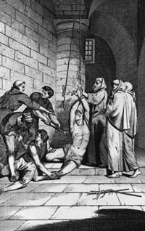
“You have been accused of conspiring against Christendom, how do you respond to these charges?” The inquisitor asked Jacob, in Spanish of course. Jacob merely groaned. He was down, but seemingly, not out.
“Do you not see how set he is in his conviction?” The inquisitor asked the crowd, “The Jews would seek to paralyze our holy Inquisition, and just as they killed Our Lord Jesus Christ, they would kill every last one of us Christians!” 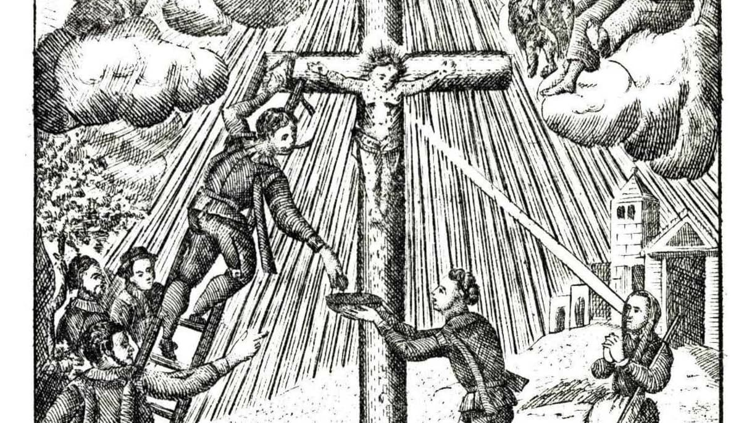
It was brutal and almost reminded me of scenes from The Passion. Jacob, bleeding profusely, could do little more than squirm. I felt terrible for him, but could do nothing to help.
“I will give you one last chance to repent.” The inquisitor announced. The crowd fell silent, listening for Jacobs words, but none came. “Very well then,” the inquisitor said, “I pronounce you guilty as charged.” The inquisitor backed off, and one of the city guards lit the pile of wood beneath the stake Jacob was bound to, as the church left the actual execution to secular authorities. 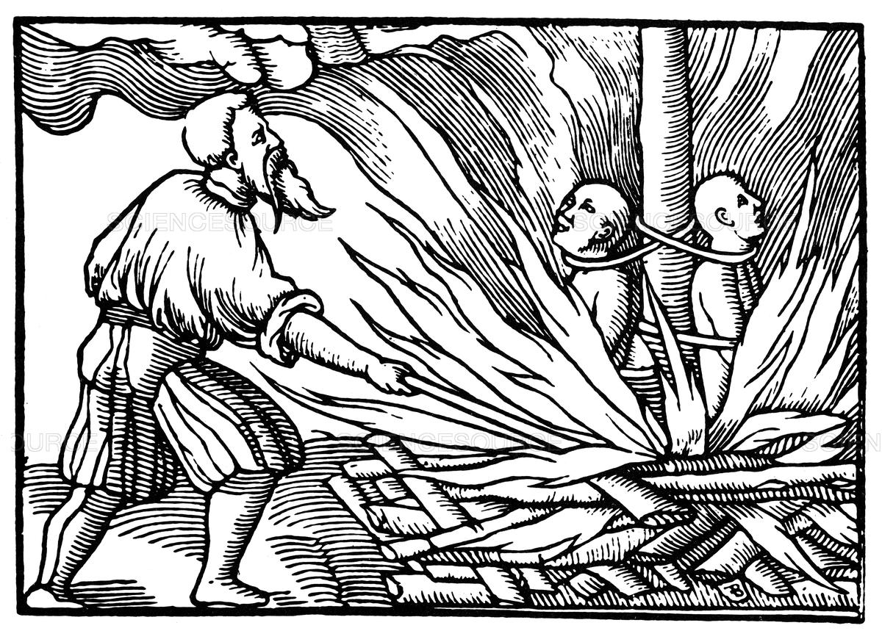It was horrible. Terrifying. Such a scene is all but impossible to portray. As the flames subsided, we saw there was nothing left but ash of Jacobs body. The crowd slowly dispersed, and we left the awful scene with them.
“These people really think they’re doing God’s work?” Jon asked, “It’s disgusting.”
“Shut up Jon! You can’t say those kinds of thing!” I said, quickly shushing him. After that, we kept our heads down and got out of town.
Poor Jacob. The worst part was that his enduring faith was only serving to prove the point of the inquisitors. If the people did believe what the Inquisition was spreading about a Jewish conspiracy, then his display of strength in the face of death would only spread more fear. Especially here in Toledo, a city with a history of religious violence and that less than four centuries ago belonged to the Muslims.
After that terrible display, we found another inn. We had decided that we most likely would not be able to reach Barcelona, so we used the real intended for mercenaries to pay for our stay and a meal. More dried goat. Yay. I can’t wait until these people start making better food.
We discussed what to do next. We had seen firsthand the anti-Semitic nature of the Inquisition. But now, we needed to see a true trial. 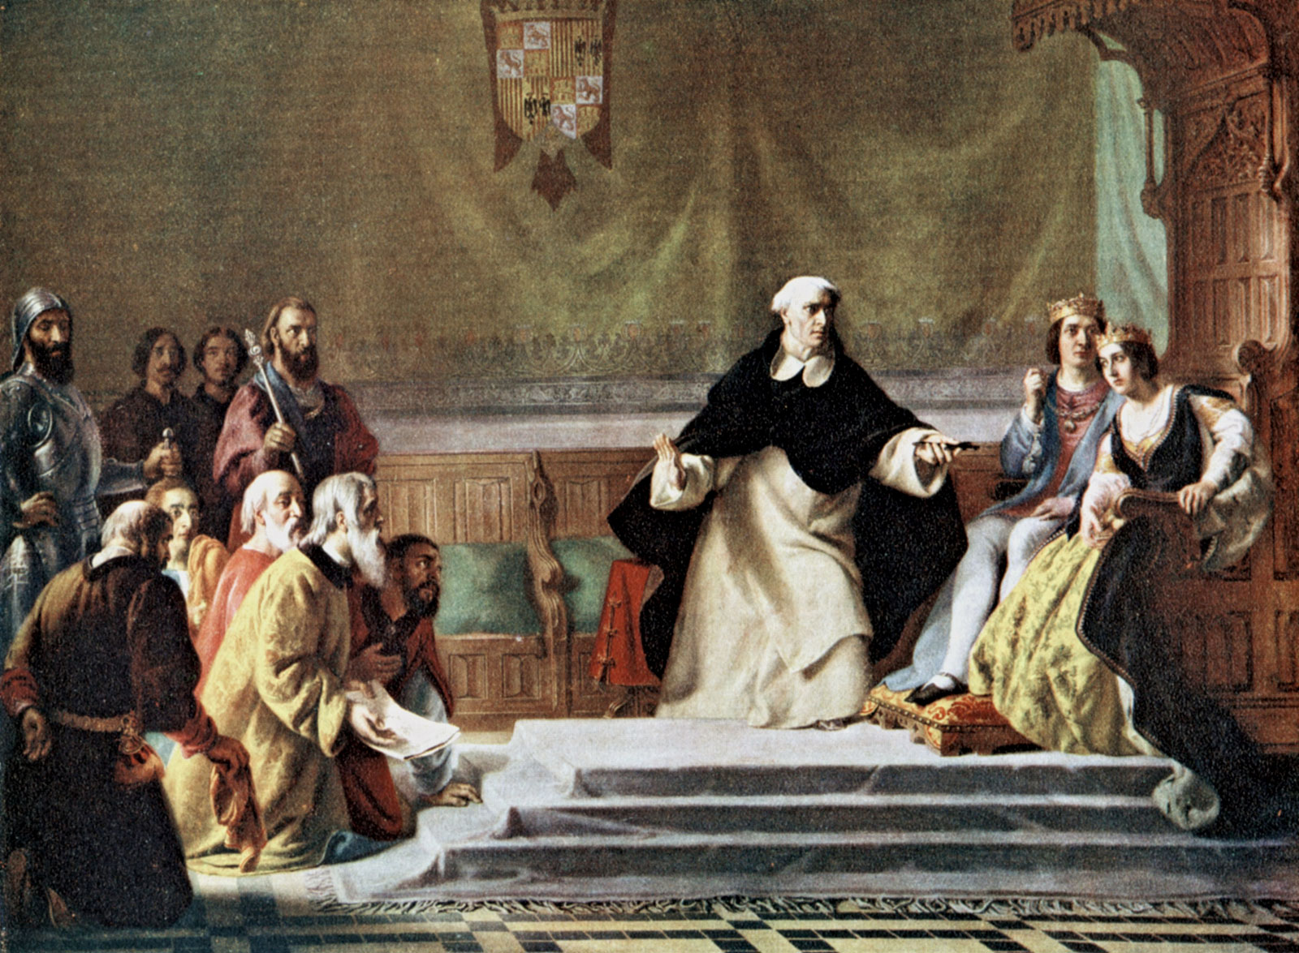 The Inquisition wasn’t just targeting Jews after all, it was targeting anyone who was not viewed as a true Roman Catholic Christian.
The next morning, we had even more dried goat, with some cheese this time. Eating all this makes me wish for dining hall food, just a little. We then moved into the town. We spent the day exploring Toledo.
As the sun began to set, we headed back to the inn. Keagan, however was acting strange. He kept stopping at every opportunity, checking fruit at merchant stalls, and he kept on taking off his shoe and shake it out, claiming there was a pebble in it. Eventually he stopped, and we figured out there was a method to his madness.
“We’re being followed. Don’t look, we can’t let him know we know.” He said.
“Are you sure? By who?” I asked.
“One of the beggars from the market square. I watched him in my peripherals each time I stopped. He’s consistently been about twenty or so yards behind us ever since we left.”
“Maybe he’s heading back home, or to wherever he sleeps.” Jon said.
“I doubt it, our inn is on the richer side of town. No way they’d let a filthy beggar like him live there, or even sleep on the streets. No, he’s definitely following us.”
As we entered the inn, I turned as I opened the door, and found the beggar was nowhere to be seen. At least we weren’t going to be robbed, but the Inquisition could be onto us. It was a restless night. And yet, morning came without interruption. We awoke from an uneasy sleep to find the inn at peace. We ate, yet again, dried goat. I felt like I was in Groundhog Day. Each day felt the same: wake up, eat dried goat, go to town, go back to inn, eat dried goat, go to sleep. And so, once we were done with our absolutely delicious dried goat, we got ready to leave the inn, as the cycle demanded. But when we opened the door, we were met with a group of inquisitors, who immediately grabbed Jon, and took him away. They didn’t even say why, he was arrested without even being told of the charges against him. But we all knew, it was all but certainly because of what he had said after Jacob’s execution. As the inquisitors walked off with Jon, heading towards a prison, we saw one of them handing the beggar a small bag of coins. For the beggar it must’ve seemed like a golden opportunity, not only could he make money by turning in Jon, but he could also help to guarantee his entrance into heaven by helping to rid the world of another heretic.
This was a catastrophe, and we had no choice but to abandon the mission. We grabbed our belongings and used our recall buttons to take us home. When we arrived back in our own time, we found that there was no sign of Jon. However, he arrived about two minutes later, looking deathly pale, and much skinnier and weaker. The doctors rushed him off to be treated as well as decontaminating all of us. A few days later, after Jon had been nursed back into health, he revealed to us that although he had arrived only two minutes after us, we had left two months before him. The inquisitors had kept him locked up, isolated, and practically starving. Three times they came to him, advising him to confess and repent, but Jon, devoted to the cause (and the massive paycheck), refused. Finally, they told him that he was going to be prosecuted, but still did not give him any charges. When they finally did bring in a prosecutor and he was made aware of the charges, he was then forced to defend himself then and there, with no preparation. Terrified, and unable to use his recall button under guard, he begged forgiveness and admitted he was wrong. The inquisitors, surprisingly, forgave him, but they would not let him out of prison. Realizing this, at the first opportunity, he used his recall button to take him home. When the doctors asked for more details, he just looked at them in shock. He told them that that was it. Everything he remembered. There was so little, and he didn’t know exactly what was going to happen, and that’s what made it so terrifying. There really was no trial, they already had their evidence, all they wanted was either a confession, or a death sentence. But at least we had all made it back safely.
Well, except for Chad.

Benzion Netanyahu, "Expulsion," in The Origins of the Inquisition in Fifteenth Century Spain, (New York, NY: Random House, 1995), 1087-092. Foxe, John. English merchant Nicholas Burton is tortured by officers of the Spanish Inquisition while imprisoned in Cadiz, 1560. Copper engraving, from a late 18th century English edition of John Foxe's 'Book of Martyrs.' Digital image. HowStuffWorks.com. February 5, 2008. Accessed November 29, 2018. https://history.howstuffworks.com/historical-figures/spanish-inquisition3.htm. Used to show how the Inquisition preferred, especially with Jews, to torture confessions out of the accused.
Carlo Ginzburg, The Cheese and the Worms: The Cosmos of a Sixteenth-Century Miller, trans. John A. Tedeschi and Anne C. Tedeschi, (Baltimore: Johns Hopkins University Press, 2013). Used as an example of a proper trial in the Inquisition.
Benzion Netanyahu, "The Age of Conversions," in The Origins of the Inquisition in Fifteenth Century Spain, (New York, NY: Random House, 1995), 163. Benzion Netanyahu, "Expulsion," in The Origins of the Inquisition in Fifteenth Century Spain, (New York, NY: Random House, 1995), 1087-092. Unknown. "Illustration of the Holy Child of La Guardia." Digital image. Haaretz. November 15, 2014. Accessed November 28, 2018. https://www.haaretz.com/jewish/.premium-1491-jews-sorcerers-burned-at-stake-1.5329187. Used to show how many Christians believed the Jews to be responsible for the death of Jesus, and justified their violence and pogroms with that belief. Also used to show the concocted plot the Inquisition made out to stir fear among the populace against the Jews, claiming they planned to stop the Inquisition and use magic to kill all Christians.
Henry Kamen,"Trial and Punishment," in The Spanish Inquisition: A Historical Revision, (New Haven: Yale University Press, 1999), 193-213. "Spanish Inquisition, Burned at Stake, 1549." Stumpf, Johannes, and François De Bonivard. "Spanish Inquisition, Burned at Stake, 1549." Digital image. Science Source. Accessed November 29, 2018. https://www.sciencesource.com/archive/Spanish-Inquisition--Burned-at-Stake--1549-SS2881460.html. Used to show that the Church technically did not execute anyone themselves, as secular authorities did the actual execution.
"Heresy and Inquisition," in Medieval Iberia: Readings from Christian, Muslim and Jewish Sources, ed. Olivia Remie Constable, (Philadelphia: University of Pennsylvania Press, 1997), 330-37. Used to show how the Inquisition targeted all that they felt were not pure, good Roman Catholic Christians.
The Passion of the Christ. Directed by Mel Gibson. Beverly Hills, CA: 20th Century Fox, 2004. Used as an analogy to the suffering of Jews with the almost “torture porn” of this film and the suffering of Jesus.
Hart, Solomon A. "Spanish Inquisition." Digital image. Encyclopædia Britannica. October 30, 2018. Accessed November 29, 2018. https://www.britannica.com/topic/Spanish-Inquisition/media/558090/197409. Used to provide a visual example of an Inquisition trial.
Cecil Roth, "Pride and Precedent," in The Spanish Inquisition, (New York, NY: W W Norton &, 1964), 26-29. Used to define Conversos, and how, despite being converted, many Jews had been Christians only in name and how the Inquisition did not trust them.
Bernard F. Reilly, "The Repopulation of the Trans-Duero: The Reconquest of Toledo," in The Contest of Christian and Muslim Spain 1031-1157, (Cambridge, Mass.: Blackwell, 1995), 79. Cecil Roth, "Pride and Precedent," in The Spanish Inquisition, (New York, NY: W W Norton &, 1964), 22. Used to reference the relatively recent reconquest of Toledo, along with its history of pogroms against Jews and other forms of religious violence.
Christine Caldwell Ames, Righteous Persecution : Inquisition, Dominicans, and Christianity in the Middle Ages, (Philadelphia: University of Pennsylvania Press, 2008). Used to show how if the Dominicans, who originally started as a group who would forgo property and live as preaching beggars, would cooperate with the Inquisition to turn people in, then an ordinary beggar certainly could as well.
Marjorie Rowling, "Roads, Bridges and Hospitality," in Everyday Life of Medieval Travellers, (New York: Dorset Press, 1989), 18-20. Used to show the hospitality of innkeepers, and how they did their best to keep their inns clean and comfortable.
Marjorie Rowling, "Roads, Bridges and Hospitality," in Everyday Life of Medieval Travellers, (New York: Dorset Press, 1989), 18-20. Used to show the high quality of inns and the services they provided to travelers, as well as their high cost.
Henry Kamen,"Trial and Punishment," in The Spanish Inquisition: A Historical Revision, (New Haven: Yale University Press, 1999), 193-213. Used to show how the Inquisition, if unable to get a confession before a trial, would put defendants in a position where they were almost all but certainly going to say something that could be used against them in order to get a guilty verdict in a dirty trial system.
Carlo Ginzburg, The Cheese and the Worms: The Cosmos of a Sixteenth-Century Miller, trans. John A. Tedeschi and Anne C. Tedeschi, (Baltimore: Johns Hopkins University Press, 2013) 82-90. Used to show how, even if the accused would confess and repent as Menocchio and Jon did, they would not always be released from prison as the Inquisition still considered them a threat and did not want their ideas to spread.

