

Apple vs. Facebook

By: Lindsey Kunath June 14, 2018

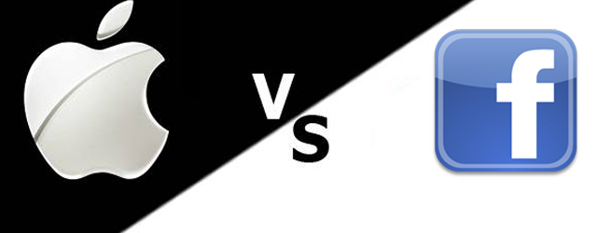

The owners of both Facebook and Apple exchanged a word war over data security (Scribner, 2018). The argument started when the Apple CEO, Tim Cook, said he would never have allowed people’s information to be breached the way Facebook has over the last few years (Scribner, 2018). He specifically pointed out the breach involving Facebook and Cambridge Analytica that bought Facebook data from a third party (Scribner, 2018). Cook mentioned how much money they could make if they breached customer information, but they have chosen not to do so (Scribner, 2018). I believe Apple is doing the right thing in this case because it is wrong to give out others information.

In an interview Mark Zuckerberg, founder of Facebook, struck back to the CEO’s comment and said he found the argument to not be aligned with the truth (Scribner, 2018). He says just because you are not paying, does not mean we do not care about you (Scribner, 2018). Since Facebook is a free product, the only way the company makes its money is advertising (Scribner, 2018). He said Facebook is unique because it is a free product (Scribner, 2018). The CEO has had the final laugh so far in this argument since Facebook’s stock dropped $40 billion in market value (Scribner, 2018).

Cook spoke out again against Facebook saying that some well-crafted regulation is necessary (Scribner, 2018). He does not think that knowing every detail about a person’s search history, contacts, and things you like and dislike should even exist (Scribner, 2018). After this comment from the CEO of Apple, Zuckerberg said he wishes to make Facebook more democratic to give members a chance to make their own decisions about what they trust on Facebook.

I think it is a great thing to have privacy and not breach your client’s information to anyone. I also think Facebook is a great service to have but even with the privacy settings, Facebook should not be able to access everyone’s most intimate things. This particular case about breaching privacy reminds me of one a few years back. It was Apple vs. FBI.

In the case of Apple vs. FBI, the FBI believed that Apple should be forced to unlock an iPhone that would allow them to solve criminal investigations. This case was back in 2016 and the government sided with Apple saying they were not required to unlock the iPhone even if it would help the investigation. The FBI had a resident that pleaded guilty to drug charges and they needed to find out who else was involved but were unable to get into the phone. A similar case happened in California when the FBI needed Apple to unlock an iPhone that belonged to a man that attacked and killed 14 people and the FBI needed the phone unlocked in order to receive information on future targets or partners.

The government’s argument came from the All Writs Act of 1789. This compelled people and companies not involved in a crime to help the government obtain evidence when needed. Congress refused to approve the proposals that would require companies to get information from phones and other devices. In this case, I think Apple should have unlocked the iPhone for the FBI since it was for a criminal investigation. They could just use very specific information so only that one phone would be affected and other customer’s information would remain private. Previously, Apple had helped the government unlock about seventy iPhones for various cases, but since they won this court ruling they have declined other government cases.

I think it is a great thing that Apple is so adamant about their consumer’s privacy. I also think that it is really good to stick to what they believe in and not want to give the government complete access to all consumer’s iPhones. I think in criminal investigation cases such as these, Apple should definitely unlock the specific iPhone in order to convict the criminal. Although these cases are very similar to the Apple vs. Facebook privacy breach, they are for different reasons. Apple vs. Facebook is proving points on how great Apple’s privacy is and how they will not sell out a consumer’s information and how Facebook has done so in the past even with privacy settings, they still know everything going on. In the case of Apple vs. FBI, the FBI wanted the phone unlocked but since Apple’s top priority is security they refused to unlock it and invade the privacy of a consumer.

Apple vs. Facebook is an ongoing argument. Apple CEO says they see Apple as a product whereas Facebook to them is just another app. As an Apple user, I really like the fact that they do not give out information to anyone for any reason. Also as a Facebook user, I think it would be nice to have more privacy on my account for various reasons. I think if Facebook would make their app more secure and not breach consumer information, the stocks would rise and would probably gain more users. Whereas Apple is more concerned about a consumer’s privacy, since they are known for not giving out information and do not want to ruin their reputation and are less concerned about the money they could make off of selling consumer information. These are the reasons why I think Apple is doing the right thing by not breaching a consumer’s information.

References:

Scribner, H. (2018, April 04). Apple vs. Facebook: Why the two tech giants are at 'war'. Retrieved from <https://www.deseretnews.com/article/900014862/apple-vs-facebook-why-the-two-tech-giants-are-at-war.html>