Name: Madison Lewis
Bi- Weekly Report Dates: March 23-29 and March 30 – April 5
Week 1 Total: 79,959 - high day was27 16,189 steps, low day was25 6743 steps
Week 2 Total: 57,023 - high day was 5 12,224 steps, low day was 31 2705 steps
Week 1 Reflection
I was MUCH more active this week than I normally get to be because of my schoolwork (which has proven to be quite the theme for me in these reflections). I lost a little sleep this week to get everything done that I needed to get done, but my step count and physical exertion went up considerably! Doing my schoolwork is not an option, so it is always a challenge to decide between sleep and a little more movement. On my high day this week, I indulged and stayed up later to get my homework done so that I could give a campus tour to prospective students on Tuesday. That tour (in the rain!) coupled with my extra meetings on campus that don’t usually happen on Tuesdays helped me get over 16,000 steps! My low day was 6743 steps on Sunday. My best friend’s birthday and my trip to Walmart to buy her flowers actually increased my step count that day. Other than that brief excursion, I spent the entire day sleeping and doing schoolwork to prepare for the coming week. On Tuesday and Sunday both my steps were spread pretty evenly across my waking hours.

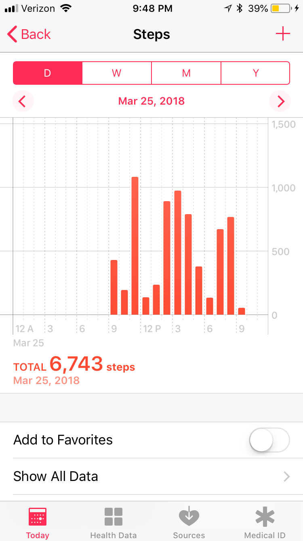
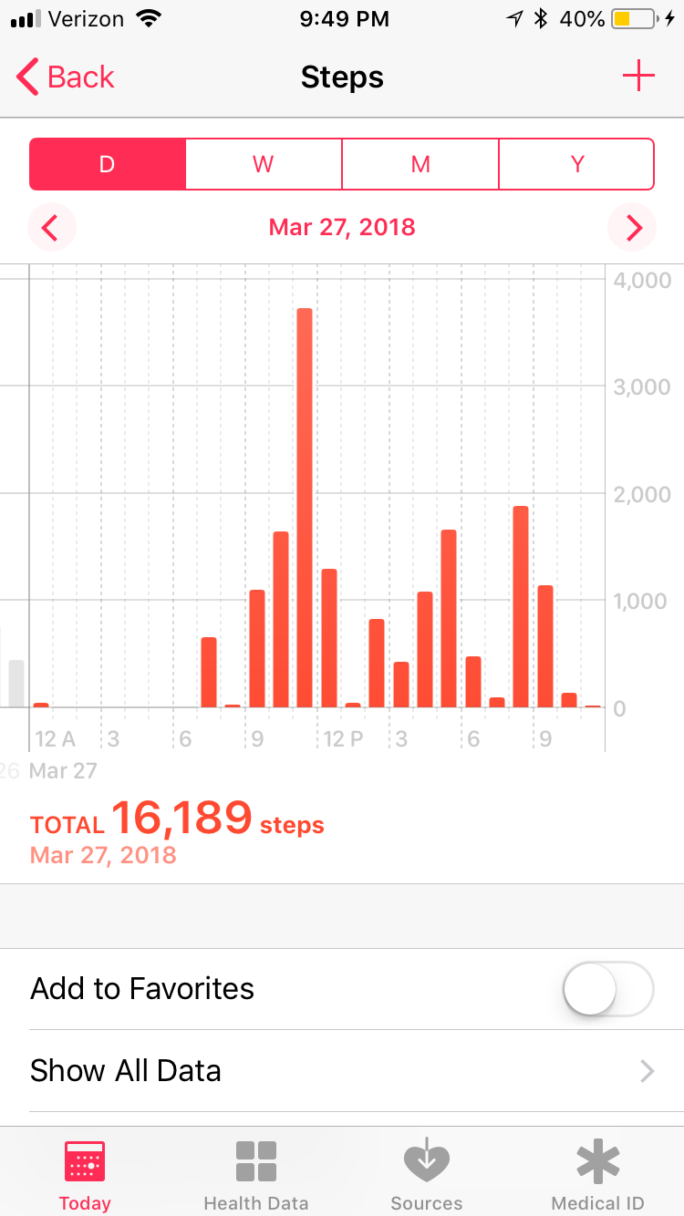
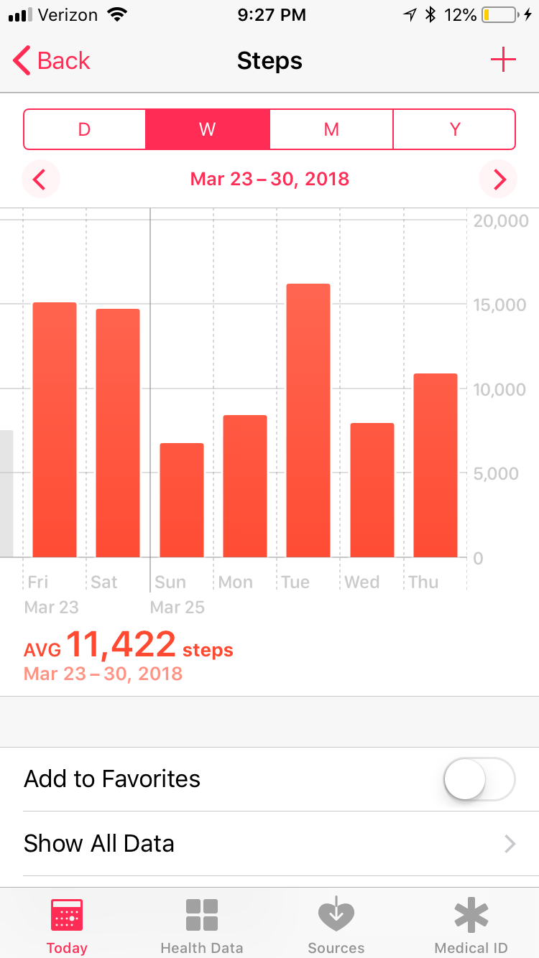
W Week High Day Low Day

Week 2 Reflection
I was moderately active compared to what I would consider “normal” for myself. I gave fewer tours and moved around less at work and in my practicum than I typically do, so I didn’t quite hit 70,000 steps in my week, which was disappointing compared to last week. I was really struck this week when comparing how good being a Longwood Ambassador has been not only for my social and mental health, but also my physical health. I always move the most when I am doing something relating to Ambassadors, and I know myself well enough to know that I wouldn’t be moving that much otherwise. I’m so grateful for how well and healthy that organization has helped make me. My high day this week was Thursday when I walked to dinner at Uptown with a prospective student. Because of that, more of my steps than usual were gotten during the evening that day. My low day was Saturday with 2705 steps. I had been so tired from my previous week that I slept in quite late, lounged around the house that day, and to top it off, I didn’t put my Apple Watch on until much later in the day, so I wasn’t actively thinking about getting my step count up. Again, my activity was spread out later in the day.
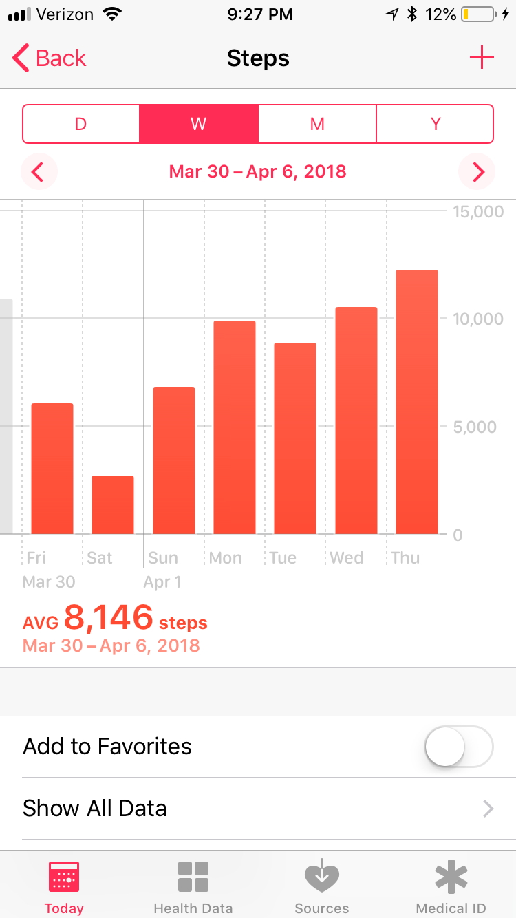
Week High Day Low Day
