hAngeli Leong
Math 150
I determined the population needed for each congressional district, using the 2010 Census data from 2010, to be approximately 727,365 people. I took the total population of Virginia in 2010, which was 8,001,024, and then divided it by the number of districts that I needed to apportion, which was 11. The map of my proposal is shown here:
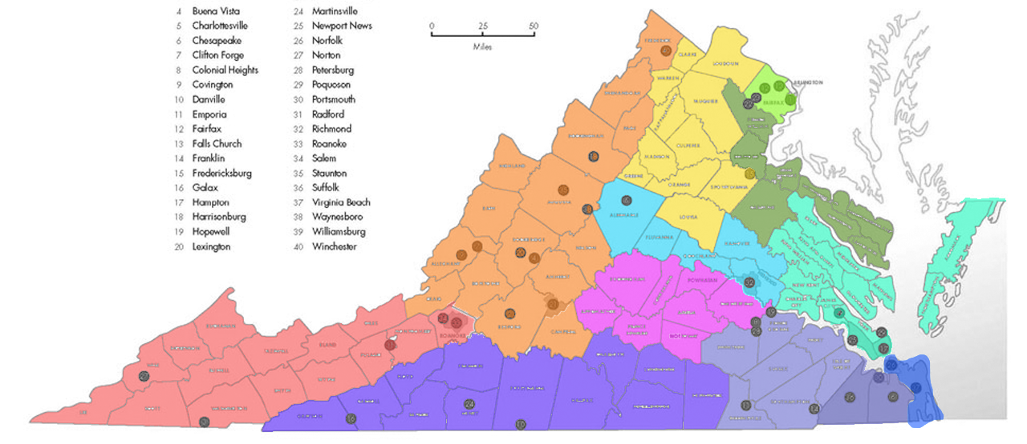
The way I redistricted Virginia was based solely on population. The biggest reason I determined the districts this way is because I wanted to make sure that they didn’t have extremely awkward shapes to them. Not only would it appear to be gerrymandered, but it would just be a confusing map to look at. I went through Table 4 in the 2010 Census Data, chose counties that were next to each other, and totaled up the population for each district, coming as close to 727,365 as I was able to. There were some over- and under- populated districts, however, such as the bright green district, the pink district, the purple district, and the green district. The bright and dark green districts were overpopulated, while the purple and pink districts were underpopulated. I couldn’t avoid this much, because I couldn’t just pick and choose whatever county I wanted, due to proximity and how gerrymandered it would appear if I had awkward shapes.
In order to prove whether or not the apportionment is gerrymandered, I needed to calculate the compactness of each district using the Washington Post method. Unfortunately, I could not calculate the actual numbers, because I could not locate a source on the perimeters of each county in Virginia. Instead, I ranked the districts from the most to least gerrymandered, based on how similar they are to a circle, in the table below:
Most Gerrymandered | Mint
 | Dark Green
 | Dark Purple
 | Red
 | Orange
 | Light Purple
 | Pink
 | Yellow
 | Light Blue
 | Dark Blue
Least Gerrymandered | Bright Green
I believe this apportionment is fair to Virginia inhabitants because the district lines are not wild and everywhere, which would have made it confusing to read a map of the districts. It is also fair because the districts were not chosen based on any other factor other than proximity to other counties, the end shape of the district, and population. I did not research what each county’s political affiliations are and pick and choose counties based on whether they are Republican or Democratic.

