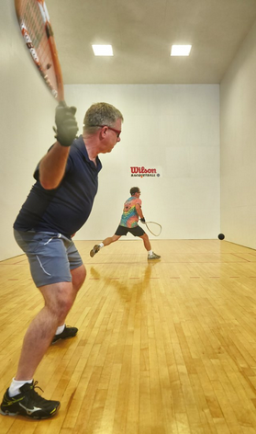

Please contact Kourtney Landis and Karly Harwood via email: [generationalgap@outlook.com](mailto:generationalgap@outlook.com) or

phone: 434-234-5698

# Battle of the Ages is a social innovation event that is focusing on the generational gap in our society. We encourage people of all ages to attend a day full of fun, activities, snack and community. 50% of profit made will be donated to Salvation Army to aid in their “Love The Elderly” campaign.

* Battle of the Ages

Kickoff event

### Saturday

September 15, 2018

**Where:** Longwood University Health and Wellness Center​

**What:** Racket Ball tournament ​

**Price:** $8 per participant ​

**Includes:** Snacks, music and community fun!