Anna Knapp, Shealynn Emerson, and Emily Jack
Math 121 Writing Assignment Spring 2016
April 26, 2016

Subjects | Arm Span | Height
A | 64 | 66
B | 63 | 64
C | 62 | 65
D | 75 | 70
E | 65 | 66
F | 67 | 61
G | 66 | 65
H | 67 | 66
I | 65 | 64
J | 64 | 63
K | 67 | 64
L | 57 | 62
M | 64 | 62
N | 60 | 64
O | 69 | 69
Domain: [57, 75] Range: [61, 70]

Height is a linear function of arm span because if arm span increases we expect height to increase as well. (A= arm span in inches, H= height in inches) When we graphed our data and found the least squares regression line, the equation came out to be H= 32.057+ .506a. The slope came out to .506, which means that for every .506 inches that the arm span increases, the height also increases .506 inches. Our model is slightly less than the rule of thumb, which is 1 inch, because we had a few subjects that did not follow our rule. Our vertical intercept in our equation is 32.057. This vertical intercept does not have practical significance for our data. There is no significance because no one would be 32.057inches tall at our age. As a group, we agree that a linear model is the best model for our data. When compared to an exponential model, the regression lines are almost identical. In the places where the lines are different, the linear model lines up with the data more accurately. This is why we chose the linear model. (see graph below)
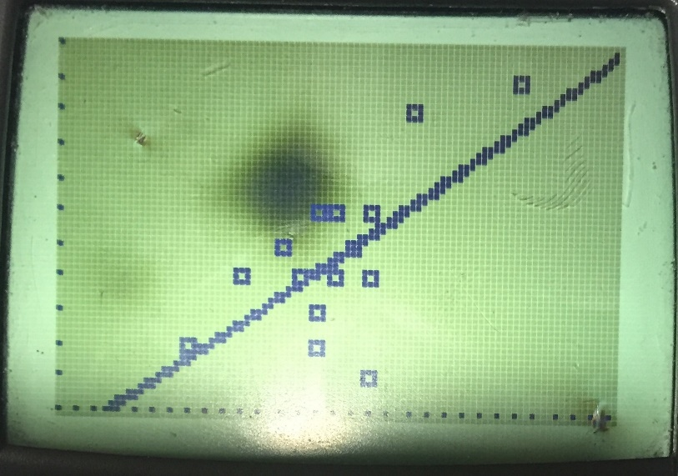

- Subject E: Arm Span= 66in Height= 65in
H= 32.057+ .506(66)
H=32.057+ 33.396
H=65.453
  - Technically, according to our equation the subject is .453in shorter than he should be according to his arm span. However, we believe that this is a very small difference, so it does not affect the data directly.

- If a subject is within an inch of their predicted height from the regression equation, than they are typical. This is how we found subject D to be typical:
Most Typical:
Subject D:
Measured Arm Span= 75in Measured Height= 70in
H= 32.057+ .506(75)
H= 32.057+ 37.95
H= 70.007
70.007-70= .007

Subject D is .007 inches shorter than their predicted height.

- A subject is classified as atypical if they have a difference of more than an inch from their predicted height. This is how we found subject F to be atypical:
Most Atypical:
Subject F:
Measured Arm Span= 67in Measured Height= 61in
H= 32.057+ .506(67)
H=32.057+ 33.902
H= 65.959
65.959-61=4.959

Subject F is 4.959 inches shorter than their predicted height.

