Anna Knapp
Bi-Weekly Report Dates: 2/10-2/16 & 2/17-2/23
Steps Week 1 Total: 73,564 High Day: 17,436 Low Day: 7,448
Steps Week 2 Total: 70,140 High Day: 16,155 Low Day: 7,063
Week 1 Graphs
Weekly Outlook
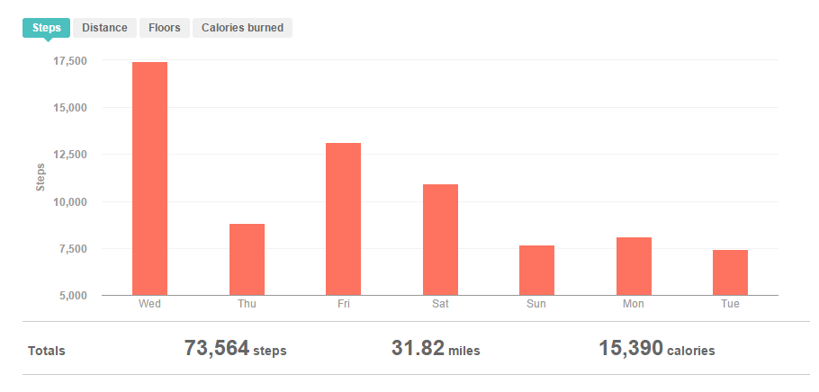
High Day
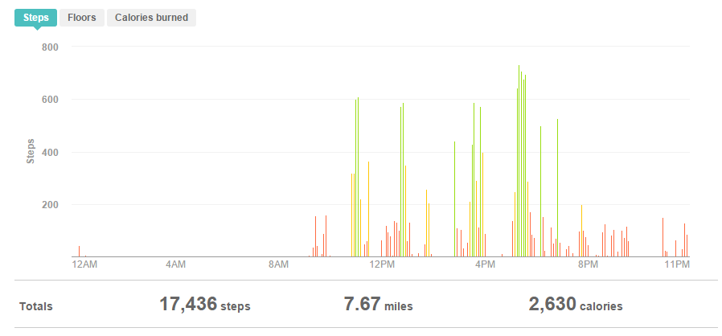

Low Day
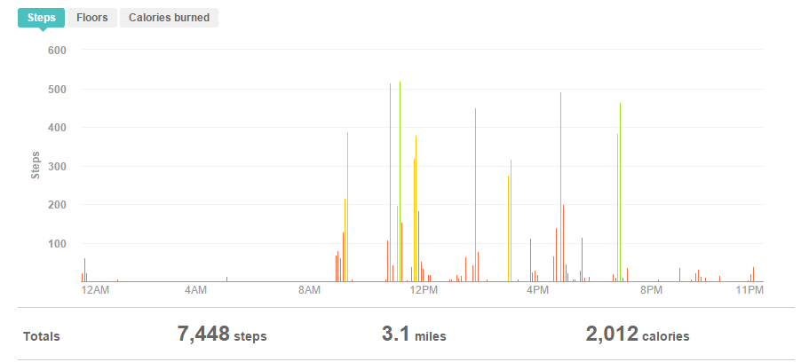
Reflection for Low Activity and High Activity Day (Week 1):
- On my high day I went to the gym
- On my high day I also had to walk to Lancer Park and back to get my car to drive to the elementary as a part of the Big Siblings Program
- On my low day I did no special activity besides walking to my classes

Week 2 Graphs
Weekly Outlook
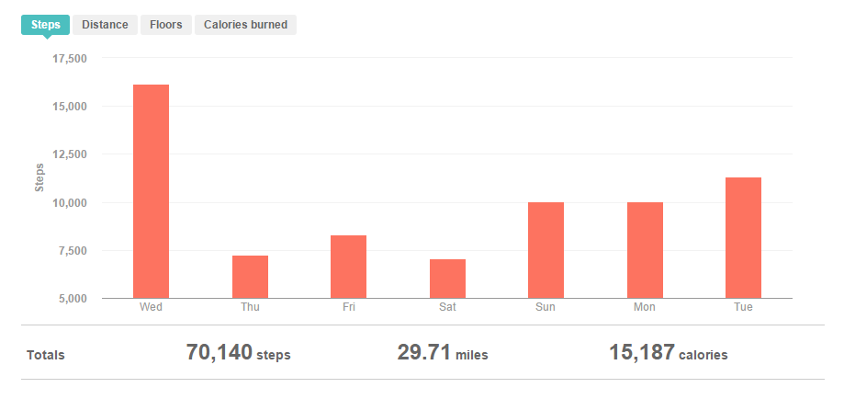

High Day
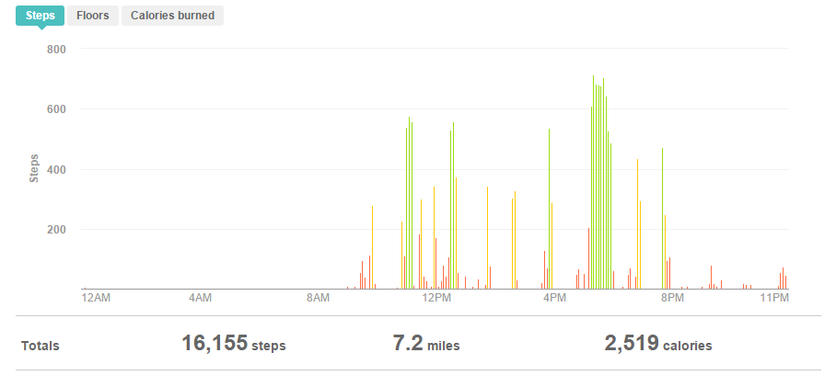
Low Day
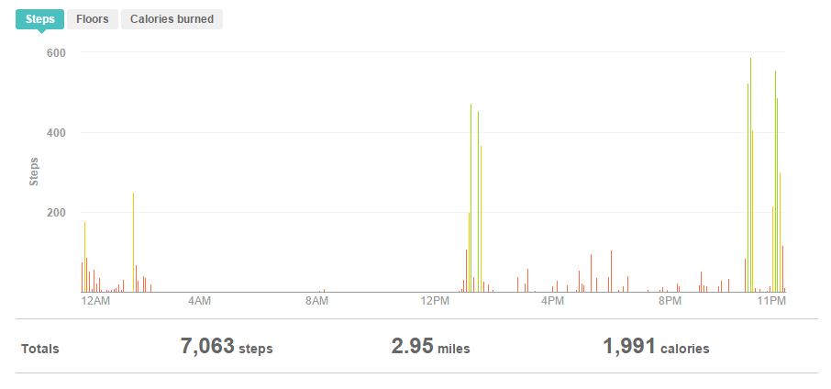

Reflection for Low Activity and High Activity Day (Week 2):
- On my high day I went to the gym
- On my high day I also had to walk to Lancer Park and back to get my car to drive to the elementary as a part of the Big Siblings Program
- On my low day I was sick so I did not leave the dorm for the majority of the day

