Samantha King-Cash

Week 1 Physical Activity Monitoring Report
Total steps this week: 70,091

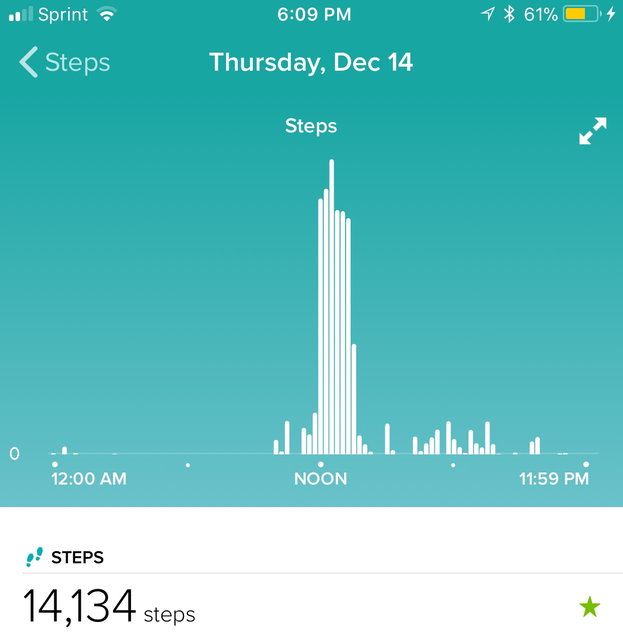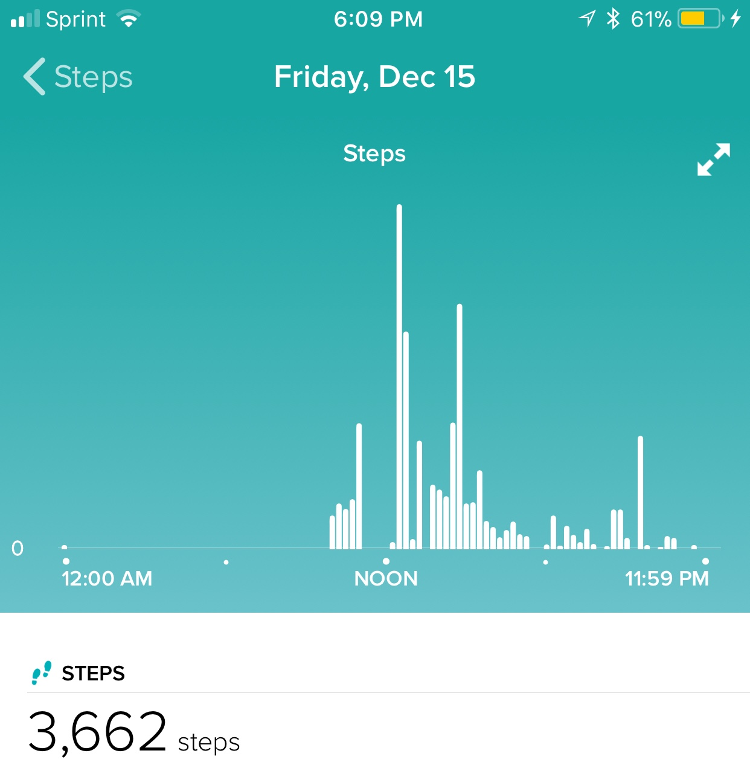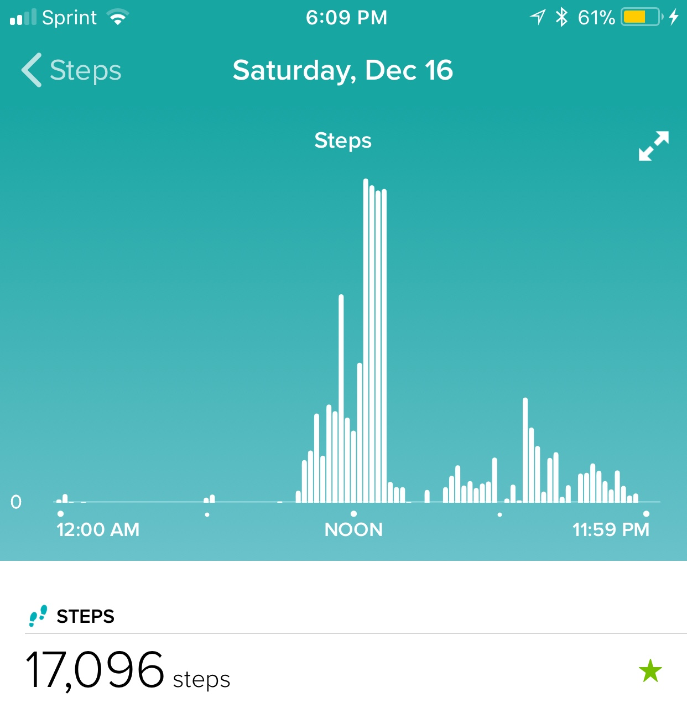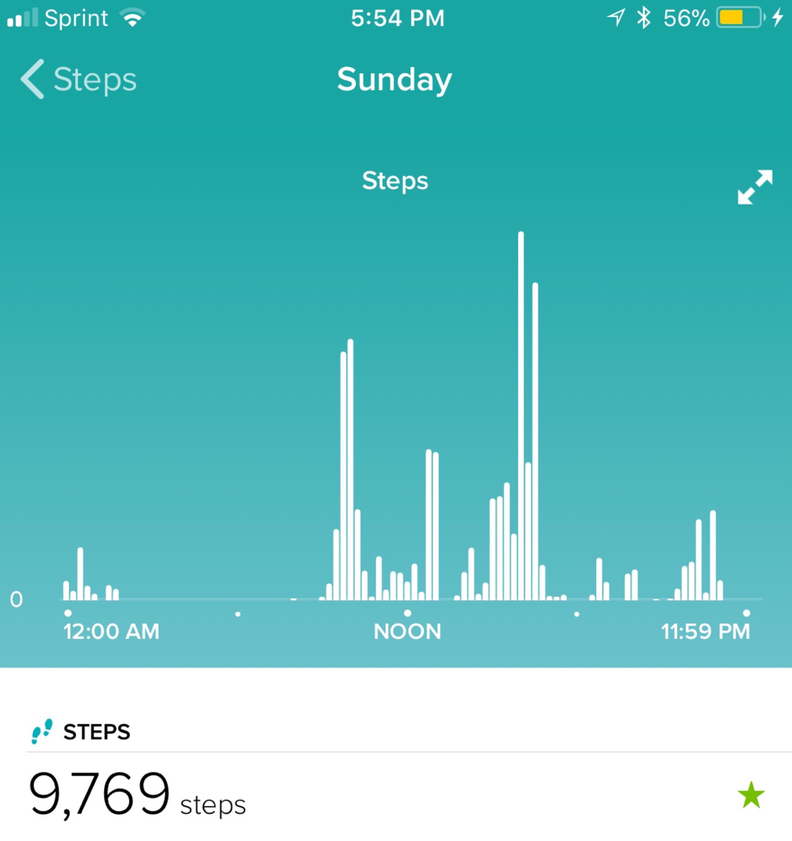
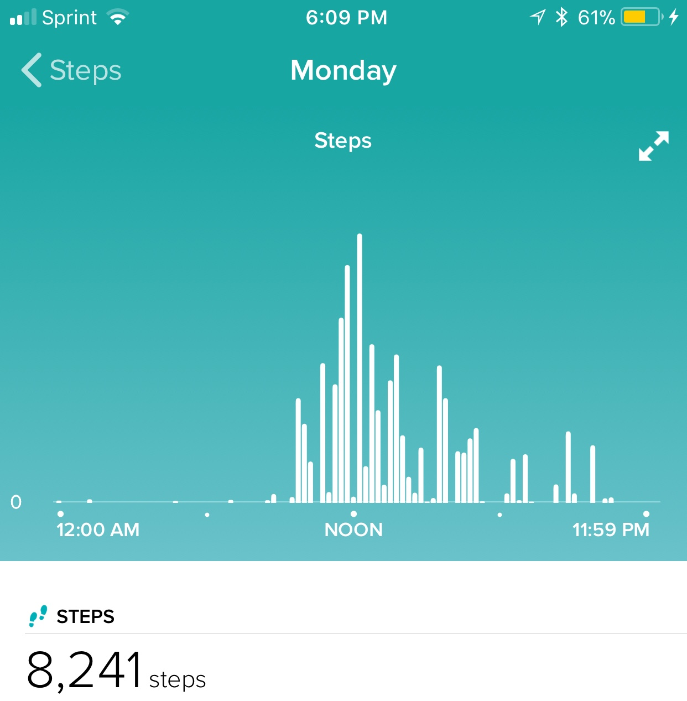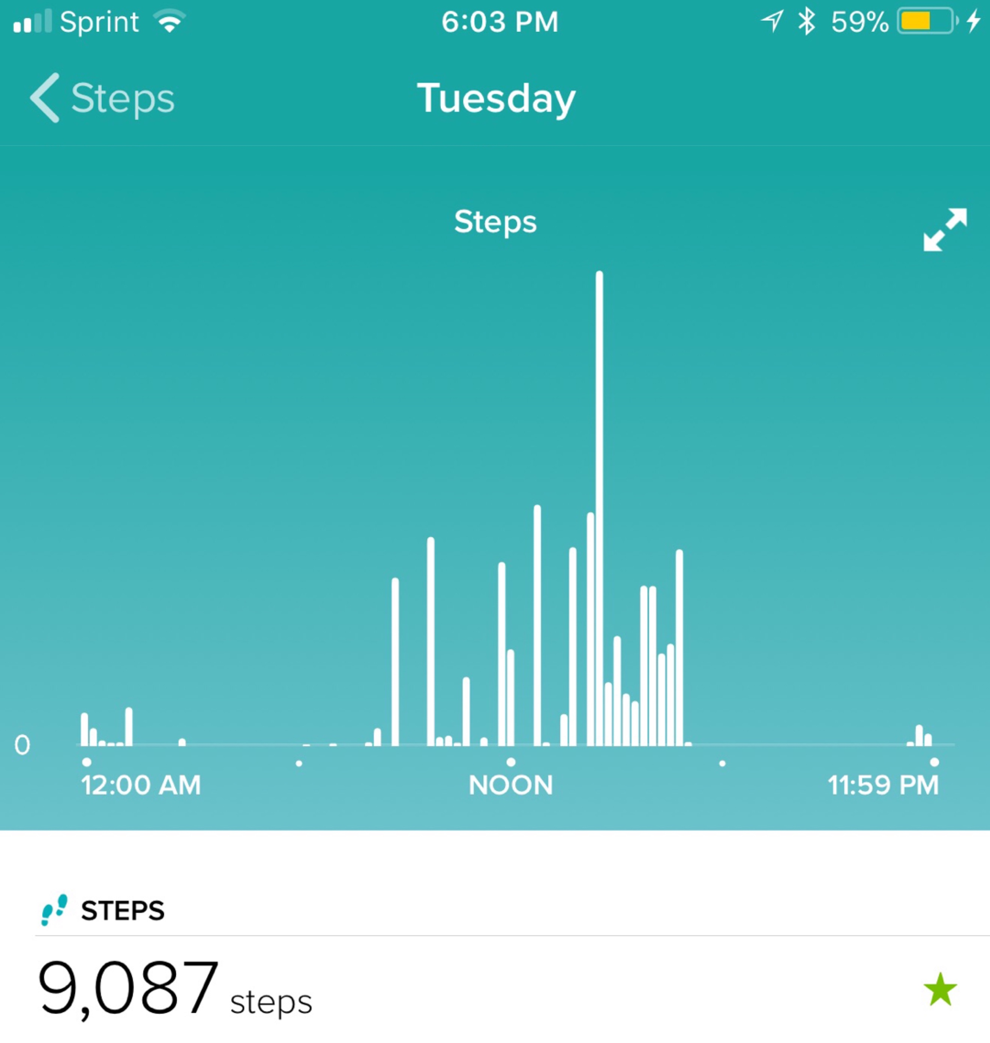
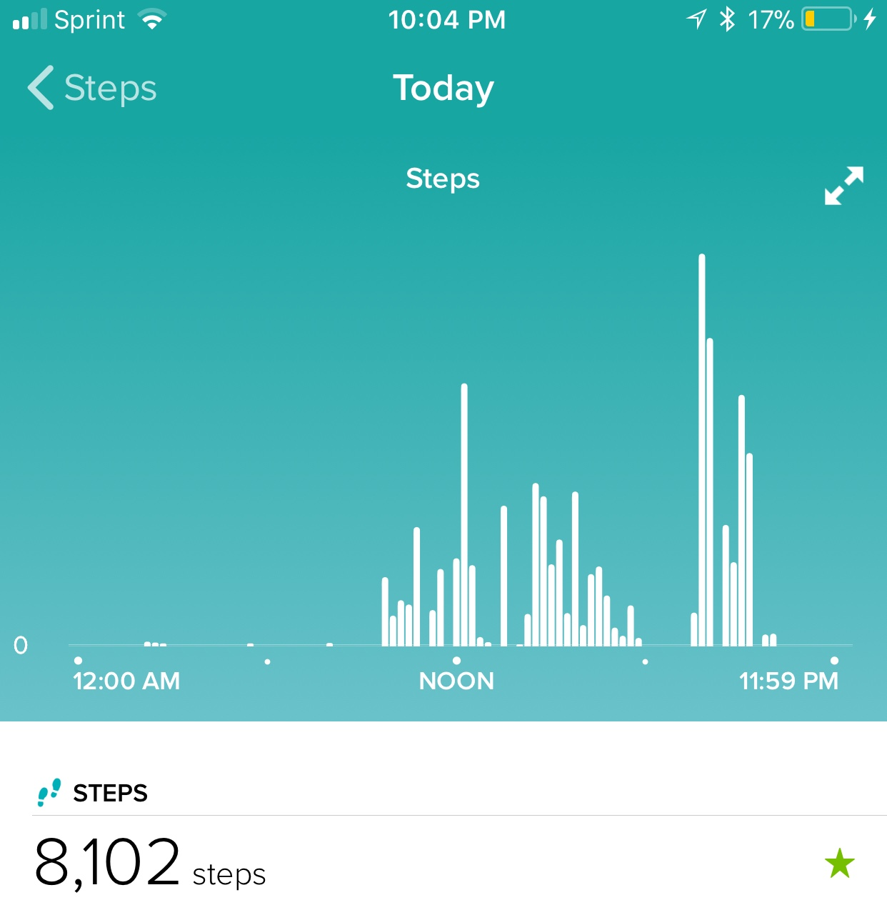

Throughout the week of December 14 to December 20, I failed to reach the daily goal of 10,000, yet I managed to reach 70, 091 steps altogether. My lowest day was on Friday, since I did not leave my house. I also had no chores to do, because I finished them all on Thursday. I failed to reach my daily goal of 10,000 steps Sunday through Wednesday with the rest of my steps relying on Thursday and Saturday, since I got so many on those days. I also did not reach my goal today, Wednesday, because I did not spend much time outside of the house, but in the evening, I vacuumed the whole house and cleaned, so this lead to my increase in steps later in the day.

On the other hand, on Thursday, my NEAT activity led up to the high amount of steps I got. As you can see, a majority of my steps occurred around noon, which is when I started chores. I cut the grass with our push mower and blew the leaves into piles and put them into bags. I did not do much on Friday; however, on Saturday, I quickly reached my goal of 10,000 steps. I drove to my friend’s house, then we walked from her house to Main Street and walked around the Christmas Farmer’s Market. Even though I didn’t reach my goal on Monday, it is noticeable that my steps slowly increased then decreased, because I went shopping then spent a while in the car driving home. Some other steps that begin to add up are my occasional trips to the park with my sister, where I walk until she finishes running.

I have realized that most of my time spent moving begins around 9-10am every day and ends between 11pm-1am. I would say, on average, I was just at moderate intensity. My average steps before I started aiming for 10,000 steps a day was 6,500, so for me, that goal is more intense than I’m used to. When I got 14,000 and 17,000, I was extremely surprised that I went so far over the daily goal. It felt satisfying to achieve that goal and I now want to push myself more to reach the goal of 10,000 steps even more.

