Hazing Prevention Comparative Research

Virginia Schools
UVA
-Hazing definitions and examples
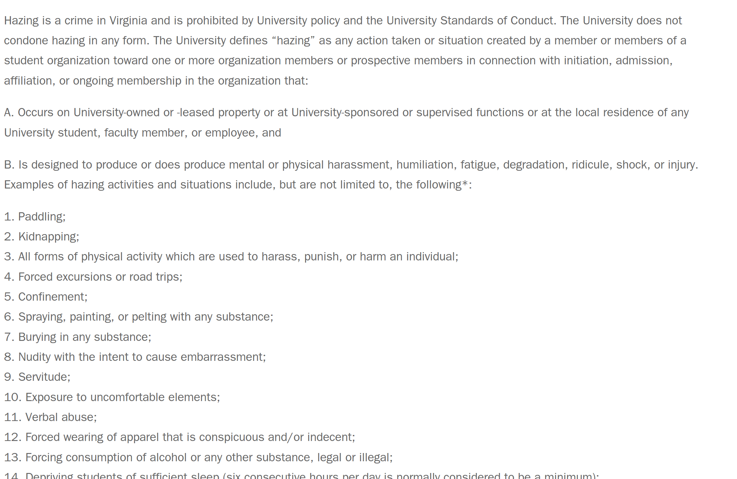
GMU- Strict Documentation on how often and were anti hazing events for each chapters are
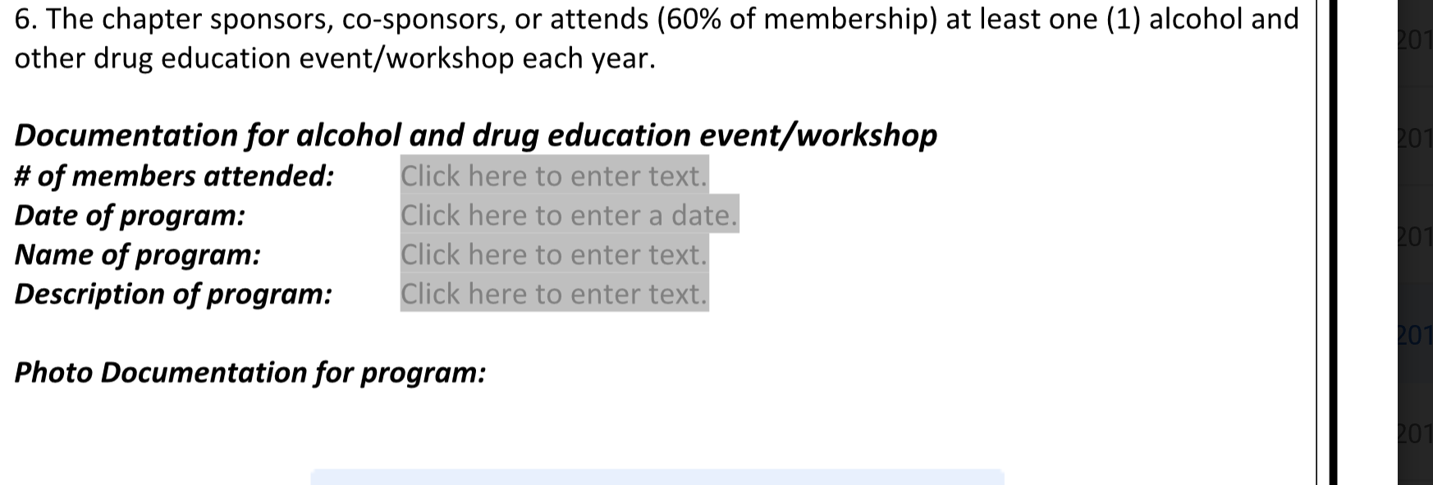
JMU- “Any chapter found in violation of JMU Hazing Policy will be brought under review by CMSS.”
Center for Multicultural Student Services

RU- Anti hazing contract for all new members
William and Mary- What can you do as an individual to stop hazing at the school (specific plans)

ODU- Sanctions and Violations-”Organizations found in violation of this policy and/or Virginia Law may face sanctions ranging from a warning to a loss of status as recognized student organization. Individuals found to be in violation of this policy may face sanction ranging from a warning to a dismissal.”

Out of State Schools
University Of Connecticut-Awards Given out for results of Anti Hazing Week

Florida State University
https://ofsl.union.fsu.edu/about/organizational-scorecard

Babson college- MA
alternatives to hazing and hazing statistics
“How much do you know about hazing quiz”

Rollins College “ Sorority hazing myths Debunked/ Explained

University of Missouri- Greek Community Conduct Report, (includes hazing for public to see) also scorecards

University of North Florida- “The University will take strong and swift action against any instances of hazing, and will refer to local or state authorities for criminal prosecution whenever appropriate”.

Initiatives
consequences, strike program, etc.

Babson College- Personal consequences of hazing and Membership and organizational sanctions

Miami University (Ohio) - Myths about hazing explained/Big or Little sister Construct
“Hazing is not about ‘earning your way in’ or ‘building loyalty and teamwork.’ It is about exerting control over another human being.”

University of North Florida- “STATEMENT OF PROCEDURES” a map for the steps of reviewing and investigating a hazing case

