Men are from Mars, Women are from Venus
By: Kelly Tarmon

You’ve heard the saying “men are from Mars, women are from Venus”, but would you believe me if I told you that saying might be far from the truth?
It seems to be common knowledge that men generally have larger hands than women, but four college students from Longwood University wanted to test this belief on a small scale. These students set out to determine this through a small experiment.
As they roamed through their anatomy class they used five female subjects and five male subjects and measured their height, hand length, and hand width. Through this, they found the average heights and hand sizes show in the picture below.

Average Heights and Hand Length and Width Based on Gender. Women seemed to have smaller measurements compared to men.

These students concluded that on average, men have a larger hand size and are taller than women, but the difference is not that significant. When doing research, they found many different studies regarding hand size.
The most relevant and interesting research found was an article by Tracy Kivell, Isabelle Guimont, and Christine Wali. This article is about Sex‐Related Shape in the Human Carpal Joints. According to Science Direct, carpal joints “consist of two rows of bones and three joint levels, the carpals closest to the arm, the middle carpal, and the knuckle part of the hand joints” as shown in the picture below (Voss, 2009).
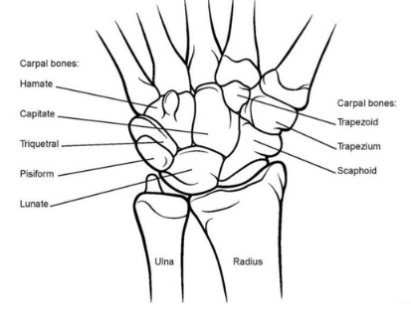
Anatomy of Wrist Joint. All carpal bones are labelled and shown.

These researchers found that “most features of carpal shape were similar between human males and females” (Kivell et al. 2013). With this research and the small research these Anatomy and Physiology students performed, they believe there is not a major difference between male and female hand size.
I guess the question now is, are men really from Mars and women from Venus? You tell me.

References:

Kivell, T. L., Guimont, I. and Wall, C. E. (2013), Sex‐Related Shape Dimorphism in the Human Radiocarpal and Midcarpal Joints. Anat Rec, 296: 19-30. doi:10.1002/ar.22609
Voss, K. (2009). Carpal Joint. Retrieved from https://www.sciencedirect.com/topics/immunology-and-microbiology/carpal-joint
http://aasharthroscopy.com/anatomy-of-wrist-joint/

